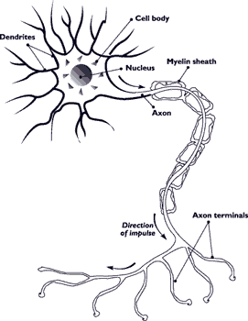
Biol 4751/5751 NEUROSCIENCE I: Cells & Circuits

Check the syllabus early and often.
Fall 2026, MWF 10:00-10:50 Matthews 312

Instructor: Dr. Jannon Fuchs
Office Hrs:
- LSCA 322A (Life Science Complex A, room 322A). A322A is inside of room 322, so knock vigorously on the door to 322. Mondays 9-9:50am and Tuesdays 9-10:30am
- Hickory Hall 266 Wednesdays 9-9:50am

- eMail to set up additional times in LSCA 322: Jannon.Fuchs@unt.edu.

Required textbook: Bear et al. Neuroscience: Exploring the Brain, 2026—The new 5th Edition. Expensive, but considering how much it costs to attend college and how important your brain is, well, it’s up to you! Optional articles and materials from other textbooks will be posted on the course website.

Date | Chpt. | Topic | Assignments
8/17 8/19, 8/21 | 1 | Neuroscience: History, Techniques
8/24. 8/26, 8/28 | 2 | Neurons & Glia | Review 1 due 8/24
8/31, 9/2, 9/4 | 3 | Resting Membrane | Review 2 due 9/2
[9/7 Labor Day]  9/9, 9/11 | 4 | Action Potential | 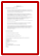  Review 3 due 9/11
9/14 Monday | Exam 1 | Chapters 1,2,3 | 
9/16 | 4 | Action Potential |   Grad students Topics title, abstract due 9/18
9/18, 9/21, 9/23 | 5 | Synaptic Transmission | Review 4 due 9/18 `
9/25, 9/28, 9/30 | 6 | Neurotransmitter Systems | Review 5 due 10/2
10/2 | 7 | Structure & Devel. of Nervous System | Review 6 due 10/2
10/5 Monday | Exam 2 | Chapters 4,5,6 | 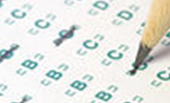
10/7, 10/9 | 7 | Structure & Devel. of Nervous System | Grad students Topics  draft due 10/11
10/12, 10/14, 10/16 | 8 | Chemical Senses | Review 7 due 10/12
10/19, 10/21, 10/23 | 9 | The Eye | Review 8 due 10/19
10/26, 10/28, 10/30 | 10 | Central Visual System | Review 9 due 10/26
11/2 | 11 | Auditory & Vestibular Systems | Review 10 due 11/2  VOTE as if your future depends on it. (guess what!)
11/4 Wednesday | Exam 3 | Chapters 7, 8, 9, 10 | 
11/6, 11/9 | 11 | Auditory & Vestibular Systems | Grad students Topics Project due 11/10
11/11, 11/13, 11/17 | 12 | Somatosensory System | 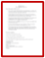  Review 11 due 11/11
11/19, 11/21 | 13 | Spinal Cord Motor System | 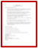  Review 12 due 11/19
11/23-11/29 Thanksgiving |  | 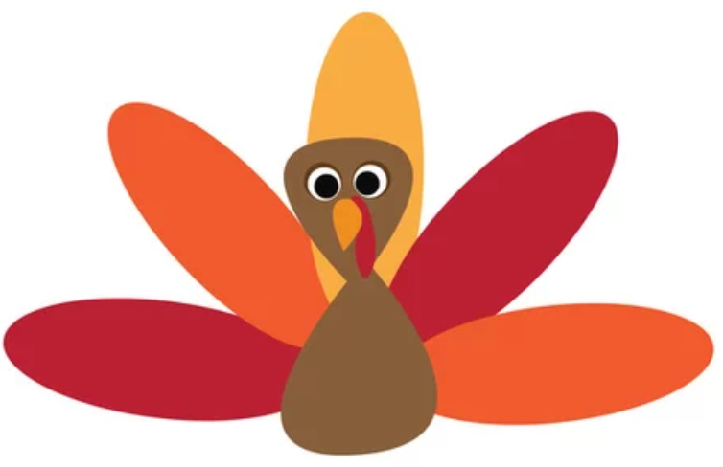
11/30 | 13 | Spinal Cord Motor System | Review 13 due 12/2
12/3 (last class) | Exam 4 | Chapters 11, 12, 13 | Home stretch.
12/9 (Wednesday)  8-10 am (I know) | Optional Final | Chapters 1-13, cumulative  (Same room, Matthews 312 | 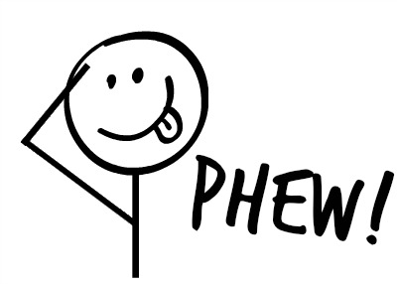  Whew!!

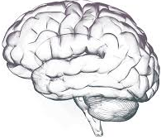
Overview. Why study the nervous system? The nervous system is the most complex piece of matter in the universe. Nothing is more intriguingly complex, mystifying and important. We experience the world through our nervous system in a highly selective, abstract form. We cannot understand the world without understanding our nervous system. The textbook for Neuroscience I & II is a reader-friendly tour of the nervous system and can be a strong foundation for advanced work in neuroscience. Neuroscience I (Cells & Circuits) covers topics in the first half of the book, including neurons, glia, synaptic circuits, neurotransmitters and drugs, sensory systems and spinal motor function. Neuroscience II (BIOL 4752/5752, Brain & Behavior) covers topics in the second half, including higher integrative functions such as memory, language, sex, sleep, attention.

Learning Objectives. A chief goal here is to understand Neuroscience as a science. Neuroscience “facts” emerge from a process of inquiry, insight, deduction, hypothesis testing, modeling and evaluating evidence. Class discussions are designed to address this. Yes, you will learn MANY terms, facts and concepts, but we aim to integrate these in ways that enhance your understanding of Neuroscience and how it applies to your daily life and our global future.


Attendance is required. Class participation is encouraged. In all courses, attendance is simply the best way to keep up, especially if you are an active listener/participant. Attendance is HIGHLY correlated with academic performance, for many reasons. Tuition is a big investment, so show up to reap the rewards. It is NOT OK to skip classes except for illness and emergencies. There will be in-class work, including small-group discussions and in-class quizzes. If you are not present when a quiz is given, you are counted as absent and there are no make-up quizzes.
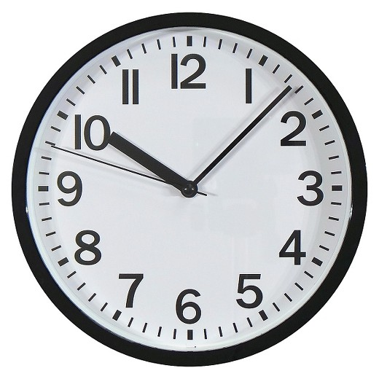
Late to class, early to leave can be disruptive/disrespectful, but there are unavoidable circumstances, and I would rather you attend part of a class than none of it.

Recorded lectures
Zoom lectures I recorded during the Pandemic will be posted because students find these to be really helpful. I can sometimes record and post classes during the semester, upon special request.

Technology requirements
- A computer with reasonable internet access. We may use Zoom for review sessions and/or remote office hours.
- A cell phone for iClicker attendance and iClicker quizzes.
- Technical assistance, helpdesk@unt.edu, 940-565-2324; location and hours, https://aits.unt.edu/support

Office hours are for you. Ask questions in class to benefit everyone, but I will also be glad to meet with you during office hours. Maybe you did not have a chance to ask questions during class or maybe would like to discuss something in more detail, such as course material, study habits, career choices, etc. The office hours listed are the best times for me, but other times are fine if you set up an appointment by email (jannon.fuchs@unt.edu). Appointments can be in-office or Zoom.

Studying. Plan to devote at least 6 hours/week of quality time outside of class to learn the material. Review PowerPoints, go over my chapter Review Questions, watch the taped lectures or classes, read your notes. read the chapters, etc. Keep a record of your efforts. If you do not have at least 6 hours/week for this, I cannot recommend that you take this course.

Superbly Successful Studying Strategies

- Preview: Please look at the scheduled textbook chapter and and/or posted lectures before class, so that we can spend class time working with the material.
- Notes and review: The most effective way to listen is to take notes on paper the old-fashioned way. It demands that you synthesize and be selective. Review your notes asap while they are still fresh in your mind.
- Keep up: Don’t cram for exams. Review as you go so that the information has time to consolidate (“settle in”). This was the secret of one of my all-time highest scoring students.

- Get a study buddy: Find a classmate(s) to study with. It helps a lot!! Your study buddy doesn’t have to know more than you do. In fact, you learn more by teaching than by listening.
- Prepare for exams: Usually at least 90% of the exam material is covered in class, and at least 94% is covered in the PowerPoints and Review Questions. Students say it is VERY helpful to go over my Chapter Review Questions, especially with a study buddy. Also, review the PowerPoints and your notes, and view my pre-recorded videos for topics/chapters that are still unclear. Read the textbook chapters to understand, reinforce and expand your mastery of the material.
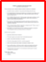
Review Assignments
- Each module on Canvas has my Chapter Review Assignments. For EACH chapter review (A) Address your choice of 3 Essay Questions, AND (B) Make up 3 multiple-choice questions, with the correct answers marked. The course website has an example of a Review Assignment. Submit the Review as a Word document on Canvas under Assignments. If you email them to me, they will probably get lost.
- Due dates are in the syllabus. Each Review is worth 1.0 points if satisfactory and on time, 0.6 points if satisfactory but late (usually within 2 days after the due date), 0 points if after the late deadline, and negative points for plagiarism or use of AI programs such as ChatGPT. I and/or a grader will spot-check reviews for completeness and accuracy. I will gladly go over any of the questions in class upon request. Please don’t ask for an extended due date unless your reason is exceptional. Note that you can submit the assignments ahead of time and then modify/resubmit them as often as you like before the due date. Who knows when the website will be down, so wait until the last minute…at your peril.
- Please do not use plagiarism or AI to prepare these assignments. That’s like signing up to learn tennis and asking Jannik Sinner to take the lessons for you.
Exams will be mostly multiple choice and fill-in-the-blank, and maybe some short-answer, matching, true/false, or diagrams. Make-up exams may be essay and/or oral. However, if you need to reschedule an exam due to illness or other exigencies, notify me and reschedule as soon as possible. We thank you in advance for not sharing Covid-19 and other contagions. If you have an extended hardship or illness, the Dean of Students Office can verify your condition and notify all of your instructors: https://cm.maxient.com/reportingform.php?UnivofNorthTexas&layout_id=23

The Optional Final Exam will cover the whole semester. It will be similar in format and difficulty, but the questions will be different from the other four exams. Your grade on the Final will replace the lowest grade of the other 4 exams. But no penalty for bombing the Final. Nevertheless, you have to actually study for it. Generally about half of the class takes the Final, and about 1/3 of those do well enough on it to replace their lowest exam grade. Calculate your probable grade at the end of the semester to know what grade you would need on the Final to raise your letter grade for the course.

iClicker Quizzes will be given in class, typically without prior notice. I hope this will help to encourage regular attendance. Approximately 13 will be given and the lowest 2 will be dropped.

Grades are based on performance, not on need. So if you “need” a certain grade, keep earning it all semester! Grades rarely skyrocket without a major boost in effort. The rules are the same for all, so for everyone’s sake, please do not ask for special extra-credit at the end of the semester!

Graduate Assignment (BIOL 5751). For graduate credit, a Topics Project is required. Canvas will have guidelines and the due dates for each of the three stages of progress on your Topics Project.

- Undergraduate credit, Biol. 4751
13 points Review Assignments (1 point each X 13)
80 points for Exams* (Average of 4 exams X 0.8)
12 Quiz points.
105 Total points

*If you opt to take the Final Exam and your score is higher the lowest of your other 4 exams, the Final Exam grade will replace the lowest of the 4 exam grades.
*I add a few extra points if needed to make the curve reasonable, so higher than 104 is possible.

Grading scale
A > 89.5
B > 79.5
C > 69.5
D > 59.5
F < 59.5

- Graduate Credit, Biol. 5751
80+ = 0.8 X the grade calculated as above for undergraduates
20 for Topics Project
100+ points total

Graduate students only: Topics Project required for graduate students only
- There are three stages for the Topics Project, each with its own due date as posted in the syllabus. These stages will save you from cobbling together a project the last minute and will allow you to get feedback from me as the project develops.
- The topic must be related to the course material and should be narrow enough that you can go into more detail than the textbook does. The format is flexible, and your creativity is welcome. Further guidelines and ideas are posted on the course website. Email your topic to me for approval before you post it.
- More directions are posted online, but in brief, for the references cite anything that is not common knowledge to the average person who has taken college biology. In the text, cite references in this format, in chronological order: (Jones, 2016; Jones & Brown, 2017; Brown et al., 2019). E.g., Aardvarks are generally solitary, territorial mammals (Jones et al., 2016). References Cited is a list of all references cited in the text, in alphabetical order by author. Other than that, choose a format from any journal. E.g., Smart, E.G., Good, U.R., and Perfect, I.M. (2016) Anatomical adaptations of arctic aardvarks, J. Gen. Behav. 19:12-94. Make sure that all references cited in the text are in this list and all references in the list are cited in the text.
- Submit the stages of your Topics Project via the course website. The final draft will go through a plagiarism & AI detection program. If I have concerns about these possibilities, I will ask you to come to my office to discuss your Topics Project.

Academic Integrity

- Any form of cheating on an exam or assignment must be reported according to UNT’s policies and will entail an appropriately serious grade penalty.
- Plagiarism includes copying or paraphrasing material from the internet or other students’ work, using AI on an assignment if it is not explicitly allowed, etc. Do use spelling and grammar checkers, but know that I would much rather read flawed sentences in your own words than perfect writing by someone or something else. Writing and revising and revising and re-revising is the way to improve those all-important writing skills. Tip: If you are looking back and forth at your source as you are writing, you are likely plagiarizing. First read the sources, think about the material, and then write without looking. Limit the use of quotations, but when used, they need to be in quotation marks, and the reference must be cited.
Health First
My lab and course policy has always been “Health First.” Crossing fingers about the SARS-CoV-2 virus, which is still merrily mutating and making the rounds. For me, wearing a mask is small sacrifice to make on behalf of myself and friends with multiple risk factors who shudder at the prospect of getting long Covid, or even short Covid. Let’s keep an eye on the #s and mask up as needed.

UNT asks that these topics also be included in each syllabus:
Attendance (UNT)
Students are expected to attend class meetings regularly and to abide by the attendance policy established for the course. It is important that you communicate with the professor and the instructional team prior to being absent, so you, the professor, and the instructional team can discuss and mitigate the impact of the absence on your attainment of course learning goals. Please inform the professor and instructional team if you are unable to attend class meetings because you are ill, in mindfulness of the health and safety of everyone in our community.

Class Recordings (UNT)

Note: Recordings of class lectures are the intellectual property of the university or instructor and are reserved for use only by students in this class and only for educational purposes. Students may not post or otherwise share the recordings outside the class, or outside the Canvas Learning Management System, in any form. Failing to follow this restriction is a violation of the UNT Code of Student Conduct and is subject to disciplinary action.

Disability Accommodation (UNT)

The University of North Texas makes reasonable academic accommodation for students with disabilities. Students seeking reasonable accommodation must first register with the Office of Disability Access (ODA) to verify their eligibility. If a disability is verified, the ODA will provide you with a reasonable accommodation letter to be delivered to faculty to begin a private discussion regarding your specific needs in a course. You may request reasonable accommodation at any time, but ODA notices of reasonable accommodation should be provided as early as possible in the semester to avoid delay in implementation. Students must obtain a new letter of reasonable accommodation for every semester and must meet with each faculty member prior to implementation in each class. Students are strongly encouraged to deliver letters of reasonable accommodation during faculty office hours or by appointment. Faculty members have the authority to ask students to discuss such letters during their designated office hours to protect the privacy of the student. For additional information, refer to the Office of Disability Access website at https://studentaffairs.unt.edu/office-disability-access or by phone (940) 565-4323.

