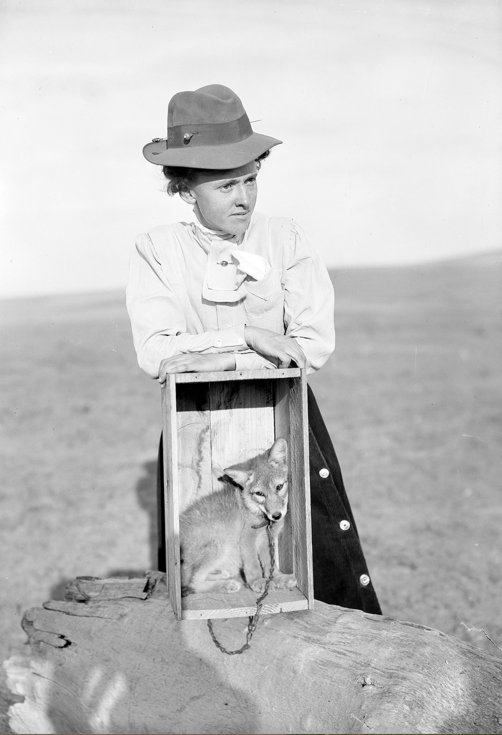  Jetta Hamilton Grey with wolf pup. Photo by Evelyn Cameron, 1907. Courtesy of the Montana Historical Society Research Center Photograph Archives, Helena, Montana. | ANIMAL HISTORIES  HIST 4276/5110 - SP2026 – F 09:00-11:50  Dr. Jennifer Jensen Wallach  Professor of History and Dean of the UNT Division of Humanities  (jennifer.wallach@unt.edu)  Dr. Michael D. Wise  Professor of History and Chair of the UNT Department of History  (michael.wise@unt.edu)  “Human” and “animal” are historically contingent categories that have transformed over time, and historians are partly responsible for creating and concealing those changes. History in the modern and postmodern eras has most often centered disciplinary debates around the actions and agencies of human animals, but what might it look like when we study how nonhuman animals also create history? How have animals and other nonhumans affected historical transformations? How have they shaped what historians write about the past? How can taking animal histories seriously help produce new and meaningful insights about our shared pasts and futures?
Learning Objectives: Students in this course will…
- Examine how historians and other scholars have represented the roles of nonhuman animals in historical transformations. This includes being able to:
  - Recognize major theoretical approaches to the concept of human-animal differences throughout world history.
  - Identify the major interpretative frameworks of human-animal relationships developed by historians, biologists, and philosophers in the modern and postmodern eras.
- Formulate and communicate (in written and digital forms) their own critical historical apparatus for comparing and evaluating human-animal relationships. This includes being able to:
  - Skillfully appraise historical and ethical arguments concerning animals as companions, as food, and as objects of display and/or conservation.
  - Integrate the historical analysis of animal-human relationships with intellectual perspectives from anthropology, biology, art, and media studies.
- Document these skills of critical historical analysis by producing final projects that communicate and showcase their original research and reflection on animal histories, including:
  - Propose new arguments about the historical representation of animals that help to construct more usable pasts for guiding current environmental and cultural concerns.
Communication: We encourage you to meet with us throughout the semester. Please email to schedule appointments.
Course Conduct: History necessarily involves the study of how systems of power have evolved over time, as well as how those forces continue to exert their weight in the present. We are all in the process of learning and unlearning many unjust logics that structure our society and our modes of communication. No one is perfect. What we ask, though, is for all of us to strive to be mindful, thoughtful, and generous in our interactions with each other in this course.
Preferred Name: If your preferred name is not the same as the name that appears on the class roster provided by UNT, please let us know so that we can use your preferred name.
Caregiver Responsibilities: Many students balance the pursuit of their education with the responsibilities of caring for children or for other family or community members. If you run into challenges that require you to miss class or meet a deadline please contact us and we can discuss ways to try support your learning with more flexibility.
Accessibility [UNT Official Language]: “The University of North Texas makes reasonable accommodations for students with disabilities. To request accommodations, you must first register with the Office of Disability Access (ODA) by completing an application for services and providing documentation to verify your eligibility each semester. Once your eligibility is confirmed, you may request your letter of accommodation. ODA will then email your faculty a letter of reasonable accommodation, initiating a private discussion about your specific needs in the course.
You can request accommodations at any time, but it’s important to provide ODA notice to your faculty as early as possible in the semester to avoid delays in implementation. Keep in mind that you must obtain a new letter of accommodation for each semester and meet with each faculty member before accommodations can be implemented in each class. You are strongly encouraged to meet with faculty regarding your accommodations during office hours or by appointment. Faculty have the authority to ask you to discuss your letter during their designated office hours to protect your privacy. For more information and to access resources that can support your needs, refer to the Office of Disability Access website (https://studentaffairs.unt.edu/office-disability-access).”
Grading Criteria (out of 100 possible points): A=90-100; B=80-89; C=70-79; D=60-69; F=<60.
Animal-human difference in the 21st century assignment (1/23/26) 5 points
Amulet assignment (2/6/26) 10
Dietary ethics position paper and debate (2/27/26) 20 (10 for grads)
Companion animal “show and tell” (3/20/26) 5
Graduate symposium assignment (4/3/26) 10
Final project (4/24/26) 40
Skills reflection (undergraduates only – 5/8/26) 10
TXAH.org submission (graduates only – 5/8/26) 10
Book review and presentation (graduates only – deadline varies) + 10 / TOTAL 100
COURSE SCHEDULE
WEEK 1 (1/16/26)
What is an Animal? What is Animal History?

WEEK 2 (1/23/26)
The Animal from Natural History to the Age of Ecology
DUE: Animal-Human Difference in the 21st Century assignment (5 points)

WEEK 3 (1/30/26)
WORKSHOP #1: Animal Amulets

WEEK 4 (2/6/26)
Animism and Personhood
DUE: Amulet assignment (10 points)
GRAD BOOK REVIEWS:
Matt Cartmill, A View to a Death in the Morning: Hunting and Nature Through History (Cambridge: Harvard University Press, 1993).
Hans Peter Duerr, Dreamtime: Concerning the Boundary between Wilderness and Civilization, trans. Felicitas Goodman, (London: Basil Blackwell, 1985).

WEEK 5 (2/13/26)
Meat’s Modern Histories
GRAD BOOK REVIEWS:
Nöelie Vialles, Animal to Edible, trans. J.A. Underwood, (Cambridge: Cambridge University Press, 1994).
Karl Jacoby, Crimes Against Nature: Squatters, Poachers, Thieves, and the Hidden History of American Conservation (Berkeley: University of California Press, 2001).

Week 6 (2/20/26)
Meat and Identity
GRAD BOOK REVIEWS:
Carol J. Adams, The Sexual Politics of Meat: A Feminist-Vegetarian Critical Theory (New York: Bloomsbury, 2015 [1990).
Steve Striffler, Chicken: The Dangerous Transformation of America’s Favorite Food (New Haven: Yale University Press, 2007).

Week 7 (2/27/26)
The Vegetarians
DUE: Dietary Ethics Position Paper and Debate assignment (20 points / 10 for grads)
GRAD BOOK REVIEWS:
Jonathan Safran Foer, Eating Animals (New York: Little, Brown, and Company 2009).
Adam Shprintzen, The Vegetarian Crusade: The Rise of an American Reform Movement, 1817-1921 (Chapel Hill: University of North Carolina Press, 2013).

Week 8 (3/6/26)
Animal Companionship
GRAD BOOK REVIEWS:
Susan D. Jones, Valuing Animals: Veterinarians and their Patients in Modern America (Baltimore: Johns Hopkins University Press, 2003).
Kathleen Kete, The Beast in the Boudoir: Petkeeping in Nineteenth-Century Paris (Berkeley: University of California Press, 2022 [1994]).

SPRING BREAK (3/13/26)
Week 9 (3/20/26)
Conservation and Display
DUE: Companion Animal “Show and Tell” (5 points)
GRAD BOOK REVIEWS:
Gregg Mitman, Reel Nature: America’s Romance with Wildlife on Film (Seattle: University of Washington Press, 2009 [1999]).
Elizabeth Hansen, Animal Attractions: Nature on Display in American Zoos (Princeton: Princeton University Press, 2002).

Week 10 (3/27/26)
Department of History Graduate Student Symposium
“History and the Public(s),” Union 332

Week 11 (4/3/26)
Field Trip
The Zend: Final Farm & Sanctuary, Justin, TX, details tbd
DUE: Symposium Reflection (10 points)

Week 12 (4/10/26)
WORKSHOP #2: Final project work and discussion

Week 13 (4/17/26)
WORKSHOP #3: Final project work and discussion

Week 14 (4/24/26)
DUE: Final Project (40 points)

READING DAY (5/1/26)

FINALS WEEK (5/8/26)
DUE: Skills Self-Reflection (undergraduates – 10 points)
TXAH.org upload (graduates – 10 points)

