University of North Texas
Principles of Health
HLTH 1900.001
Spring 2016

Faculty Contact Information
Instructor: Jody Terrell, Ph.D. E-mail: jody.terrell@unt.edu
Phone: Office: 940-898- 2843 Office Hours: M-1:30 – 2:30, T-2:30 – 4:00
Office: PEB 208 W- 12:00 – 1:30, TH- 1:30 – 2:30 Class Meeting Time: TTH 12:30 – 1:50 PM Also, available upon request
Classroom: BLB 010

Recommended Text:
Donatelle, R.J., Ketcham, P. (2013). Access to Health. 13th ed. Pearson. ISBN 9780321832023

Course Description
This course is designed to help prepare students understand and define personal health problems of humans; knowledge, attitudes and behavior related to responsible healthful living.

Course Objectives
The student who successfully completes this course will be able to:
1. Describe core concepts of personal health
2. Identify personal health problems and solutions,
3. Identify attitudes and behaviors that reinforce positive health.
To accomplish this, students should attend class, read all course materials, participate in discussions, and consider participating in the KHPRos Club for academic and professional development (visit PEB 209 to sign up)

Course Goals
1. Evaluate and prioritize health issues and concerns
2. Demonstrate how to recognize health issues and assess solutions
3. Demonstrate how to read and follow directions
4. Effectively prioritize life issues, goals, responsibilities to avoid stress related health issues.
5. Identify areas and employment where graduates with a Health Promotion degree can be
Successful.

Student Learning Outcomes – (to name a few)
At the end of the course the students will be able to successfully:
1. Describe the immediate and long-term rewards of healthy behaviors and the effects that
your health choices may have on others.
2. Identify your own current risk behaviors, the factors that influence those behaviors, and
the strategies you can use to change them.
3. Examine the physical, emotional, and social health risks that may occur with chronic
stress.
4. Describe the benefits of physical activity for health, fitness, and performance.
5. Discuss what cancer is, how it develops, its causes and the ways to prevent cancer and
the implications of behavioral risks.
6. Explain why it is important to be a responsible health care consumer and how to
encourage health care consumers to take action.
7. Discuss issues facing our health care system.
8. Explain how to properly eat and exercise in order to improve your general health

Expectations
The learner enrolled in this course will behave as mature adult learners engaged in undergraduate level of study. As a mature learner he/she will:
- Interact with other learners in a respectful manner
- Accept responsibility for his/her behavior and learning.
- Assess his/her progress and request assistance as needed.
- Accept constructive criticism as an essential component of learning
- Accept responsibility for reading and following all directions and deadlines.

Teaching Style
My teaching style tries to reach all the different learning styles for each of my students. I will lecture with visual power points. I have group discussions and activities to reach the kinesthetic learner, and we have class discussions for the auditor learner. I enjoy learning from my students and also enjoy when the class can have fun learning. It is my philosophy that if you are having fun you will learn.

Pace of Course
This is a face to face class and we will meet twice a week. We will cover the chapters in the book, with the schedule attached to this syllabus. Please follow the schedule posted and any changes will be announced in class and on the blackboard announcement.

Activities, Assignments, and Grading Policy

Outcome Measures Point Value Grading Scale (in points)
Discussion Boards (6 X 15 points), (1x10) 100 A = 900 -1000
Health Topic Paper 100 B = 800 - 899
Quizzes & Learning Activities 300 C = 700 - 799
Topic Tests (4 x 100) 400 D = 600 - 699
Course Reflection Paper 100 F = 599 and Below
Total 1000

It is your responsibility to regularly monitor your points in the Bb Grade Center. If you notice a discrepancy, contact me immediately. Do not wait until the end of the semester to question your grades.
Grading and Instructor Feedback
Grading
Please see course rubrics which are posted on Blackboard. NO Late work will be accepted and all work will be turned in through the Assignment Link on Blackboard. No exceptions. Please do not e-mail me any assignments or attachments.

Late Work: See the course schedule for specific due dates. Your work will be considered late if posted after 11:59:00 PM on the stated due date. No late work will be accepted, so please submit all of your work according to the deadlines set forth in the syllabus. The due dates are the absolute latest you can submit an assignment, but please note that you can always submit earlier if you would like. If there is a mistake on my part for example two different due dates for an assignment, the latest date will be accepted. Please make sure it is the latest date, and no papers will be graded until the due date is past.

As all course materials and due dates are provided up front, no make-up work will be accepted, unless it is a university excused absence. In accordance with UNT policy, make-up work will only be accepted for those who provide for the following:
1) Illness certified by a physician;
2) Serious illness or death in student’s immediate family;
3) Absence from the campus with the sanction of the University or for a religious holiday,
or other university sanctioned events.
You need to contact me ahead of the due date to discuss your options.

Style and Format
Assignments (all out of class assignments) MUST be typed, double-spaced, using 12-point Times New Roman font. APA style must be used on all writing assignments. When submitting assignments online via the course Bb website, the file title should be formatted in this way: Last Name - Title of Assignment. For example, Jane Doe would submit Assignment 1 for Principles of Health in this manner: Jane Doe, HLTH 1900, Assignment 1

You are to save your assignment in a word document and then post it to the drop box or Assignment link of Blackboard. The comment section in the Assignment link is for comments only and not for the posting of your paper. I will not accept any papers that are typed in the “comment” section of the assignment link. If you have questions on how to post your assignments, please see the IT department.

All assignments without your name on them will receive a 0 and you will not be able to make up this assignment. This goes for all papers, quizzes, and in class activities.

Do not e-mail me any assignments regardless of the reason. I will not open attachments from students for any reason.

Instructor Feedback
Feedback for assignments will be returned within two weeks of the assignment due date. You will receive feedback through the Assignment link. Discussion boards will be graded two weeks after the close of each discussion board. I will grade your paper and it will be returned with the appropriate feedback on it. If you have questions before an assignment is due, please see me and I will be happy to review your paper before you turn it in however, no points for this privilege.

Discussion Protocol
Since this is an in face class you will be required to add to the class discussions. You will also have Seven discussion boards that you will be required to participate in on the Blackboard Discussion link. You will be required to post one original post and then respond to two of your peers for the full credit on each discussion posting. Please review the rubric below for the way to maximize your points. Each original post must be at least 300 words, and when responding to your peers you must have at least 100 words in the response, this means “Nice job” will not qualify for points. You will only get points for the posting which are posted on different days, which means, if you respond to three of your peers on February 13, 2016, you must respond on two other days to get full credit. This is to help spread out the posting so that everyone doesn’t post on the last day.
When posting an original discussion thread, please keep the following criteria in mind.
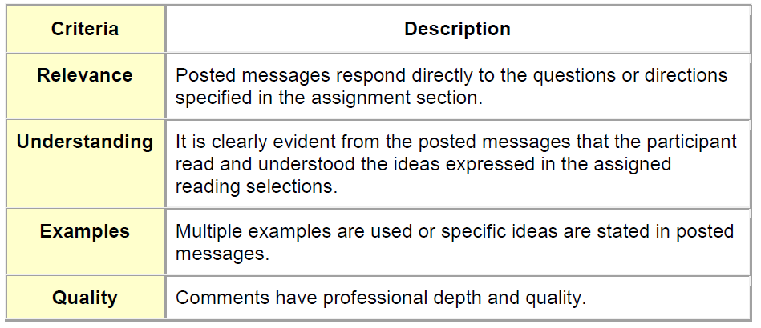

When replying to a discussion thread, please keep these criteria in mind.
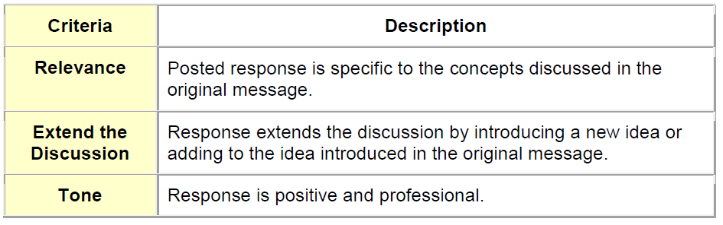
Participation
It is your responsibility to come to class prepared, ready to learn and participate in the activities of the class. If you have questions or need guidance, please utilize office hours to your benefit. I will be willing and able to stay after class if need. Also, I can meet you in the commons area 30 minutes before or after class if needed. Students are expected to engage in class discussions to share their knowledge and understanding with the class. Students are also expected to participate in classroom activities that complement the lectures and discussions, including online discussions. There are no make-ups for in class activities regardless of the reason for missing the class. Students are expected to arrive on time. Arriving late to class or leaving early is disruptive and disrespectful to the learning environment. Please refer to the student code of conduct. The Code of Student Conduct can be found at www.dos.unt.edu/conduct.

Major Course Assignments and Exams
Discussion Boards (100 pts.)
You will complete 7 discussion board assignments listed on Bb. Click on “discussions” and then you will see the questions listed for each assignment. You will need to provide in-text references and a reference page at the end of each assignment using APA 6th edition. Please use credible sources (no Wikipedia or .com sites). Each response should be significant, approximately 200 words. Peer responses to Discussion Boards you will need to respond to two peer for each discussion board assignment. Your response should add to the discussion. “Good job” or “nice work” will NOT be sufficient. The word count for each peer response should be at least 50 words or more. Also, remember to cite using APA 6th edition. You need to respond to at least two of your peers to get full credit. There needs to be a day between each discussion board response.

In Learning Activities and quizzes (300)
In Learning Activities are to assist the student to get a better understanding of the concepts taught in this class. They will be a combination of outside activities, group discussions, team work and brainstorming, and outside observation. Because this class is designed to prepare you for health promotion and health education you will have the opportunity to assess your own learning style, participate in class activities and learn presentation techniques. All in activities will be given during the semester and will help you prepare for the unit exams and quizzes.

Topic Tests (4 X 100)
Each exam covers the material addressed since the prior exam. The exams are worth 100 points each and will include multiple choice, true/false, short answer, and essay questions. Students will be taking these exams through Blackboard, and will not have to attend class during this time. You will be allowed 90 minutes or less to complete the test. This is not an open book exam so you will not have the chance to look up questions. Dates and times will be announced, and the test will be available for a period of three days. Once you start the test, it will time out at the designated time limit. Each test will be explained before it is posted.

Health Topic Paper (100 Points)
You are to choose some health topic that interest you and write a 1000 word informal paper on this topic. Please cover the topic and how it affects the public, health professional and other areas, for example workplace, public buildings and common areas. For ideas, please reference your book, the internet or other materials. Also, this must be in APA format. It is better to have more than less words. Please see the rubric in the assignment link.

Submission of Assignments
Assignments for this class will be submitted in various ways via the assignment link Blackboard, on the discussion board, or by taking an exam using a link that will be made available in course modules when they are due. Instructions are provided throughout the course shell in Blackboard, so please read carefully to ensure that you are submitting in the correct way. If your name is not on your assignment you will receive a 0, no exceptions.

Assignment Due Dates
Every assignment is due by the designated date and time unless otherwise noted. Please note that due dates are the very last day and time that an assignment will be accepted, and students may submit earlier than the due date. Your work will be considered late if posted after 10pm on the stated due date. No late work will be accepted, so please submit all of your work according to the deadlines set forth in the syllabus.

Communication & Response Times
It is your responsibility to communicate with me via email at least 48 hours prior to the due date if you have any questions or concerns regarding assignments. I am diligent about responding within 48 hours (usually 24 hrs.). If my response is deemed useful for the entire class, I will send it to everyone. A general Announcement will be posted for communications between students, but if your question is about an assignment, email me.

Any emails received after 5 pm on Friday, will be responded to within 48 hours beginning Monday morning. Please do not expect me to respond to you on the weekends.

Preplanned Extended Time Away from Course Room
If you know that you will be required to miss an assignment due date, you must inform me as soon as possible in order to make arrangements. In extenuating circumstances it may be possible to make alternate arrangements, but you must contact me before the due date of the assignment. If you provide less than 24 hour notice of a problem, it is possible that there may not be much that can be done. College level work requires you to plan ahead in order to complete tasks in a timely manner. Failing to be prepared at least 24 hours ahead of a due date may reflect a time management problem. Please plan ahead in order to complete all the assignments on time.

Attendance and Absences

All absences are viewed the same: there are no excused and unexcused absences. Attendance is vital to the full education experience. This is a heavily performance based class with regular activities. You cannot contribute effectively if you are not in class. Attendance is taken via sign-in each class, and there is a 25 point penalty for signing someone else’s name who is not present. The instructor will not accept documentation for any absence (exception: if you have a prolonged condition that warrants consideration for an incomplete, documentation is required). No late materials will be accepted. Electronic assignments are not accepted in the event of an absence. Absences for any reason affect your grade as follows:
Absences 0 – 3 No Penalty, no deduction
Absence 4 Drop one letter grade
Absence 5 Drop one more letter grade
Absence 6+ Automatic “F”
It is your responsibility to keep up with your absences. You will be notified final exam week if you are in attendance trouble. This may be too late for you to correct your course, so if you have questions or doubts, see me immediately.

Your attendance is solely based on you signing the attendance sheet that will be passed around at the beginning of the class. If you fail to sign the sheet, regardless if you are in class and have proof of being in class, you will be counted absent. No exceptions to this rule!

University Activities
Attendance exception: Students should notify the instructor of planned absences ahead of time to receive alternative accommodations if appropriate. Planned absences due to participation in sponsored activities must be approved in advance by department chairs and academic deans. Within three days after the absence, students must obtain authorized absence cards from the Dean of Students for presentation to their instructors. Students with authorized absence cards may make up the work missed, when practicable, or be given special allowance so that they are not penalized for the absence. It is preferred for the student to make up any missed assignments ahead of time.

Absence for Religious Holidays
Attendance exception: Students who are absent due to the observance of a religious holiday may take an examination or complete assignments scheduled for the day missed within 7 days after the absence. Travel time required for religious observance shall also be excused. Students are encouraged to inform the instructor at the beginning of the term to receive accommodations before the absence occurs if possible.

Students called to Active Duty
Please contact Dean’s office of your department.

Special Bonus Points:
5 Bonus points will be awarded for perfect attendance and signing the attendance sheet to your final grade. An explanation will be given on the first day of class. If you are not in attendance to hear the explanation, you will not be eligible for this bonus, regardless when you signed in for the class. If you do not sign the attendance sheet you will be counted absent regardless of the reason or excuse you have for not signing it. This is even if you have proof you were in class, if you did not sign the attendance sheet, you will not be counted in the class. There is no exception to this rule. If for any reason you miss class or forget to sign the attendance sheet, you will not be eligible for the 5 bonus points. It is your responsibility to sign the sheet and not my responsibility to keep track of all the students in this class.
This is a privilege not a right.
This is the only extra credit for this class so please do not ask me for extra credit.

Access to information – Eagle Connect
Your access point for business and academic services at UNT occurs within the my.unt.edu site www.my.unt.edu All official communication from the university will be delivered to your Eagle Connect account. For more information, please visit the website that explains Eagle Connect and how to forward your email; http://eagleconnect.unt.edu/

Remember, if you have a problem, or need more explanation please see me immediately. I am here for you and would be more than happy to help you succeed in this class.
Let the fun begin

COURSE SCHEDULE HLTH 1900 Spring, 2016 (Subject to change if necessary)
HLTH 1900 Spring 2016, Tentative Schedule…May be changed if needed
Date | Test | Topic | Assignment and Chapter readings
1/19/16 | 1 | Syllabus - Expectations Introduction to Principles of Health Project management | In Class Activity  Discussion board 1 opens
1/21/16 | 1 | What is Health Promotion
1/26/16 | 1 | Assessing your Health | pgs 2 - 27
1/28/16 | 1 | Promoting and Preserving your Psychological Health | pgs 28 - 57
2/2/16 | 1 | Cultivating your Spiritual Health | pgs 58 – 68, Discussion board 1 closes
2/4/16 | 1 | Managing Stress and Coping with Life Challenges | pgs 70- 111
2/9/16 | 1 | Managing Stress and Coping with Life Challenges Continued | In Class Activity  Discussion board 2 opens
2/11/16 | 1 | Managing Stress Continued | Notes not in the book
2/16/16 | 1 | Stress Management Techniques Applied | Notes not in book, In Class Activity Test 1 Goes Online tonight
2/18/16 |  | NO Class - Test 1 | Discussion board 2 Closes
2/23/16 | 2 | Creating Healthy and Caring Relationships | Notes not in the book
2/25/16 | 2 | Creating Healthy and Caring Relationships | pgs. 112 135  Discussion Board 3 opens
3/1/16 | 2 | Understanding your Sexuality Considering Your Reproductive Choices | pgs 136- 161
3/316 | 2 | Building Healthy Lifestyles, Eating for a Healthier You, Reaching and Maintaining a Healthy Weight | Pgs 202 - 266
3/8/16 | 2 | Enhancing your body Image, Improving your Physical Fitness | Pgs 266-309  Discussion board 3 closes
3/10/16 | 2 | Recognizing and Avoiding Risks from Harmful Habits | pgs 310-336  Discussion board 4 opens
Spring Break March 12-19, 2016 Be Safe
3/22/16 | 2 | Special Notes not in book
3/24/16 |  | No Class, Work on Online Test 2 | Discussion board 4 closes
Date | Test | Topic | Assignment and Chapter readings
3/29/16 | 3 | Preventing Cardiovascular Disease, Minimizing your Risk for Diabetes, Reducing your Cancer Risks | pgs 458 – 543  Discussion board 5 opens
3/31/16 | 3 | Choosing Conventional and Complementary Health Care | Health Topic Paper Due at 11:59:00 PM Tonight
4/5/16 | 3 | Preventing Violence and Abuse | pgs 575-594
4/7/16 | 3 | Preventing Violence and Abuse Continued | Discussion board 5 closes
4/12/16 | 3 | Reducing your risk of Unintentional Injury | pgs 598-614 Test 3 goes online tonight Discussion board 6 opens
4/14/16 | 3 | No Class - Test 3 Online
4/19/16 | 4 | Preserving and Protecting your Environment | pgs 614 - 635

4/21/16 | 4 | Preserving and Protecting your Environment Continued | pgs 614 – 635 Discussion board 6 closes
4/26/16 | 4 | Preserving and Protecting your Environment | pgs 614 – 635 Discussion board 7 opens
4/28/16 | 4 | Preparing for Aging, Death, and Dying
4/30/16 | 4 | Preparing for Aging, Death, and Dying | pgs 638-659
5/5/16 | 4 | Final notes, not in book | Discussion board 7 closes
5/7/16 | 4 | Wrapping it up/Review | Test 4 goes online tonight
5/10/16 |  | Final Week Begins

Notes: _____________________________________________________________________________
__________________________________________________________________________________________________________________________________________________________________________________________________________________________________________________________________________________________________________________________________________________________________________________________________________________________________________________________________________________________________________________

