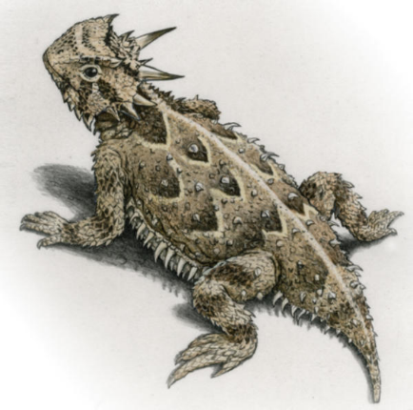

Herpetology (BIOL 4/5005)
Lecture: MWF 11-11:50am
Wooten Hall 214
Lab: W 1-4:50 PM
ENV 358

Instructor Information
Dr. Jason R. Bohenek
jason.bohenek@unt.edu, ENV 320B
Office Hours: by appointment
Fastest way to reach me: Microsoft Teams (@Bohenek, Jason)

Course Description and Objectives
BIOL 4/5005 is an introductory herpetology lecture and laboratory course focused on the biology, evolution, ecology, and conservation of amphibians and reptiles. The course includes lectures, laboratory, and field components. In the field, you will gain hands-on experience with species identification, survey techniques, study design, and data collection.

Required Text
Pough, F. H., Andrews, R. M., Cadle, J. E., Crump, M. L., Savitzky, A. H., & Wells, K. D. (2016). Herpetology. Sinauer Associates, Incorporated, Publishers.

Lecture Schedule
The course schedule is subject to change.
Week | Date | Topic | Exams | UG % lecture grade | Grad % lecture grade
Week 1 | 1/12/2025 | Evolutionary History
Week 2 | 1/19/2025 | Monday – no class; Classification & Diversity
Week 3 | 1/26/2025 | Traits
Week 4 | 2/2/2025 | Biogeography
Week 5 | 2/9/2025 | Physiological Ecology | Exam 1: Feb 10th | 22.5% | 17.5%
Week 6 | 2/16/2025 | Physiological Ecology
Week 7 | 2/23/2025 | Behavioral Ecology
Week 8 | 3/2/2025 | Behavioral Ecology
Week 9 | 3/9/2025 | SPRING BREAK – NO CLASS
Week 10 | 3/16/2025 | Reproductive Ecology | Exam 2: Mar 17th | 22.5% | 17.5%
Week 11 | 3/23/2025 | Reproductive Ecology
Week 12 | 3/30/2025 | Development & Life Stages
Week 13 | 4/6/2025 | Life History | Exam 3: Apr 11th | 22.5% | 17.5%
Week 14 | 4/13/2025 | Ecology
Week 15 | 4/20/2025 | Ecology
Week 16 | 4/27/2025 | Conservation | Final: Monday May 5th 10:00am-noon | 22.5% | 17.5%

Assessing Your Work
Four exams (3 during the semester + the final) will comprise the majority of the grade for undergraduates, and 70% of the grade for graduate students. The final is not comprehensive. If needed, grades will be curved, but all grades are final and non-negotiable. I cannot grade your effort or intentions, only the final product you submit. Problems with technology are NOT an excuse for missed or late work. I do not talk to parents.
Letter Grade | Percent % | Description
A | 90–100 | High effort, high mastery
B | 80–89
C | 70–79
D | 60–69
F | < 60 | Low effort, low mastery

Undergraduate Lecture Grade:
Assignment | Calculation | Grade
4 exams | 4*22.5% | 90%
Attendance | 10% | 10%
TOTAL |  | 100%

Graduate Lecture Grade:
Assignment | Calculation | Grade
4 exams | 4*17.5% | 70%
Lecture outline | 5% | 5%
Lecture | 15% | 15%
Attendance | 10% | 10%
TOTAL |  | 100%

Graduate Student Lecture
All graduate students are expected to deliver a full class period lecture of 50 minutes on a textbook topic of their choosing. An outline of their lecture is expected one week prior to the delivery of the lecture. This lecture and outline will count as 20% of the lecture grade for graduate students.

Attendance and Participation
Attendance is mandatory.

Format
Classic lectures + in-person exams on the designated dates.

University policies

ADA accommodation statement:
The University of North Texas makes reasonable academic accommodation for students with disabilities. Students seeking reasonable accommodation must first register with the Office of Disability Access (ODA) to verify their eligibility. If a disability is verified, the ODA will provide you with a reasonable accommodation letter to be delivered to faculty to begin a private discussion regarding your specific needs in a course. You may request reasonable accommodations at any time; however, ODA notices of reasonable accommodation should be provided as early as possible in the semester to avoid any delay in implementation. Note that students must obtain a new letter of reasonable accommodation for every semester and must meet with each faculty member prior to implementation in each class. Students are strongly encouraged to deliver letters of reasonable accommodation during faculty office hours or by appointment. Faculty members have the authority to ask students to discuss such letters during their designated office hours to protect the privacy of the student. For additional information, refer to the Office of Disability Access website (http://www.unt.edu/oda). You may also contact ODA by phone at (940) 565-4323.

Supporting Your Success and Creating an Inclusive Learning Environment
Every student in this class has the right to learn and engage within an environment of respect and courtesy from others. I encourage you to review UNT’s student code of conduct so that we share a civil understanding (Code of Student Conduct) (https://deanofstudents.unt.edu/conduct). Please always feel free to reach out to me concerning any issues you may experience while taking this class, or for any other reason. Other useful information: Student Support Services & Policies | Center for Learning Experimentation, Application, and Research (unt.edu)

Academic Integrity
Please review the Academic Integrity Policy: (https://policy.unt.edu/sites/default/files/06.049_Standard%20Syllabus%20Policy%20Statements_supplement.pdf).

Campus Closings
Students will be notified by Eagle Alert if there is a campus closing, please review the Emergency Notifications and Procedures Policy (PDF): (https://policy.unt.edu/sites/default/files/06.049_Standard%20Syllabus%20Policy%20Statements_supplement.pdf).

Large Language Models (AI)
You are permitted to use large language models (LLM) as a helpful tool for take home assignments. It is your responsibility to ensure that the material is accurate. The best way to do this is to only use an LLM as an editor rather than a content generator.

