

American Sign Language 1

SGNL 1010

Section 002: 2:00-3:20pm in GAB 527

Section 003: 3:30-4:50pm in LANG 319
Instructor: JoAnn Nunnelly, M.Ed. Office: LANG 401 B Hours: By appointment – MW before/after class
E-Mail : jo.nunnelly@unt.edu
*Connect with me through email or Canvas. During busy times, my inbox becomes full, so if you contact me and do not receive a response within 2 business days, please send a follow up email.
Tutors: Jenna Jones: JennaJones@my.unt.edu
Text & Other Materials/Supplies:
- Interactive Online Student Materials for Signing Naturally Units 1-6 ($69.95)

- Canvas - To fully participate in this class, students will need internet access to reference content on the Canvas Learning Management System. If circumstances change, you will be informed of other technical needs to access course content.
Course Description: American Sign Language I is an elementary course in ASL utilizing a meaningful communication approach to teaching language. Common communicative events and interactions are employed to gain knowledge of a basic vocabulary and grammar of ASL. The course includes development of socio-linguistic behaviors appropriate within the cultural diversity functioning in the Deaf community.
Expected Learning Outcomes Assessments: Students will learn to use a variety of simple phrases and sentences in 1:1 and small group conversations.
- Students will demonstrate an understanding of the relationship between the practices and perspectives of American Deaf culture
- Students will compare ASL with English.
- Students will use ASL in non-classroom conversational experiences with the Deaf community.
Upon completion of Unit 1, students will effectively use ASL receptively/expressively in the following domains:
- Fingerspelling of names and the numbers 1-15
- Same & different regarding names, shapes, letters, and numbers
- Gender, physical appearance, clothing, colors
- Following instructions - drawing shapes, writing names & writing numbers and letters
- Getting one’s attention
Upon completion of Unit 2, students will effectively use ASL receptively/expressively in the following domains:
- Identifying people, negate and correct responses, ask and answer yes/no questions
- Numbers 1 – 29 and adding and subtracting using American Sign Language
- Leisure activities
- Identifying people, giving information and preferences
- Talking about oneself in a video production
Upon completion of Unit 3, students will effectively use ASL receptively/expressively in the following domains:
- Living situations
- Commands and directions, in the classroom, halls and buildings around campus
- Numbers and counting 1-66
- Living arrangements, including roommates and pets
- Directions
- Modes of transportation and time to work and/or school
Helpful web resources: www.lifeprint.com, www.aslpro.com, www.aslbrowser.com

How to Succeed in this Course
No Talking Policy: We insist on maintaining a signing environment in the classroom for two reasons:
- It is imperative you develop the habit of signing when Deaf people are present because it is considered rude and insulting to talk in front of a Deaf person. Information should be accessible for everyone present.
- This is an immersion class; only the target language is used. Using ASL will help develop both comprehension and expressive skills quickly and effectively. Talking disrupts this process and delays language development. If a peer asks for help, use signs you have learned, gesture or by writing back and forth.
ADA accommodation statement: The University of North Texas makes reasonable academic accommodation for students with disabilities. Students seeking reasonable accommodation must first register with the Office of Disability Access (ODA) to verify their eligibility. If a disability is verified, the ODA will provide you with a reasonable accommodation letter to be delivered to faculty to hold a private discussion regarding your specific needs in a course. You may request reasonable accommodations at any time; however, ODA notices of reasonable accommodation should be provided as early as possible in the semester to avoid any delay in implementation. Note that students must obtain a new letter of reasonable accommodation for every semester and must meet with each faculty member prior to implementation in each class. Students are strongly encouraged to deliver letters of reasonable accommodation during faculty office hours or by appointment. Faculty members have the authority to ask students to discuss such letters during their designated office hours to protect the privacy of the student. For additional information, refer to the Office of Disability Access. You may also contact ODA at (940) 565-4323.
Participation: Students are expected to attend ALL class meetings and participate during class. It is important to communicate with the professor PRIOR to being absent, so you and the professor, can discuss the impact of the absence on your attainment of course learning goals. Because participation happens in the classroom with the instructor and peers, points cannot be made up. Calculation of participation is based on the number of activities counted by instructor, then divided by the number of events student participated in (to give an average).
Research has shown that students who attend class are more likely to be successful. Being punctual indicates our respect for others. Please arrive before class begins to find a seat and connect with your peers. The beginning of class is especially critical; however, being late to class is sometimes inevitable. If you are late, know you are welcome to join, but please do so without distracting others.

Supporting Your Success and Creating an Inclusive Learning Environment
I value the perspectives students bring to our campus. Work with me to create a classroom culture of open communication, mutual respect, and inclusion. All discussions should be respectful and civil. Although disagreements and debates are encouraged, personal attacks are unacceptable. I want to ensure a safe and welcoming classroom for all. If you ever feel this is not the case, let me know. We are all learning together.
Every student has the right to learn and engage within an environment of respect and courtesy from others. We will discuss our classroom’s habits of engagement and I encourage you to review UNT’s student code of conduct so that we can all start with the same baseline civility understanding: Code of Student Conduct

Assessing Your Work: Grades are based on mastery of the content. As a rule, I do not grade on a “curve” because that is a comparison of your outcomes to others. I encourage you to find opportunities to learn with and through others. Explore Navigate’s Study Buddy tool to join study groups. Maximize your learning with our student tutors. Focus on areas you are struggling with by attending scheduled study group sessions or with the tutor before each exam.
Course Evaluation
Three regular Exams, one Final Exam 50%
Participation, Homework, 5Q 50%

A = 90-100% B = 80-89.99% C = 70-79.99% D = 60-69.99% F = 59.99% or less
Course Policies
Classroom: Appropriate behavior is expected of all students taking this course. Turn off all electronic devices.
The average college student is expected to spend three (3) hours per week for each one (1) hour of class working on the course to learn the content. If you are an “average” college-level learner, you should spend about nine (9) hours per week to studying for this course. Adjust hours to accommodate your learning level.
Help maintain a positive learning environment by arriving on time, turning off phones before arriving to class, and avoiding distracting behaviors. Any student whose behavior disturbs our learning environment may be asked to leave, and participation points will not be awarded for the day.
Course Calendar will be posted on Canvas.
Students will be learning Units 1-3 in ASL 1 and Units 4-6 in ASL 2.

Exams: There will be four exams this semester. The instructor has a policy of NO MAKE-UP EXAMS unless there is an extreme emergency and SUBSTANTIAL documentation provided at the following class attended. No late documentation will be accepted. Documentation must be provided by a qualified practitioner and will be verified. Students must abide by the UNT Academic Integrity Policy. Students committing academic dishonesty will receive a grade of Zero (0) and will be referred to the Dean of Students office (see Student Code of Conduct).

Assignments: Fifty percent of your grade will be calculated using your participation, homework assignments and 5 Q. Students will receive regular feedback on their performance from the instructor. This is a college course: NO EXTRA CREDIT opportunities will be available.

Late Work: A grade of zero (0) will be assigned to any homework assignment that is not completed and turned in on the date and time it is due. NO EXCEPTIONS. Do not send homework to the instructor via email.
Academic Honesty: Academic integrity is taking responsibility for one’s own work, being individually accountable, and demonstrating intellectual honesty and ethical behavior. Ethical behavior and independent thought are essential for the highest level of academic achievement. It is the aim of the faculty the University to foster a spirit of complete honesty and a high standard of integrity. The attempt of students presenting any work that they have not honestly performed is regarded by the faculty and administration as a serious offense and renders the offenders liable to serious consequences, possibly suspension. “Scholastic dishonesty” includes, but is not limited to cheating, plagiarism, collusion, falsifying academic records, misrepresenting facts, and any act designed to give unfair academic advantage to the student (such as, but not limited to, submission of essentially the same written assignment for two courses without the prior permission of the instructor) or the attempt to commit such an act. Students who plagiarize will receive a grade of zero for the assignment and the case will be submitted to the Office of Student Conduct.
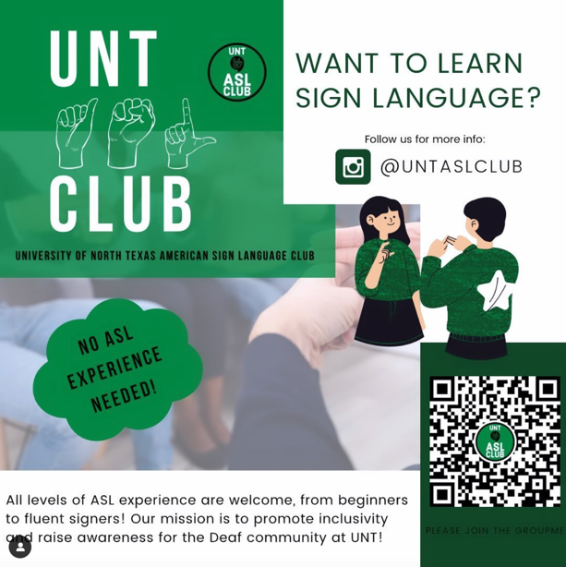
Deaf Culture Events: Students are encouraged to attend or complete two (2) Deaf Culture Events during the semester. Pick any 2 from the following:
ASL Club Meetings – every other Tuesday evening from 6:00-7:00pm in the Union room 401.
Contact information: officialuntaslclub@gmail.com

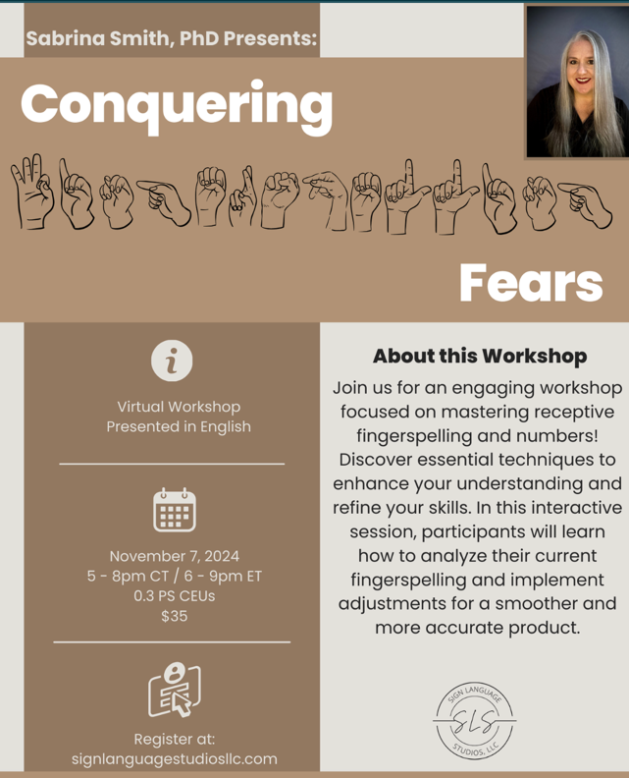
Conquering Fears: Virtual Fingerspelling Workshop
Presented in English: November 7, 2024, 5-8pm CT
Workshop Description: Join us for an engaging workshop focused on mastering receptive fingerspelling and numbers! Discover essential techniques to enhance your understanding and refine your skills. In this interactive session, participants will learn how to analyze their current fingerspelling and implement adjustments for a smoother and more accurate product.
Certificate of completion is required to earn credit. Certificate must have name and date of completion to earn credit.

National Deaf Center OnDemand Learning

Certificate of completion is required to earn credit. Certificate must have name and date of completion to earn credit.
Deaf 101
Attitudes and Biases as Barriers for Deaf People
SELF-PACED BOOK STUDIES ***If you choose the book study, no additional Deaf events are required.

