South Asian Women Writers
ENGL 3924/ WGST 3720
Meets Mondays and Wednesday
Dr. Ishanika Sharma
Office Hours: TBD
Email: ishanika.sharma@unt.edu | Office: LANG 407E
This course will survey poems, novels, short stories, drama, and films by South Asian women in the postcolonial period, focusing on how they explore questions of identity and difference in predominantly male literary genres. We will approach how writing by South Asian women interrogates the categories and contradictions of nationalism, capitalism, globalization, desire, marriage, family, the environment, and migration.
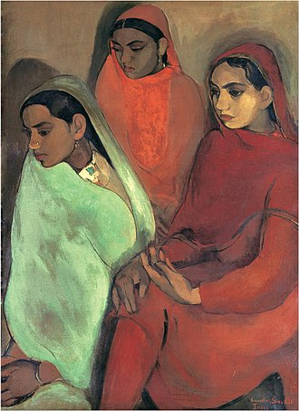
“Three Girls” by Amrita Shergill
Course Texts
Bapsi Sidhwa, Cracking India
Arundhati Roy, The God of Small Things
Amruta Patil, Kari
Jhumpa Lahiri, Interpreter of Maladies

Most course readings are available in your course pack. The rest will be available on Canvas under a module titled “Course Readings”.
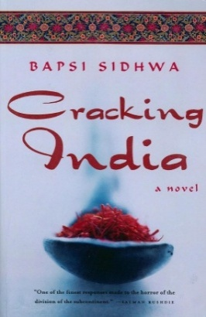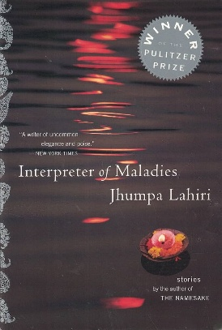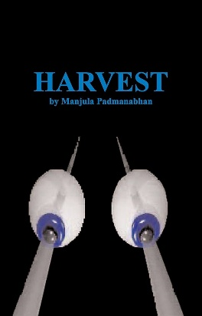
To succeed in this class, purchase the above texts in the correct editions well in advance; read and annotate everything before we meet; and bring your annotated texts to our course meetings.

Learning Outcomes
- Critically read and creatively respond to a range of writing by South Asian writers.
- Build a critical vocabulary to analyze texts across a range of literary genres produced in the postcolonial period.
- Engage in ethical scholarship using evidence-based research and well-supported argumentation. Summarize, analyze, synthesize, and evaluate the ideas of others as you undertake scholarly inquiry to produce your own arguments.
- Read closely and attentively to unpack complex arguments. Engage thoughtfully with the texts through your writing.
- Develop and refine your writing process.

Course Policies and Resources
Accessibility
I strive to create an inclusive learning environment for all. I am invested in your success in this class and at UNT, so do let me know early and often if anything is standing in the way of you doing your best work. This can include your own learning strengths, ESL or language obstacles, disability or chronic illness, and/or personal issues that impact your work.
Contact and Communication
The best way to get in touch with me is over email. I will generally respond to your emails over 24 – 48 hours, though I may take longer on weekends and over holidays. Please write to me again with your request if I have not responded to you in time. I also expect you to check your UNT email and our Canvas webpage regularly for updates about the class and your progress.
Attendance
Attendance is crucial and will affect your participation in this class. Research has shown that students who attend class are more likely to be successful. You should attend every class unless you have a university excused absence such as active military service, a religious holy day, or an official university function as stated in the Student Attendance and Authorized Absences Policy (PDF) (https://policy.unt.edu/policy/06-039). If you cannot attend a class due to an emergency, please let me know. Your safety and well-being are important to me. Aside from documented absences for school-related activities, you may miss two classes without incident. Meet with me if you feel your situation warrants an exception to this rule. Bring appropriate documentation to our meeting.
Note on technology
Please refrain from using your devices in our course meetings. Cellphones are not permitted for use in class under any circumstances (except if you have sought permission from me beforehand). The use of laptops and tablets is strongly discouraged; most of the secondary texts are included in your course pack.
Late work
All assignments are due by the time and date specified. I will not accept late work without granting advance permission via email, and permission is not guaranteed. You will be allowed one free-pass that grants you a 24-hour extension on your work. Each day’s delay after that will impact your grade. Please contact me as soon as possible if you face any difficulty turning in your assignment.
Academic Integrity
Every student in my class can improve by doing their own work and trying their hardest with access to appropriate resources. Students who use other people’s work without citations will be violating UNT’s Academic Integrity Policy. You can learn more about UNT’s policy on academic integrity here: https://policy.unt.edu/policy/06-003.
Cooling-Off Period: When I return a graded assignment to you, I request that you read my comments about your work carefully and wait 24 hours before coming to speak with me about your grade. I have found that asking for this “cooling-off” period results in more productive discussions about graded work.
AI Policy
The use of generative AI writing tools (such as ChatGPT, GrammarlyGO, GPT-3, GPT-4, BERT, or others) is prohibited in this class. Assignments have been designed to help you develop as a writer without the use of these technologies. You will generate ideas, read, revise, and write on your own and/or in consultation with peers, me, or Writing Center tutors; and you will not use AI at any stage of your writing process. You are the author of your work and authorship means you take responsibility for your words and claims. Any use of AI in your work will be considered a violation of UNT's academic integrity policy and addressed accordingly.
Writing Center
I recommend that you visit the Writing Center with your assignments for this class. All writers can benefit from sharing and discussing their work with a trained peer tutor, early and often. A tutor can help you get started on a paper or help you decide what to revise on an existing draft. During an appointment with a tutor, you can develop your ideas, organize your thoughts, and clarify your prose. For more information or to make an appointment, visit writingcenter.unt.edu, call 940-565-4665, or stop by Sage Hall 150.
Office of Disability Access
The University of North Texas makes reasonable accommodation for students with disabilities. Students needing a reasonable academic accommodations must first register with the Office of Disability Access (ODA) to verify their eligibility. If a disability is verified, the student will request their letter of accommodation. ODA will provide faculty with a reasonable accommodation letter via email to begin a private discussion regarding a student’s specific needs in a course. Students may request reasonable accommodations at any time, however, ODA notices of reasonable accommodation should be provided as early as possible in the semester to avoid any delay in implementation. Note that students must obtain a new letter of reasonable accommodation for every semester and must meet with each faculty member prior to implementation in each class. Students are strongly encouraged to meet with faculty regarding their accommodations during office hours or by appointment. Faculty members have the authority to ask students to discuss such letters during their designated office hours to protect the privacy of the student. For additional information, refer to the Office of Disability Access website.
Academic Freedom
UNT has a robust policy regarding academic freedom and academic responsibility. Crucially, this policy encompasses not only the rights of faculty members but also the rights “of the student to freedom in learning.” As a student in this classroom, therefore, you have the right to encounter and debate new ideas, diverse forms of knowledge, and unfamiliar or contrary points of view. According to UNT policy, “it is not the proper role of the University to attempt to shield individuals from ideas and opinions they find unwelcome, disagreeable, or even deeply offensive.” At the same time, to encourage the free exchange of ideas, and to ensure that your right to learn is protected, the tone for such discussion must always be civil and respectful; hateful or discriminatory speech will not be tolerated. For more information, please consult the full UNT policy at https://policy.unt.edu/policy/06-035.
Audio/Video Recording
Although UNT is a publicly supported institution, our classroom is not a public space. Therefore, in order to protect the intellectual property and privacy rights of both faculty and students, video and audio recordings are prohibited during class. The exception is for students who have been granted explicit approval as an ODA accommodation. For more information, please consult the full UNT policy at https://studentaffairs.unt.edu/office-disability-access/faculty/faculty-guide/accommodations-explained/Audio-Recording-Faculty.html
Note on Syllabus
I reserve the right to make necessary changes to the syllabus at my discretion at any time.

Course Assessment
10%|Attendance
20%| Participation
20%| Online Posts
20%| Presentation
30%| Critical Essay

Attendance
If you would like to succeed in this class, please mind your attendance. I expect you to be present on time. After the two unexcused absences, I will dock your grade by a full letter per couple of absences. Six or more absences may automatically result in failure, unless we are in close communication about your participation in this course and have come to a mutual understanding.
Participation
You are active stakeholders in the success of this class. Come to class having read, annotated, and reflected on the assigned text. Make sure you have a copy of the text in front of you. To succeed in this class, you need to speak and speak regularly. This class will only be as strong and rigorous as the contributions you make.
To be a good participant in this class, you need not only to speak but also to listen carefully. Remember that you are here to speak with people, and not at them. Be mindful of how you articulate your responses to the texts and to each other.
Online Posts
Your online posts are short, low-stakes responses (200 words) where you can begin formulating your initial thoughts and observations. Your postings should identify a line or short passage in the set reading that interests you (start off by quoting and citing it!); explain what interests you about the line or passage; and ask one question about it!! (Avoid rhetorical questions like “is the world ready for change?” or “how could this have been allowed to happen?”)
Paired Presentations
Please sign up for your presentation on the first day of class.
You will be required to give a 20-minute presentation once in the semester. Think of this assignment as a well-crafted, jointly written Canvas post being presented in real time. These presentations will be used to guide the class for that specific day. Your presentation will be scheduled for the start of our course meeting.
For detailed instructions, refer to the document linked under the module titled “Course Information” on our Canvas site.

Critical Essay
For this assignment, you will complete a 6-7-page paper that compares and contrasts two texts by exploring a shared theme. Your paper must have an argument about how these texts engage with that mutual theme. More instructions are forthcoming.

Grade Breakdown
Note: To earn a passing grade, you must complete all major writing assignments.
• 90-100%=A
• 80-89.99%=B
• 70-79.99%=C
• 60-69.99%=D
• 59.99% and less=F

Schedule
UNIT: Introductions
1/12 Introduction and Syllabus Review
1/14 Chandra Talpade Mohanty, “Under Western Eyes”

UNIT: Partition, Women, and the Nation
1/19 MLK Day; no class
1/21 Amrita Pritam, “To Waris Shah”; Ritu Menon and Kamala Bhasin, from Borders and Boundaries

1/26 Bapsi Sidhwa, Cracking India (ch.1-10)
1/28 Cracking India (ch.11-15)

2/2 Cracking India (ch.16-28)
2/4 Cracking India (ch.29-end)

UNIT: Desire
2/9 Ismat Chughtai, “The Quilt” (“Lihaaf”)
2/11 Ismat Chughtai, “In the Name of those Married Women…”

2/16 Kamala Das, “An Introduction”
2/18 Mira Nair, Monsoon Wedding

2/23 Amruta Patil, Kari (1-72; until “Playing”)
2/25 Kari (until end)

UNIT: Globalization and Dystopia
3/2 Manjula Padmanabhan, Harvest (Acts I-II)
3/4 Harvest

3/9 Spring Break
3/11 Spring Break

UNIT: Labor and Love
3/16 Arundhati Roy, The God of Small Things (pp 1-93; until “Abhilash Talkies”)
3/18 The God of Small Things (pp 94-135; until “Cochin Kangaroos”)

3/23 The God of Small Things (pp 136-214; until “The God of Small Things”)
3/25 The God of Small Things (pp 215-267; until “Work is Struggle”)

3/30 The God of Small Things (pp 268-end)
4/1 Deepika Bahri, “Geography is not History”

UNIT: Subaltern Counter Stories
4/6 Mahasweta Devi, “Douloti, the Bountiful”
4/8 Gayatri Spivak, “Woman in Difference: Mahasweta Devi's “Douloti the Bountiful””
4/13 “Draupadi”; Spivak, “Translator’s Foreword,”
4/15 Spivak, “Can the Subaltern Speak?”; final paper workshop

UNIT: Dreams and Diasporas
4/20 Jhumpa Lahiri, “When Mr. Pirzada Came to Dine”; “Mrs. Sen’s”; “Interpreter of Maladies”
4/22 “The Third and Final Continent”; “A Temporary Matter”

4/27 Rokeya Sakhawat Hossain, “Sultana’s Dream”; thesis discussion
4/29 Tarfia Faizullah, “The Perfect Place”; “Immigrant Petition for Alien Workers”

