ENGL 3000: Introduction to Literary Analysis and Interpretation Skills
English Beyond Empire

“My tongue is heavy with new language/ but I cannot give birth speech”
– “Negus,” Kamau Brathwaite

Meets Mondays & Wednesdays
Dr. Ishanika Sharma
Course Description
With over a billion speakers worldwide, the English language seems to be everywhere. And yet, despite being the world’s most widely spoken language, English is native to fewer than 400 million speakers.
In this gateway course to the major, we will trace the widespread uptake of English from the everyday realms of education and technology to the official corridors of commerce and diplomacy by attending to the trail of neglected literatures and forgotten dialects left in its wake.
By engaging a diverse range of poetry, drama, novels, short stories, films, and essays, we will ask how writers from across the Caribbean, Africa, South Asia, and the United States, navigate and transcribe a world stamped by the colonial origins, postcolonial legacy, and globalizing aspirations of the English language.
We will ask how Anglophone thinkers and artists have variously rejected, adopted, and adapted English to voice their resistance not only to Empire, but also against national hierarchies of oppression. We will also reflect on the future trajectories of the language, accounting for its centrality to the discourses of globalization and multiculturalism.
Some of the writers and thinkers we will read include Jean Rhys, Ngũgĩ wa Thiong’o, Arundhati Roy, Gloria Anzaldúa, Athol Fugard, etc.

Course Texts
Jean Rhys, Wide Sargasso Sea (ISBN-10: 9780141185422)
Arundhati Roy, The God of Small Things (ISBN-10: 0812979656)

Most course readings are available in your course pack. The rest will be available on Canvas under a module titled “Course Readings”.

To succeed in this class, purchase the above texts in the correct editions well in advance; read and annotate everything before we meet; and bring your annotated texts to our course meetings.

Learning Outcomes
- Critically read and creatively respond to a range of historical and contemporary materials with attention to the rise of English as a global language.
- Develop an understanding of form and genre. Build a critical vocabulary to analyze texts.
- Engage in ethical scholarship using evidence-based research and well-supported argumentation. Summarize, analyze, synthesize, and evaluate the ideas of others as you undertake scholarly inquiry to produce your own arguments.
- Read closely and attentively to delineate complex arguments. Engage thoughtfully with the texts through your writing.
- Develop and refine your writing process.

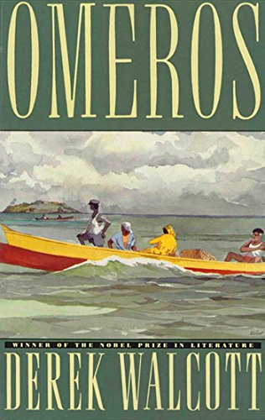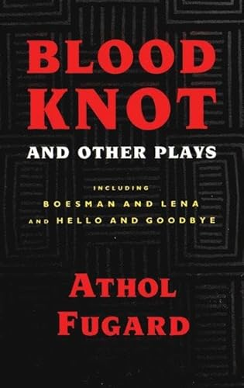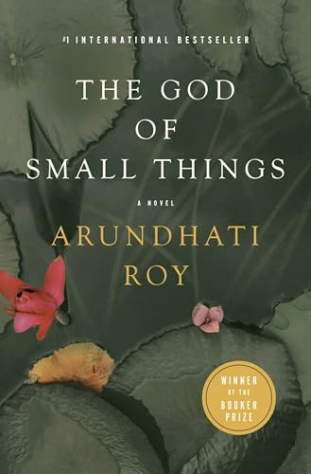

Course Policies and Resources
Accessibility
I strive to create an inclusive learning environment for all. I am invested in your success in this class and at UNT, so do let me know early and often if anything is standing in the way of you doing your best work. This can include your own learning strengths, ESL or language obstacles, disability or chronic illness, and/or personal issues that impact your work.
Contact and Communication
The best way to get in touch with me is over email. I will generally respond to your emails over 24 – 48 hours, though I may take longer on weekends and over holidays. Please write to me again with your request if I have not responded to you in time. I also expect you to check your UNT email and our Canvas webpage regularly for updates about the class and your progress.
Attendance
Attendance is crucial and will affect your participation in this class. Research has shown that students who attend class are more likely to be successful. You should attend every class unless you have a university excused absence such as active military service, a religious holy day, or an official university function as stated in the Student Attendance and Authorized Absences Policy (PDF) (https://policy.unt.edu/policy/06-039). If you cannot attend a class due to an emergency, please let me know. Your safety and well-being are important to me. Aside from documented absences for school-related activities, you may miss two classes without incident. Meet with me if you feel your situation warrants an exception to this rule. Bring appropriate documentation to our meeting.
Missing six or more classes may result in automatic failure of the course unless you have been proactive in keeping me informed and we have a mutual understanding about your participation.
Please note that I need you to be on time for our meetings. I also need you to be active and engaged in class; simply showing up and doing the readings will not cut it. I expect you to be active stakeholders in the discussion. This means: no sleeping, no checking out, no being distracted by devices.
Note on technology
Please refrain from using your devices in our course meetings. Cellphones are not permitted for use in class under any circumstances (except if you have sought permission from me beforehand). The use of laptops and tablets is strongly discouraged; most of the secondary texts are included in your course pack.
Late work
All assignments are due by the time and date specified. I will not accept late work without granting advance permission via email, and permission is not guaranteed. You will be allowed one free-pass that grants you a 24-hour extension on your work. Each day’s delay after that will impact your grade. Please contact me as soon as possible if you face any difficulty turning in your assignment.
Note on Course Content
I reserve the right to make necessary changes to the course syllabus at my sole discretion at any point in the semester.
Academic Integrity
Every student in my class can improve by doing their own work and trying their hardest with access to appropriate resources. Students who use other people’s work without citations will be violating UNT’s Academic Integrity Policy. You can learn more about UNT’s policy on academic integrity here: https://policy.unt.edu/policy/06-003.
Cooling-Off Period: When I return a graded assignment to you, I request that you read my comments about your work carefully and wait 24 hours before coming to speak with me about your grade. I have found that asking for this “cooling-off” period results in more productive discussions about graded work.
AI Policy
The use of generative AI writing tools (such as ChatGPT, GrammarlyGO, GPT-3, GPT-4, BERT, or others) is prohibited in this class. Assignments have been designed to help you develop as a writer without the use of these technologies. You will generate ideas, read, revise, and write on your own and/or in consultation with peers, me, or Writing Center tutors; and you will not use AI at any stage of your writing process. You are the author of your work and authorship means you take responsibility for your words and claims. Any use of AI in your work will be considered a violation of UNT's academic integrity policy and addressed accordingly.
Writing Center
I recommend that you visit the Writing Center with your assignments for this class. All writers can benefit from sharing and discussing their work with a trained peer tutor, early and often. A tutor can help you get started on a paper or help you decide what to revise on an existing draft. During an appointment with a tutor, you can develop your ideas, organize your thoughts, and clarify your prose. For more information or to make an appointment, visit writingcenter.unt.edu, call 940-565-4665, or stop by Sage Hall 150.
Office of Disability Access
The University of North Texas makes reasonable accommodation for students with disabilities. Students needing a reasonable academic accommodations must first register with the Office of Disability Access (ODA) to verify their eligibility. If a disability is verified, the student will request their letter of accommodation. ODA will provide faculty with a reasonable accommodation letter via email to begin a private discussion regarding a student’s specific needs in a course. Students may request reasonable accommodations at any time, however, ODA notices of reasonable accommodation should be provided as early as possible in the semester to avoid any delay in implementation. Note that students must obtain a new letter of reasonable accommodation for every semester and must meet with each faculty member prior to implementation in each class. Students are strongly encouraged to meet with faculty regarding their accommodations during office hours or by appointment. Faculty members have the authority to ask students to discuss such letters during their designated office hours to protect the privacy of the student. For additional information, refer to the Office of Disability Access website.

Course Assessment
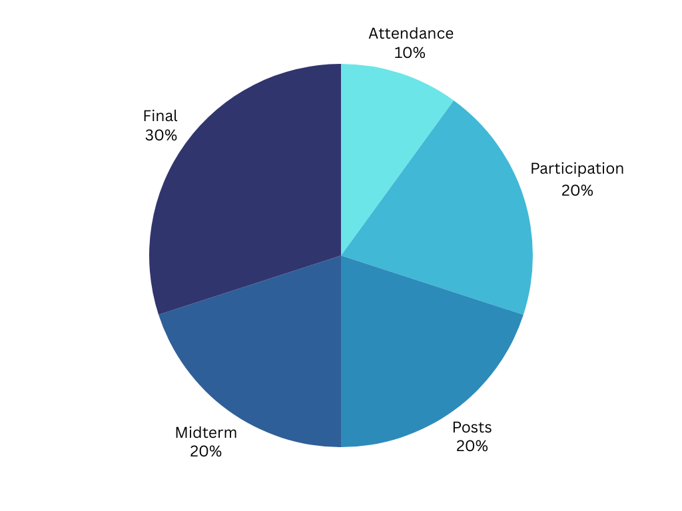
10% | Attendance
20% | Participation
20% | Online Posts
20% | Close Reading Midterm
30% | Compare/Contrast Essay

Attendance
If you would like to succeed in this class, please mind your attendance. I expect you to be present on time. After the two unexcused absences, I will dock your grade by a full letter per couple of absences. Six or more absences may automatically result in failure, unless we are in close communication about your participation in this course and have come to a mutual understanding.

Participation
You are active stakeholders in the success of this class. Come to class having read, annotated, and reflected on the assigned text. Make sure you have a copy of the text in front of you. To succeed in this class, you need to speak and speak regularly. This class will only be as strong and rigorous as the contributions you make.
To be a good participant in this class, you need not only to speak but also to listen carefully. Remember that you are here to speak with people, and not at them. Be mindful of how you articulate your responses to the texts and to each other.

Online Posts
Your online posts are short, low-stakes responses (200 words) where you can begin formulating your initial thoughts and observations. For each post, think about how the content you are reading relates to its form.

Your postings should identify a line or short passage in the set reading that interests you (start off by quoting and citing it!); explain what interests you about the line or passage; and ask one question about it!! (Avoid rhetorical questions like “is the world ready for change?” or “how could this have been allowed to happen?”)

Close Reading Midterm
This 1200-word essay will be due at the mid-semester mark. More instructions are forthcoming.

Compare/Contrast Essay
This process-based final assignment (5-6 pages) will be due close to the end of the term. Instructions are forthcoming.
Course Schedule
1/12  1/14  1/19  1/21  1/26  1/28  2/2  2/4  2/9  2/11  2/16  2/18  2/23  2/25  3/2  3/4  3/9  3/11  3/16  3/18  3/23  3/25  3/30  4/01  4/06  4/08  4/13  4/15  4/20  4/22  4/27  4/29 | Introductions and Syllabus Overview; The Open University, “The History of English”  Meena Kandasamy, “Mulligatawny dreams”  MLK day; no class  T.S. Eliot, “Tradition and the Individual Talent”  Derek Walcott, Omeros (Chapters I-IV)  Kamau Edward Brathwaite, from History of the Voice  Brathwaite, “Negus”  Gregson vs Gilbert; M. NourbeSe Philip, selections from Zong!  Sharon Hamilton, “Narration” from Literary Terms; Mikhail Bakhtin, “The Epic and the Novel”  Jean Rhys, Wide Sargasso Sea (part one; pp. 1-42)  Wide Sargasso Sea (pp. 43-108)  Wide Sargasso Sea (pp. 109-end)  Hamilton, “Setting” from Literary Terms  Athol Fugard, Blood Knot (scene 1-2)  Blood Knot (Scene 3-5)  Blood Knot (Scene 6-7)  Spring Break  Spring Break  Thiong’o, “The Language of African Literature”  J.M. Coetzee, “The Novel in Africa”  Arundhati Roy, The God of Small Things (pp 1-87; until “Big Man…”)  The God of Small Things (pp 88-123; until “God’s Own Country”)  The God of Small Things (pp 124-186; until “Mrs. Pillai…”)  The God of Small Things (pp 187-227; until “Kochu Thomban”)  The God of Small Things (pp 228-294; until “Cochin Harbour Terminus”)  The God of Small Things (pp 295-340; the end)  Gloria Anzaldúa, “How to Tame a Wild Tongue”  Amy Tan, “Mother Tongue”  Octavia Butler, “Speech Sounds”  Jennifer Egan, “Black Box”  Gauri Shinde, English Vinglish  Boots Riley, Sorry to Bother You

