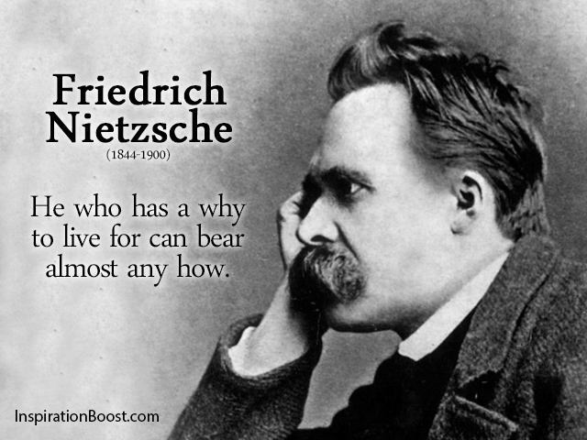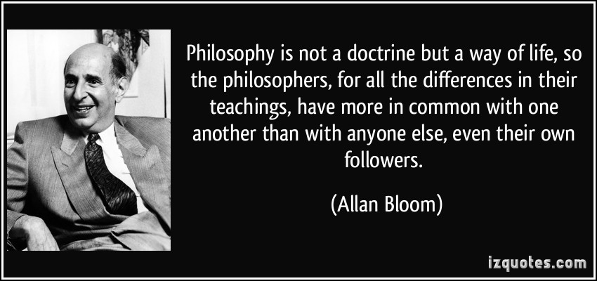

#### **There are many goals for this class, including challenging your thinking, beliefs, and assumptions concerning the role of music in our culture and in formal education. This will require a certain sense of risk-taking on your part!**

**1. Course description & objectives**

**2. How to take this course**

**3. Course activities**

**4. Course Evaluation**

**5. Professional Expectations**

**Philosophical Foundations & Principles of Music Teaching**

**When and Where:**

**Music Building #321**

**Tuesday**

**5:00 – 7:50 pm**

## Contact information:

## Office #306

## [**donna.emmanuel@unt.edu**](mailto:donna.emmanuel@unt.edu)

## email for an appointment

# What is in this syllabus?

**Faculty: Dr. Donna Emmanuel**

Analysis of instructional objectives in music; justification and rationales for music instruction in settings of schooling and education. Systems of thought and methods of philosophical inquiry as applied to music and aesthetic education (from catalog **)**

**This course will contain three primary components – an examination of what philosophers across time have had to say about music; developing your writing skills; and learning the basics of reason and logic. These three components will intertwine in hopefully meaningful ways for each of you.**

### Course Description

**The Division of Music Education is dedicated to empowering students through learning opportunities that are contextual and relevant to a career in teaching. To become an effective music educator, each student must commit to excellence in both teaching and musicianship.**

# No Text Required!



**RV-ing-**

**There’s nothing wrong with being in the outdoors with all the comforts of home, but you will miss out on a lot if you restrict yourself to your comfort zone. You’re an RV-er if you think this course as just a check-mark on your list or if you’re going to do only what you have to do to pass the course. You don’t want to challenge your beliefs or think outside the box…**

**Tent camping –**

**You’re a bit more willing to push yourself. Maybe you’ve had some initial experience in expanding your intellectual horizons. You’re ready to learn more! You’re a tent camper if you engage in meaningful classroom discussion, you aren’t afraid to try new things and think in new ways, & go above and beyond in your work.**

**Backpacking –**

**You’re all in! You are ready to reflect on what happens during class and you actively seek new ways of thinking about music teaching and learning. You are passionate about music and you spend time and effort making your assignments meaningful to you as an individual. You want to continue to explore who you are so you can be a master teacher.**

##### **It’s not what you get in this course, it’s how deep you go. Because I’m from the mountains of Virginia, I like to think this course operates on three levels: RV-ing, tent camping, and backpacking**.

# How to take this course…

What you will hopefully gain from this course…

**•** To introduce different approaches in logic and reasoning as applicable to the teaching of music in different settings; defining terms and developing lines of argument relevant to thinking about music instruction and music education research

**•** To develop the basic skills necessary to critically analyze text and discourse to determine the strength of the arguments presented. To introduce research tools that would be useful in scholarly exploration

**•** To explore the works of prominent philosophers who have had an impact on the field of music teaching and learning and be able to apply their ideas in practical applications

**•** To explore justifications for music in the school curriculum and determine the place of arts advocacy in the life of the music educator. More personally, to discover why we as music teachers and performers do what we do and determine why that is important

**•** To synthesize, compare, and evaluate classical and contemporary philosophical positions of music and music education

**•** To express personal ideas and the ideas of others clearly and convincingly in writing and verbal discourse

**•** To clarify and develop a personal philosophy of music teaching and learning based on self-exploration of beliefs, attitudes, values, and goals, and reflection on those attributes

!

• 

**Class Participation –** Attendance is required, and class participation is necessary. We will be learning from each other via group discussions and activities, therefore regular attendance and participation is mandatory.

**Formal Written Assignments –** There will be several writing assignments to be submitted to me either electronically or in hard copy. Many assignments will be responses/reactions to specific readings, others will be “open.” Assignments will be written using a word processor and submitted in hard copy unless otherwise notified. **I will NOT ACCEPT hand written work and I will NOT ACCEPT late assignments. Assignments not received on time will be given a zero. Back up all your work on disk.**

**Journals –** Several written assignments will be more informal and in the context of “journal” entries. This will either be submitted individually or posted on our blog for open discussion.

**Readings –**  In order to develop good writing skills and the ability to function philosophically, there will be a number of reading assignments. Even if there is no written assignment in conjunction with the reading, you are expected to be able to discuss the reading in an informed manner.

**Developing a personal philosophy –** Throughout the semester, we will work toward developing a personal philosophy statement that might be used for future applications for employment. This is also a part of the promotion and tenure process at most universities, and is not only necessary for career advancement, but is also useful for stimulating reflection on teaching and learning, growth as an educator, and a revisit to the goals and values that are important to each of us.

Because this course is customized to the students enrolled, there is no predetermined course calendar. Rather, readings will be assigned based on the needs of students in the class.

**Course Activities**



COURSE EVALUATION

###### Writing Assignments 50%

Reflection and Discussion 30%

Final project 20%

##### **Professional Expectations**

I will expect you to view yourselves as professionals, and therefore act as professionals. Just as you will expect your students to attend class regularly and arrive on time, I will expect the same of you. This is an interactive class and we will be learning from each other. At this point you should prepare yourself for the professional world. I would not expect a professional to skip work: I do not expect you to skip class.

In addition, the real world of music teaching is never predictable! In order to help prepare you to be able to improvise in the moment, to go with the flow, and think creatively, this course will be structured loosely. I will strive to keep you on your toes, to surprise you on a daily basis, and to give you as much preparation for the actual role of being a public school teacher!

Let’s work hard and have lots of fun!

Regular attendance with promptness and assignments completed reflects a positive, accepting attitude in University education. With the responsibility of being a music education student comes a conscious decision to act professionally at all times.

More than TWO UNEXCUSED absences will result in a failing grade. Only University absences are excused. Illness is NOT an excused absence! Three late arrivals will count as one absence.

ONLY University absences will be accepted. You must present notification to Dr. Emmanuel, which can be obtained from the Dean of Students office.

Division of Music Education Attendance Policy