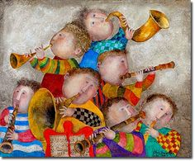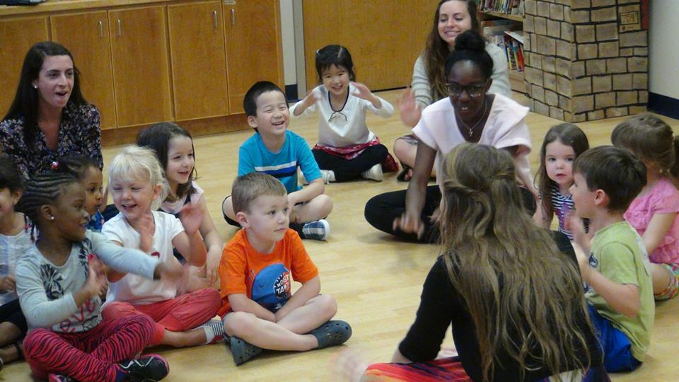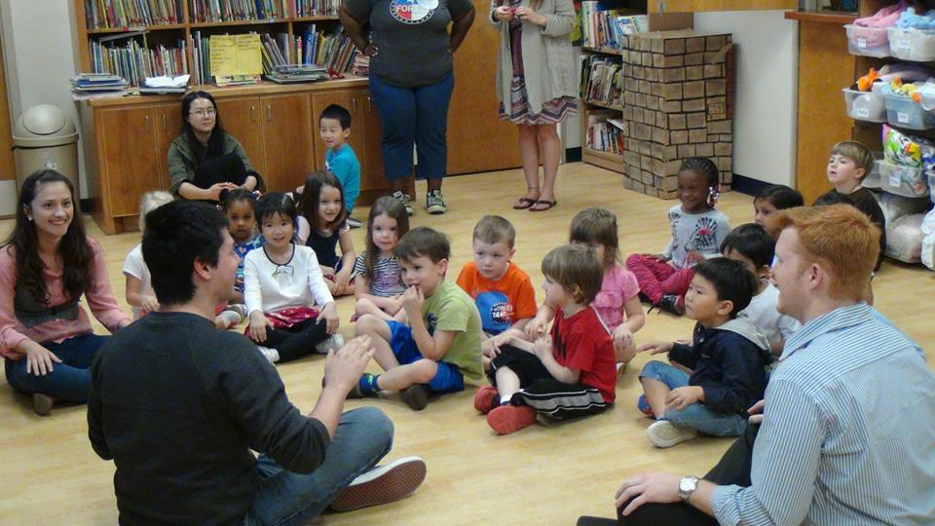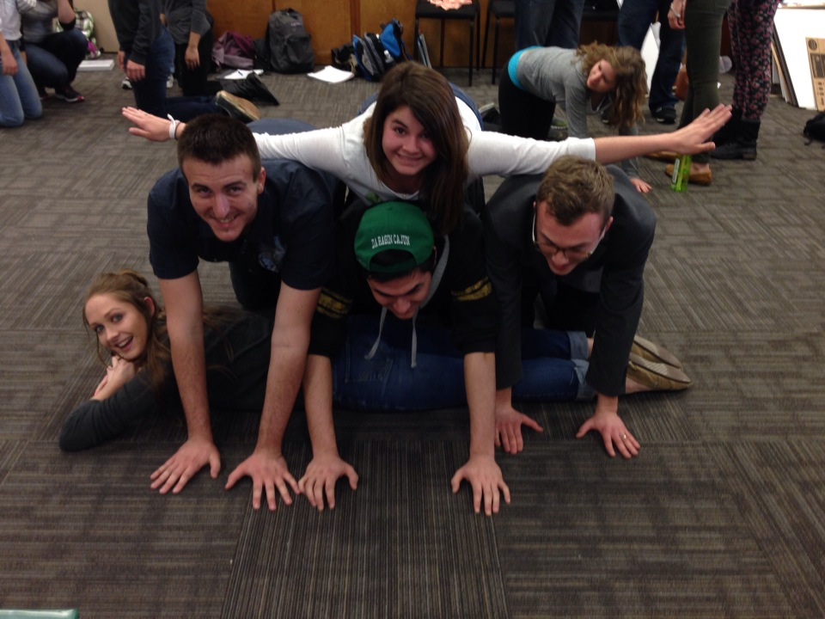

**When and Where:**

**Music room 324**

**Tuesday/Thursday**

**9:30-10:50**

**1. How to take this course**

**2. Course activities**

**3. Developing musicianship**

**4. Grading**

#### **There are many goals for this class, but one is to challenge your thinking concerning elementary general music in the public schools, what it entails, and how powerful it can be for students AND teachers.**

## Contact information:

## Office #306

## [**donna.emmanuel@unt.edu**](mailto:donna.emmanuel@unt.edu)

## email for an appointment

# What is in this syllabus?

**Faculty: Dr. Donna Emmanuel**

**Musicianship for Teaching II**

**This course provides an introduction to the teaching and decision-making skills necessary to be an effective elementary general music teacher. Through peer teaching, assignments,**

**and working with young children, you will begin to develop knowledge and skills in the context of working with elementary children. Because many of you will work at the secondary level, I will work to make information relevant for that level as well. Teaching concepts and strategies we experience in this course are applicable at any level**

### Course Description

**The Division of Music Education is dedicated to empowering students through learning opportunities that are contextual and relevant to a career in teaching. To become an effective music educator, each student must commit to excellence in both teaching and musicianship.**

# No Text Required!



**RV-ing-**

**There’s nothing wrong with being in the outdoors with all the comforts of home, but you will miss out on a lot if you restrict yourself to your comfort zone. You’re an RV-er if you think of music ed as a fallback, or if you’re going to do only what you have to do to pass the course. You don’t want to challenge your beliefs or think outside the box…**

**Tent camping –**

**You’re a bit more willing to push yourself. Maybe you’ve had some initial experience in some kind of leadership role. You’re ready to learn more! You’re a tent camper if you engage in meaningful classroom discussion, you aren’t afraid to try new things, you can remember what it’s like to be a kid, & go above and beyond in your work.**

**Backpacking –**

**You’re all in! You are ready to reflect on what happens during class and you actively seek new ways of thinking about teaching music. You are passionate about music education, and you spend time and effort making your assignments meaningful to you as an individual. You want to continue to explore who you are so you can be a master teacher.**

##### **It’s not what you get in this course, it’s how deep you go. Because I’m from the mountains of Virginia, I like to think this course operates on three levels: RV-ing, tent camping, and backpacking**.

# How to take this course…

What you will hopefully gain from this course…

1. To develop an understanding of and be able to successfully engage students in listening, singing, chanting, playing instruments, improvising, and moving.

2. To be able to apply knowledge of individual differences among children to the preparation of lesson plans and improvising instruction in the moment.

3. To be able to think and plan, short term and long term, sequentially.

4. To become familiar with elementary music pedagogies, methods, and materials.

5. To be able to transfer what you learn in this class to whatever setting in which you might be a teacher.

6. To continually question, to challenge your own thinking, to welcome new ideas, to think outside the box, to become reacquainted with the child inside you!

• 

• **Class Participation** – active participation is absolutely necessary in this class. We will be learning from each other via group discussions and teaching segments.

• **Assignments** – you will be completing assignments that will be relevant to topics of discussion and teaching in class. These might include developing a listening map, teaching a rhythm activity, or designing rating scales. Assignments turned in late will receive a ZERO.

• **Peer teaching** – you will be teaching in class on a regular basis. Peer teaching involves leading your classmates in musical activities. If you are absent on a day you are assigned to peer teach, you will receive a ZERO.

• **Practice teaching** – you will have to opportunity to work with real children during our class times. For the last few weeks of the semester, we will work with the 4-5 yr olds from the UNT child development lab. If you are absent on a day you are assigned to teach, you will receive a ZERO.

**Observations**

Throughout the semester, we will have multiple opportunities to observe real teachers in real classrooms. Most of this will be done via Skype, so we will not be limited to those settings close to us.

We will also have guests who will be able to share their expertise in specific pedagogies, such as Orff, Kodaly, and Gordon.

**Course Activities**



Course Evaluation –

Assignments – 30%

Peer teaching – 30%

Practice teaching – 30%

Tonal Patterns – 10%

##### **Professional Expectations**

I will expect you to view yourselves as professionals, and therefore act as professionals. Just as you will expect your students to attend class regularly and arrive on time, I will expect the same of you. This is an interactive class and we will be learning from each other. At this point you should prepare yourself for the professional world. I would not expect a professional to skip work: I do not expect you to skip class.

In addition, the real world of music teaching is never predictable! In order to help prepare you to be able to improvise in the moment, to go with the flow, and think creatively, this course will be structured loosely. I will strive to keep you on your toes, to surprise you on a daily basis, and to give you as much preparation for the actual role of being a public school teacher!

Let’s work hard and have lots of fun!

Regular attendance with promptness and assignments completed reflects a positive, accepting attitude in University education. With the responsibility of being a music education student comes a conscious decision to act professionally at all times.

More than THREE UNEXCUSED absences will result in a failing grade. Only University absences are excused. Illness is NOT an excused absence! Three late arrivals will count as one absence.

ONLY University absences will be accepted. You must present notification to Dr. Emmanuel, which can be obtained from the Dean of Students office.

Division of Music Education Attendance Policy