MUED 4900 Early Childhood Music

When and Where:
Music 324
Tuesday/Thursday
8:00 – 9:20 am

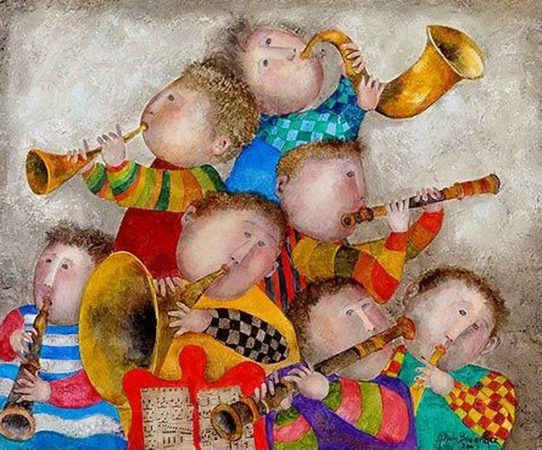
Contact information:
Donna.Emmanuel@unt.edu

What is in this syllabus?
Faculty: Dr. Donna Emmanuel

Course Description
This course will provide an introductory overview of the teaching and decision-making skills needed by music teachers working with young children. Through readings, discussions, observations, assignments, and hands-on teaching, students will become more aware of their developing identities as future music educators and their role in the context of working with young children. Students will also work to develop their musicianship skills to support their role as a future music educator.

1. How to take this course
2. My goals for you
3. Course activities
4. Grading
5. Professional expectations

How to take this course…
It’s not what you get in this course, it’s how deep you’re willing to go. Because I grew up on the Florida Gulf Coast, I like to think of it on three levels – wading, snorkeling, and scuba diving.

Scuba diving -
You’re all in! You are
ready to reflect on
what happens during
class and you actively
seek new ways of
thinking about
teaching music. You
are passionate about
music education, and
you spend time and
effort making your
assignments
meaningful to you as
an individual. You surf the web for related topics and resources, share your ideas with us, and put into practice what you’ve experienced in class.

Snorkeling - You’re a bit more curious to see what’s beneath the surface and willing to push yourself. Maybe you’ve had some
initial experience in
some kind of leadership role. You’re ready to learn
more! You’re a snorkeler if you engage in meaningful
classroom discussion,
if you go a bit above and beyond on your assignments, and you start thinking about what it takes to be a master teacher of young children.

Wading – there’s nothing wrong with staying in the shallows, but you will miss out on a lot if you just stick close to the shore. You’re a wader if you’re thinking of music education as a fall-back, or if you are just going to do what you have to do in order to pass the course. Minimal effort gets minimal results.
COURSE ACTIVITIES

- Class Participation
Active participation is absolutely necessary in the class. We will be learning from each other through group discussions and teaching segments. Regular attendance is crucial!

- Assignments
You will be completing assignments that will be relevant to topics of discussion, teaching in class, and preparing to teach little ones. These might include developing a listening map; teaching a rhythm activity; leading singing segments; creating an original composition; creating a movement activity; or creating a song without words in multiple modalities.

- Peer Teaching
You will be teaching your fellow classmates on a regular basis by leading them in a variety of musical activities that would be appropriate in an early-childhood setting.

- Field Experience
Beginning around the 7th week of the semester, one day a week will be spent in the Early Childhood Center. We will first observe, then participate in individual teaching segments with the little ones there.

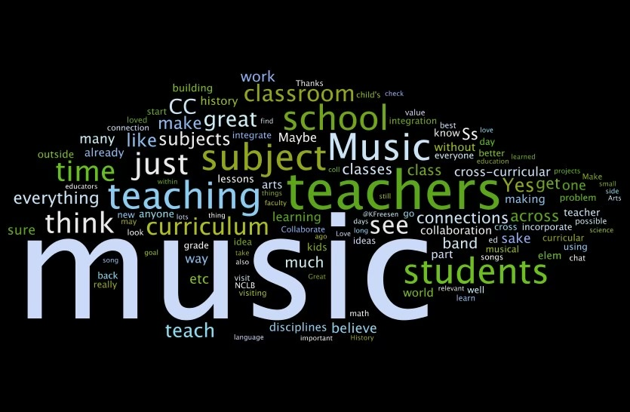
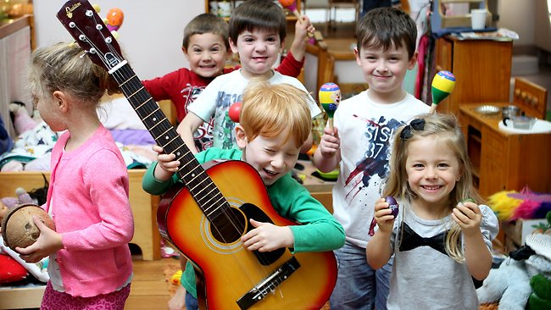
PROFESSIONAL EXPECTATIONS
I will expect you to view yourselves as professionals, and therefore, to act professionally. Just as YOU will expect YOUR students to attend class regularly and arrive on time, I will expect the same of you. This is an interactive class, and we will be learning through experience. At this point, you should be preparing yourselves for the professional world. I would not expect a professional to skip work; I do not expect you to skip class. Because of the experiential nature of this class, it will be impossible to make up work you miss.
In addition, the real world of music teaching is unpredictable! In order to help prepare you to go with the flow, to improvise in the moment, and to think creatively, I will do my best to keep you on your toes, to surprise you on a daily basis, and to give you substantial preparation for the actual role of music educator.
Let’s work hard and have fun!
Course evaluation –
Assignments – 25%
Peer teaching – 25%
Field experience – 30%
Final project - 20%
Credit Load:
This course carries a 3-hour credit load. As such, students should expect to spend at least 6 hours
each week outside of class preparing, which includes reading, practicing, and completing
assignments. Some weeks will require more time spent working outside of class than others, and actual
time spent may vary depending on previous experience and knowledge.
Attendance:
This is a highly interactive class, and there is no replacement for experiences that take place during class
time. Per the division of Music Education handbook, the official attendance policy is:
"Students cannot miss more than 3 classes in a given semester for each music education course (not
counting university excused absences). If more than 3 classes are missed, the student will earn an “F”
for the semester grade for that course. Instructors may have more stringent policies than this basic
policy. Please check individual class syllabi for any additional attendance requirements."
In addition to this policy, at the instructor's discretion, each absence and every two tardies can lower the
grade by one level (e.g., A becomes B).

Do not schedule your juries or end-of-semester playing tests during our class time. This will be an
unexcused absence!

In order to student teach, you must:
Have an overall grade point average (GPA) of 2.75 on all UNT coursework
Have an overall GPA of 2.75 in all MUXX courses and all EDXX courses
Have a minimum of a C in all music and education courses
Have an overall GPA of 2.75 in your professional development classes. See your Student
Handbook for a list of these courses.
Have successfully completed ALL proficiency examinations before you apply for student
teaching. This includes your piano proficiency, concentration proficiency, and all components of
the music education student review. No other coursework can be taken during student teaching.

NO TEXT REQUIRED
All readings and materials will be provided on Canvas. I will provide a list of resources if you wish to purchase for your own library.
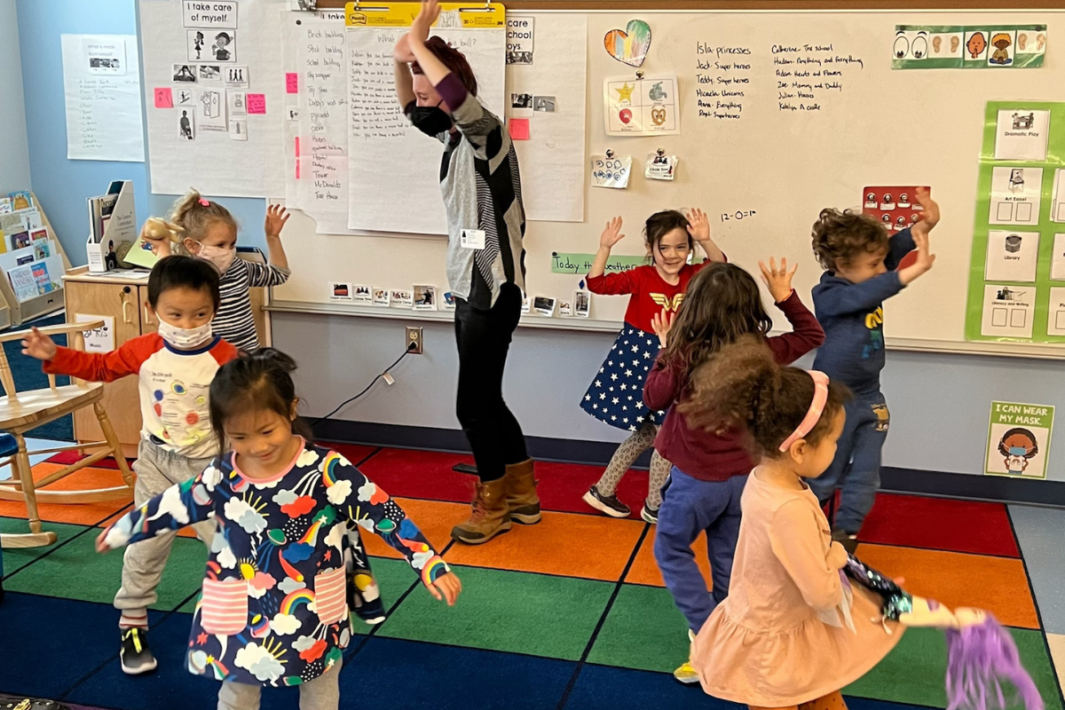
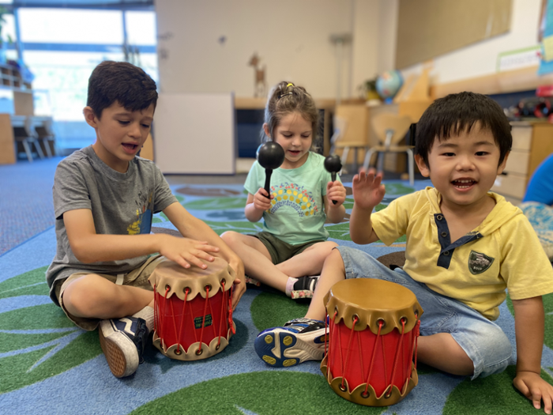
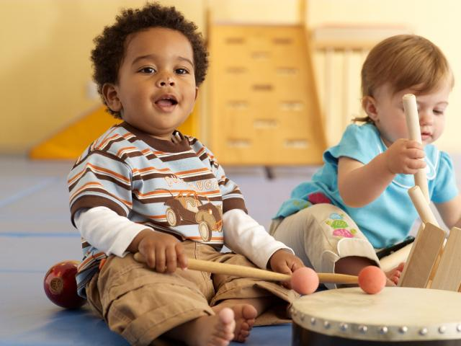

What you will hopefully gain from this course...
1. To develop an understanding of and be able to successfully engage young students in listening, singing, chanting, playing instruments, improvising, and moving.
2. To be able to apply knowledge of individual differences among children to the
preparation of lesson plans and improvising instruction in the moment.
3. To be able to think and plan, short term and long term, sequentially.
4. To become familiar with early childhood music pedagogies, methods, and materials.
5. To be able to transfer what you learn in this class to whatever setting in which
you might be a teacher.
6. To continually question, to challenge your own thinking, to welcome new ideas,
to think outside the box, to become reacquainted with the child inside you!

7. To open the door to your own creativity and understand how to get there!

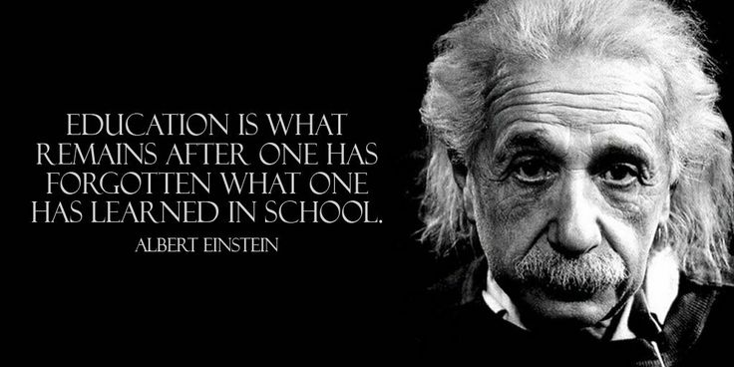
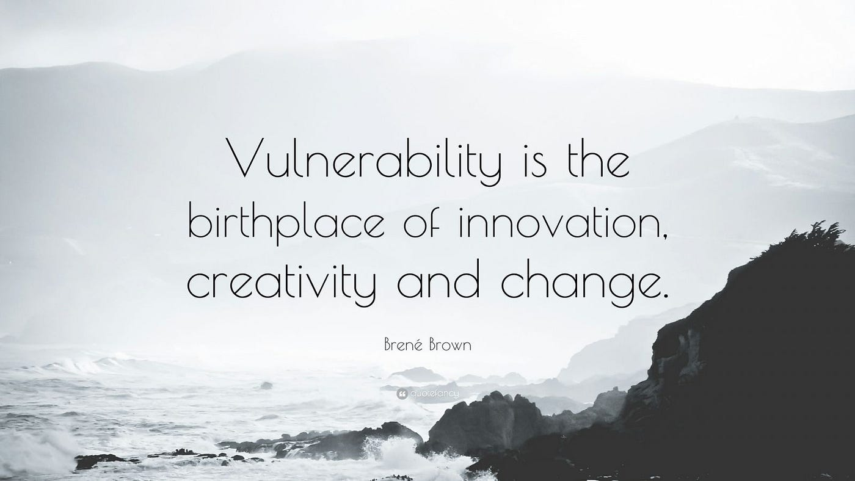
ACADEMIC INTEGRITY
Students caught cheating or plagiarizing will receive a "0" for that particular assignment or exam [or specify alternative sanction, such as course failure]. Additionally, the incident will be reported to the Dean of Students (Office of Academic Integrity), who may impose further penalty. According to the UNT catalog, the term “cheating" includes, but is not limited to: a. use of any unauthorized assistance in taking quizzes, tests, or examinations; b. dependence upon the aid of sources beyond those authorized by the instructor in writing papers, preparing reports, solving problems, or carrying out other assignments; c. the acquisition, without permission, of tests or other academic material belonging to a faculty or staff member of the university; d. dual submission of a paper or project, or resubmission of a paper or project to a different class without express permission from the instructor(s); or e. any other act designed to give a student an unfair advantage. The term “plagiarism” includes, but is not limited to: a. the knowing or negligent use by paraphrase or direct quotation of the published or unpublished work of another person without full and clear acknowledgment; and b. the knowing or negligent unacknowledged use of materials prepared by another person or agency engaged in the selling of term papers or other academic materials.
See: Academic Integrity
LINK: https://policy.unt.edu/policy/06-003
STUDENT BEHAVIOR
Student behavior that interferes with an instructor’s ability to conduct a class or other students' opportunity to learn is unacceptable and disruptive and will not be tolerated in any instructional forum at UNT. Students engaging in unacceptable behavior will be directed to leave the classroom and the instructor may refer the student to the Dean of Students to consider whether the student's conduct violated the Code of Student Conduct. The university's expectations for student conduct apply to all instructional forums, including university and electronic classrooms, labs, discussion groups, field trips, etc.
See: Student Code of Conduct
Link: https://deanofstudents.unt.edu/conduct
ACCESS TO INFORMATION – EAGLE CONNECT
Your access point for business and academic services at UNT occurs at my.unt.edu. All official communication from the university will be delivered to your Eagle Connect account. For more information, please visit the website that explains Eagle Connect.
See: Eagle Connect
LINK: eagleconnect.unt.edu/ODA STATEMENT
The University of North Texas makes reasonable academic accommodation for students with disabilities. Students seeking accommodation must first register with the Office of Disability Access (ODA) to verify their eligibility. If a disability is verified, the ODA will provide you with an accommodation letter. You can now request your Letters of Accommodation ONLINE and ODA will mail your Letters of Accommodation to your instructors. You may wish to begin a private discussion with your professors regarding your specific needs in a course. Note that students must obtain a new letter of accommodation for every semester. For additional information see the Office of Disability Access.
See: ODA
LINK: disability.unt.edu. (Phone: (940) 565-4323)
Health and Safety Information
Students can access information about health and safety at: https://music.unt.edu/student-health-and-wellness
Registration Information for Students
See: Registration Information
Link: https://registrar.unt.edu/students
Academic Calendar, Fall 2025
See: Fall 2025 Registration Information
Link: https://registrar.unt.edu/registration/fall-academic-calendar.html
Final Exam Schedule, Fall 2025
See above
Financial Aid and Satisfactory Academic Progress
Undergraduates
A student must maintain Satisfactory Academic Progress (SAP) to continue to receive financial aid. Students must maintain a minimum 2.0 cumulative GPA in addition to successfully completing a required number of credit hours based on total hours registered. Students cannot exceed attempted credit hours above 150% of their required degree plan. If a student does not maintain the required standards, the student may lose their financial aid eligibility.
Students holding music scholarships must maintain a minimum 2.5 overall cumulative GPA and 3.0 cumulative GPA in music courses.
If at any point you consider dropping this or any other course, please be advised that the decision to do so may have the potential to affect your current and future financial aid eligibility. It is recommended that you to schedule a meeting with an academic advisor in your college or visit the Student Financial Aid and Scholarships office to discuss dropping a course before doing so.
See: Financial Aid
LINK: http://financialaid.unt.edu/sap

Graduates
A student must maintain Satisfactory Academic Progress (SAP) to continue to receive financial aid. Students must maintain a minimum 3.0 cumulative GPA in addition to successfully completing a required number of credit hours based on total registered hours per term. Music scholarships require a 3.5 cumulative GPA. Students cannot exceed maximum timeframes established based on the published length of the graduate program. If a student does not maintain the required standards, the student may lose their financial aid eligibility.
If at any point you consider dropping this or any other course, please be advised that the decision to do so may have the potential to affect your current and future financial aid eligibility. It is recommended you schedule a meeting with an academic advisor in your college, an advisor in UNT-International or visit the Student Financial Aid and Scholarships office to discuss dropping a course.
See: Financial Aid
LINK: http://financialaid.unt.edu/sap
RETENTION OF STUDENT RECORDS
Student records pertaining to this course are maintained in a secure location by the instructor of record. All records such as exams, answer sheets (with keys), and written papers submitted during the duration of the course are kept for at least one calendar year after course completion. Course work completed via the Canvas online system, including grading information and comments, is also stored in a safe electronic environment for one year. You have a right to view your individual record; however, information about your records will not be divulged to other individuals without the proper written consent. You are encouraged to review the Public Information Policy and the Family Educational Rights and Privacy Act (FERPA) laws and the university’s policy in accordance with those mandates.
See: FERPA
Link: http://ferpa.unt.edu/
COUNSELING AND TESTING
UNT’s Center for Counseling and Testing has an available counselor for students in need. Please visit the Center’s website for further information:
See: Counseling and Testing
Link: http://studentaffairs.unt.edu/counseling-and-testing-services.
For more information on mental health resources, please visit:
See: Mental Health Resources
Link: https://disparities.unt.edu/mental-health-resources

ADD/DROP POLICY
Please be reminded that dropping classes or failing to complete and pass registered hours may make you ineligible for financial aid. In addition, if you drop below half-time enrollment you may be required to begin paying back your student loans. See Academic Calendar (listed above) for additional add/drop Information.
Drop Information: https://registrar.unt.edu/registration/fall-academic-calendar.html
STUDENT RESOURCES
The University of North Texas has many resources available to students. For a complete list, go to:
See: Student Resources
Link: https://success.unt.edu/aa-sa-resources
CARE TEAM
The Care Team is a collaborative interdisciplinary committee of university officials that meets regularly to provide a response to student, staff, and faculty whose behavior could be harmful to themselves or others.
See: Care Team
Link: https://studentaffairs.unt.edu/care-team

