EDRE 4850: ASSESSMENT AND EVALUATION OF READING
INSTRUCTOR: OFFICE: EMAIL ADDRESS: OFFICE HOURS:
CLASS MEETING/SECTIONS:

REQUIRED TEXTS (Bring to class daily):
Biggam, S., & Itterly, K. (2009). Literacy profiles: A framework to guide assessment, instructional strategies and intervention, K-4. Boston, MA: Allyn and Bacon.
Lesie, L., & Caldwell, J.S. (2011). Qualitative reading inventory 5. Upper Saddle River, NJ: Allyn and Bacon.
Texas Essential Knowledge and Skills for English Language Arts and Reading (available at www.tea.state.tx.us). Be sure to download the TEKS, put them in your notebook and bring them to class daily.

TK20:
This course requires the Diagnostic Literacy Profile to be uploaded and graded in the UNT TK20 Assessment System. This will require the one-time purchase of TK20. Student subscriptions will be effective for seven years from the date of purchase. Key assignments must be uploaded into the TK20 system for instructors to assess. Please go to the following link for directions on how to purchase TK20. Announcements regarding TK20 will also be posted on this website. http://www.coe.unt.edu/tk20
Blackboard Vista:
This course utilizes Blackboard Vista. More information will be given in class. To access this course, log in at https://ecampus.unt.edu/webct/entryPage.dowebct.

CATALOG COURSE DESCRIPTION:
Examines a variety of assessment and evaluation strategies that are appropriate for the classroom teacher to utilize. Although both formal and informal procedures are introduced, the main focus is on non-intrusive, naturalistic procedures. Observations are required. Prerequisite(s): EDRE 4450 or equivalent.

CONCEPTUAL FRAMEWORK:
The Educator as Agent of Engaged Learning
Improving the quality of education in Texas schools and elsewhere is the goal of program for the education of educators at the University of North Texas. To achieve this goal, programs leading to teacher certification and advanced program for educators at the University of North Texas 1) emphasize content, curricular, and pedagogical knowledge acquired through research and informed practice of the academic disciplines, 2) incorporate the Texas Teacher Proficiencies for learner-centered education, 3) feature collaboration across the university and with schools and other agencies in the design and delivery of programs, and 4) respond to the rapid demographic, social, and technological change in the United States and the world.
The educator as agent of engaged learning summarizes the conceptual framework for UNT’s basic and advanced programs. This phrase reflects the directed action that arises from simultaneous commitment to academic knowledge bases and to learner-centered practice. “Engaged learning” signifies the deep interaction with worthwhile and appropriate content that occurs for each student in the classrooms of caring and competent educators. “Engaged learning” features the on-going interchange between teacher and student about knowledge and between school and community about what is worth knowing. This conceptual framework recognizes the relationship between UNT and the larger community in promoting the commitment of a diverse citizenry to life-long learning. In our work of developing educators as agents of engaged learning, we value the contributions of professional development schools and other partners and seek collaborations that advance active, meaningful, and continuous learning. Seeing the engage learner at the heart of a community that includes educators in various roles, we have chosen to describe each program of educator preparation at UNT with reference to the following key concepts, which are briefly defined below.
- Content and curricular knowledge refers to the grounding of the educator in content knowledge and knowledge construction and in making meaningful to learners the content of the PreK-16 curriculum.
- Knowledge of teaching and assessment refers to the ability of the educator to plan, implement, and assess instruction in ways that consistently engage learners or, in advanced programs, to provide leadership for development of programs that promote engagement of learners.
- Promotion of equity for all learners refers to the skills and attitudes that enable the educator to advocate for all students within the framework of the school program.
- Encouragement of diversity refers to the ability of the educator to appreciate and affirm formally and informally the various cultural heritages, unique endowments, learning styles, interests, and needs of learners.
- Professional communication refers to effective interpersonal and professional oral and written communication that includes appropriate applications of information technology.
- Engaged professional learning refers to the educator’s commitment to ethical practice and to continued learning and professional development.

PURPOSE AND RATIONALE:
Given the current controversies about effective literacy instruction and teacher accountability, it is imperative that preservice teachers understand their responsibility to be able to properly assess and evaluate students’ reading and writing competencies. Classroom teachers are expected to administer and interpret evaluation tools. In addition, they are expected to use the collected data to customize instruction to facilitate student progress. Despite concern about these issues in public and professional circles, there is a great deal of research-based information and myriad instruments that enable educators to assess and evaluate student’s literacy behaviors. This course will enable students to increase their awareness and understanding of informal and formal assessment and evaluation measures and to explore ways to incorporate this knowledge into their developing professional repertoires.

USE OF TECHNOLOGY:
Current media resources related to reading and language arts abound. Some of these resources enhance a teacher’s ability to assess and facilitate students’ language and literacy skills. As a component of this course, students are expected to become aware of technological resources and to grow in their knowledge and application of these tools as a part of their professional competencies. Students should demonstrate skills in accessing information resources and incorporating technology into assignments and the preparation of instructional activities. In addition, students must begin to familiarize themselves with available software and be able to critically evaluate its role and effectiveness for successful literacy instruction. Some demonstrations of available products will be presented in class.

DIVERSITY:
Acknowledging the pluralism extant in our society, this course focuses on the literacy needs and the variety of learning strategies of diverse school populations. Students in the class are expected to be sensitive to and responsible for the needs of children in their instructional planning, materials selection, and proposed activities. In addition, students are expected to broaden their knowledge base of multicultural issues, including: language differences; learning styles; economic disparities; and cultural variations, and to evidence growing insight into these perspectives in their assignments as they prepare to work in public school classrooms. This insight is particularly needful given the common use of literacy assessment instruments that may not take into account the language and cultural diversity of many students.

LLBE PROGRAM EXPECTATIONS FOR FUTURE TEACHERS:
- Develop a reflective mindset about his/her learning and teaching.
- Develop a sensitivity to the English Language Learner.
- Endorse integration in the teaching of language arts.
- Become a lifelong learner.
- Support student-centered instruction.

COURSE GOALS/OBJECTIVES:
The student will:
- demonstrate knowledge of the relationship between instruction and assessment;
- demonstrate knowledge of assessment as a continuous and ongoing process;
- develop an ability to administer and interpret a variety of informal reading, writing, listening, and speaking assessments based on authentic literacy tasks;
- demonstrate observational and diagnostic skills specific to a targeted student’s literacy behaviors and develop means of recording and reflecting upon those observations in order to drive and enhance instruction;
- be able to complete a running record and miscue analysis of the oral reading of a student and understand the results’ implications for instruction;
- be able to compile a profile of student’s work that contains descriptions and analyses of work completed with the student, plus identifies instructional alternatives for future instruction;
- understand the appropriate uses of scores from standardized tests;
- understand the strengths and weaknesses of both formal and informal assessments.

PEDAGOGY AND PROFESSIONAL RESPONSIBILITES (PPR) STANDARDS:
Standard I: The teacher designs instruction appropriate for all students that reflects an understanding of relevant content and is based on continuous and appropriate assessment. (1.1, 1.2, 1.3, 1.4, 1.5, 1.6, 1.7, 1.9, 1.11, 1.12, 1.14, 1.19, 1.20, 1.24, 1.25, 1.26, 1.27, 1.28, 1.29, 1.30, 1.31)
Standard III: The teacher promotes student learning by providing responsive instruction that makes use of effective communication techniques, instructional strategies that actively engage students in the learning process and timely, high-quality feedback. (3.5, 3.7, 3.9, 3.10, 3.11, 3.15, 3.16, 3.17, 3.18, 3.19, 3.20)

ENGLISH LANGUAGE ARTS AND READING GENERALIST STANDARDS:
Standard X: Assessment and Instruction of Developing Literacy--Teachers understand the basic principles of assessment and use a variety of literacy assessment practices to plan and implement literacy instruction for young students (10.1, 10.2, 10.3, 10.3, 10.4, 10.5, 10.6, 10.7, 10.8)
TEXAS ESSENTIAL KNOWLEDGE AND SKILLS (TEKS):
 | Knowledge and Skills Statement |  | K | 1 |  | 2 | 3 | 4 | 5 | 6 | 7 | 8
Reading
Beginning Reading/ Print Awareness | Students understand how English is written and printed.
Beginning Reading/ Phonological Awareness | Students display phonological awareness.
Beginning Reading/ Phonics | Students use the relationships between letters and sounds, spelling patterns, and morphological analysis to decode written English. (Grades 1, 2) Students will continue to apply earlier standards with greater depth in increasingly complex texts.
Beginning Reading/ Strategies | Students comprehend a variety of texts drawing on useful strategies as needed.
Fluency | Students read grade level text with fluency and comprehension.
Vocabulary Development | Students understand new vocabulary and use it when reading and writing.
Comprehension Skills | Students use a flexible range of metacognitive reading skills in both assigned and independent reading to understand an author’s message. Students will continue to apply earlier standards with greater depth in increasingly more complex texts as they become self-directed critical readers.
Oral and Written Conventions
Conventions | Students understand the function of and use the conventions of academic language when speaking and writing. Students will continue to apply earlier standards with greater complexity.
Handwriting/ Capitalization/ Punctuation | Students write legibly and use appropriate capitalization and punctuation conventions in their compositions. (Grade 8) Students will continue to apply earlier standards with greater complexity.
Spelling | Students spell correctly.
 | Knowledge and Skills Statement | K | 1 | 2 | 3 | 4 | 5 | 6 | 7 |  | 8
Listenning and Speaking
Listening | Students use comprehension skills to listen attentively to others in formal and informal settings. Students will continue to apply earlier standards with greater complexity.
Speaking | Students speak clearly and to the point, using the conventions of language. Students will continue to apply earlier standards with greater complexity.
from University of Texas Syst http://www.englishspanishte System/Texas Education Agency (2009). R eks.net/files/standards/TEKS/ELAR_TEKS_ Retri EKS_K-1 rieved K-12 d fro 2.pdf rom f

UNIVERSITY POLICY STATEMENTS:

A. ACADEMIC HONESTY
“Students are encouraged to become familiar with UNT’s policy on academic integrity: http:// www.unt.edu/policy/UNT_Policy/volume3/18_1_16.pdf. Academic dishonesty, in the form of plagiarism, cheating, or fabrication, will not be tolerated in this class. Any act of academic dishonesty will be reported, and a penalty determined, which may be probation, suspension, or expulsion from the university.”

B. ATTENDANCE POLICY
Expectations for attending class are in accordance with the statement on attendance set forth in the University of North Texas Bulletin: Undergraduate Catalog, “Regular and punctual class attendance is expected. . . . Absences may lower the student’s grade where class attendance and class participation are deemed essential by the faculty member.” In this class, students should attend every scheduled meeting. Having more than three absences is considered excessiveand will result in a lowered grade, or possibly a failing grade, for the course. Those with extenuating circumstances should meet individually with the instructor.

C. DISABILITIES ACCOMMODATION
“The University of North Texas complies with Section 504 of the 1973 Rehabilitation Act and with the Americans with Disabilities Act of 1990. The University of North Texas provides academic adjustments and auxiliary aids to individuals with disabilities, as defined under the law. Among other things, this legislation requires that all students with disabilities be guaranteed a learning environment that provides for reasonable accommodation of their disabilities. If you believe you have a disability requiring accommodation, please see the instructor and/or contact the Office of Disability Accommodation at 940-565-4323 during the first week of class.”

D. STUDENT CONDUCT
Expectations for behavior in this class accord with the Code of Student Conduct: “Student behavior that interferes with an instructor’s ability to conduct a class or other students’ opportunity to learn is unacceptable and disruptive and will not be tolerated in any instructional forum at UNT. Students engaging in unacceptable behavior will be directed to leave the classroom and the instructor may refer the student to the Center for Student Rights and Responsibilities to consider whether the student’s conduct violated the Code of Student Conduct. The university’s expectations for student conduct apply to all instructional forums, including university and electronic classrooms, labels, discussion groups, field trips, etc.” See www.unt.edu.csrr.
ADDITIONAL INFORMATION FROM INSTRUCTOR
A. Cell Phones and Laptop: Students should turn off cell phones when they are in class. This means vibrate as well as ring modes. Also, there should be no texting during class. Laptops may be used in class for taking notes and for engaging in learning activities for the course.
B. SETE: The Student Evaluation of Teaching Effectiveness (SETE) is expected for all organized classes at UNT. This brief online survey will be made available to you at the end of the semester, providing you a chance to comment on how this class is taught. I am very interested in the feedback I get from students, as I work to continually improve my teaching. I consider the SETE to be an important part of your participation in this class.
C. Collection of Student Work: In order to monitor students' achievement, improve instructional programs, and publish research findings, the Department of Teacher Education and Administration collects anonymous student work samples, student demographic information, test scores, and GPAs to be analyzed by internal and external reviewers.
D. Late Assignments: All papers and projects should be submitted on the date that they are due, and thus late assignments may not be accepted. Of course, there are some events in life that may cause a delay in work products; this will be taken into consideration on an individual basis. Please discuss with instructor PRIOR to due date.

COURSE REQUIREMENTS/ASSIGNMENTS:
Each student is required to comply with the following expectations. All deadlines are listed on the course calendar.
DIAGNOSTIC LITERACY PROFILE: Students will identify a child to work with for up to ten (10), one hour sessions. During these sessions, students will administer a variety of assessment and evaluation tools. Students will summarize their assessment sessions, interpret the collected data diagnostically, and develop instructional recommendations. Evidence of these tasks will be assembled into a literacy profile that includes results and recommendations. More specific guidelines will be presented in class. This is a Key Assignment with a Key Assessment. This assignment MUST be uploaded to TK20 to begraded.
ASSESSMENTS and SYNOPSIS OF FINDINGS/REFLECTIONS: Students will complete a minimum of fifteen (15) assessments with the child they work with. For each assessment, students will write a brief synopsis of findings, including child’s areas of strength and areas that need improvement and implications for future instruction. Appropriate form for synopsis and required assessments will be discussed in class. There are definite due dates for each assessment.
DIALECTICAL JOURNAL: In order to encourage regular reading of the text and classroom participation, students are required to complete a dialectical journal in reaction to their readings. The appropriate format will be modeled in class. The reading assignments are listed below. Due dates are listed in course calendar.
Dialectical Journal #1: chapter 1 OR 5 Dialectical Journal #2: chapter 3 Dialectical Journal #3: chapter 4 OR 6 Dialectical Journal #4: chapter 9 Dialectical Journal #5: chapter 7 OR 8 OR 10
IN-CLASS ASSIGNMENTS: In order to encourage participation in class and interaction with the course objectives, there will be five (5) in-class assignments reflecting application of the concepts discussed in class as well as outside readings. These may or may not be announced ahead of time. Also, since they are completed in class, there is no make-up if a student is absent.
CONFERENCES: Students will meet twice with the instructor during the semester to present completed assessments. The purpose of each conference is to provide an opportunity to develop communication skills as well as to receive feedback. Dates for conferences are listed on the course calendar. More information will be given in class regarding how to prepare for the conference as well as which assessments are due at each conference.

EVALUATION AND GRADING:
Students will be evaluated according to the following criteria:
In-class assignments 20% Assessments/Synopses 15% Diagnostic Literacy Profile 40% Dialectical Journals 15% Conferences 10%
90-100% A 80-89% B 70-79% C Below 60% F

COURSE OUTLINE:
The tentative course outline and calendar are as follows. Instructor reserves the right to make adjustments as deemed necessary. Announcements of changes will be made in class and on the class blackboard.
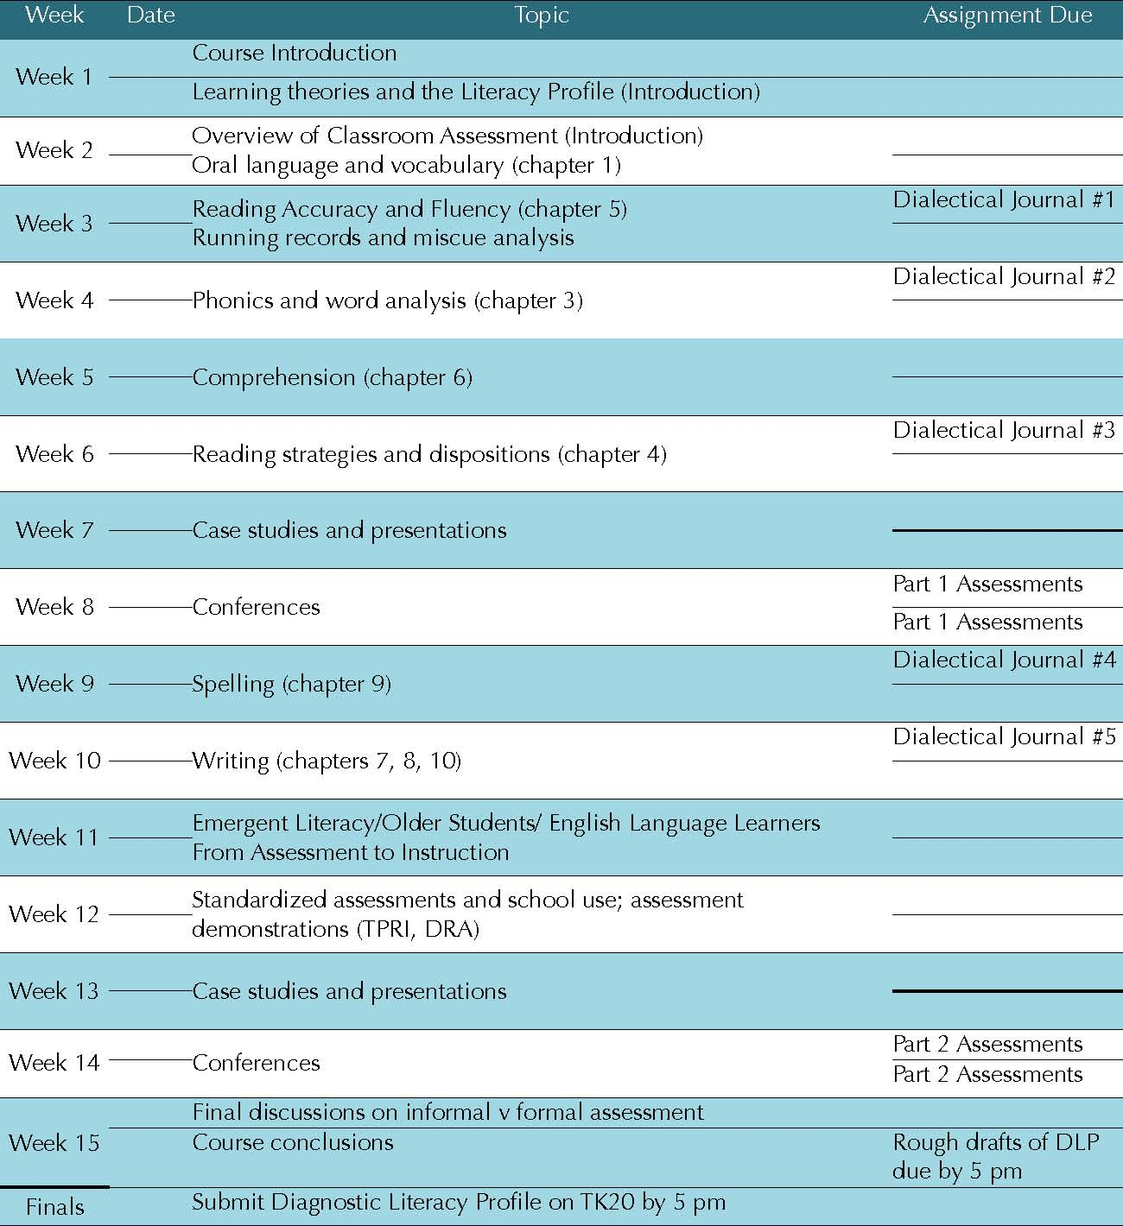
BIBLIOGRAPHY
Biggam, S., & Itterly, K. (2009). Literacy profiles: A framework to guide assessment, instructional strategies and intervention, K-4. Boston, MA: Allyn and Bacon.
Brown, H., & Cambourne, B. (1990). Read and retell. Portsmouth, NH: Heinemann. Calkins, L., Montgomery, K., Santman, D., & Falk, B. (1998). A teacher’s guide to standardized reading tests: Knowledge is power. Portsmouth, NH: Heinemann.
Clay, M. M. (2006). An observation survey of early literacy achievement (2nd ed.). Portsmouth, NH:
Heinemann. Goodman, Y. M., & Marek, A. M. (1996). Retrospective miscue analysis: Revaluing readers and reading. Katonah, NY: Richard C. Owen.
Goodman, Y., Watson, D., & Burke, C. (2005). Reading miscue inventory: From evaluation to instruction (2nd ed.). Katonah, NY: Richard C. Owen.
Johnston, P. H. (1997). Knowing Literacy: Constructive literacy assessment. York, ME: Stenhouse. McAndrews, S. L. (2008). Diagnostic literacy assessments and instructional strategies. Newark, DE: International Reading Association.
McKenna, M. C., & Stahl, K. A. (2009). Assessment for reading instruction (2nd ed.). New York City, NY:
Guilford Press. Popham, W. J. (2004). Classroom assessment: What teachers need to know (4th ed.). Boston, MA: Allyn & Bacon.
Reutzel, D. R., & Cooter, R. B. (2011). Strategies for reading assessment and instruction: Helping every
child succeed (4th ed.). Boston, MA: Pearson. Rhodes, L. K., & Shanklin, N. L. (1993). Windows into literacy: Assessing learners, K-8. Portsmouth, NH: Heinemann.
Strickland, K., & Strickland, J. (2000). Making assessment elementary. Portsmouth, NH: Heinemann.

PROFESSIONAL ORGANIZATIONS
International Reading Association www.reading.org National Council of Teachers of English www.ncte.org Literacy Research Association www.nrconline.org

KEY VOCABULARY TERMS
assessment informal assessment portfolios self-assessment checklist rubric anecdotal record interview running record informal reading inventory miscue analysis formal assessment norm-referenced test criterion-referenced test grade equivalent scores percentile ranking stanine scores screening assessment diagnostic assessment formative assessment summative assessment independent reading level instructional reading level

