**UNIVERSITY OF NORTH TEXAS**

**Department of Sociology**

**SOCI 1510: Introduction to Sociology   
Spring, 2019, Cury Hall, Rm 204**

**Dale E. Yeatts, Ph.D. Phone: 940-565-2238**

**Professor E-mail: yeatts@unt.edu**

**Chilton Hall, 390 Suite Fax: 940-369-7035**

**Office Hours: T/TR: 12:30-1:50 Yeatts’ Web Page:**

**and (preferably) by appointment Http://www.yeatts.us**

**I. Learning Objectives:**

A. To discover and learn about many of the subject areas under investigation by sociologists including health care, criminology, race, gender, gerontology, marriage and family, socialization, culture, social class, and social influences on the physical environment

B. To become familiar with the research methods used to gain knowledge of the various subject areas including survey research, observation of subjects, and the experimental design

C. To become aware of the historical development of sociology and the theories that have been developed to explain the development of society

**II. Learning components**

A. Readings: To help meet the objectives, the following books are required (available on Amazon or at UNT bookstore):

REQUIRED: Henslin, James M. (2015, 11th edition or newer). Essentials of Sociology: A Down to Earth Approach. Boston, MA: Pearson.

Henslin, James M. (2011, 4th edition). Life in Society, Boston, MA: Pearson. (you can use an earlier edition but you may need to get copies of some of the readings found in the 4th edition if the readings are not in the earlier edition).

B. Class time: will be focused on the objectives through lectures, class discussions, movies, small group activities, and guest lecturers.

**III. Course Policies**

A. Class Attendance: regular and punctual class attendance is expected. It will be difficult to master all the material if class is missed. While students will not usually be penalized for missing class they will be penalized for coming to class late or leaving class early since these disrupt the class. If you need to come late or leave early, please let Dr. Yeatts know beforehand. Students can gain extra credit points by attending class (see below). Students who miss a lot of class will be given NO leeway in grading and may lose points while students who miss no or only a few classes will be given MUCH leeway in grading and may gain points. For example, a recent student missed more than half the classes, had a test grade average of 69, and wanted one point added to his/her final grade in order to receive a “C”. The student got a “D”. Another student missed only a few classes had an average grade of 88 and was given two extra points to receive an “A”.

B. Academic integrity: as the student guidebook points out, academic integrity is required. Plagiarism and cheating will result in failure and a report to the Dean.

C. Acceptable Student Behavior: Student behavior that interferes with an instructor’s ability to conduct a class or other students' opportunity to learn is unacceptable and disruptive and will not be tolerated. Students engaging in unacceptable behavior (including continual texting during class) will be directed to leave the classroom and the instructor may refer the student to the Center for Student Rights and Responsibilities to consider whether the student's conduct violated the Code of Student Conduct. The Code of Student Conduct can be found at [www.unt.edu/csrr](http://www.unt.edu/csrr)

D. Special Needs: UNT’s counseling center provides free career and personal counseling to UNT students (up to 8 sessions per year). Appointments can be made by calling 940-565-2741. For our class, appropriate adjustments and auxiliary aid are available for persons with disabilities. See Dr. Yeatts and/or call 817-565-2456 (TDD access 1-800-735-2989).

E. Cell Phones and texting: you should know that many professors and instructors find it insulting when a student is constantly texting or otherwise using their phones during class. Consequently, if the time comes that the student could use some “leeway” in her/his grade, and the student has constantly used his/her phone during class, no leeway will be given and points could be removed.

F. Laptops may not be used in class unless the student sits in the front row. Unfortunately, past experience shows that some students with laptops use them for purposes other than the class and this, in turn, distracts students around them.

G. Office Hours are Tues/Thursday, 2:00 – 3:15. To be sure that I will be available when you come by, please email me the day before and let me know you are coming. Or, if my office hours do not work for you, let me know and we can find a day/time that works for both of us. I enjoy getting to know students and can be very helpful if given the chance. I will be happy to discuss the course material, your progress in the class, your plans for the future, personal issues, need for a letter of recommendation, or anything else of interest/importance to you. Perhaps we can go to lunch. Some students will set an appointment just to introduce themselves and share a bit about their activities and progress at UNT.

H. If unexpected problems develop for you during the semester (e.g., health or emotional issues), please contact me as soon as these become apparent. I can then work with you to develop a plan that will assist you. Students, who approach their instructors/professors when problems develop, are much more likely to receive help and consideration. Don’t wait until the end of the semester when it is too late to find a solution. This is a good rule-of-thumb for any class you take.

I. Grading: final grades will be based on the following:

1. Four (4) tests will be given worth 20% each of your final grade. The fourth test will not be cumulative. The format is expected to include multiple choice and true/false questions. Grades will be posted on Dr. Yeatts’ web page. (go to www.[yeatts.](mailto:yeatts@unt.edu)us, click on 1510).

You are responsible for using the restroom prior to the beginning of a test so **do not** **ask to use the restroom** in the middle of a test (unfortunately a few of us would use this as an opportunity to review our notes in the middle of taking the test).

2. A two to five page paper is required. It is worth 20% of your final grade. A description of the paper requirements will be provided.

February 14 (Thursday), test 1 20%

March 19 (Tuesday), test 2 20%

April 2 (Tuesday), Research Paper (see handout/website) 20%

April 11 (Thursday), test 3 20%

May 9 (Thursday, during exam week, time: 10:30-12:30 ) 20%

3. Make-up Tests: may be allowed within one week from the original exam day. The test score will be reduced by one letter grade unless there is documentation verifying an illness or other serious situation. Students who have missed none or one or two classes are likely to be given some leeway.

4. Class Participation: Those who contribute meaningful, thoughtful, and knowledgeable comments/ideas will receive extra points added to their final grade if their final grade is close to the next higher grade. For example, an 88 would be raised to a 90. Similarly, those who attend all (or almost all) classes will receive extra points.

5. Extra Credit Opportunities: There are two ways to obtain extra credit. Please see the “**Opportunities for Extra Credit”** below for details.

J. How to Study for Tests:

1. Read carefully and give thought to the assigned chapters and readings to be covered on the test (ideally keep up weekly).

2. Read the assignments before they are discussed in class so you are more prepared to contribute to discussions.

3. **Learn the major concepts (bolded and italicized concepts) in the chapters and what they mean. Pay attention to section headings within the chapter.**

4. Know the answers to the **study guide questions** that are placed on Dr. Yeatts’ web page (www.[yeatts.](mailto:yeatts@unt.edu)us). These questions were developed from the test questions. If you can answer the study guide questions you will increase your chances of knowing the answers to the test questions.

**IV. Topics to be Covered/Reading Assignments**(all Chapter assignments refer to the Henslin text book (11th edition); Henslin Readings refer to the Henslin Life in Society book

Week 1 (January 15):

Overview of class, Chapter 1 (Sociological Perspective)

Possible: Youtube—what is sociology?

https://www.youtube.com/watch?v=TFdUtCAXAUM&feature=related

China Fullbright

Week 1 (January 17):

Chapter 1 continued: Origins of sociology (social theory)

Henslin Readings: 1, 2, 3, 5

Possible movies: Why Sociology (MV9404)

W.E.B. DuBois (MV 7620, first 30 minutes)

Hull House (MV4227)

Weeks 2 (January 22):

Chapter 1 continued: Social Research Methods

Possible movie: How to Read and Understand a Research Study

(DVD 10566R; 25 minutes)

Weeks 3 (January 29):

Chapter 2: Culture

Possible movie: Chinese Business Culture (MV 7265)

YouTube examines health care: http://www.youtube.com/watch?v=yVgOl3cETb4

Week 4 (February 5):

Chapter 3: Socialization

Possible movie: Socialization (MV 8902)

Week 5 (February 12): Chapter 3 continued

**Test 1 on chapters 1-3, Henslin readings 1, 2, 3, 5, and class materials** **(February 14, Thursday)**

Week 6 (February 19):

Medical Sociology (not covered in text book)

YouTube: We’re #37

Week 7 (February 26):

Chapter 5: Social Groups and Formal Organizations

Henslin Readings 4, 6 - 8

Possible movie: Lyrics lead to violence (MV 8699, 22 min.)

Violence (MV6268, 30 min)

Week 8 (March 5):

Chapter 6: Criminology, Deviance and Social Control

Preparing Class Research Paper

Possible movie: Quite Rage (jailers/prisoners study; MV5305, 40+m)

Diary of a Terrorist (MV7706, 52 min)

Behind Closed Doors (MV7341, interpersonal violence,29 min)

Week 9: (March 12):

**Spring Break**

**Test 2 on medical sociology, Henslin chapters 5-6, Henslin readings 4, 6-8, and class materials (March 19, Tuesday)**

Week 10 (March 21):

Chapter 7: Global Stratification

Henslin Readings 9, 10, 12

Research Paper due November 3 (see handout for details)

Possible movie: Diary of a Terrorist (MV7706, 52 min)

Week 11 (March 28):

Chapter 8: Social Class in the U.S.

**Turn in Research Paper on April 3**

(only hard copies accepted/no emailed copies)

Possible movie: Tumaini (AIDES, prostitution, Africa; MV10099, 30)

Untouchable (Caste and Class changes in India; MV7401 v.18, 25 minutes)

Critical Condition

Week 12 (April 4):

Chapter 9: Race and Ethnicity

Possible movies: Solving Inner-City Poverty (MV 3256, 28 min)

History of NAACP (MV7064)

Race the Power of an Illusion (how racist U.S. has

been, importance of supreme court; M9028 v3 52m)

Life of Dubois

**Test 3 on chapters 7-9, Henslin readings 9, 10, 12, and class materials**

**(April 11, Thursday)**

Week 13 (April 16):

Chapter 10: Gender and Age

Henslin Readings 11, 16, 21, 22

Possible movie: Alzheimers (MV 5739A, 34 min)

Women, (MV6480, media control perceptions 34 min)

Breaking the Glass Ceiling (MV8082 v1; 23 minutes)

The Double Shift (MV 7504, conflict of family & work)

Age (overview, 30 mins.)

Possible Speakers: Director of Women’s Studies

Week 14 (April 23):

Chapter 12: Marriage and Family

Possible movies: Family Violence (MV4168, husband abuse)

Families Matter (MV3737)

Behind Closed Doors (MV7341, interpersonal violence,29 min)

Possible Speakers: Friends of Family; Professor Seward

Week 15 (April 30):

Chapter 15: Social Change and the Environment

Possible movies: Collective Behavior and Social Movements (MV4528)

Culture Change (MV 9871)

The Black Soil (MV10084, locating near poor)

A Bientot (MV9384, interviews workers in France in 70s about working conditions, unionization, strikes)

Critical Condition (follows 4 families without insurance)

**Test 4 on chapters 10, 12, 15, Henslin readings 11, 16, 21, 22, and class materials; Taken on Exam Day, Thursday, May 9, 10:30-12:30**

**Research Paper**

All students who take Introduction to Sociology must write a sociological analysis paper. The paper should be 2 – 5 pages long and provide an analysis of several tables that will be provided to you. You will be provided a three page handout that gives detailed instructions on how to write the paper.

**Opportunities for Extra Credit**

1. Five Page Library Research Paper

Collect cartoons and comic strips that draw on a sociological topic, such as changing perspectives on marriage, family life, health care, prison life, gender inequality, life in other countries, how human social life is similar/comparable to some other thing, etc. At the same time, do a library search on the topic to identify scholarly, peer-reviewed research articles on the topic (you can use popular magazines such as Time or “internet” sources but these should be no more than 10% of your citations/references). Write a 5 page paper, double spaced, that reviews the topic. You will receive up to 3 extra points added to your final grade.

For the paper do the following: (1) present copies of the cartoons and strips in color where possible (these do not count as part of the 5 typed, double-spaced pages), (2) discuss the topic using peer reviewed journal articles and citing them in the paper and providing the full citation at the end of the paper (i.e., the reference list), and (3) for a **fourth extra-credit point** you can present your project to the class, if approved by the professor. The paper must be turned in no later than April 18. If you present your paper, use powerpoint or some other way of displaying some of the most interesting cartoons/comic strips. If you wait until the last few days before deciding to do this, it will show in what you turn in and you may receive no extra points.

2. In-Class Assignments

Students will be given the opportunity to obtain extra credit points during class. For example, students may be asked to work in groups during class to solve one or more problems and then each student will turn in their own answer(s) before the end of class and one or more extra points will be added to the student’s next test grade. Students who are absent, or come to class late, or leave class early will not be eligible for these extra points. A student who does not miss class will typically accumulate 5 – 6 points to be added to her/his next test grade.

# Inequality: A Sociological Analysis

**Assignment Overview:**

All UNT students who take sociology 1510: Introduction to Sociology (regardless of whom is teaching it) are required to write a research paper. The purpose of this exercise is to demonstrate your ability to synthesize numerical data and sociological perspectives.

Throughout the semester, you will develop your understanding of the Conflict and Functionalist perspectives. In this exercise, you will use the data attached from the Central Texas Sustainability project (CTSIP) to (1) identify patterns in the data and (2) use each of the perspectives to explain why these patterns may exist. Thus, from a functional perspective one would provide explanations that this perspective offers. From a conflict perspective one would have a different explanation(s) for the patterns seen in the data. The CTSIP is a comprehensive evaluation of "sustainability indicators" in Central Texas.

Below is a suggested outline to help guide your development of the paper.

# Suggested Outline:

|  |  |  |
| --- | --- | --- |
| Paragraph 1 | Introduction | State the issue that you will be examining (relationship between income inequality and health coverage/status). Explain why this is an important area to examine. Be sure to gain the readers interest in the topic within your introduction. End by letting the reader know what major areas are covered in the paper |
| Paragraph 2-3 | Theory | Explain that there are two theoretical perspectives (conflict and functional) that provide explanations for income inequality and health care coverage/status.  Provide a brief description of each perspective and what each might predict and why with regard to health care coverage and status in the U.S. |
| Paragraph 4-7 | Data | Provide an overview of what the information in the tables tells us. What explanation does the functional perspective gives us with regard to the relationships found in the tables? What explanation(s) does the conflict perspective provide? Discuss each theory’s ability to explain the findings. Which theory appears to do the best job of explaining the findings? Perhaps they each do a good job but from a different perspective (there is no right or wrong answer but you must support whatever perspective you take). |
| Paragraph 8 | Conclusion | Provide a brief conclusion that (1) summarizes the data and how each theory explains the data and (2) considers the social implications of the data (note how these patterns relate to the larger society). |

**Formatting Requirements:**

The assignment must adhere to the following formatting requirements:

* The paper must be at least 2 pages and no more than 5 pages (not including bibliography).
* The paper must be emailed to the TA in PDF format. The paper must also be printed and

the hard copy turned in on the day it is due (thus 2 copies on emailed one turned in).

* The paper must be written in 12 point Times New Roman font.
* The paper must be double spaced.
* All page margins must be 1 inch.
* Citations can be used but are not necessary. Any articles, books, etc. that are used must be cited appropriately, using any conventional citation method you are familiar with (e.g., APA, MLA, ASA, etc.). A reference list (bibliography) should also be provided at the end of the paper to show the resources used/cited. If you are not familiar with a citation method, seek assistance from the instructor or the free University writing lab (http:// [www.unt.edu/writinglab/).](http://www.unt.edu/writinglab/))
* If you have any questions send your professor an email: [yeatts@unt.edu.](mailto:yeatts@unt.edu)

*TABLE 1: Percentage Reporting No Health Care Coverage across Various Income Levels*

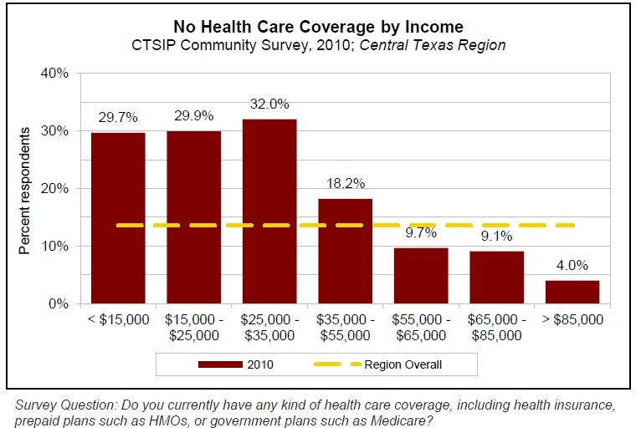

*TABLE 2: Reason for No Health Care Coverage*

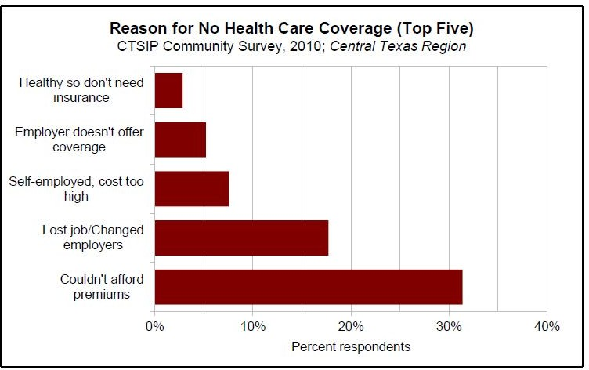

*TABLE 3: General Health Status for Various Income Levels*

