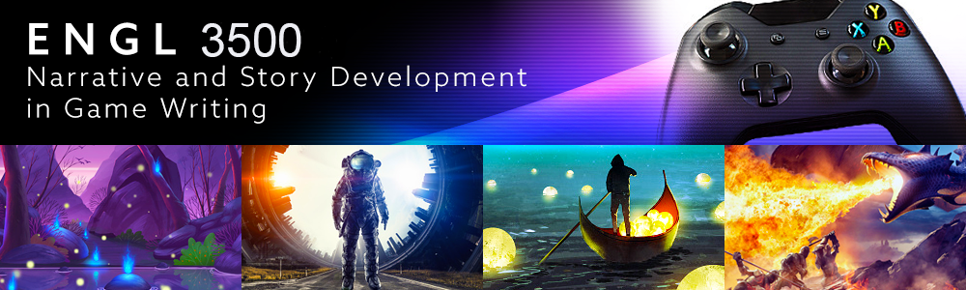

**Narrative and Story Development in Game Writing**

Fall 2025

Instructor: Dr. Darin Bradley ([darin.bradley@unt.edu](mailto:darin.bradley@unt.edu))

Office Hours: by appointment

# **REQUIRED TEXTS:**

*The Ultimate Guide to Video Game Writing and Design* by Flint Dille and John Zuur Platten

*Video Game Storytelling* by Evan Skolnick

*Wired for Story* by Lisa Cron

# **COURSE DESCRIPTION AND REQUIREMENTS**

Video games are the new frontier of imaginative literature. Game writers rely on traditional narrative concepts but also craft stories within the unique context of gameplay and mechanics. In recent years, titles such as *The Last of Us* and *What Remains of Edith Finch* demonstrate the rapid advancement in the sophistication of story-rich gaming. This course examines basic elements of game writing in the framework of design, character development, and gameplay. We will scrutinize craft elements in traditional narrative for their utility within the forms of video game genre and mechanics.

The course is a workshop in which you will produce overviews and scripting. Exercises and assignments will prioritize methods of characterization and how to incorporate characterization techniques into game mechanics. You will produce a Game Concept Document and then a partial script incorporating your ideas developed through a character template and that concept material. You will produce a significant revision of the scripting by incorporating feedback from the workshop and instructor.

A workshop is a collaborative effort. For our workshop to succeed, you must be willing to offer feedback about your peers’ work after having read it carefully and considered the goals it suggests for itself, rather than your own ideas for what might work better. You are graded as much for your contributions to the workshop effort as the imaginative dynamics of your own work.

I look forward to reading your work and exploring with you how game writers conceive story and characters and participate in the larger production team effort.

**Grade Breakdown by Assignment**

Revision of Scene 15%

Discussions and Workshop Critiques 25%

Writing Exercises 5%

Quizzes 10%

Game Concept Document 15%

Cutscene Script 20%

Character Template 10%

PLAGIARISM

Plagiarists will receive an “F” and be reported to the Dean of Students. You cannot submit work written for another class or a previous attempt at this class. Please note that the unapproved use of assistive technologies such as ChatGPT or other A.I. tools is considered academic dishonesty. Upon detection, you will be reported to the Dean of Students with a recommendation for expulsion from the class with a grade of F.

EMAIL

I reply to all email. I can’t promise better than a 24-hour response time during the week, however. I will occasionally send class announcements via email. Please check your university email periodically. The most reliable way to get in touch with me is via message in Canvas.

I send important course updates via the Announcements on Canvas. Please check Canvas announcements daily for course reminders, changes, and other important information.

ADA COMPLIANCE

If you have a disability for which you will require reasonable accommodation under the terms of the Americans with Disabilities Act of 1973, please discuss your needs with me and present your written requests to the campus Office of Disability Accommodation.

**SEMESTER SCHEDULE (tentative!)**

Week 1: Video Game Stories and their writers

1. Discussion: Introduce Yourself
2. Materials Comprehension Quiz
3. Writing Activity: Weave a story into a common game

Week 2: Building Characters in the Context of Game Construction

1. Discussion: Character Empathy and Player Agency
2. Quiz
3. Writing Activity: Character Template

Week 3: Create your own Game Concept Document

1. Quiz
2. Major Assignment: Concept Document

Week 4: Script Your Cutscene/Cinematic or Quest

1. Writing Exercise: Rewrite a Key Moment
2. Major Assignment: Cinematic/Cutscene script or Quest Structure

Week 5: Workshop Concept Document

Week 6: Workshop Concept Document

Week 7: Workshop Concept Document

Week 8: NPCs (Non-Player Characters) who make a difference

1. Quiz
2. Discussion: NPCs and Agency

Level 9: Worldbuilding: “I have all this Lore!”

1. Discussion: Reverse Engineer a Favorite World
2. Exercise: Take Us to Your World

Week 10: Cinematic Cutscene Workshop

Week 11: Cinematic Cutscene Workshop (Cont’d)

Week 12: Cinematic Cutscene Workshop

Week 13: Revision of Cutscene or Quest

Week 14: Synopsis and Change Statements

Week 15: Self-reflections