**EDCI 3800: ISSUES IN EDUCATION**



**FALL 2019 – Section 006**

**T/Th 8-9:20 – MH 108**

**Instructor Contact Information**

|  |  |
| --- | --- |
| **Office** | Matthews Hall 205K |
| **E-mail** | Danelle.Adenji@unt.edu |
| **Phone Number** | (832) 431- 6429 |
| **Office Hours** | Tuesdays and Thursdays: 9:30am-11:00am, and by appointment. Please make appointments even if during office hours. |

# COMMUNICATION

The best way to reach me, outside office hours and class, is to email me via @[Danelle.Adeniji@unt.edu](mailto:Danelle.Adeniji@unt.edu) (allow 24 hours for response, especially on the weekends). Please include your class number (EDCI 3800) in the subject and your full name at the end of your message.

# REQUIRED TEXTBOOK

Goldstein, D. (2014). The teacher wars: A history of America’s most embattled profession. New York, NY: Doubleday. ·

* Available for purchase at UNT bookstore & Amazon (ebook, new & used, etc.)
* Available as audiobook through Audible

**SUGGESTED TEXTBOOK**

Essex, N. L. (2015). A teacher's pocket guide to school law (3rd Ed.). Boston. MA: Pearson.

**CATALOG COURSE DESCRIPTION**

3 hours. Overview of American education, including history, purposes, legal bases, school organization, education as a profession and analysis of characteristics required for professional success.

*Prerequisite(s): None*

**Welcome to the class!**

Welcome to EDCI 3800:006 Professional Issues in Teaching! I’m Danelle Adeniji and I am excited to explore the history and foundations of education with you this semester. I was an elementary school teacher for six years; I taught 3rd and 4th grade math and science. I began my doctoral journey this summer in the area of curriculum and instruction. I specifically would like to focus on working with pre-service teachers on how they instruct Black and Brown students in low socioeconomic areas and building a relatable curriculum for Black and Brown students.

**This syllabus provides** basic information about our course and assignments, but **the course calendar is your class-to-class guide with instructions of what assignments you will need to complete**. As the instructor, I reserve the right to change or modify course assignments, projects, and examinations as are needed to improve our class, but you will be notified with sufficient time for adjustment.  I have **high expectations** for your professional and ethical approach to our class, which includes **communicating as soon as possible** if you will miss a class or deadline in part or in whole to make arrangements with me. **If you are absent** on a due date, it is your responsibility to find what was missed. Assignments or projects due during an absence should be turned in on time digitally via Canvas or other means unless arrangements were made with appropriate notice.

# COURSE WEBSITES

This course utilizes Canvas and blogs through EduBlog.

**COURSE OBJECTIVES**

This course is organized around addressing from a historical perspective the big questions: *What kind of education, for whom, and why*? And *What makes a good teacher?* By the end of this course, students will

* Demonstrate an understanding of the history of education in the United States.
* Demonstrate an understanding of the educational policies and philosophies discussed in class.
* Demonstrate an understanding of the education system in the United States with emphasis on education in Texas.
* Demonstrate an understanding of the importance of equity and the impact of diversity in the classroom.
* Be able to identify and discuss current issues in education in the United States generally and Texas specifically.
* Demonstrate an understanding of the process of becoming a teacher in Texas.
* Demonstrate an understanding of the expectations for a teacher in Texas
* Be able to make an informed choice about teaching as a profession.

**BELIEFS ABOUT LEARNING**

* + - Learning is an active, personal process and endeavor.
    - Learning is a social process of collaboration and interaction with others. We will share our responses and understandings as well as serve as a support system for each other during small and large group activities and discussions.
    - Learning occurs when we make connections to our experiences.
    - Choice allows learners to connect to their own experiences and feel ownership of the learning process.
    - Reflection is a vital part of the learning process.
    - Appreciation of diversity enhances learning.

**TExES COMPETENCIES**

**Standard I: Domain I: Competency 001-004 Domain III: Competency 007-010:** The teacher designs instruction

appropriate for all students that reflects an understanding of relevant content and is based on continuous and appropriate

assessment.

**Competency 2 (A) (B) (D) (F):** The teacher understands student diversity and knows how to plan learning experiences and design assessments

that are responsive to differences among students and that promote all students’ learning.

**Standard III: Domain III: Competency 007-010:** The teacher promotes student learning by providing responsive

instruction that makes use of effective communication techniques, instructional strategies that actively engage students in

the learning process and timely and high-quality feedback.

**Competency 7 (A) (D):** The teacher understanding and applies principles and strategies for communicating

effectively in varied teaching and learning contexts.

**Competency 9 (A) (B) (D) (E) (H):** The teacher incorporates the effective use of technology to plan, organize,

deliver and evaluate instruction for all students.

**Standard IV: Domain IV: Competency 011-013:** The teacher fulfills professional roles and responsibilities and adheres

to legal and ethical requirements of the profession.

**Competency 12 (C) (D) (E):** The teacher enhances professional knowledge and skills by effectively interacting

with other members of the educational community and participating in various types of professional activities.

**Competency 13 (A) (B) (C) (F) G):** The teacher understands and adheres to legal and ethical requirements for

educators and is knowledgeable of the structure of education in Texas.

**ATTENDANCE POLICY\***

* Please note that you have **2 absences** (of any sort) without losing points from your grade. Please email if you know you will be absent in advance. It is your responsibility to get any missed information.
* Each absence after the initial absences will compound:
  + - * 3rd absence - 3 points from final grade
      * 4th absence - 6 points from final grade
      * 5th absence - 9 points from final grade
      * and so on.
* There are exceptions to the attendance policy: documented severe illness or emergency, documented court appearance, or documented death of an immediate family member. Valid documentation, in original hard copy form, should be presented upon your return to class.

|  |  |
| --- | --- |
| **COURSE REQUIRED ASSIGNMENTS** | **Percentage** |
| **PROFESSIONALISM AND PREPAREDNESS**  Teachers must exhibit a high degree of professional behavior and have exemplary attendance in order to best meet the needs of their students. As a teacher candidate, it is essential to begin practicing what will be expected of you as a teacher including reliability, responsibility, flexibility, punctuality, integrity, and ability to work efficiently and productively with your colleagues. This grade will include daily attendance**\* (see above)**, preparedness for activities (discussions), peer reviews, in-class discussions about content, responses to readings, presentations, daily blog responsibilities, and professional behavior. | 15% |
| **BLOG WORK**  You will create a blog and post periodically on various topics and ideas discussed and learned in class bringing your own unique perspectives and experiences as you develop and refine a professional identity. You will also be commenting and interacting with your peers’ writing as well. | 15% |
| **FIRST YEAR TEACHER INTERVIEW**  You will individually interview a teacher regarding their first-year teaching experiences. With your discussion group you will synthesize and present common themes and experiences, as well as unique findings from your individual interviews. | 15% |
| **DISCUSSION GROUPS**  With your PLN (Professional Learning Network), you will rotate discussion roles as you process through readings and concepts. | 15% |
| **BIOGRAPHY PROJECT**  You will explore the educational experiences of an individual with a different background than your own. You will present findings making specific connections to ongoing course themes. | 10% |
| **LESSON PLAN**  To accompany our learning and exploration of state and national standards, you will select a standard, create a lesson plan, with an aligned assessment using the UNT universal lesson design template. | 10% |
| **CASE LAW PROJECT/PRESENTATION**  You will select a seminal education court case, provide historical context, summarize opinions (for and against), and ensure classmates understand the importance and impact of the case on the classroom and teaching practice. | 10% |
| **QUIZZES**  There will be 2 quizzes throughout the semester. Each is worth 5%. | 10% |

***Changes may occur as the course progresses and adjustments may need to be made regarding topics, readings, and/or assignment due dates. Check Canvas for specific assignment due dates/times. **Upload all assignments as a PDF. Points will be deducted for ALL late work.**

# GRADING SCALE

A 90-100%

B 80-89%

C 70-79%

D 60-69%

F Below 60%

|  |  |  |
| --- | --- | --- |
| **COURSE SCHEDULE**  *Subject to change. Check Canvas for due dates. I highly recommend printing this schedule.*  **Online**  **No class meeting** | | |
| Access course slides [here](https://docs.google.com/presentation/d/1KaahR5MphGbmGP8_v3cr5TSK-kX1p0NV0kHP1HWWeyM/edit?usp=sharing) | | |
| **Week/Reading**  *(to be completed* ***prior*** *to class Wednesday)* | **Topic/Activity** | **Assignments Due**  *(All assignments are to be completed* ***prior*** *to Thursdays class unless otherwise noted.)* |
| **Week 1**  *Aug. 27, Aug. 29* | **T:** Welcome; Course overview; Get to know classmates; Introduction to themes; Canvas/Blog logins; Daily Log  **Th:** TEA ethics scavenger hunt; Discussion Group Introduction & model; Ethics modules; Blog 1 post | **Blog site setup** |
| **Week 2**  *Sept. 3, Sept. 5*  ***Reading***  *Philosophy Readings in Canvas* | **T:** Developing a teaching philosophy  **Th:** Discussion groups; **ETHICS QUIZ** | **Ethics Modules**  **Blog Post 1**  **Discussion Role Responsibilities** |
| **Week 3**  *Sept. 10, Sept. 12*  ***Reading***  *“Introduction”: The Teacher Wars* | **T:** Guest Speakers: Teacher Ed Program and Certification  **Th:** Discussion Groups; First Year Videos/Blog 2 | **Blog 1 comments**  **Discussion Role Responsibilities** |
| **Week 4**  *Sept. 17, Sept. 19*  ***Reading***  *“Missionary Teachers”: The Teacher Wars* | **T:** Colonial and New Republic Schools; Introduce First Year Teaching Interview Project  **Th:** Missionary Teachers - discussion groups; Interview Question Brainstorm | **Blog post 2**  **Discussion Role Responsibilities** |
| **Week 5**  *Sept. 24, Sept. 26*  ***Reading***  *“Repressed Indignation”: The Teacher Wars* | **T:** Common School Era - continued  **Th:** Repressed Indignation - Discussion groups | **Blog post 2 comments**  **Discussion Role Responsibilities** |
| **Week 6**  *Oct. 1, Oct. 3*  ***Reading***  *“No Shirking, No Skulking”: The Teacher Wars* | **T:** African-American Educational leaders  **Th:** No Shirking, No Skulking - Discussion groups; Positionality & Experience Blog post 3 | **First Year Teacher Interview (individual work)**  **Discussion Role Responsibilities** |
| **Week 7**  *Oct. 8, Oct. 10*  ***Reading***  *“School Ma’ams as Lobbyists”: The Teacher Wars* | **T:** The Progressive Era; First year interview group work  **Th:** Online Discussion Groups; First year interview group work | **Blog post 3**  **Discussion Role Responsibilities** |
| **Week 8**  *Oct. 15, Oct. 17*  ***Reading***  *“An Orgy of Investigation”: The Teacher Wars* | **T:** FIRST YEAR TEACHER PRESENTATIONS  **Th:** FIRST YEAR TEACHER PRESENTATIONS  : | **FIRST YEAR TEACHER PRESENTATIONS (turned in on Canvas Tuesday, Oct. 15)**  **Blog post 3 Comments** |
| **Week 9**  *Oct. 22, Oct. 24*  ***Reading***  *“The Only Valid Passport from Poverty”: The Teacher Wars* | **T:** Larger view of civil rights; Case Law Project  **Th:** Online Discussion; Case Law Project Work | **Discussion Role Responsibilities** |
| **Week 10**  *Oct. 29, Oct. 31*  ***Reading***  *“We Both got Militant”: The Teacher Wars* | **T:** Blog Post 4 - Social Media Post  **Th:** Discussion groups; **QUIZ 2** | **Discussion Role Responsibilities** |
| **Week 11**  *Nov. 5, Nov. 7*  ***Reading***  *“Very Disillusioned”: The Teacher Wars* | **T: CASE LAW PRESENTATION**  **Th:** A Nation at Risk; Reform Efforts; Very Disillusioned - Discussion groups | **Blog post 4**  **Discussion Role Responsibilities** |
| **Week 12**  *Nov. 12, Nov. 14*  ***Reading***  *“Big Measurable Goals”: The Teacher Wars* | **T:** NCLB and Standards Movement; Lesson plan preparation  **Th:** LESSON PLAN | **Blog post 4 comments**  **Lesson Plan Standards**  **Discussion Role Responsibilities** |
| **Week 13**  *Nov. 19, Nov. 21*  ***Reading***  *“Let Me Use What I Know”: The Teacher Wars* | **T:** Big Measurable Goals - Discussion groups  **Th: BIOGRAPHY PROJECT PRESENTATIONS (Roundtable)** | **Biography project** |
| **Week 14**  *Nov. 26, Nov. 28* | **No Class**  **Happy Thanksgiving!** | |
| **Week 15**  *Dec. 3, Dec. 5*  ***Reading***  *“Lessons From History...”: The Teacher Wars* | **T:** The Good, the Bad, & the Ugly; Blog Post 5  **Th: No Class - Reading Day** | **Blog post 5 (Completed in class)** |
| **Week 16**  **Finals Week**  *Dec. 9*  ***Reading***  *Notes, discussion work, projects (if taking final)* | **Final Exam**  **8:00a - Matthews 108** | |

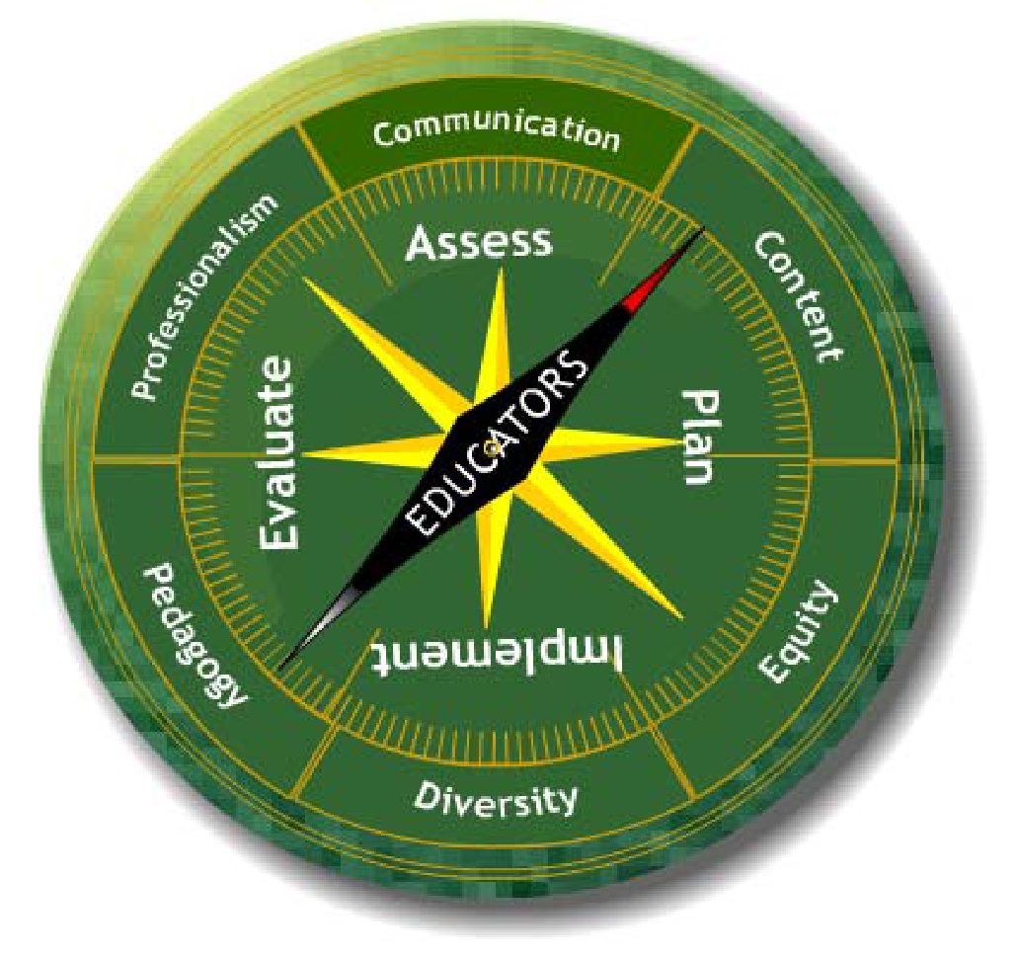

***The Educator as Agent of Engaged Learning:***

Improving the quality of education in Texas schools and elsewhere is the goal of programs for the education of educators at the University of North Texas. To achieve this goal, programs leading to teacher certification and advanced programs for educators at the University of North Texas 1) emphasize content, curricular, and pedagogical knowledge acquired through research and informed practice of the academic disciplines, 2) incorporate the Texas Teacher Proficiencies for learner centered education, 3) feature collaboration across the university and with schools and other agencies in the design and delivery of programs, and 4) respond to the rapid demographic, social, and technological change in the United States and the world.

**The educator as agent of engaged learning** summarizes the conceptual framework for UNT's basic and advanced programs. This phrase reflects the directed action that arises from simultaneous commitment to academic knowledge bases and to learner centered practice. "Engaged learning" signifies the deep interaction with worthwhile and appropriate content that occurs for each student in the classrooms of caring and competent educators. "Engaged learning" features the on-going interchange between teacher and student about knowledge and between school and community about what is worth knowing. This conceptual framework recognizes the relationship between UNT and the larger community in promoting the commitment of a diverse citizenry to life-long learning. In our work of developing educators as agents of engaged learning, we value the contributions of professional development schools and other partners and seek collaborations which advance active, meaningful, and continuous learning.

Seeing the engaged learner at the heart of a community that includes educators in various roles, we have chosen to describe each program of educator preparation at UNT with reference to the following key concepts, which are briefly defined below.

1. **Content and curricular knowledge** refer to the grounding of the educator in content knowledge and knowledge construction and in making meaningful to learners the content of the PreK-16 curriculum.
2. **Knowledge of teaching and assessment** refers to the ability of the educator to plan, implement, and assess instruction in ways that consistently engage learners or, in advanced programs, to provide leadership for development of programs that promote engagement of learners.
3. **Promotion of equity for all learners** refers to the skills and attitudes that enable the educator to advocate for all students within the framework of the school program.
4. **Encouragement of diversity** refers to the ability of the educator to appreciate and affirm formally and informally the various cultural heritages, unique endowments, learning styles, interests, and needs of learners.
5. **Professional communication** refers to effective interpersonal and professional oral and written communication that includes appropriate applications of information technology.
6. **Engaged professional learning** refers to the educator's commitment to ethical practice and to continued learning and professional development.

Through the experiences required in each UNT program of study, we expect that basic and advanced students will acquire the knowledge, skills, and dispositions appropriate to the educational role for which they are preparing or in which they are developing expertise.

A broad community stands behind and accepts responsibility for every engaged learner. UNT supports the work of PreK-16 communities through basic and advanced programs for professional educators and by promoting public understanding of issues in education.

*Ethical Behavior and Code of Ethics:* The Teacher Education & Administration Department expects that its students will abide by the Code of Ethics and Standard Practices for Texas Educators (Chapter 247 of the Texas Administrative Code www.sbec.state.tx.us) and as outlined in Domain IV: Fulfilling Professional Roles and Responsibilities of the Pedagogy and Professional Responsibilities (PPR) Texas Examination of Educator Standards (TExES); and as also addressed in codes of ethics adopted by professionals in the education field such as the National Education Association (NEA) and the American Federation of Teachers (AFT).

*Submitting Work:* All assignments will be submitted via Canvas. Assignments posted after the deadline will be considered late and points will be deducted from the final grade.

*Grading and Grade Reporting:* Grading rubrics for all assignments can be found on the course Canvas website with the assignment. Students are encouraged to review the grading rubrics to guide them in successfully completing all assignments.

*Writing Policy:* Teachers are judged on the accuracy of everything they write, whether it is a letter to parents or an email to a principal or a worksheet for students. Your written products – including, but not limited to, papers, lesson plans, and emails – should include appropriate and accurate spelling, grammar, punctuation, syntax, format, and English usage. You should expect that all assignments will be evaluated on these writing skills, in addition to any other expectations of a particular assignment. The UNT Writing Lab (Sage Hall 152) offers one-on-one consultation to assist students with their writing assignments. To use this resource, call (940) 565-2563 or visit <https://ltc.unt.edu/labs/unt-writing-lab-home>.

**Teacher Education & Administration**

***Departmental Policy Statements***

*UNT Career Connect:* All undergraduate students are expected to participate in “UNT Career Connect.” Each student needs to set up a UNT e-portfolio for this purpose. As a UNT student engages in real-life, career-related experiences in curricular and/or co-curricular settings, s/he should upload documentation of these experiences into his/her UNT e-portfolio. Course instructors will help students identify appropriate experiences and accompanying documentation/artifacts for inclusion in the e-portfolio. Through their respective e-portfolios, students are able to make connections across their student experiences and reflect upon their learning and skills in order to prepare them with marketable skills for careers and graduate degrees. The e-portfolio also serves as a useful device for future job interviews. Career Connect places emphasis on important job skills such as communication, teamwork, and critical thinking. For students seeking teacher certification, these on-the-job skills will be evaluated during student teaching using the North Texas Appraisal of Classroom Teaching (NTACT) or its successor instrument. Follow this link to learn more and to set up your personal e-portfolio: <http://careerconnect.unt.edu/default> .

*Disabilities Accommodation:* “The University of North Texas complies with Section 504 of the 1973 Rehabilitation Act and with the Americans with Disabilities Act of 1990. The University of North Texas provides academic adjustments and auxiliary aids to individuals with disabilities, as defined under the law. Among other things, this legislation requires that all students with disabilities be guaranteed a learning environment that provides for reasonable accommodation of their disabilities. If you believe you have a disability requiring accommodation, please see the instructor and/or contact the Office of Disability Accommodation at 940-565-4323 during the first week of class.” Dr. Barbara Pazey is the compliance officer and contact person for the Department of Teacher Education & Administration.

*Observation of Religious Holidays:* If you plan to observe a religious holy day that coincides with a class day, please notify your instructor as soon as possible.

*Academic Integrity:* Students are encouraged to become familiar with UNT’s policy on Student Standards of Academic Integrity: <https://policy.unt.edu/sites/default/files/06.003.AcadIntegrity.Final_.pdf>. Academic dishonesty, in the form of plagiarism, cheating, or fabrication, will not be tolerated in this class. Any act of academic dishonesty will be reported, and a penalty determined, which may be probation, suspension, or expulsion from the university.

*Acceptable Student Behavior:* Student behavior that interferes with an instructor’s ability to conduct a class or other students' opportunity to learn is unacceptable and disruptive and will not be tolerated in any instructional forum at UNT. Students engaging in unacceptable behavior will be directed to leave the classroom and the instructor may refer the student to the Dean of Students to consider whether the student's conduct violated the Code of Student Conduct. The university's expectations for student conduct apply to all instructional forums, including university and electronic classroom, labs, discussion groups, field trips, etc. The Code of Student Conduct can be found at <https://deanofstudents.unt.edu/conduct>.

*Attendance:* See the instructor’s attendance policy*.*

*Eagle Connect*: All official correspondence between UNT and students is conducted via Eagle Connect and it is the student's responsibility to read their Eagle Connect Email regularly.

*Cell Phones and Laptops:* Students should turn off cell phones when they are in class unless the phones are being used for learning activities associated with the course. Similarly, laptops should be turned off, unless they are being used to take class notes and/or participate in class activities.

*SPOT:* The Student Perceptions of Teaching (SPOT) is expected for all organized classes at UNT. This brief online survey will be made available to you at the end of the semester, providing you a chance to comment on how this class is taught. I am very interested in the feedback I get from students, as I work to continually improve my teaching. I consider the SPOT to be an important part of your participation in this class.

*Collection of Student Work*: In order to monitor students' achievement, improve instructional programs, and publish research findings, the Department of Teacher Education and Administration collects anonymous student work samples, student demographic information, test scores, and GPAs to be analyzed by internal and external reviewers.

Foliotek e-Portfolio: Foliotek is a software data management system (DMS) used in the assessment of your knowledge, skills, and dispositions relevant to program standards and objectives. You will be required to use your Foliotek account for the duration of your enrollment in the College of Education in order to upload required applications, course assignments, and other electronic evidences/evaluations as required. *This course may require assignment(s) to be uploaded and graded in Foliotek.* The College of Education will track your progress in your program through this data to verify that you have successfully met the competencies required in your program of study. **All students must register in the program portfolio that aligns with their degree plan. Registration codes and tutorials can be found on this site:**<https://coe.unt.edu/educator-preparation-office/foliotek>

*Comprehensive Arts Program Policy.* The Elementary Education program area supports a comprehensive arts program to assist preservice and inservice teachers to design and implement curricular and instructional activities which infuse all areas of the arts (visual, music, theater, and movement) throughout the elementary and middle school curriculum.

*Technology Integration Policy.* The Elementary, Secondary, and Curriculum & Instruction program areas support technology integration to assist preservice and inservice teachers to design and implement curriculum and instruction activities which infuse technology throughout the K-12 curriculum.

*TExES Test Preparation*. To meet state requirements for providing 6 hours of test preparation for teacher certification candidates, the UNT TExES Advising Office (TAO) administers the College of Education TExES Practice Exams. Students who want to take a practice exam should contact the TAO (Matthews Hall 103). Students may take up to *two exams* per session that relate to their teaching track/field at UNT. Students should also plan accordingly, as they are required to stay for the entire testing period. Current students must meet the following criteria in order to sit for the TExES practice exams: Students must (1) be admitted to Teacher Education, (2) have a certification plan on file with the COE Student Advising Office, and (3) be enrolled in coursework for the current semester. For TExES practice exam information and registration, go to: <http://www.coe.unt.edu/texes-advising-office/texes-exams>. If you need special testing accommodations, please contact the TAO at 940-369-8601 or e-mail the TAO at [coe-tao@unt.edu](mailto:coe-tao@unt.edu). The TAO website is [www.coe.unt.edu/texes](http://www.coe.unt.edu/texes). Additional test preparation materials (i.e. Study Guides for the TExES) are available at [www.texes.ets.org](http://www.texes.ets.org).

*“Ready to Test” Criteria for Teacher Certification Candidates*. Teacher certification candidates should take the TExES exams relating to their respective certification tracks/teaching fields during their early-field-experience semester (i.e. the long semester or summer session immediately prior to student teaching).

*Six Student Success Messages.* The Department of Teacher Education & Administration supports the six student success messages on how to succeed at UNT: (1) Show up; (2) Find support; (3) Get advised; (4) Be prepared; (5) Get involved; and (6) Stay focused. Students are encouraged to access the following website: <https://success.unt.edu>. The site contains multiple student resource links and short videos with student messages.