BCIS 3610 – Basic Information Systems
COURSE SYLLABUS – Summer 2018
Instructor: | Dr. Chang Koh | Office: | BLB 319A
Phone: | (940) 565-3625 | Office Hours: | 2:00 – 4:00 pm, Mon – Wed
E-mail: | Chang.koh@unt.edu |  | And by Appointment

COURSE OBJECTIVES
As a College of Business foundation course, this course is designed for all business majors. One of the key objectives is to give students an understanding of how technology relates to their chosen field and how it is applied in organizations, as well as to introduce students to the fundamentals of database concepts and development. Upon completion of this course, students should be able to:
- Understand information technology terms and concepts in the business environment.
  - Identify information systems concepts
  - Understand information.
  - Know technology terms.
- Know the overall structure (or components) of information technology.
  - Know the difference between hardware and software.
  - Know business processes.
  - Know different architectures in information technology.
- Know managerial issues in information technology.
  - Explain how information technology affects business.
  - Explain how information technology is used as a tool for business productivity.
- Explain how information technology applies to their chosen field
  - Explain the relevance of information technology in their chosen field.
  - Understand the importance of information technology in their chosen field.
- Demonstrate fundamental database understanding.
  - Understand general database concepts.
  - Understand how databases are used in the business and personal environments.
  - Know how to use a database management system.

PREREQUISITES
- BCIS 2610
- You must have a basic knowledge of computer hardware, software, file structures, and processing. You are expected to have a working knowledge of Microsoft Windows, accessing web sites on the Internet, a word processor, and a spreadsheet.

TEXTBOOKS AND OTHER MATERIALS
- Exploring Microsoft Office Access 2016 Comprehensive Custom Package (ISBN-13: 9781323785935) for University of North Texas. The package contains:
  - Using MIS by Kroenke & Boyle, Student Value Edition (ISBN-10: 0134126270)
  - Exploring Microsoft Office Access 2016 Comprehensive (ISBN-10: 1323764208)
  - MyITLab access key
- Access to Microsoft Access 2016
- iClicker/Reef Polling

iClicker/Reef Polling - Participation
Engagement, participation and interaction are important elements of the learning process. To that end, we will be using iClicker/Reef Polling, so each student must be registered to iClicker/Reef and have a device (computer, smartphone or tablet) for polling responses for this course.
You may participate by using one of the two options below:
- iClicker/Reef Polling app: You may use your smartphone or tablet by downloading the iClicker/Reef app – available for iOS and Android
- iClicker/Reef Polling website – https://app.reef-education.com/#/login – for browser-based use
With either option, you will create an account with iClicker/Reef, enter your EUID (your Blackboard login ID) in the Student ID (optional) space, select University of North Texas as your institution, and search for each course in which you will use iClicker/Reef. Licenses for iClicker/Reef at UNT-Denton are provided for your use at no cost to you.
This course is listed as “BCIS 3610-003 Summer 2018 by Dr. Koh”
Add this course to your iClicker/Reef course list. Click on the course and JOIN when we are in session. Connecting via Wifi in UNT classrooms is highly recommended.
You may not make up missed questions, regardless whether you have forgotten to bring a response device, you are late to class, or you miss class. Again, there is no makeup for missed questions. (If you have extenuating circumstances, please notify me so that we may work together to ensure your success in learning the material.)
Academic Integrity: *Please note that the misuse of iClicker/Reef will be considered a violation of proper student conduct and will be treated as cheating. For this class, iClicker/Reef is to be used as a learning tool by you in the classroom. Misuse would include submitting answers for a friend who is not in attendance in class, submitting answers when you are absent, having someone else submit answers for you when you are absent, or any other use of iClicker/Reef by which you are not submitting your own work in class.
For additional information on iClicker/Reef, please check Blackboard.
Your instructor may have additional required materials.

Instructor’s Blackboard Site
Your instructor will use blackboard to provide additional information and material in support of the course.

BCIS 3610 POLICIES AND PROCEDURES

GRADE DETERMINATION
Your grade will be determined on the basis of your performance on the activities identified below. Three exams are scheduled. Students are required to complete eight Microsoft Access tutorial simulations and assignments. There are also end of chapter quizzes (assessments).
No make-ups for exams, projects, or daily work (exercises and quizzes) will be given. No “extra work” will be assigned to individuals as a replacement for, or in addition to, these components.
Additional quizzes or other assignments may be given with or without notice in advance at the instructor’s discretion.
Point Distribution |  |  | Grading Scale*
Component | Points |  | Percent | Grade
2 semester exams (180 points each)  Using MIS End of Chapter Quizzes (7.5 points each)  Access Simulations  8 Access Assignments (25 points each)  Class Quizzes (Participation) & Other Activities | 360  90  80  200  270 |  | 90.0 % or above  80.0 - 89.9 %  70.0 - 79.9 %  60.0 - 69.9 %  Lower than 60.0 % | A  B  C  D  F
TOTAL** | 1000
* Rounding is at the discretion of the instructor.
** The final total point may vary depending of the number of class quizzes actually administered
Your instructor will post your grades on blackboard. Blackboard grades are for informational purposes; the instructor gradebook is the final authority on student’s grades.
Please be advised that your grades cannot be given out over the telephone or email due to FERPA restrictions.
You have one week after a grade has been posted to discuss it.

EXAMS
There are two exams; the last exam takes the place of the final exam. If the student does not take an exam, a grade of zero (0) will be recorded for that exam. The exam will be held in the Sage Hall Testing Center, Rooms 331, 334, and 335. Exams are administered online via blackboard. If there is an attempt to take the exam outside of the testing center, a grade of zero will be given. Do not open the exam until the exam time. Be sure to have your student ID. No make-up exams will be given.

ACCESS
Hands-On Exercises
Each chapter has a simulation which follows the hands on exercises in the book. The text, combined with the simulations (hands on exercises), prepares the student for the MS Access assignment.
Assignments
There is an assignment due for each chapter in Access. The assignments and any necessary files are located in MyITLab. MyITLab also contains additional study material such as video and audio PowerPoints. The assignment is to be completed offline using the Access software.
After the student completes the assignment, he/she will upload the assignment into MyITLab. The system will auto grade the assignment and provide feedback. The student will be given an additional attempt to correct and resubmit the assignments for a higher grade.
The system keeps a record of every assignment ever submitted and has the ability to flag integrity violations. If an integrity violation is identified, both students will receive an automatic 0 for the assignment.

Using MIS END OF CHAPTER assessments
Each chapter of your textbook has an assessment (quiz) associated with it on blackboard. You must complete the assessment associated each chapter of the textbook prior to the in-class exam covering that chapter. Each assessment is worth 7.5 points.

Class Quizzes (Participation) & Other Activities Group Assignments
In each class, students will be quizzed on the subjects and materials covered and to be covered in class using the REEF polling system. Each quiz is worth 20 points and no make-up quiz is allowed. At the end of the semester, the lowest quiz score will be dropped.
More information on the use of the REEF polling system can be found in Blackboard.

ATTENDANCE
Regular and punctual attendance for the full class period is expected. Absences and tardiness may lower your grade. In-class quizzes or other assignments are given at during class meetings and cannot be made up.
Students who will miss class because of a university sponsored activity must arrange with the instructor to complete any work that will be missed before their absence rather than after the absence. Additional information is provided below.
- For UNT administrative purposes, we will take attendance until the 12th-day class rolls are finalized.
- Family events, weddings, ski trips, car trouble, car wrecks, being sick, etc. are NOT what the University considers a "university authorized absence" or a "state law exception." If you have any questions check with the UNT DEAN OF STUDENTS before you miss an exam.
- It is the student's responsibility to execute the proper drop procedures for a grade of ’W’ should s/he need to stop attending class. Failure to execute the drop procedure will result in an automatic grade of 'F' which cannot be changed.
- CAMPUS CLOSURES: Should UNT close campus, it is your responsibility to keep checking your official UNT e-mail account (EagleConnect) to learn if your instructor plans any changes.
- Take all exams with your enrolled section (unless you have obtained written permission from your instructor to do otherwise). Taking another section’s exam earns you a grade of ZERO (0).

CODE OF CONDUCT AND ETHICS
The policies stated here were derived from the University of North Texas Student Handbook (www.unt.edu/csrr/student_conduct). You are responsible for information published by the University.
Scholastic integrity must be exhibited in your academic work, conduct, and methods. Course work for which you receive an individual grade must be your original, individual effort. If there is any evidence of copying, cheating, or any other form of academic dishonesty on all or part of any of your graded course work, you (and any others involved) will be given a zero for that work. A second incident will result in a grade of F in this course and a recommendation for further action by the Dean of Students. This course adheres to the UNT policy on academic integrity. The policy can be found at http://vpaa.unt.edu/academic-integrity.htm

Professional Behavior Guidelines
A student with an unprofessional and disruptive behavior will be asked to leave the class. The student may be administratively dropped from the course for repeated violations. Disruptive behaviors are, but not limited to, actions such as being late, leaving early, talking on the phone, texting during the lecture, doing homework, talking to other students at inappropriate times, etc.

STUDENTS WITH DISABILITIES
The College of Business Administration complies with the Americans with Disabilities Act in making reasonable accommodations for qualified students with disability. If you have an established disability as defined in the Americans with Disabilities Act and would like to request accommodation, please visit the office of disability (ODA). The ODA office will provide you with the proper documentation to submit to your instructor.

MISCELLANEOUS POLICIES
LECTURES: All electronic devices (cell phones, pagers, tape recorder, etc.) must be turned off before lecture begins. Tape recording of class lectures is permitted only with your instructor’s knowledge and consent. Please ask your instructor before using your recorder.
INCOMPLETE GRADES: A grade of “I” will be given only in exceptional circumstances to passing students, and only for circumstances occurring during the last week of regular class meetings. That is, only emergency situations such as an illness or death in your immediate family constitute exceptional circumstances (and these must be fully documented).
PROBLEMS: You have one week after the return of an assignment or exam to request a review of its grade. The instructor has final authority to determine the credit for an assignment or examination.
Any problems experienced with the administration of this course must follow the procedure outlined below.
- Make an appointment and discuss the issue with your instructor.
- If the problem cannot be resolved at this meeting, you and your instructor complete and sign the Student Problem Form.
- Make an appointment with the BCIS 3610 course coordinator, Professor Melody White (BLB 394D, melody.white@unt.edu), bring the completed form, and present the problem.
- If a resolution is not reached, schedule a conference with the ITDS Department Chair, Dr. Leon Kappelman, your instructor, and yourself to discuss the problem. Leave the Student Problem Form with Dr. Kappelman’s secretary when you request the meeting.

THREE BEFORE ME RULE: If you have any issues or questions about assignments, class policies and schedules, etc. and want to speak with the instructor following is the policy. You must have attempted at least three different options before you come to me. You must tell me what you tried and the results before I will answer any questions.

GENERAL INFORMATION ABOUT BCIS 3610 SOFTWARE
- We will test you on your knowledge of Microsoft Access 2016 as operating under Windows 10 – not Apple’s operating systems. The Apple versions of Office, when available, are not identical to the Windows versions.
- THE LEAST-EXPENSIVE THING TO DO is to use the CoB labs on BLB’s First Floor or a virtual machine (VM) client installed on your computer (see this web address for details on VM: http://www.cob.unt.edu/lab/virtuallab.php).
- If you have an Apple computer, you have the following options:
  - If you are NOT a Business major, follow Item #2 above. Save your time, effort, and money!
  - If you ARE a Business major, at some point you are going to have to take the Windows plunge because the vast majority of companies use Microsoft products, or products that depend on Windows. Your decision is when to take that plunge:
    - If you need now to save time, effort, and money, follow item #2 above.
    - Create a dual-boot environment on your Apple (using Boot Camp or 3rd-party program), install a copy of Windows on the second partition (Apple OS is on the first), and then install Microsoft Office 2016 and other Windows software on that second partition.
    - Buy a Windows notebook for your business courses -- check Fry’s, Best Buy, www.logicbuy.com, www.tech4less.com for deals. Many cheap models are available!
- As a UNT student, you can download a FREE copy of Windows 10 and a FREE copy of Office 2016. USE THIS VERSION OF OFFICE 2016! Go to untsystem.onthehub.com , login with your EUID & password, click on “Students” tab, click on “Microsoft”, and finally select what you need:

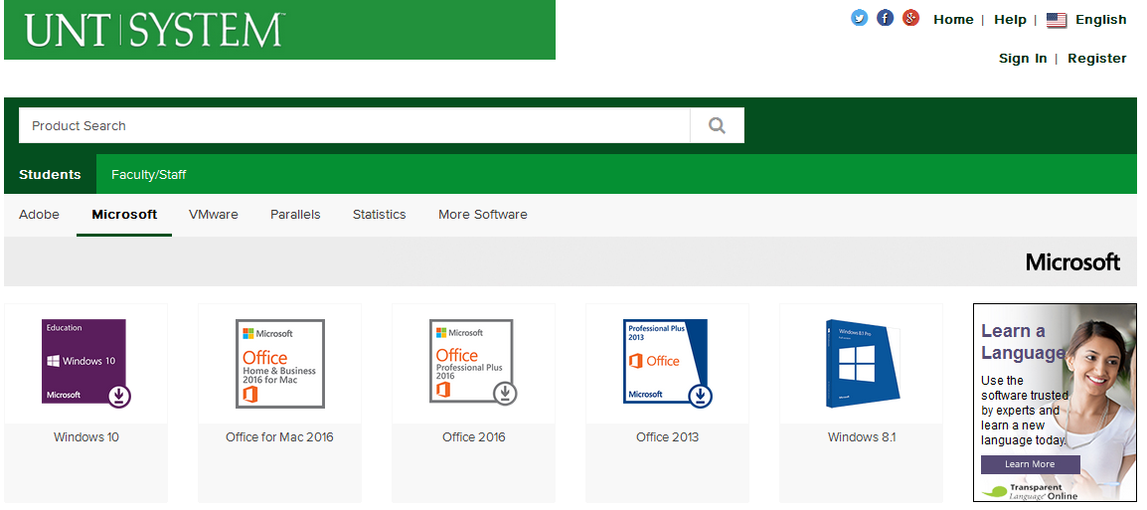

- 3610 Tutors work only in CoB 131. All BCIS tutors can help you with 3610 questions. CoB posts their office hours at the CoB labs, on hallway bulletin boards, and online at the CoB site (http://www.coba.unt.edu/lab). More information about the tutors is stated below.
- The UNT Computing Support Helpdesk for general computing problems or problems with your web site account is in Sage Hall, Room 119.
http://www.unt.edu/helpdesk  helpdesk@unt.edu  940-565-2324 | 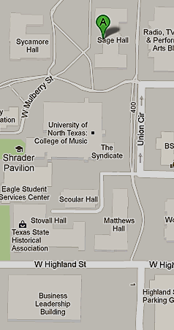

- If you do not have a DVD drive for your laptop or PC, take your disk to the CoB Labs, get a Lab PC, and copy the disc contents to your USB storage device. Install to your personal computer from the USB copy.

Statement on Responsibilities of BCIS Lab Tutors
The BCIS Department employs tutors, located on the ground floor of the BLB to assist students with their course material. As the above definition indicates, a tutor’s position does not entail performing tasks for students or giving them specific, step-by-step instructions. This department defines the tutor’s role as helping students solve their own problems, not doing the assignments for them. We believe the learning process is enhanced through the problem-solving process.
Accordingly, the responsibilities of the student and the tutor are as follows:
STUDENT: Prior to asking for assistance, the student must:
- Have read the material on which the assignment is based,
- Have made a valid attempt on the assignment,
- Be prepared to tell the tutor what steps he/she took to arrive at their current predicament,
- Have made an attempt to solve the problem on his/her own,
- Have all the documentation associated with his/her attempt to solve the problem, and
- Be prepared to use the advice given to find a solution.
TUTOR: To assist the students, the tutor will:
- Be familiar with the software and the project assignments,
- Be punctual and courteous in their dealings with students,
- Help the student identify the cause of their problems, and
- Make suggestions to guide the student to a solution to their problem.

The tutor does not touch or do anything to the hardware in the computer labs.

Tentative Class Schedule
BCIS 3610

 | Week | Topic | Note
1 | 6/4 | Chapter 1 – The Importance of MIS  Chapter 2 – Collaboration Information Systems  Chapter 3 – Strategy and Information Systems
Access Chapter 1 – Introduction to Microsoft Access
Access Chapter 2 – Tables and Queries in Relational Database
2 | 6/11 | Chapter 4 – Hardware, Software, and Mobile Systems  Chapter 5 – Databases Processing  Chapter 6 – The Cloud
 |  | Access Chapter 3 – Using Queries | Using MIS End of Chapter Quizzes for Chapters 1 – 6 due Midnight, Sunday, June 17
3 | 6/18 | Exam 1 Using MIS Chapters 1-6  Monday, June 18
 |  | Chapter 7 – Processes, Organizations, and Information Systems  Chapter 8 – Social Media Information Systems  Chapter 9 – Business Intelligence Systems | Access simulation and assignments for Chapter 1 -3 due Midnight, Tuesday, June 19
Access Chapter 4 – Forms and Reports
Access Chapter 5 – Data Validation and Analysis
4 | 6/25 | Chapter 10 – Information Systems Security  Chapter 11 – Information Systems Management  Chapter 12 – Information Systems Development
 |  | Access Chapter 6 – Action and Special Queries  Access Chapter 7 – Advanced Forms and Reports  Access Chapter 8 – Get Connected | Using MIS End of Chapter Quizzes for Chapters 7 – 12 due Midnight, Sunday, July 1
5 | 7/2 | Exam 2 Using MIS Chapters 7-12  Monday, July 2
 |  |  | Access simulation and assignments for Chapter 4 -8 due Midnight, Thursday, July 5

