  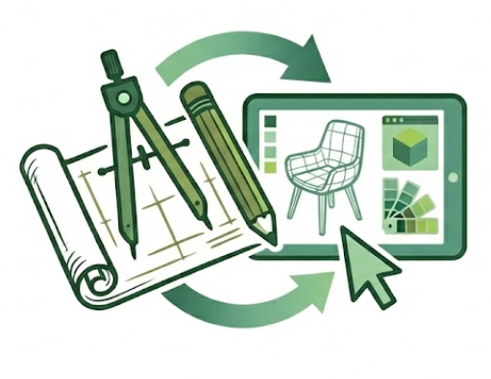 |  | FADM 3410: Technologies in Furnishings & Décor
Spring 2026 - Dr. Brandon

Tuesdays/Thursdays: 9am to 10.50am- Chilton 240 & 349
Changes made as needed.
Additional details will be in individual guidelines.
Course Syllabus, SLO’s, and Policies for FADM Furnishings & Décor Courses
See also the CMHT Polices posted in Canvas.
You are responsible for reading and understanding all documents related to courses, typically posted in Canvas

Syllabus - FADM 3405 Drawing and Planning for Furnishings & Décor
Time & Place: | Spring 2026: Tuesday/Thursday: 9.00am to 10.50am, Chilton 240 and occasionally 349
Course Description: | Students will apply both traditional and digital design tools, including CAD and AI applications, to optimize the planning, selection, arrangement, and placement of furnishings, cabinetry, and materials. Emphasis is on integrating functional, aesthetic, and economic factors to enhance efficiency and innovation. Through critical and creative thinking, students will address contemporary industry challenges, developing expertise for professional practice.
Required Texts: | 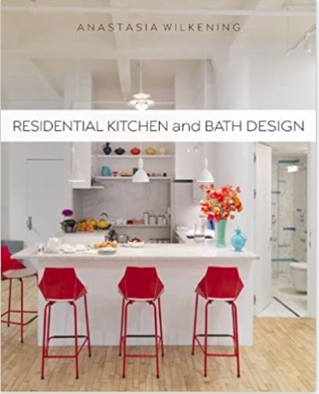 |  |  | Residential Kitchen and Bath Design by Anastasia Wilkening, 2013, Paperback |  | 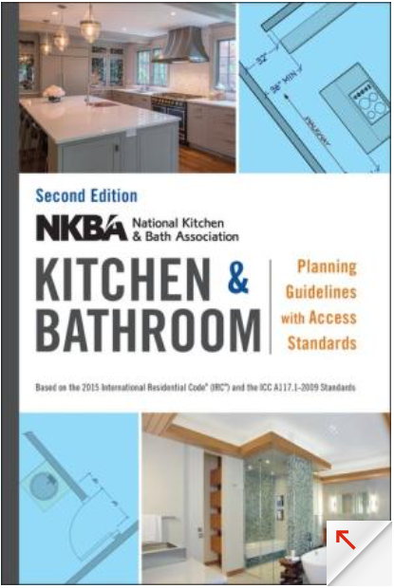 |  | NKBA Kitchen and Bathroom Planning Guidelines with Access Standards by NKBA (National Kitchen and Bath Association)
Required | - Use of CAD software, Chief Architect and other, provided via CMHT.  - Basic drafting equipment per list provided in class. Items can be used in other FADM courses.  - Online access to other industry publications.
Recommended  And Related  Books | 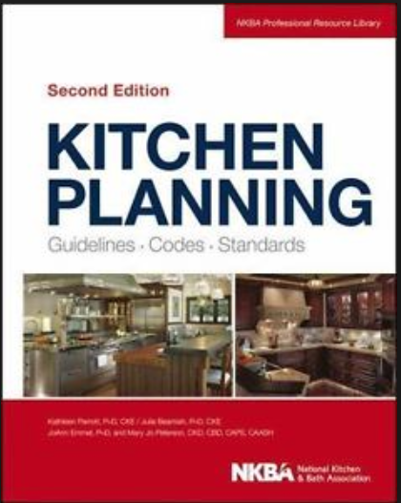 |  | Kitchen Planning: Guidelines, Codes, Standards, Beamish, Parrott, Emmel, & Peterson (2013, 2nd ed.). NKBA |  | 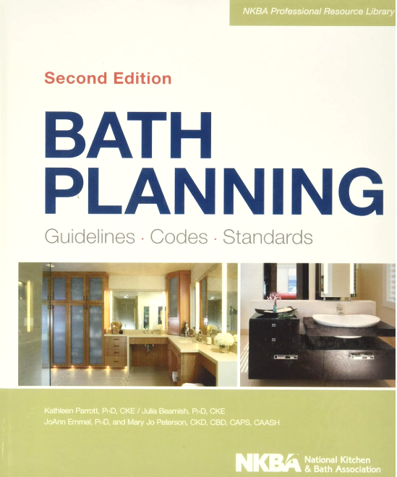 |  | Bath Planning: Guidelines, Codes, Standards (NKBA Professional Resource Library) 2nd Ed |  |  | Kitchen and Bath Design: A Guide to Planning Basics by Mary Fisher Knott, 2011
Instructor & Office | Dr. Lynn Brandon, Furnishings & Décor Merchandising Program Coordinator  342E Chilton Hall
Office Hours | - Monday thru Thursday: 11am to 12pm  - Via Canvas Inbox, please make an appointment during office hours to ensure availability.  - If time is unavailable during office hours, other by appointment only, in person or virtual.
E-Mail: |  | Use the Canvas Inbox as first contact option. For FADM degree or other topics, use the email -  Lynn.Brandon@unt.edu Provide your Name, Course Number, topic in Subject line.
E-Mail check schedule |  | - Canvas Inbox checked Monday thru Thursday: 11am to 12pm; UNT email checked frequently.  - May occasionally be checked at other times (Mon. – Fri.), but not before 8:00am nor after 5:00pm and not on weekends.  - If you have questions regarding an assignment, do so well in advance of the due date/time of an assignment. The day before or the day of the due date is not “well before”.
Office Hours & Teaching Schedule |  | Please make an appointment via Canvas Inbox (not my UNT email) for a time during office hours to ensure availability. Office hours can be in person in Chilton or via Zoom, but you must turn on camera during any Zoom meeting – I need to see you! If your desired meeting time is unavailable during office hours, other times may be possible and made by appointment only.
 |  | 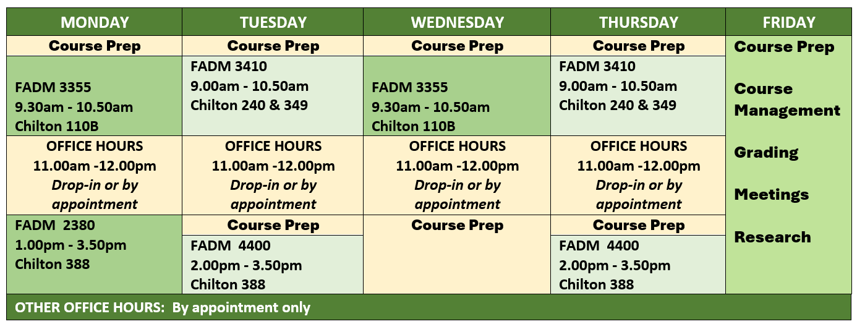
Use of CANVAS |  | - Canvas is supplement and not a substitution for attending our face-to-face class.  - I use Canvas to communicate many items to you through its Announcement feature.  - You should check Canvas Announcements daily, not just on class days.  - However, some items will be communicated only through face-to-face, so attend class regularly.  - Selected items may be posted for discussions/class topics.  - NOT all course materials will be posted in Canvas.  - Procedural and submission details provided per individual assignments/projects.  - Some assignments are ICA – in-class only and you must be present to participate and earn points. Other assignments will be submitted via Canvas.  - It is your responsibility to be in class to retrieve those items and to keep up with your grades whether they are posted in CANVAS or returned in class.
Canvas Grading |  | - Canvas is not the final grade book because this is not a 100% online course.  - Your final grade may not be completely known from just the items in the CANVAS gradebook. I keep an official grade book.  - So….keep up with your own grades as they are returned in class or posted in Canvas – create a spreadsheet (Excel, other) you know how or ask me!  - After individual grades are posted or returned, you have one week/7 days to make an appointment to ask about a grade, after that time the grade will stand.
Class Seating & Attendance and Late Arrival |  | - A seating chart may be used.  - Attendance will be recorded. Be early or on-time to class so ensure your attendance is recorded and stay for the entire class time to keep your full attendance status.  - Late arrivals are recorded and 3 lates = 1 absence. It is your responsibility to be in class on time and if late, inform me of this late arrival at the end of class that day – not after class is over and not by email/Canvas Inbox.

Your purpose in this course is to learn and apply planning standards and research, analyze products and trends, address consumer needs through critical analysis and problem-solving, communicate design concepts and solutions, and demonstrate professional readiness via portfolio projects.
Student Learning Outcomes  SLOs | 1. Design Communication and Digital Tools  Goal 1: Acquire proficiency in sketching, drafting, and documenting concepts using professional standards and effective visual communication practices, supported by digital and manual tools, CAD, and AI technologies.  Specific Learning Outcomes (SLOs):  - Apply Drafting Principles: Use architect’s scale, dimensioning, and architectural symbols to create technical drawings through manual and digital methods.  (Bloom’s: Understand, Apply)  - Produce Professional Drawing Sets: Develop plans, elevations, and related documents that communicate basic construction, electrical, and spatial details.  (Bloom’s: Apply, Analyze)  - Leverage Digital Design Technology: Utilize CAD and AI tools to generate, critique and edit layouts, documents, and material selections.  (Bloom’s: Apply, Create)  - Demonstrate Professional Communication Standards: Apply architectural lettering, annotation, and standardized symbols for clarity and precision.  (Bloom’s: Apply)  - Select Appropriate Tools: Evaluate and justify the use of traditional or digital tools for tasks from concept sketches to final documentation.  (Bloom’s: Apply, Evaluate)  2. Planning Criteria, Research, and Standards  Goal 2: Integrate industry standards, planning criteria, and research to develop functional, efficient, and aesthetically innovative design solutions.  Specific Learning Outcomes (SLOs):  - Summarize Planning Research: Identify research foundations for modern planning criteria.  (Bloom’s: Remember, Understand)  - Apply Industry Standards: Implement NKBA and related standards in kitchens, baths, and other spaces. (Bloom’s: Apply, Analyze)  - Evaluate Space Plans: Assess layouts for circulation, ergonomics, zoning, and more.  (Bloom’s: Evaluate)  - Analyze Lifecycle Needs: Adapt spaces to meet consumer lifecycle and lifestage requirements. (Bloom’s: Analyze, Apply)  - Develop Preliminary Solutions: Generate multiple solution concepts addressing functional and aesthetic challenges.  (Bloom’s: Apply, Create)  - Judge Proposals: Evaluate solutions based on functionality, aesthetics, and performance criteria. (Bloom’s: Evaluate)  3. Marketplace, Products, and Industry Trends  Goal 3: Analyze products, strategies, and industry trends to inform proposals, product planning, and professionalism.  Specific Learning Outcomes (SLOs):  - Select Product Categories: Research and analyze marketspace products including cabinetry, appliances, fixtures, and finishes.  (Bloom’s: Remember, Understand)  - Compile Product Standards: Interpret pricing, finishes, installation, durability, and performance requirements.  (Bloom’s: Understand, Apply)  - Interpret Market Trends: Analyze thematic and marketplace trends in furnishings and décor. (Bloom’s: Analyze)  - Utilize Trade Resources: Apply manufacturer catalogs, specifications, and trade publications to decisions.  (Bloom’s: Analyze, Evaluate)  - Research Sustainable Innovations: Investigate green practices, sustainable materials, and emerging technologies.  (Bloom’s: Analyze, Create)  - Explore Career Pathways: Examine roles in kitchen and bath retail firms, product development, and more in terms of career paths.  (Bloom’s: Understand, Evaluate)  4. Consumer Needs, Problem-Solving, and Communication  Goal 4: Integrate problem-solving and communication strategies to create solutions tailored to client needs and marketplace conditions.  Specific Learning Outcomes (SLOs):  - Research Consumer Needs: Analyze living spaces to address requirements.  (Bloom’s: Analyze)  - Translate Market Offerings: Select marketplace products to meet specific client needs.  (Bloom’s: Apply, Analyze)  - Assemble Material Resources: Compile materials, finishes, and products for professional proposals. (Bloom’s: Apply, Create)  - Recommendations: Justify solutions for spatial, functional, and aesthetic challenges.  (Bloom’s: Evaluate)  - Communicate Outcomes: Present solutions through verbal, written, and visual formats. (Bloom’s: Apply, Create, Evaluate)  5. Professional Practice, Creativity, and Portfolio Development  Goal 5: Employ creative, visual, and professional practices to prepare for career entry in the furnishings and décor industry.  Specific Learning Outcomes (SLOs):  - Apply Elements & Principles: Incorporate design elements, principles, and color theory into presentations.  (Bloom’s: Apply, Create)  - Develop Professional Presentations: Create compelling presentations integrating digital renderings, technical documentation, and materials.  (Bloom’s: Create, Evaluate)  - Interpret History: Analyze historical and contemporary styles relative to specific spaces and their influence on furnishings and décor.  (Bloom’s: Understand, Analyze)  - Engage with Industry Media: Evaluate emerging issues and industry publications (e.g., KBB, KBIS).  (Bloom’s: Understand, Evaluate)  - Prepare Portfolio Projects: Ready the completed project for portfolio inclusion.  (Bloom’s: Evaluate, Create)

COURSE SCHEDULE/CALENDAR
This document may be changed by the professor as needed and will be updated in Canvas.
ICA = InClass Only Assignment
Date | DAY | In Class TOPICS and Work | ASSIGNMENTS –  check DUE dates per each assignment | Points
Items not completed in class due to time constraints, will be completed as homework HW– as instructed – and due per Canvas.
Week 1
Jan 13 | Tues | LECTURE: Intro/F&D Model  LAB: Sketch NEST – I provide sketch paper | - Student Survey  - VARK | 0 to 5  0 to 5
Jan 15 | Thur | LECTURE: Drafting Conventions - Reading FLPL, Symbols, etc.  LAB: Reading FLPL, Symbols;  NEST – Sketch & Architectural Lettering | - The NEST: Part 1 – Sketching to Proportion  - Reading FLPL  - Symbols: The Visual Language  - Architectural Lettering 1 | 0 to 5  0 to 15  0 to 10  0 to 10
Quizzes are on “paper” only, beginning of class – for the first 10 minutes, no makeups. One quiz will be dropped at the end of the semester. Can start quiz 5 minutes before class if you come early.
Week 2
Jan 20 | Tues | LECTURE: Measuring & More  LAB: NEST – measuring; NEST – start Grid/Graph | - The NEST: Part 2 – MEASURE & Dims | 0 to 10
Jan 22 | Thur | QUIZ 1 - Reading FLPL, Symbols, Lines, Dims, Lettering, Measuring, and More  LECTURE: Kitchen & Bath (K&B) History & Research, E&P, Docs & Project Planning Mgt.  LAB: NEST–finish grid/graph; Using the SCALE intro | - The NEST: Part 3 – GRID PAPER- | 0 to 15  Q 0 to 20
Week 3 | Starting Now: Bring both textbooks to class daily or not earn full attendance/participation points.
 | Rest of schedule posted next week after confirmation on future items.
Jan 27 | Tues | 
Jan 29 | Thur
Week 4
Feb 03 | Tues | LECTURE: as needed  LAB: Using the SCALE  NEST – Hardline Pencil/Scale
Feb 05 | Thur | QUIZ 2 – RKBD -Ch. 1, 2, 3, 8 & 10  LAB: NEST – Hardline Pencil/Scale | - NEST – Hardline Pencil/Scale | 0 to 20  Q 0 to 20
Week 5 |  | BRING daily from now to semester end these items for watching videos in class –  your laptop or tablet (or check one out from CMHT IT), and 2) earbuds/phones
Feb 10 | Tues | LECTURE: As needed.  LAB: NEST – Hardline – by PEN  (start in class, complete for homework – Due beginning of class next Tuesday) | - F!ND: Kitchen Design Research  - Model Homes | 0 to 30  0 to 50
Feb 12 | Thur | QUIZ 3 – RKBD - Ch 4 Materials/ Counters &  Ch. 5 Cabinetry  LAB: Client Survey Form | - NEST: Hardline - Scaled PEN  - The Client: & Survey Creation  - The Client: Interview Meeting  - The Client: Interview Summary | 0 to 20  0 to 15  0 to 15  0 to 30  Q 0 to 20

Date | DAY | In Class TOPICS and Work | ASSIGNMENTS –  check DUE dates per each assignment | Points
Thurs Feb. 12 | BONUS 1: Leadership Symposium – (Professional Development Opportunity – PDO). Thurs, Feb. 12.  - Union 333, 11am- 12.20pm, bring ID to check in/out; Attend full presentation. I will be there.  - Take notes for Summary submission - 0 to 10 points based on completion of the requirements.  - Compose 1 full page, double spaced in paragraphs (not just bullets) summary of your top 5 take-a-ways, professionally written and formatted for submission (title page, paragraph/section headings, margins, etc.).  - Include a selfie of you before the event with the stage in the background.  - Due in Canvas 1 week after the event – Canvas will open a few days after the event.  If you are in more than one of my classes, submit the same requirements, but must upload separately in each class.
Week 6 |  | Bring NKBA Manual and RKBD Textbook daily
Feb 17 | Tues | LECTURE: K&B planning, Chief Architect  LAB: CA Assignments | - CA: Intro Videos & Assignment 1 | 0 to 20
Wed.  Feb 18 | BONUS 2: CMHT Career Expo - Wed 2/18 - 10:00 AM -1:00 PM (come and go, stay at least 1 hour) (another PDO)  - Union 314, bring ID to check in/out. I will be there.  - Visit with at least 4 different companies (apparel, F&D, hotel/restaurant) and meet their reps. Takes notes and selfies.  - Compose a 1 to 2 full pages, double spaced in paragraphs (not just bullets) summary listing the companies you visited and what you learned about entering the work force – their tips for success. Include 2 or more selfies.  - Professionally written and formatted for submission (title page, paragraph/section headings, margins, etc.).  - 0 to 10 points based on completion of the requirements.  - Due in Canvas 1 week after the event – Canvas will open a few days after the event.  - If you are in more than one of my classes, submit the same requirements, but must upload separately in each class.
Feb 19 | Thur | QUIZ 4 - Kitchen Plan/NKBA Guidelines Set 1  LECTURE: K&B as needed, Chief Architect  LAB: Chief Architect (CA) – |  | Q 0 to 20
Week 7
Feb 24 | Tues | LECTURE: K&B planning, NKBA Guidelines & Chief Architect  LAB: Chief Architect (CA) | - CA: Assignment 2 -Kitchen & Bath Bootcamp | 0 to 20
Feb 26 | Thur | Field Trip – CONFIRMED  The Kitchen Source - 1544 Slocum St. Dallas, TX  214.741.1912. Tour begins at 9am, arrive by 8.45am to peruse before tour begins, take notes, take pictures, create Summary, due 1 week after. | - Field Trip (Attendance & Summary) | 0 to 25
Week 8
Mar 3 | Tues | QUIZ 5- RKBD – NKBA Guidelines, Kitchen Source, Chief Architect (CA)  LECTURE: as needed  LAB: Chief Architect – Floor Plan KC SHELL (walls, windows, doors, roof, room labels, existing fixtures, dimensioned, etc – completed and checked in class).
Mar 5 | Thur | QUIZ 6 - Ch. 6 Appliances, 7 Plumb, & 9 Elec  LECTURE: as needed  LAB: Use KC SHELL for Preliminaries 2 & 3 completed and graded in class only | Complete Preliminary 1 for the KC Shell Plan
 | Week 9 - Mar 8 – Mar 15 SPRING BREAK

Date | DAY | In Class TOPICS and Work | ASSIGNMENTS –  check DUE dates per each assignment | Points
Week 10
Mar 17 | Tues | LECTURE: as needed  LAB: Prelim 1 and WMBH catalog pricing  Start Prelim 2 as time allows, finish for HW | KC Challenge Major Project –  Complete Client Survey as early as possible to provide you with data to use in Preliminaries.  - CA: Kitchen Prelim + NKBA CKList – ICA  - Prelim 1 – WMBH cabinetry pricing  - CA: Kitchen Prelim 2 + NKBA CKList – HW – Due by 8am Thurs, Mar. 19  Additional Prelim Solutions in class & HW  Start KC Job Time LOG -daily | 0 to 15  0 to 10  0 to 15
Mar 19 | Thur | LECTURE: as needed  LAB: Prelim 1 and WMBH catalog pricing  - Start Prelim 2 as time allows, finish for HW | Continue items for the proposal as assigned.
Week 11
Mar. 24 | Tues | LECTURE: as needed  LAB: Prelim 1 and WMBH catalog pricing  Start Prelim 2 as time allows, finish for HW | Continue items for the proposal as assigned.
Mar 26 | Thur | LECTURE: as needed  LAB: Prelim 3 + NKBA Checklist in class only – Due by end of class.  Begin Decision Day individual meetings for FSP  Prelims must have the following prior to meeting:  - FLPL with all cabinetry, appliances, etc. in place and all meets NKBA Checklist, which is completed per each different Prelim.  - Know your details of Client Survey & Summary  - You have one opportunity fof FSP approved and will be randomly visited to determine work completed and final decision on best solution plan to carry forward for pricing and more.  - 4 mins per person is all the time we have  That means that everyone should have all required work completed. Have your questions ready. | - CA: Kitchen Prelim 3 + NKBA CKList ICA  - Additional Preliminaries assigned individually for HW – based on success of Prelim 1, 2, & 3  - The better and more NKBA compliant all of your Prelims are, the faster we can make a decision about your final solution plan FSP.  Kitchen FSP Final Solution Plan Decision Made by EOC today, NKBA Checklist for FSP | 0 to 15  0 to 10 FSP
Week 12
Mar 31 | Tues | QUIZ as needed  LECTURE: as needed  LAB: KC – FSP –  Final Solution Plan FINALIZATION - ALL ITEMS | - Lighting/Electrical MEP  - Cabinetry – Elevation Labels (all or “0”)  Checked/graded EOC – end of class today | 0 to 15  0 to 5  Q 0 to 20
Apr 2 | Thur | LECTURE: as needed  LAB: KC FSP – Final Solution Plan FINALIZATION –  MEP & CABINETRY, and more | - All Selections – Cabinets, Appliances Specs, Finishes, Furn | 0 to 10
Week 13
Apr 7 | Tues | QUIZ as needed  LAB: KC FSP – FINALIZATION - ALL ITEMS, FSP to Layout | - BCS – Budget Control Sheet – All items in Excel, priced, etc. correlated to each MFG.  - MFG Spec Sheets - correlated to Excel entry.  Checked/graded | 0 to 10  0 to 10
Apr 9 | Thur | QUIZ as needed  LECTURE: as needed and LAB: KC FSP – FINALIZATION - ALL ITEMS, FSP to Layout | Continue items for the proposal as assigned.

Week 14
Apr 14 | Tues | Kitchen Challenge –  All last work completed and assembled in KC Digital Proposal  Last time for questions – in class only - do not email with questions. | - Aesthetic Drawings – Check off (all or “0”)  - Floor plan, Elevations, & 3Ds  - Sample Boards – Check off (all or “0”)  Checked/graded EOC – end of class today | 0 to 5  0 to 5
April 15 | Wed | Full KC Proposal DUE in Canvas before deadline of 11.59pm Wednesday, April 15
Apr 16 | Thur | Kitchen Challenge Presentations  In class only – no makeups  Peer Evaluations | Presentations – details will be announced prior. | 0 to 50  0 to 15  0 to 10
Week 15
Apr 21 | Tues | LECTURE:  LAB: Rhino | - Rhino Assignment 1 | 0 to 20
Apr 23 | Thur | LECTURE:  LAB: RHINO |  | 0 to 20
Week 16
Apr 28 | Tues | LECTURE:  LAB: Rhino | Rhino Assignment 2 | 0 to 10
Apr 30 | Thur | LECTURE:  LAB: Rhino
Week 17
 |  | Attendance | Late 5 mins or more to class, 3 lates = 1 absence | 0 to 100
 |  | Bonus Opportunities
 |  | Other
May 7  May 9 | Tues  Thur | Finals | Total points

- This schedule is a guide and may be subject to modifications; if changed, you will be notified in class and it will be updated online in Canvas.
- ICA = In-Class only Assignments - only be available in class. You must be present to complete and earn points even if the items are available via Canvas.
- Late work will not be accepted for grading. If a Canvas submission is marked as late, it is, regardless of “technical difficulties”.
- Bonuses are offered to all as per course information. No bonuses offered on an individual basis.
- See exam/test make-up policy per course.
- Other documents detail policies and procedures related to the course and the college. Typically posted in Canvas.
- Point values will be verified per assignment and edits made as needed.
- Due dates are per assignment – add to the calendar as we progress.

COURSE GRADE SCALE: these numbers may change based on the total point value, this scale is used:
A = 90% -100%
B = 80% - 89.9%
C = 70% - 79.9%
D = 60% - 69.9%
F = 59.9% and below

