  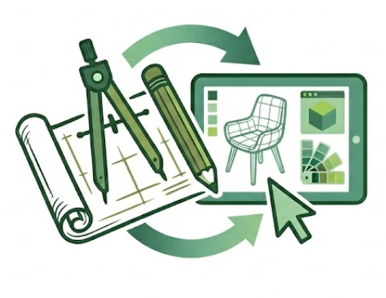 |  | FADM 3410: Technologies in Furnishings & Décor
Spring 2026 - Dr. Brandon

Tuesdays/Thursdays: 9am to 10.50am- Chilton 240 & 349
Changes made as needed.
Additional details will be in individual guidelines.
Course Syllabus, SLO’s, and Policies for FADM Furnishings & Décor Courses
See also the CMHT Polices posted in Canvas.
You are responsible for reading and understanding all documents related to courses, typically posted in Canvas

Syllabus - FADM 3405 Drawing and Planning for Furnishings & Décor
Time & Place: | Spring 2026: Tuesday/Thursday: 9.00am to 10.50am, Chilton 240 and occasionally 349
Course Description: | Students will apply both traditional and digital design tools, including CAD and AI applications, to optimize the planning, selection, arrangement, and placement of furnishings, cabinetry, and materials. Emphasis is on integrating functional, aesthetic, and economic factors to enhance efficiency and innovation. Through critical and creative thinking, students will address contemporary industry challenges, developing expertise for professional practice.
Required Texts: | 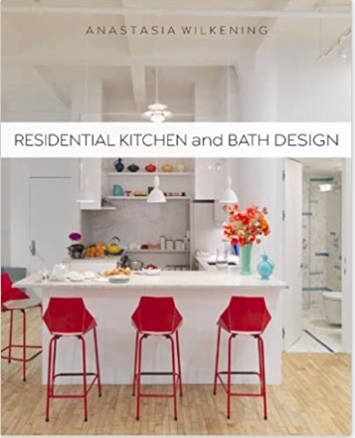 |  |  | Residential Kitchen and Bath Design by Anastasia Wilkening, 2013, Paperback |  | 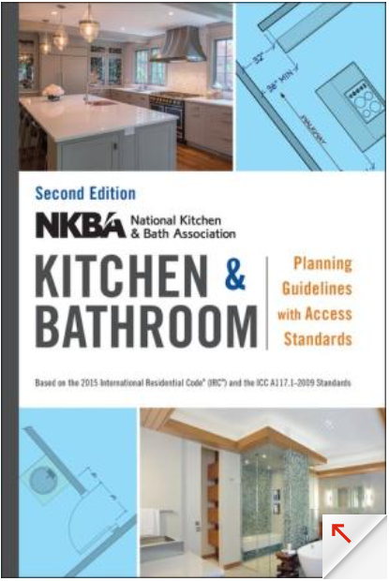 |  | NKBA Kitchen and Bathroom Planning Guidelines with Access Standards by NKBA (National Kitchen and Bath Association)
Required | - Use of CAD software, Chief Architect and other, provided via CMHT.  - Basic drafting equipment per list provided in class. Items can be used in other FADM courses.  - Online access to other industry publications.
Recommended  And Related  Books | 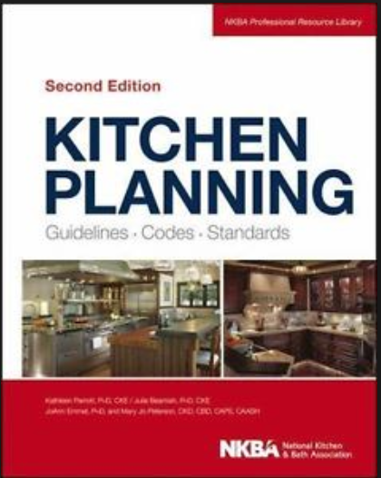 |  | Kitchen Planning: Guidelines, Codes, Standards, Beamish, Parrott, Emmel, & Peterson (2013, 2nd ed.). NKBA |  | 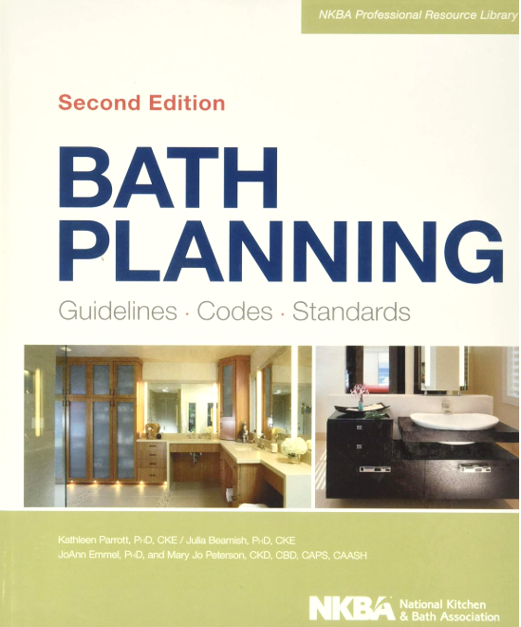 |  | Bath Planning: Guidelines, Codes, Standards (NKBA Professional Resource Library) 2nd Ed |  |  | Kitchen and Bath Design: A Guide to Planning Basics by Mary Fisher Knott, 2011
Instructor & Office | Dr. Lynn Brandon, Furnishings & Décor Merchandising Program Coordinator  342E Chilton Hall
Office Hours | - Monday thru Thursday: 11am to 12pm  - Via Canvas Inbox, please make an appointment during office hours to ensure availability.  - If time is unavailable during office hours, other by appointment only, in person or virtual.
E-Mail: |  | Use the Canvas Inbox as first contact option. For FADM degree or other topics, use the email -  Lynn.Brandon@unt.edu Provide your Name, Course Number, topic in Subject line.
E-Mail check schedule |  | - Canvas Inbox checked Monday thru Thursday: 11am to 12pm; UNT email checked frequently.  - May occasionally be checked at other times (Mon. – Fri.), but not before 8:00am nor after 5:00pm and not on weekends.  - If you have questions regarding an assignment, do so well in advance of the due date/time of an assignment. The day before or the day of the due date is not “well before”.
Office Hours & Teaching Schedule |  | Please make an appointment via Canvas Inbox (not my UNT email) for a time during office hours to ensure availability. Office hours can be in person in Chilton or via Zoom, but you must turn on camera during any Zoom meeting – I need to see you! If your desired meeting time is unavailable during office hours, other times may be possible and made by appointment only.
 |  | 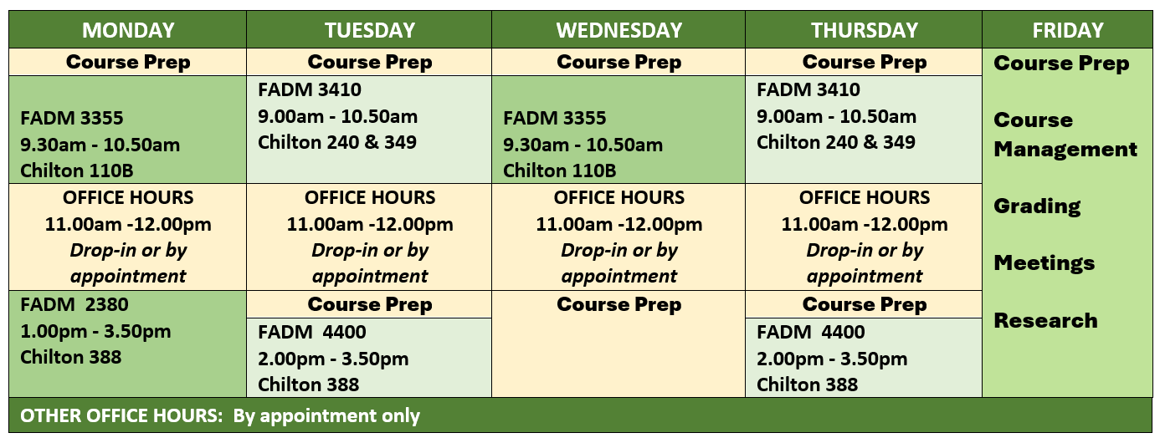
Use of CANVAS |  | - Canvas is supplement and not a substitution for attending our face-to-face class.  - I use Canvas to communicate many items to you through its Announcement feature.  - You should check Canvas Announcements daily, not just on class days.  - However, some items will be communicated only through face-to-face, so attend class regularly.  - Selected items may be posted for discussions/class topics.  - NOT all course materials will be posted in Canvas.  - Procedural and submission details provided per individual assignments/projects.  - Some assignments are ICA – in-class only and you must be present to participate and earn points. Other assignments will be submitted via Canvas.  - It is your responsibility to be in class to retrieve those items and to keep up with your grades whether they are posted in CANVAS or returned in class.
Canvas Grading |  | - Canvas is not the final grade book because this is not a 100% online course.  - Your final grade may not be completely known from just the items in the CANVAS gradebook. I keep an official grade book.  - So….keep up with your own grades as they are returned in class or posted in Canvas – create a spreadsheet (Excel, other) you know how or ask me!  - After individual grades are posted or returned, you have one week/7 days to make an appointment to ask about a grade, after that time the grade will stand.
Class Seating & Attendance and Late Arrival |  | - A seating chart may be used.  - Attendance will be recorded. Be early or on-time to class so ensure your attendance is recorded and stay for the entire class time to keep your full attendance status.  - Late arrivals are recorded and 3 lates = 1 absence. It is your responsibility to be in class on time and if late, inform me of this late arrival at the end of class that day – not after class is over and not by email/Canvas Inbox.

Your purpose in this course is to learn and apply planning standards and research, analyze products and trends, address consumer needs through critical analysis and problem-solving, communicate design concepts and solutions, and demonstrate professional readiness via portfolio projects.
Student Learning Outcomes  SLOs | 1. Design Communication and Digital Tools  Goal 1: Acquire proficiency in sketching, drafting, and documenting concepts using professional standards and effective visual communication practices, supported by digital and manual tools, CAD, and AI technologies.  Specific Learning Outcomes (SLOs):  - Apply Drafting Principles: Use architect’s scale, dimensioning, and architectural symbols to create technical drawings through manual and digital methods.  (Bloom’s: Understand, Apply)  - Produce Professional Drawing Sets: Develop plans, elevations, and related documents that communicate basic construction, electrical, and spatial details.  (Bloom’s: Apply, Analyze)  - Leverage Digital Design Technology: Utilize CAD and AI tools to generate, critique and edit layouts, documents, and material selections.  (Bloom’s: Apply, Create)  - Demonstrate Professional Communication Standards: Apply architectural lettering, annotation, and standardized symbols for clarity and precision.  (Bloom’s: Apply)  - Select Appropriate Tools: Evaluate and justify the use of traditional or digital tools for tasks from concept sketches to final documentation.  (Bloom’s: Apply, Evaluate)  2. Planning Criteria, Research, and Standards  Goal 2: Integrate industry standards, planning criteria, and research to develop functional, efficient, and aesthetically innovative design solutions.  Specific Learning Outcomes (SLOs):  - Summarize Planning Research: Identify research foundations for modern planning criteria.  (Bloom’s: Remember, Understand)  - Apply Industry Standards: Implement NKBA and related standards in kitchens, baths, and other spaces. (Bloom’s: Apply, Analyze)  - Evaluate Space Plans: Assess layouts for circulation, ergonomics, zoning, and more.  (Bloom’s: Evaluate)  - Analyze Lifecycle Needs: Adapt spaces to meet consumer lifecycle and lifestage requirements. (Bloom’s: Analyze, Apply)  - Develop Preliminary Solutions: Generate multiple solution concepts addressing functional and aesthetic challenges.  (Bloom’s: Apply, Create)  - Judge Proposals: Evaluate solutions based on functionality, aesthetics, and performance criteria. (Bloom’s: Evaluate)  3. Marketplace, Products, and Industry Trends  Goal 3: Analyze products, strategies, and industry trends to inform proposals, product planning, and professionalism.  Specific Learning Outcomes (SLOs):  - Select Product Categories: Research and analyze marketspace products including cabinetry, appliances, fixtures, and finishes.  (Bloom’s: Remember, Understand)  - Compile Product Standards: Interpret pricing, finishes, installation, durability, and performance requirements.  (Bloom’s: Understand, Apply)  - Interpret Market Trends: Analyze thematic and marketplace trends in furnishings and décor. (Bloom’s: Analyze)  - Utilize Trade Resources: Apply manufacturer catalogs, specifications, and trade publications to decisions.  (Bloom’s: Analyze, Evaluate)  - Research Sustainable Innovations: Investigate green practices, sustainable materials, and emerging technologies.  (Bloom’s: Analyze, Create)  - Explore Career Pathways: Examine roles in kitchen and bath retail firms, product development, and more in terms of career paths.  (Bloom’s: Understand, Evaluate)  4. Consumer Needs, Problem-Solving, and Communication  Goal 4: Integrate problem-solving and communication strategies to create solutions tailored to client needs and marketplace conditions.  Specific Learning Outcomes (SLOs):  - Research Consumer Needs: Analyze living spaces to address requirements.  (Bloom’s: Analyze)  - Translate Market Offerings: Select marketplace products to meet specific client needs.  (Bloom’s: Apply, Analyze)  - Assemble Material Resources: Compile materials, finishes, and products for professional proposals. (Bloom’s: Apply, Create)  - Recommendations: Justify solutions for spatial, functional, and aesthetic challenges.  (Bloom’s: Evaluate)  - Communicate Outcomes: Present solutions through verbal, written, and visual formats. (Bloom’s: Apply, Create, Evaluate)  5. Professional Practice, Creativity, and Portfolio Development  Goal 5: Employ creative, visual, and professional practices to prepare for career entry in the furnishings and décor industry.  Specific Learning Outcomes (SLOs):  - Apply Elements & Principles: Incorporate design elements, principles, and color theory into presentations.  (Bloom’s: Apply, Create)  - Develop Professional Presentations: Create compelling presentations integrating digital renderings, technical documentation, and materials.  (Bloom’s: Create, Evaluate)  - Interpret History: Analyze historical and contemporary styles relative to specific spaces and their influence on furnishings and décor.  (Bloom’s: Understand, Analyze)  - Engage with Industry Media: Evaluate emerging issues and industry publications (e.g., KBB, KBIS).  (Bloom’s: Understand, Evaluate)  - Prepare Portfolio Projects: Ready the completed project for portfolio inclusion.  (Bloom’s: Evaluate, Create)

COURSE SCHEDULE/CALENDAR
This document may be changed by the professor as needed and will be updated in Canvas.
ICA = InClass Only Assignment
Date | DAY | In Class TOPICS and Work | ASSIGNMENTS –  check DUE dates per each assignment | Points
Items not completed in class due to time constraints, will be completed as homework – as instructed – and due per Canvas.
Week 1
Jan 13 | Tues | LECTURE: Intro/F&D Model  LAB: Sketch NEST – I provide sketch paper | - Student Survey  - VARK | 0 to 5  0 to 5
Jan 15 | Thur | LECTURE: Drafting Conventions - Reading FLPL, Symbols, etc.  LAB: Reading FLPL, Symbols;  NEST – Sketch & Architectural Lettering | - The NEST: Part 1 – Sketching to Proportion  - Reading FLPL  - Symbols: The Visual Language  - Architectural Lettering 1 | 0 to 5  0 to 15  0 to 10  0 to 10
Quizzes are on “paper” only, beginning of class – for the first 10 minutes, no makeups. One quiz will be dropped at the end of the semester. Can start quiz 5 minutes before class if you come early.
Week 2
Jan 20 | Tues | LECTURE: Measuring & More  LAB: NEST – measuring; NEST – start Grid/Graph | - The NEST: Part 2 – MEASURE & Dims  - Architect Lettering 2 – ICA | 0 to 10  0 to 10
Jan 22 | Thur | QUIZ 1 - Reading FLPL, Symbols, Lines, Dims, Lettering, Measuring, and More  LECTURE: Kitchen & Bath (K&B) History & Research, E&P, Docs & Project Planning Mgt.  LAB: NEST–finish grid/graph; Using the SCALE intro | - The NEST: Part 3 – GRID PAPER- | 0 to 15  Q 0 to 20
Week 3 | Starting Now: Bring both textbooks to class daily or not earn full attendance/participation points.
 | Rest of schedule posted next week after confirmation on future items.
Jan 27 | Tues | QUIZ 2 – RKBD -Ch. 1, 2 (E&P) & 3  LECTURE: as needed  LAB: NEST – Hardline Pencil/Scale | - F!ND: Kitchen Design Research (~1 week)  - Model Homes (~ 3 weeks)  - Using the SCALE  - Design Meets Code: NKBA Guidelines and Kitchen & Bath Trends | 0 to 30  0 to 50  0 to 10  0 to 20  Q 0 to 20
Jan 29 | Thur | QUIZ 3 – RKBD - Ch. 8 Docs & 10 Prj Planning  LECTURE: Kitchen & Bath (K&B) Research Design Reports, E&P, Docs & Project Planning Mgt.  LAB: NEST – Hardline Pencil/Scale  LECTURE: Materials & Countertops  LAB: NEST – Hardline – by Pencil/Scale & by PEN | - NEST: Hardline - Scaled Pencil FLPL and Elevations 11x17  - NEST: Hardline - Scaled PEN  - The Client: Survey Creation  - The Client: Interview Meeting (~2 weeks) | 0 to 20  0 to 15  0 to 10  0 to 30  Q 0 to 20
Week 4
Feb 03 | Tues | QUIZ 4 – RKBD - Ch 4 Materials/ Counters  LECTURE: K&B - Cabinetry & Appliances  LAB: Kitchen Challenge (KC): Porches Plan – SCALE/Pencil | - Kitchen Challenge (KC): Porches Plan –  SHELL - SCALED w/Dims in PENCIL  - The Client: Summary & AI Kitchen Collage – Feedback – based on client summary – do not upload names or addresses | 0 to 20  0 to 20  Q 0 to 20
Feb 05 | Thur | QUIZ 5 – RKBD - Ch. 5 Cabinetry  LECTURE: K&B – Appliance, Electrical & Plumbing  LAB: KC Porches Plan – SCALE/Pencil;  Kitchen Prelim 1 overlay | - KC: Pencil Prelim 1 + NKBA Checklist – Kitchen layout option and primary bath/closet layout per NKBA guidelines | 0 to 15  Q 0 to 20

Date | DAY | In Class TOPICS and Work | ASSIGNMENTS –  check DUE dates per each assignment | Points
Week 5 |  | BRING daily from now to semester end these items for watching videos in class –  - your laptop or tablet (or check one out from CMHT IT), and 2) earbuds/phones
Feb 10 | Tues | QUIZ 6 - RKBD - Ch. 6 Appliances  LECTURE: K&B NKBA Guidelines Review, &  Chief Architect – Intro  LAB: CA Look Around & Assignments | - CA: Intro Videos & Assignment 1 | 0 to 20  Q 0 to 20
Feb 12 | Thur | QUIZ 7- RKBD - Ch. 9 Elec & 7 Plumb  Catch-Up/Get Ahead Day  Attendance recorded, this is not a day off. | Catch-UP: You may complete and submit one missed or redo one to-this-point assignment (not quizzes) completed today in class; must be submitted EOC to be (re)graded.  Get Ahead: Complete Residential Bootcamp | Q 0 to 20
BONUS 1: Leadership Symposium – attend after class today (Professional Development Opportunity - PDO)
- Union 333, 11am- 12.20pm, bring ID to check in/out; Attend full presentation. I will be there.
- Take notes for Summary submission - 0 to 10 points
- Compose 1 full page, double spaced in paragraphs (not just bullets) summary of your top 5 take-a-ways, professionally written and formatted for submission (title page, headings, margins, etc.) Due in Canvas 1 week after the event.
Week 6
Feb 17 | Tues | QUIZ 8 - Kitchen Plan/NKBA Guidelines Set 1  LECTURE: K&B as needed, More Chief Architect  LAB: CA Assignments - Porches Plan SHELL - in class how to upload, import, scale. | - CA: KC SHELL PLAN 1 (Porches Plan – walls, windows, doors, roof, room labels, existing fixtures, dimensioned, etc). | 0 to 20  Q 0 to 20
Wed.  Feb 18 | BONUS 2: CMHT Career Expo - Wed 2/18 - 10:00 AM -1:00 PM (come and go, stay at least 1 hour) (another PDO)  - Union 314, bring ID to check in/out. I will be there.  - Visit with at least 4 different companies (apparel, F&D, hotel/restaurant) and meet their reps. Takes notes and selfies.  - Compose a 1 to 2 full pages, double spaced in paragraphs (not just bullets) summary listing the companies you visited and what you learned about entering the work force – their tips for success. Include 2 or more selfies.  - Professionally written and formatted for submission (title page, headings, margins, etc.).  - 0 to 10 points based on completeness of assignment. Due in Canvas 1 week after the event.
Feb 19 | Thur | QUIZ 9 - Chief Architect (CA) Set 1  LECTURE: K&B as needed, More Chief Architect  LAB: Chief Architect (CA) – Kitchen Bootcamp1 | - CA: Assignment 2 -Kitchen & Bath Bootcamp | 0 to 20  Q 0 to 20
Week 7
Feb 24 | Tues | QUIZ 10 - Kitchen Planning & NKBA Guidelines Set2  LECTURE: As needed  LAB: Prelim 2 & 3  Chief Architect (CA) –  Start KC Job Time LOG -daily | - CA: Kitchen Prelim 2 + NKBA CKL - ICA  - CA: Kitchen Prelim 3 + NKBA CKL - ICA  - Appliances & MFGs Research | 0 to 15  0 to 15  0 to 10  Q 0 to 20
Feb 26 | Thur | Field Trip??? Not confirmed yet, may be on another day or not at all. Will let you know.  If Field Trip is on another day, schedule will be updated – quizzes, etc. | - Field Trip (Attendance & Summary) | 0 to 25
Week 8
Mar 3 | Tues | QUIZ 11- Chief Architect (CA) Set 2  LECTURE: as needed  LAB: Chief Architect – Kitchen Prelim 4 ICA | - CA: Kitchen Prelim 4 – complete in class  Brandon Bucks Budget set | 0 to 15
Mar 5 | Thur | QUIZ 12 -General NKBA, CA, etc.  LECTURE: as needed  LAB: Kitchen FSP – Decision Day and Cabinetry Selections | - Kitchen FSP Final Solution Plan Decision Day  NKBA Checklist for FSP  - All Selections – Cabinets, Appliances Specs, Finishes, Furn (graded all or “0”)  - KC Job Time LOG – check off | 0 to 10  0 to 10  0 to 5
 | Week 9 - Mar 8 – Mar 15 SPRING BREAK
Date | DAY | In Class TOPICS and Work | ASSIGNMENTS –  check DUE dates per each assignment | Points
Week 10
Mar 17 | Tues | QUIZ as needed  LECTURE: as needed  LAB: KC FSP – Final Solution Plan FINALIZATION – MEP & CABINETRY | - Lighting/Electrical MEP  - Cabinetry – Elevation Labels (all or “0”)  Checked/graded EOC – end of class today | 0 to 15  0 to 5
Mar 19 | Thur | QUIZ as needed  LECTURE:  LAB: KC – FSP –  Final Solution Plan FINALIZATION - ALL ITEMS | - BCS – Budget Control Sheet – All items in Excel, priced, etc. correlated to each MFG.  - MFG Spec Sheets - correlated to Excel entry.  Checked/graded EOC – end of class today | 0 to 10  0 to 10
Week 11
Mar. 24 | Tues | QUIZ as needed  LECTURE:  LAB: KC FSP – FINALIZATION - ALL ITEMS, FSP to Layout | - Aesthetic Drawings – Check off (all or “0”)  - Floor plan  - Elevations  - 3Ds  - Sample Boards – Check off (all or “0”)  Checked/graded EOC – end of class today | 0 to 5  0 to 5
Mar 26 | Thur | Catch-Up/Get Ahead Day  Attendance recorded, this is not a day off. | Catch-UP: You may complete and submit one missed or redo one to-this-point assignment (not quizzes) completed today in class; must be submitted EOC to be (re)graded.  Get Ahead:  - Assemble Proposal/ get feedback,  - Learn more of CA – NKBA CEU. Ask for link.
Week 12
Mar 31 | Tues | Kitchen Challenge –  All last work completed and assembled in KC Digital Proposal | Last time for questions – in class only - do not email with questions.
April 1 | Wed | Full KC Proposal DUE in Canvas before deadline of 11.59pm Wednesday, April 1 (no joke!)
Apr 2 | Thur | Kitchen Challenge Presentations  In class only – no makeups  Peer Evaluations | Presentations – details will be announced prior. | 0 to 15  0 to 10
Week 13
Apr 7 | Tues | LECTURE:  LAB: Rhino 1 | - Rhino Assignment 1 | 0 to 20
Apr 9 | Thur | QUIZ 13 - Rhino 1  LECTURE:  LAB: RHINO – Setting the Scene 1 | - Rhino Assignment 2 | 0 to 20  Q 0 to 20
Week 14
Apr 14 | Tues | LECTURE:  LAB: RHINO - Setting the Scene 2 | - Rhino Assignment 3 | 0 to 20
Apr 16 | Thur | QUIZ 14 – Rhino 2  LECTURE:  LAB: RHINO - Setting the Scene 3 | - Rhino Assignment 4 | 0 to 20  Q 0 to 20
Week 15
Apr 21 | Tues | LECTURE:  LAB: RHINO – Learn It to Teach It  Openwork F&D Product 1 | - Rhino Assignment 5 | 0 to 20
Apr 23 | Thur | LECTURE:  LAB: RHINO – Learn It to Teach It  Openwork F&D Product 2 | - Rhino Assignment 5 | 0 to 20

Date | DAY | In Class TOPICS and Work | ASSIGNMENTS –  check DUE dates per each assignment | Points
Week 16
Apr 28 | Tues | RHINO –Openwork F&D Product Presentation and Peer Critiques | - Peer Evaluations  - Portfolio items – Edited and Portfolio ready | 0 to 10  0 to 15
Apr 30 | Thur | Portfolio ready items | Submit:  - Architectural Digital Field Guide  - Pen/Inked Porches Plan  - Kitchen Challenge – Final Proposal  - Rhino – Setting the Scene  - Rhino – Openwork Product Lesson Plan
Week 17
 |  | Attendance | Late 5 mins or more to class, 3 lates = 1 absence | 0 to 100
 |  | Bonus Opportunities
 |  | Other
May 7  May 9 | Tues  Thur | Finals | Total points | Re add all ~950

- This schedule is a guide and may be subject to modifications; if changed, you will be notified in class and it will be updated online in Canvas.
- ICA = In-Class only Assignments - only be available in class. You must be present to complete and earn points even if the items are available via Canvas.
- Late work will not be accepted for grading. If a Canvas submission is marked as late, it is, regardless of “technical difficulties”.
- Bonuses are offered to all as per course information. No bonuses offered on an individual basis.
- See exam/test make-up policy per course.
- Other documents detail policies and procedures related to the course and the college. Typically posted in Canvas.
- Point values will be verified per assignment and edits made as needed.
- Due dates are per assignment – add to the calendar as we progress.

COURSE GRADE SCALE: these numbers may change based on the total point value, this scale is used:
A = 90% -100%
B = 80% - 89.9%
C = 70% - 79.9%
D = 60% - 69.9%
F = 59.9% and below

