 |  | AESTHETICS & ENVIRONMENT  Spring 2026 – Dr. Brandon
COURSE SYLLABUS & CLASS SCHEDULE/CALENDAR
This document may be changed as needed by the professor.
Time & Place: | Lecture/Lab: Mondays – 1pm to 3.50 pm Chilton 388.
Description: | Exploration in product development techniques and processes with emphasis on aesthetics and functionality.
Required  Texts  & Materials: | - The Design of Everyday Things: Revised and Expanded Edition Paperback – by Don Norman  - UNT Library LibGuides/FADM Subject Guides  - F&D Industry Trade publications (HFN, HAT, others), trade websites, E-newsletters, and assigned for other readings/assignments.  - CMHT- supplied computer and mouse – use these in class – check of from CMHT IT as needed. |  | 
 | - Materials supplies needed: architect’s scale, a sketchbook (7x10 or 8 ½ x 11”, 50 or more pages, mixed media or other thickish paper), drawing eraser (Pentel or Staedtler), and mechanical pencils - .7 or .9, very fine point black Sharpie, basic drawing/drafting equipment (triangle, etc.)  - Other: Most I can supply – do not buy anything yet - markers, colored pencils, trash/tracing paper, etc.  - If you are unsure about any of these items ask me before you buy them.  Send me a picture of what you have.  - These items must be brought to class each class meeting.  - Access to CAD software/apps for project completion and for portfolio creation.  - Some project may require a cost involved for completion approximately $20 details will be given in class. |  | 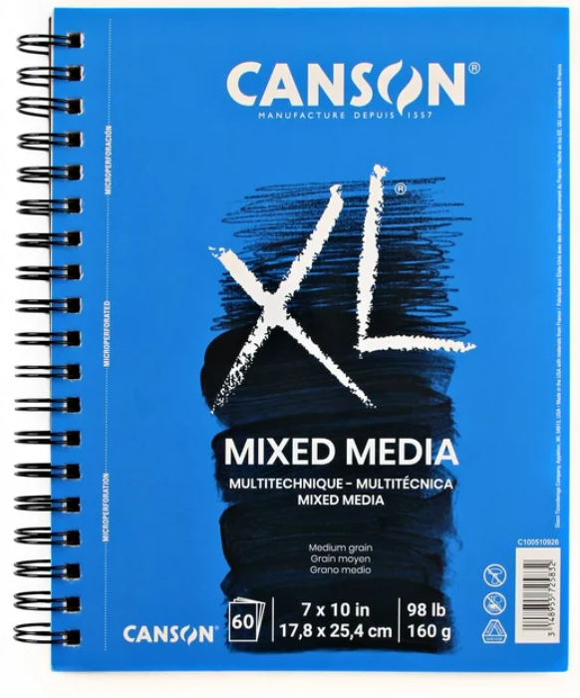
Recommended for Building Your Resource Library | The Substance of Style: How the Rise of Aesthetic Value Is Remaking Commerce, Culture, and Consciousness,  Virginia Postrel, Harper Perennial |  | 
Instructor & Office | Dr. Lynn Brandon, Furnishings & Décor Merchandising Program Coordinator  342E Chilton Hall
Office Hours | - Monday thru Thursday: 11am to 12pm  - Via Canvas Inbox, please make an appointment during office hours to ensure availability.  - If time is unavailable during office hours, other by appointment only, in person or virtual.
E-Mail: | Use the Canvas Inbox as first contact option. For FADM degree or other topics, use the email -  Lynn.Brandon@unt.edu Provide your Name, Course Number, topic in Subject line.
E-Mail check schedule | - Canvas Inbox checked Monday thru Thursday: 11am to 12pm; UNT email checked frequently.  - May occasionally be checked at other times (Mon. – Fri.), but not before 8:00am nor after 5:00pm and not on weekends.  If you have questions regarding an assignment, do so well in advance of the due date/time of an assignment. The day before or the day of the due date is not “well before”.
Office Hours & Teaching Schedule | - Please make an appointment via Canvas Inbox (not my UNT email) for a time during office hours to ensure availability.  - Office hours can be in person in Chilton or virtual, but you must turn on camera during any Zoom meeting – I need to see you!  If your desired meeting time is unavailable during office hours, other times may be possible and made by appointment only.
 | 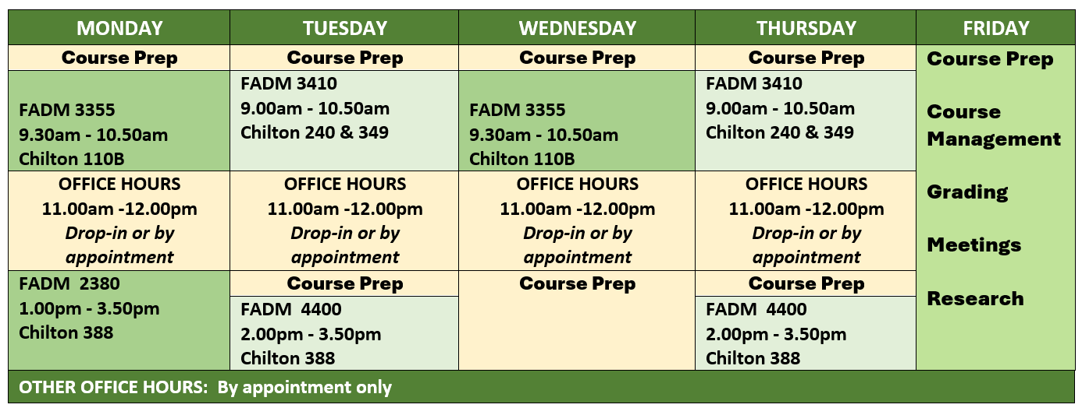
Use of CANVAS  &  General Assignment Information | Role of Canvas  - Canvas is a supplement, not a substitute, for attending face-to-face class sessions.  - NOT all course materials will be posted in Canvas.  - Selected items may be posted for discussions or class topics.  Communication Through Canvas  - Canvas Announcements are a primary communication tool in this course.  - You should check Canvas Announcements daily, not only on class days.  - Selected information communicated only in face-to-face class, so regular attendance is critical.  Assignments & Submissions  - Procedural and submission details are provided per individual assignment or project.  - Some assignments are ICA (in-class only); you must be present to participate and earn points.  - Other assignments will be submitted via Canvas.  Student Responsibility  - It is your responsibility to attend class to receive information and complete assignments.  - You are responsible for recording your grades, whether posted in Canvas or returned in class.
Grade Tracking & Gradebook Policy | Canvas is NOT the final grade book repository because this is not a fully online course.  - Your final grade cannot be determined solely from the Canvas gradebook; the professor maintains the official grade record.  - You are responsible for recording and tracking your own grades as they are returned in class or posted in Canvas—create a spreadsheet (ask for help if needed).  Once a grade is posted or returned, you have one week (7 calendar days) to schedule an appointment to discuss it; after that window, the grade stands.

Class Seating & Attendance and Late Arrival | Seating  - A seating chart may be used; you may also be moved to different seating during the semester.  Attendance Requirements – Attendance Grade is part of the Course Grade.  - Attendance will be recorded each class session.  - Arrive early or on time to ensure your attendance is accurately recorded.  - Remain for the entire class period to maintain full attendance status.  Late Arrivals  - Late arrivals are recorded.  - Three (3) late arrivals = one (1) absence.  If you arrive late, it is your responsibility to inform the instructor at the end of that class session. Notifications after class, or via email/Canvas Inbox, will not be accepted.
SLOs – Student Learning Outcomes
I. Strategic Research & Industry Insight
1. Professional Trend Analysis: Utilize industry publications, digital resources, and trade tools to research and interpret emerging market trends. (Bloom’s Level 2: Understand)
2. Brand & Market Analysis: Analyze how F&D companies align their brand identities with specific product offerings to compete in the marketplace. (Bloom’s Level 4: Analyze)
II. Design Foundations & Creative Application
3. Applied Design Foundations: Apply the elements and principles of design specifically to the design, selection, and development of furnishings and décor products. (Bloom’s Level 3: Apply)
4. Integrated Synthesis: Combine knowledge of materials, aesthetics, and trends to develop cohesive design solutions for furnishings & décor products. (Bloom’s Level 6: Create)
III. Technical Development & Manufacturing
5. Product Lifecycle & Process: Execute the standard stages of the product development process, from initial concept through to a finished state. (Bloom’s Level 3: Apply)
6. Technical Critique & Quality Control: Evaluate product concepts and construction methods for quality, durability, and more. (Bloom’s Level 5: Evaluate)
7. Prototyping & Manufacturability: Construct original, aesthetically pleasing product prototypes that respect work world manufacturing constraints and budget criteria. (Bloom’s Level 6: Create)
IV. Professional Communication & Portfolio
8. Multi-Platform Visual Literacy: Communicate design intent through a professional mix of hand-drawing, manual drafting, and computer-aided design (CAD). (Bloom’s Level 3: Apply)
9. Professional Pitching & Documentation: Articulate project rationales and design ideas effectively through written reports and verbal presentations. (Bloom’s Level 3: Apply)
10. Career Readiness & Portfolio Curation: Curate a professional portfolio of work that demonstrates technical proficiency and creative vision to potential employers. (Bloom’s Level 6: Create)

Tentative COURSE SCHEDULE/CALENDAR
This document may be changed by the professor as needed and will be updated in Canvas.
Read all CMHT, FADM, and other policies and documents posted in Canvas.
DoET is the abbreviation for the textbook – Design of Everyday Things
GoD is the abbreviation for Genius of Design videos
Week |  | Date |  |  | Topics for Lecture & Learning | PRIOR TO THE NEXT CLASS - Homework Assignments –  Items will be added as needed. Check Due deadlines on each individual item’s instruction.
Complete homework per assigned in class or via Canvas
Bring your text and your notes from reading and videos to each class or you may not be able to complete the ICA – In-Class Assignments. You cannot borrow the text.
1 |  | Jan 12 |  |  | - F&D Industry Overview | - Get textbook – Design of Everyday Things (DoET)  For next class:  - READ - DoET - Ch. 1 & 2 – highlight important items and take great notes.  - WATCH - Genius of Design Part 1 (GoD) – take great notes  - F!ND - an item at home that is 1) a great design OR 2) needs much improvement (it does not have to be a furnishings item; needs to be easily transportable to class!)
2 |  | Jan 19 |  |  | MLK – NO Class, but homework for the week.
3 |  | Jan 26 |  |  | Lecture & Lab  F&D Industry Overview  - F&D Model - Industry Insights  - Trade Publications  - F&D Product Categories | For next class:  - READ - DoET - Ch. 3 - highlight important items in text and take great notes. Bring text and your notes to class.  - WATCH - Genius of Design Part 2 – take great notes and bring to class.
4 |  | Feb 2 |  |  | Lecture & Lab  - F&D Companies to Know  - Forecasting  Assignments related to homework:  - DoET Ch 3 & GoD Pt 2  - Design Elements & Principles  - Sketching | For next class:  - READ - DoET - Ch. 4 - highlight important items in text and take great notes. Bring text and your notes to class.  - WATCH - Genius of Design (GoD) Part 4 – take great notes and bring to class.  - Bring the F!ND product from home to class.
5 |  | Feb 9 |  |  | Lecture & Lab  - DoET Ch 4 & GoD Pt 4  - Final Project Intro and Initial Work | For next class:  - READ - DoET - Ch. 5 - highlight important items in text and take great notes. Bring text and your notes to class.  - WATCH - Genius of Design (GoD) Part 5 – take great notes and bring to class.  - Final Project Assigned – work in class and out begins.
Thursday  Feb. 12 |  |  | BONUS 1: Leadership Symposium  - Union 333, 11am- 12.20pm, bring ID to check in/out; Attend full presentation  - Take notes for Summary submission - 0 to 10 points  - Compose 1 full page, double spaced in paragraphs (not just bullets) summary of your top 5 take-a-ways, professionally written and formatted for submission (title page, headings, etc.)  - Due in Canvas 1 week after the event.
6 |  | Feb 16 |  |  | SPARK – meet in Willis Library (right side, 1st floor) today during class. Assignment will be completed in class, no makeup for this assignment. | For next class:  - 3x3 Candle holder  - Complete Spark 3D Training – submit required items to Canvas and print and bring to class on Mar. 2 or as assigned per Field Trip
Wednesday  Feb 18 |  |  |  | BONUS 2: CMHT Career Expo - Wed 2/18 - 10:00 AM -1:00 PM (come and go, stay at least 1 hour)  - Union 314, bring ID to check in/out. I will be there.  - Visit with at least 4 different companies (apparel, F&D, hotel/restaurant) and meet their reps. Takes notes and selfies.  - Compose a 1 to 2 full pages, double spaced in paragraphs (not just bullets) summary listing the companies you visited and what you learned about entering the work force – their tips for success. Include 2 or more selfies.  - Professionally written and formatted for submission (title page, headings, margins, etc.).  - 0 to 10 points based on completeness of assignment. Due in Canvas 1 week after the event.
7 | Feb 23 |  |  |  | Field Trip???  OR Lecture & Lab  Lecture/Lesson as needed  - Final Project – Phase 1 | - READ - DoET - Ch. 6 - highlight important items in text and take great notes. Bring text and your notes to class.
8 | Mar 2 |  |  |  | Lecture & Lab  - Final Project – Phase 2
9 | Mar 9 |  |  |  | SPRING BREAK
10 | Mar 16 |  |  |  | Lecture & Lab  - Final Project – Phase 3 | - READ - DoET - Ch. 7 - highlight important items in text and take great notes. Bring text and your notes to class.
11 | Mar 23 |  |  |  | Lecture & Lab  - Final Project – Phase 4 | As assigned
12 | Mar 30 |  |  |  | Lecture & Lab  - Final Project – Phase 4 | As assigned
13 | Apr 6 |  |  |  | Lecture & Lab  - Final Project – Phase 5 | As assigned
14 | Apr 13 |  |  |  | Lecture & Lab  - Final Project – Phase 5 | As assigned
15 | Apr 20 |  |  |  | Final Project – Last work day and opportunity for feedback and questions | Final Project DUE – in Canvas before deadline of Sunday, April 19 EOD (11.59pm)
16 | Apr 27 |  |  |  | Project Presentations – In Class Only | Product Pitch and Peer Evaluations
17 | May 4 |  |  |  | Finals – Wrap Up

- This schedule is a guide and may be subject to modifications; if changed, you will be notified in class and it will be updated online in Canvas.
- Individual due dates will be posted per assignment or project.
- In-Class only Assignments - only be available in class. You must be present to complete and earn points even if the items are available via Canvas.
- Bonuses are offered to all as per course information. No bonuses offered on an individual basis.
- Late work will not be accepted for grading. If a Canvas submission is marked as late, it is, regardless of “technical difficulties”.
- See exam/test make-up policy per course.
- Other documents detail policies and procedures related to the course and the college. Typically posted in Canvas.

 | Assignments
1 | F&D Model Industry Overview Assignments  - Industry Insights – LibGuides/Product Categories  - ….  - …. |  | As assigned | up to 50
2 | Sketching Assignments (some in Final Project)  - S1 - Sketching  - S2 - Sketching  - ……… |  | As assigned | up to 50
3 | Computer Assignments (some in Final Project)  - Computer assignments  - Computer assignments  - … |  | Point values as assigned | up to 70
4 | DoET – Textbook chapter assessments |  | As assigned | Up to 50
5 | Design Assignments  - Genius of Design  - Dieter Rams, etc.  - Product Critiques, etc. |  | As assigned | Up to 50
 |  |  | Section total | 0 to 270
6 | Final Project components –  phases below assigned with grading and points possible.
1 | Research & Analyze |  |  | 0 to 50
2 | Interpret & Compare |  |  | 0 to 20
3 | Create & Critique - Concept Creation |  |  | 0 to 30
4 | Execute & Professionally Present |  |  | 0 to 50
5 | Other as assigned |  |  | 0 to 30
6 | Peer Evaluation of Product Pitch & Presentation |  |  | 0 to 20
 | Final Project total points possible |  |  | 0 to 200
 | Guest Speakers/Field Trips - TBA
 | Each Field Trip or Guest Speaker – Attendance and Summary required |  |  | 0 to 25
 | Attendance |  |  | 0 to 100
Bonuses:
 | Bonus 1 |  | 0 to 10 each
 | Bonus 2 |  | 0 to 10 each
 |  | Tentative point totals |  | ~ 600
- In-class assignments cannot be made up. However, bonus opportunities are offered to make up points missed or earn additional points.
- The final exam, if required, must be completed during the time it is opened, per UNT. It cannot be made up and will not be reopened on an individual basis
The final semester grade will be determined as follows:
A = 90-100%
B = 80-89.9%
C = 70-79.9%
D = 60-69.9%
F = 59.9% or below

