 | 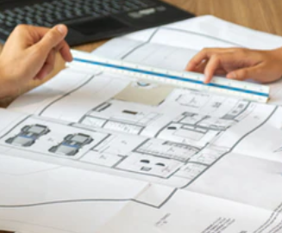 |  | 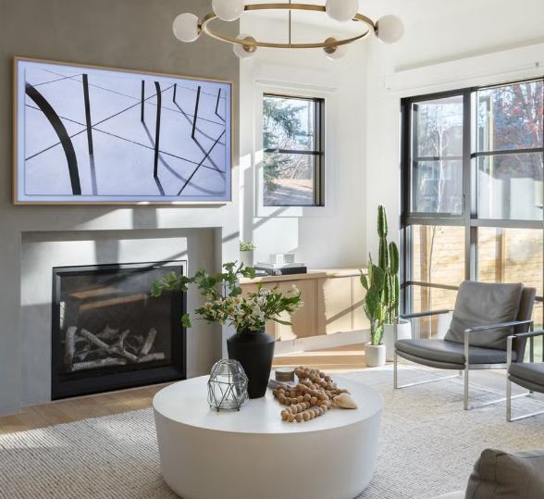
COURSE SYLLABUS & Tentative CALENDAR/SCHEDULE
FADM 4400 Capstone in Furnishings & Decor
Spring 2026 – Dr. Brandon - TTH – 2.00pm to 3.50pm Chilton 349
This document may be changed by the professor as needed.
Read CMHT, FADM, and other Policies, etc, in Canvas

Time & Place: | Tuesday & Thursday, 2pm – 3.50 pm, Chilton 349
Description: | Practical aspects of home furnishings and interior treatments and arrangement. Emphasis is placed on interior materials, estimating and calculating those materials.
Required Texts & Materials: | - Neilson & Taylor. Interiors: An Introduction, Wm. C. Brown (5th ed.) Willis Library Reserves  - Allison, Diana. Costing and Estimating for Interior Designers, 2nd, ed. Fairchild/Bloomsbury Books, 2021  - Access to online concept/moodboard creator software (free versions).  - Access to Chief Architect, other CAD, and software/apps for portfolio creation, etc.  - Other: Markers, colored pencils, rendering items, trash/tracing paper, architect’s scale and basic drafting equipment, calculator, as needed. | 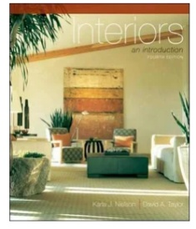& 
Recommended | Riggs, R. Materials and Components of Interior Design, latest ed., Prentice-Hall or similar.
Instructor & Office | Dr. Lynn Brandon, Home Furnishings Merchandising Degree Program Coordinator  342E Chilton Hall
Office Hours | - Monday thru Thursday: 11am to 12pm  - Via Canvas Inbox, please make an appointment during office hours to ensure availability.  - If time is unavailable during office hours, other by appointment only, in person or virtual.
E-Mail: | Use the Canvas Inbox as first contact option. For FADM degree or other topics, use the email -  Lynn.Brandon@unt.edu Provide your Name, Course Number, topic in Subject line.
E-Mail check schedule | - Canvas Inbox checked Monday thru Thursday: 11am to 12pm; UNT email checked frequently.  - May occasionally be checked at other times (Mon. – Fri.), but not before 8:00am nor after 5:00pm and not on weekends.  - If you have questions regarding an assignment, do so well in advance of the due date/time of an assignment. The day before or the day of the due date is not “well before”.

Office Hours & Teaching Schedule | - Request appointment availability during office hours via Canvas Inbox (not my UNT email).  - Office hours options: In person (Chilton) or virtual, but your camera must be on during any Zoom meeting – I need to see you!  - If your desired meeting time is unavailable during office hours, other times may be possible and made by appointment only.
My Schedule | 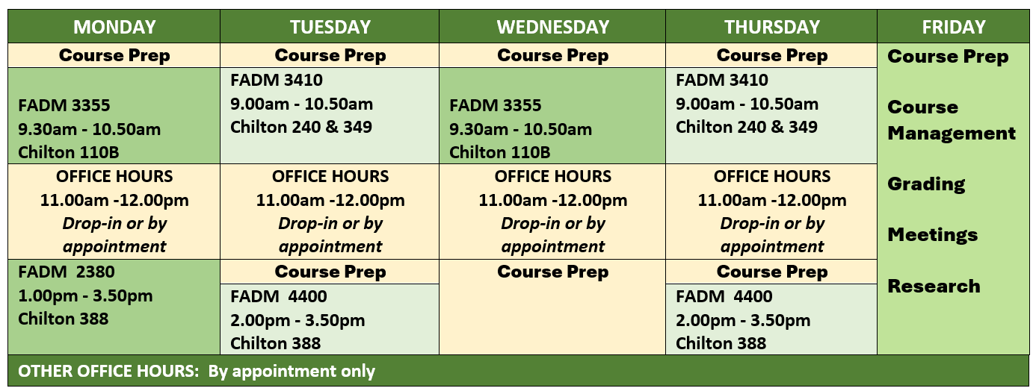
Use of  CANVAS  &  General Assignment Information | Role of Canvas  - Canvas is a supplement, not a substitute, for attending face-to-face class sessions.  - NOT all course materials will be posted in Canvas.  - Selected items may be posted for discussions or class topics.  Communication Through Canvas  - Canvas Announcements are a primary communication tool in this course.  - You should check Canvas Announcements daily, not only on class days.  - Selected information communicated only in face-to-face class, so regular attendance is critical.  Assignments & Submissions  - Procedural and submission details are provided per individual assignment or project.  - Some assignments are ICA (in-class only); you must be present to participate and earn points.  - Other assignments will be submitted via Canvas.  Student Responsibility  - It is your responsibility to attend class to receive information and complete assignments.  - You are responsible for recording your grades, whether posted in Canvas or returned in class.
Grade Tracking & Gradebook Policy | Canvas is NOT the final grade book repository because this is not a fully online course.  - Your final grade cannot be determined solely from the Canvas gradebook; the professor maintains the official grade record.  - You are responsible for recording and tracking your own grades as they are returned in class or posted in Canvas—create a spreadsheet (ask for help if needed).  - Once a grade is posted or returned, you have one week (7 calendar days) to schedule an appointment to discuss it; after that window, the grade stands.
Class Seating & Attendance and Late Arrival | Seating  - A seating chart may be used; you may also be moved to different seating during the semester.  Attendance Requirements – Attendance Grade is part of the Course Grade.  - Attendance will be recorded each class session.  - Arrive early or on time to ensure your attendance is accurately recorded.  - Remain for the entire class period to maintain full attendance status.  Late Arrivals  - Late arrivals are recorded.  - Three (3) late arrivals = one (1) absence.  If you arrive late, it is your responsibility to inform the instructor at the end of that class session. Notifications after class, or via email/Canvas Inbox, will not be accepted.

SLOs –  Student Learning Outcomes | - Goal (G). The student will know about PRODUCTS - finishes, furnishings, and materials (FF&M) for environments.  - General Learning Outcome – GLO. The student will examine FF&M product categories and features.  Specific Learning Outcome Statements –sLOs. The student will……  - determine the types of products in the FF&M category.  - define construction and manufacturing techniques of products.  - Goal (G). The student will understand the PERFORMANCE CHARACTERISTICS of FF&M products.  - General Learning Outcome – GLO. The student will examine the components of products.  Specific Learning Outcome Statements –sLOs. The student will……  - identify the attributes of FF&M products.  - evaluate features of products.  - understand the properties of interior components and furnishings.  - interpret applications and uses of interior components and furnishings.  - report on product innovations.  - Goal (G). The student will review various CONSTRUCTION METHODS of products related to FF&M.  - General Learning Outcome – GLO. The student will identify production techniques of products.  Specific Learning Outcome Statements –sLOs. The student will……  - compare the construction features of a variety of FF&M products.  - learn about technological developments in products performance features.  - physically inspect and assess furniture quality.  - Goal (G). The student will learn about FF&M COMPANIES and their importance in the industry.  - General Learning Outcome – GLO. The student will gain expanded knowledge of HF companies.  Specific Learning Outcome Statements –sLOs. The student will……  - identify which companies develop and produce FF&M products.  - identify sales channels for home furnishings.  - evaluate store atmospherics and merchandising practices.  - explore career opportunities in the industry.  - Goal (G). The student will learn about BESPOKE TREATMENTS.  - General Learning Outcome – GLO. The student will explore ready-made and custom interior treatments.  Specific Learning Outcome Statements –sLOs. The student will……  - identify a variety of treatments used in home furnishings environments.  - differentiate among a variety of treatments.  - evaluate and determine appropriate choices for interior treatments.  - apply guidelines for pattern and material coordination.  - create a variety of treatments using newly acquired skills.  - Goal (G). The student will compute MATERIAL CALCULATIONS for products.  - General Learning Outcome – GLO. The student will demonstrate the use of industry computations.  Specific Learning Outcome Statements –sLOs. The student will……  - apply industry adopted mathematical formulas to calculate quantities of materials and finishes.  - use principles of the trade in pricing materials, finishes, and furnishings.  - identify and select materials, finishes, and furnishings appropriate for specific circumstances.  - Goal (G). The student will learn appropriate concepts of product PLACEMENT AND CLEARANCES.  - General Learning Outcome – GLO. The student will demonstrate the use of drawing, arranging, and rendering related to home furnishings products.  Specific Learning Outcome Statements –sLOs. The student will……  - apply elements & principles, color theory, and rendering techniques.  - use and evaluate consumer floor planning CAD software.  - illustrate concepts of furniture placement and use of clearances.  - demonstrate decorative accessory arrangement and product staging techniques.  - Goal (G). The student will learn BUSINESS PROCESSES related to product procurement and estimations.  - General Learning Outcome – GLO. The student will assemble documentation related to selection, creation, and installation of home furnishings products and custom treatments.  Specific Learning Outcome Statements –sLOs. The student will……  - use industry publications and sources to resolve project challenges.  - create and/or complete appropriate forms and business documentation.  organize and present information regarding home furnishings business practices.
- Goal (G). The student will complete items for inclusion in a FADM PORTFOLIO.
  - General Learning Outcome – GLO. The student will build the portfolio through assignments and assembly of collected items related to the industry.
Specific Learning Outcome Statements –sLOs. The student will……
    - use appropriate software (graphics, CAD, concept/sample board, etc.).
    - compose appropriate written items
    - create projects required for the HFMD Portfolio
- professionally present the portfolio as if in an interview situation.
Class Schedule/Calendar
Date | DAY | In Class TOPICS and Work | In class or HOMEWORK – add as assigned
Week 1
Jan 13 | Tues | LECTURE/LESSON/LAB  - Intro to class and  - My Circle assignment | As assigned
Jan 15 | Thur | LECTURE/LESSON/LAB  - EPC Assignment  - KJN/Willis: Ch. 3 & 4 | As assigned
Week 2
Jan 20 | Tues | LECTURE/LESSON/LAB  - DA: Ch. Per your team’s material witness  - KJN: Ch. Per material witness | As assigned
Jan 22 | Thur | LECTURE/LESSON/LAB  - Check off – EPC - BOC – mostly complete | - Consumer CAD Software – start looking for and testing at least 2 free versions.
Week 3 | The Weather Week
Jan 27 | Tues | 
Jan 29 | Thur | LECTURE/LESSON/LAB  - PRESENT – Consumer Software | As assigned
Week 4
Feb 03 | Tues | LECTURE/LESSON/LAB  - Furniture Selection, Types, Styles, Arrangement  DA: Ch. As per your material  KJN: Ch 8, 9, 14, 15 (Furniture Selection, Arrangement, Dec acc, history) | - Work on - Material Witness - Work in teams – per instructions in class.  - Meet with Brandon as Scheduled  - Work on finalizing the presentation –  per Part 2 instructions
Feb 05 | Thur | LECTURE/LESSON/LAB  - Furniture Selection, Types, Styles, Arrangement  DA: Ch. As per your material  KJN: Ch 8, 9, 14, 15 (Furniture Selection, Arrangement, Dec acc, history) | - Portfolio – Create Bio, new headshot pictures, find items from past classes, work experiences  - Meet with Brandon as Scheduled  - Work on finalizing the presentation –  per Part 2 instructions
Week 5 | Each Class: Bring textbook (DA) & SCALE daily to earn full attendance and participation points
Feb 10 | Tues | LECTURE/LESSON/LAB  Check final presentations– Read to present format  Hard, Tile, Stone, Soft, Man-made/Quartz  DA: Ch. 6 & 7  KJN: Ch. 12  Prepare for Final Project (KJN Ch. 5, 6, 7) | Preview and work on Material Witness Sample Floor Plan – Square footage, area, perimeter, basic math for our work.  Prepare for Final Project (KJN Ch. 5, 6, 7)
Thurs Feb. 12 | BONUS 1: Leadership Symposium – (Professional Development Opportunity – PDO). Thurs, Feb. 12.  - Union 333, 11am- 12.20pm, bring ID to check in/out; Attend full presentation. I will be there.  - Take notes for Summary submission - 0 to 10 points based on completion of the requirements.  - Compose 1 full page, double spaced in paragraphs (not just bullets) summary of your top 5 take-a-ways, professionally written and formatted for submission (title page, paragraph/section headings, margins, etc.). Include a selfie of you before the event with the stage in the background.  - Due in Canvas 1 week after the event – Canvas will open a few days after the event.  - If you are in more than one of my classes, submit the same requirements, but must upload separately in each class.
Feb 12 | Thur | LECTURE/LESSON/LAB  Check final presentations- Read to present format Paint, WC, Drapery/Curtains, Top Treatments, Hard, Soft Treatments  Flooring –HARD & SOFT  DA: Ch. 6 & 7  KJN: Ch. 12  Prepare for Final Project (KJN Ch. 5, 6, 7) | Preview and work on Material Witness Sample Floor Plan – Square footage, area, perimeter, basic math for our work.
Week 6 |  |  | By Monday, Feb. 16, before 11.59pm  All Team Presentations Due in Canvas
Feb 17 | Tues | LECTURE/LESSON/LAB  MATERIAL WITNESS –Team Presentation & Estimates  - HARD flooring Wood/Wood Products  - Estimating for these products  - Estimate Forms  Material/Properties/Specs/Formulas/Calc/Est  DA: Ch. 6  KJN: Ch. 12 | Final Project Work As Assigned
Wed.  Feb 18 | BONUS 2: CMHT Career Expo - Wed 2/18 - 10:00 AM -1:00 PM (come and go, stay at least 1 hour) (another PDO)  - Union 314, bring ID to check in/out. I will be there.  - Visit with at least 4 different companies (apparel, F&D, hotel/restaurant) and meet their reps. Takes notes and selfies.  - Compose a 1 to 2 full pages, double spaced in paragraphs (not just bullets) summary listing the companies you visited and what you learned about entering the work force – their tips for success. Include 2 or more selfies.  - Professionally written and formatted for submission (title page, paragraph/section headings, margins, etc.).  - 0 to 10 points based on completion of the requirements.  - Due in Canvas 1 week after the event – Canvas will open a few days after the event.  - If you are in more than one of my classes, submit the same requirements, but must upload separately in each class.
Feb 19 | Thur | LECTURE/LESSON/LAB  MATERIAL WITNESS –Team Presentation & Estimates  - TILE – Flooring and Countertops  - Estimating for these products  - Estimate Forms  DA: Ch. 6  KJN: Ch. 12 | Final Project Work As Assigned  Test 1 – EPC, Furn – Selection, Arrangement, History, chapters, etc.  Tests typically open on Friday at noon and close on Saturday at noon.
Week 7
Feb 24 | Tues | LECTURE/LESSON/LAB  MATERIAL WITNESS –Team Presentation & Estimates  - STONE – Flooring and Countertops  - Estimating for these products  - Estimate Forms  DA: Ch.  KJN: Ch. 12 | Final Project Work As Assigned
Feb 26 | Thur | Field Trip – Confirmed  McGannon & Associates start appointment at 2.30
Week 8
Mar 3 | Tues | LECTURE/LESSON/LAB  MATERIAL WITNESS –Team Presentation & Estimates  - SOFT/Resilient flooring (NOT areas rugs)  - Estimating for these products  - Estimate Forms  DA: Ch. 7  KJN: Ch. 12 | Final Project Work As Assigned
Mar 5 | Thur | LECTURE/LESSON/LAB  MATERIAL WITNESS –Team Presentation & Estimates  - SOFT/Resilient flooring (NOT areas rugs)  - Estimating for these products  - Estimate Forms  DA: Ch. 7  KJN: Ch. 12 | Final Project Work As Assigned
Week 9 |  | Week 9 - Mar 8 – Mar 15 SPRING BREAK
Week 10
Mar 17 | Tues | LECTURE/LESSON/LAB  MATERIAL WITNESS –Team Presentation & Estimates  - ENGINEERED STONE/MAN-MADE/QUARTZ  - Estimating for these products  - Estimate Forms  DA: Ch. 2  KJN: Ch. 11 | Final Project Work As Assigned
Mar 19 | Thur | LECTURE/LESSON/LAB  MATERIAL WITNESS –Team Presentation & Estimates  - PAINT and finishes  - Estimating for these products  - Estimate Forms  DA: Ch. 2  KJN: Ch. 11 | Final Project Work As Assigned  Test 2 – Flooring – Hard (Wood, WP, tile, carpet, resilient) etc.  Tests typically open on Friday at noon and close on Saturday at noon.
Week 11
Mar. 24 |  | LECTURE/LESSON/LAB  MATERIAL WITNESS –Team Presentation & Estimates  - WALL COVERINGS  - Estimating for these products  - Estimate Forms  DA: Ch. 3  KJN: Ch. 11 | Final Project Work As Assigned
Mar. 26 | Tues | LECTURE/LESSON/LAB  MATERIAL WITNESS –Team Presentation & Estimates  - WALL COVERINGS – MORE INFO  - Estimating for these products  - Estimate Forms  DA: Ch. 3  KJN: Ch. 11 | Final Project Work As Assigned  Staging Matters Assigned
Week 12
Mar 31 |  | LECTURE/LESSON/LAB  MATERIAL WITNESS –Team Presentation & Estimates  - DRAPERY & CURTAINS - WINDOW TREATMENTS  - Estimating for these products  - Estimate Forms  DA: Ch. 10 & 11  KJN: Ch. 11 & 13 | Final Project Work As Assigned
Apr 2 | Tues | LECTURE/LESSON/LAB  MATERIAL WITNESS –Team Presentation & Estimates  - TOP TREATMENTS - WINDOW TREATMENTS  - Estimating for these products  - Estimate Forms  DA: Ch. 10 & 11  KJN: Ch. 11 & 13 | Final Project Work As Assigned
Week 13
Apr 7 | Tues | LECTURE/LESSON/LAB  MATERIAL WITNESS –Team Presentation & Estimates  - HARD - WINDOW TREATMENTS  - Estimating for these products  - Estimate Forms  DA: Ch.  KJN: Ch. 11 & 13 | Final Project Work As Assigned  Portfolio – Website and required items  DUE by Sunday, Apr. 12 before 11.59pm
Apr 9 | Thur | LECTURE/LESSON/LAB  MATERIAL WITNESS –Team Presentation & Estimates  All Window Treatments  Portfolio Check in class as time allows.  DA: Ch.  KJN: Ch. 11, 13 | Final Project Work As Assigned
Week 14
Apr 14 | Tues | LECTURE/LESSON/LAB  MATERIAL WITNESS –Team Presentation & Estimates  - SOFT TREATMENTS  - Estimating for these products  - Estimate Forms  DA: Ch. 12 & 13  KJN: Ch. 11 & 13 | Final Project Work As Assigned
Apr 16 | Thur | LECTURE/LESSON/LAB  MATERIAL WITNESS –Team Presentation & Estimates  All Soft Treatments  DA: Ch. 12 & 13  KJN: Ch. 11, 13 | Final Project Work As Assigned  Staging Matters DUE by Sunday, April 19, before 11.59pm
Week 15
Apr 21 | Tues | LECTURE/LESSON/LAB  Final Project Work As Assigned
Apr 23 | Thur | LECTURE/LESSON/LAB  Final Project Work As Assigned  Last Day for Questions | Final Project DUE:  Sunday, April 26, before 11.59pm
Week 16 |  |  | PORTFOLIO final version  DUE: Monday, Apr. 27 before 11.59pm
Apr 28 | Tues | Presentations in Class - Kasa Kinley & Final Portfolio
Apr 30 | Thur | Pre-Finals Day – Course Wrap-up
Week 17
May 5 |  | Finals Week  Monday, May 4 test opens at 3pm and closes at 5pm  Test 3 – Paint and Wall Coverings, All Window Treatments & Soft Treatments, etc. | 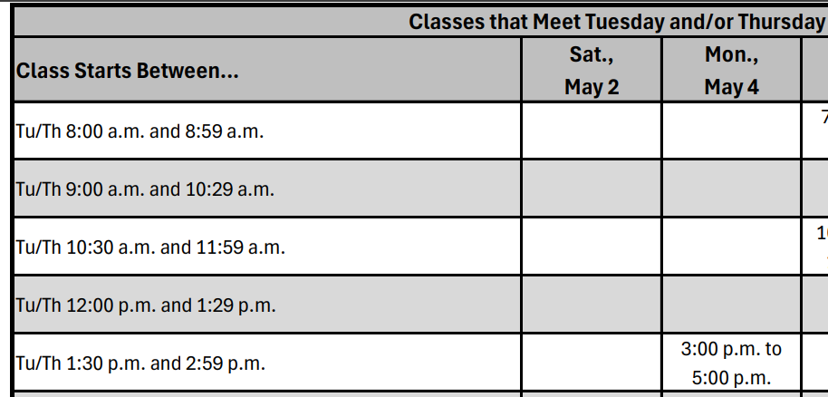

Assignments and Assessments: Keep up with your grades.
- Grades in Canvas are a repository only. Official Grade Book is not Canvas, but the Course Excel gradebook I keep.
- No late work accepted for grading.

No. | Item |  | Points Possible | Enter points you earned | DUE DATE/DUE TIME –  per individual assignment
Record Assignments Below.
Some are in class only for grading, some for homework. See individual assignments.
 | Attendance Grade |  | 0 to 100 |  | ~100
 | Assignments
 | My Circle |  | 0 to 5
 | Elements & Principles |  | 0 to 30
 | Consumer Software |  | 0 to 20
 | Material Witness – Part 1 & Brandon meeting |  | 0 to 10
 | Material Witness – Check off for Final Version |  | 0 to 10
 | Material Witness – Part 2 – Presentation & Estimating |  | 0 to 50
 | Furniture Arrangement – 349Loft |  | 0 to 30
 | Est/Calc/Features – Flooring Estimates - Hard |  | 0 to 10
 | Est/Calc/Features – Flooring Estimates - Tile |  | 0 to 10
 | Est/Calc/Features – Flooring Estimates - Stone |  | 0 to 10
 | Est/Calc/Features – Flooring Estimates – Soft/Resilient |  | 0 to 10
 | Est/Calc/Features – Paint |  | 0 to 10
 | Est/Calc/Features – Wall Coverings - WC |  | 0 to 10
 | Est/Calc/Features – Window Treats – Drapery/Curtains |  | 0 to 10
 | Est/Calc/Features – Window Treats – Top treatments |  | 0 to 10
 | Est/Calc/Features – Window Treats – Hard |  | 0 to 10
 | Est/Calc/Features – Man-made/Engineered |  | 0 to 10
 | Est/Calc/Features – Soft Treatments |  | 0 to 10
 | Add any others assigned….
Total points this section |  |  |  |  | Approximately ~ 265
TESTS
1 |  | Test 1 - EPC, Furn Selection & Arrangement | 0 to 50
2 |  | Test 2 – Flooring | 0 to 50
3 |  | Test 3 – Paint & Wall Coverings | 0 to 50
Total points this section |  |  |  |  | Approximately ~ 150

ASSIGNMENTS/PROJECTS
1 | Staging Matters | 0 to 45
2 | Final Project | 0 to 210
3 | Portfolio – Part 1 | 0 to 10
6 | Portfolio – Presentation | 0 to 20
 | Add any others assigned….
Total points this section |  |  |  | Approximately ~ 285
Guest Speakers, Events, Field trips, etc. |  | ID needed for sign in/out at CMHT/MDR events.
 | Attendance and Assignment/Summary as required
 | Speaker - 1 | 0 to 25
 | Field Trip - 1 | 0 to 25
 |  | 0 to 25
 |  | 0 to 25
 | Add any others assigned….
Total points this section |  |  |  | Approximately ~ 50+
TOTAL for COURSE (not including bonuses) |  |  |  | Approximately ~ 900
BONUS OPPORTUNTIES – documentation required, details given in class
- Bonus 1 |  |  |  | 0 to 10
- Bonus 2 |  |  |  | 0 to 10
- Other – TBA |  |  |  | 0 to 10

COURSE GRADE SCALE: these numbers may change based on the total point value, this scale is used:
A = 90% -100%
B = 80% - 89.9%
C = 70% - 79.9%
D = 60% - 69.9%
F = 59.9% and below

