Syllabus and Policies for FADM Furnishings & Décor Courses
FADM 3570 Products & Process (TU/TH – Fall 2026)
(a.k.a. -Decorative Accessories Merchandising)
Fully read before class meeting #2…
- SMHM Polices and 2) FADM Policies for Courses posted in Canvas
You are responsible for reading and understanding syllabus, policy, course schedule
and other documents related to courses.
Time & Place: | Tuesday & Thursday, 12.45pm to 2.05pm, Chilton 349. Dr. Lynn Brandon
Description: | Overview of decorative accessories in their historical context and in current industry applications. Production and merchandising of products including giftware, lighting, home accents, accent furniture, rugs, soft goods, tabletop, etc.
Required Texts & Resources: | - Elsasser, V. H. (2016). Know Your Home Furnishings, 2nd Ed.  - UNT Library LibGuides/FADM Subject Guides  - F&D Industry Trade publications (F/T, HFN, HAT, others), trade websites, E-newsletters, and assigned for other readings/assignments.  - Use of UNT Library Print & Electronic Resources.  - APA - Publication Manual of the American Psychological Association, 7th ed. (used in all MDR courses for format of projects and assignments). |  | 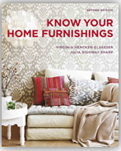
Building Your Resource Library | - The Substance of Style: How the Rise of Aesthetic Value Is Remaking Commerce, Culture, and Consciousness, Virginia Postrel, Harper Perennial  - Any publications by Judith Miller (i.e., The Illustrated Dictionary of Antiques & Collectibles.  - And many more! | 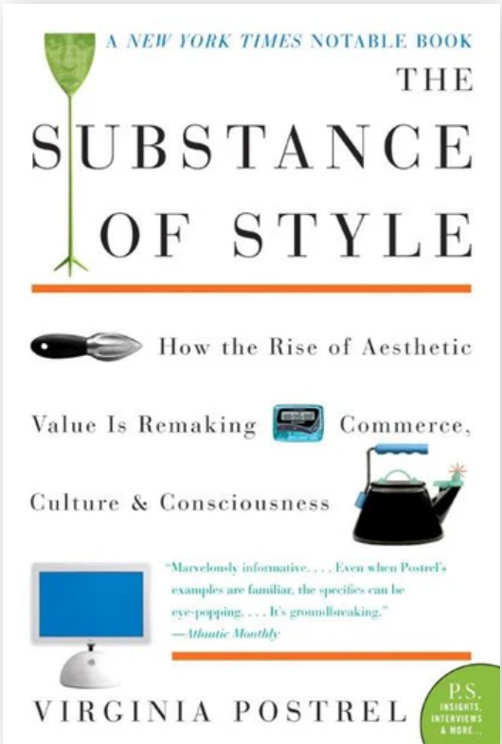
Professor | Dr. Lynn Brandon, Furnishings & Décor Merchandising Program Coordinator
Office & Phone | Chilton 342E. Main office telephone: 940-565-2436.  Canvas Inbox is most efficient/quickest way to get in touch for information and answers.
Office Hours & Teaching Schedule | Please make an appointment via Canvas Inbox (not my UNT email) for a time during office hours to ensure availability. Office hours can be in person in Chilton or via Zoom, but you must turn on camera during any Zoom meeting – I need to see you! If your desired meeting time is unavailable during office hours, other times may be possible and made by appointment only.
Office Hours & Teaching Schedule | 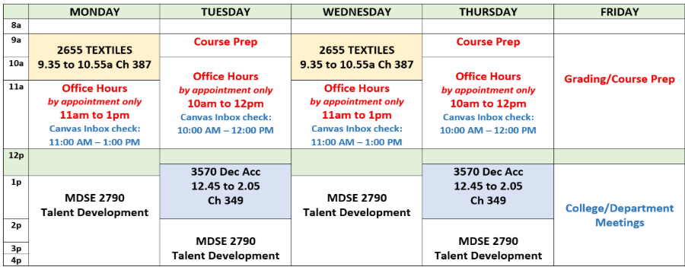
E-Mail: | For class-related questions, only use Canvas Inbox. Canvas email will be answered before UNT email due to volume. However, for general industry, FADM and degree topics, use email - Lynn.Brandon@unt.edu Provide your Name, Course Number, topic in Subject line.
Canvas Inbox and UNT Email Office Hours | - Canvas Inbox checked M & W: 11.00am to 1pm; Tu & Th: 10am to 12pm. It may also be checked at other times (Mon. – Fri.), but not before 8:00am nor after 5:00pm. No weekend checks.  - If you have questions regarding an assignment due over a weekend, ask questions at least 3 days before the due date/time to allow you time to receive an answer.  - UNT email checked regularly, but not as often as Canvas Inbox.
Use of CANVAS | - Canvas is supplement and not a substitution for attending our face-to-face class.  - I use Canvas to communicate many items to you through its Announcement feature.  - Check Canvas Announcements daily, not just on class days.  - However, some items will be communicated only through face-to-face, so attend class regularly.  - Selected items may be posted for discussions/class topics, NOT all items posted in Canvas.  - Individual instructions, via assignment or in class, will be provided per assignments/projects and how they will be submitted. Some assignments are ICA – in-class only and you must be present to participate. Most other assignments will be submitted via Canvas.
Canvas Grading | - Canvas is not the final grade book because this is not a 100% online course.  - Your final grade may not be completely determined via CANVAS gradebook, an official grade book is kept.  - Keep up with your grades as they are returned/posted in Canvas (use Excel) you know how or ask me!  - After individual grades are posted or returned, you have one week/7 days to make an appointment to ask about a grade, after that time the grade will stand.
Class Seating & Attendance and Late Arrival | - A seating chart may be used.  - Attendance will be recorded. Be early or on-time to class so ensure your attendance is recorded and stay for the entire class time to keep your full attendance status.  - Late (after 5 minutes of class start time) arrivals are recorded. 3 lates = 1 absence. It is your responsibility to be in class on time. If late, inform me of your late arrival at the end of class that day – not after class is over and not by email/Canvas Inbox.

SLOs – Student Learning Outcomes for the Course

SLOs are the basis for the design of your assessments, assignments, quizzes, tests, projects, and more.
This is what you must complete to accomplish the goals set for you in the course.
Main Student Learning Outcomes (SLO)

Objective 1: Product Knowledge and Market Evaluation
You will assess and evaluate furnishings and decorative accessory product categories using industry terminology, product characteristics, quality indicators, and market information.
You will:
- Analyze the attributes, design features, and construction characteristics of furnishings and decorative accessory products.
- Evaluate quality indicators and selling features across product categories.
- Compare retail pricing structures, price points, and market positioning among furnishings and décor product categories.
- Interpret industry data and market information related to furnishings and décor products.

Objective 2: Industry Dynamics and Merchandising
You will analyze merchandising practices and business strategies within the furnishings and décor industry.
You will:
- Evaluate industry trade publications and professional resources to identify current market trends and more.
- Analyze branding, merchandising, and marketing strategies used by furnishings and decorative accessory companies.
- Identify major brands and their market positions within product categories.
- Assess partnerships, licensing agreements, and collaborations that influence product design, development and offerings.
- Examine professional networking strategies and industry relationships.

Objective 3: Materials, Finishes, and Product Components
You will evaluate materials, finishes, and component applications used in furnishings and decorative accessory products.
You will:
- Identify materials, finishes, and surface treatments used in furnishings and decorative products.
- Differentiate among material properties and characteristics.
- Determine appropriate functional and aesthetic applications of materials in furnishings and décor products.

Objective 4: Design Development, Sourcing, and Global Production
You will analyze product development processes within the global furnishings and décor industry.
You will:
- Examine design techniques and product development processes used in creating furnishings and decorative products.
- Analyze sourcing strategies and supply chain considerations within the industry.
- Evaluate the global impact of design, sourcing, and production decisions.
- Identify key countries and regions involved in sourcing and manufacturing furnishings and decorative products.

Objective 5: Manufacturing, Construction, and Quality Assessment
You will evaluate manufacturing processes, construction methods, and quality standards used in furnishings and decorative accessory products.
You will:
- Analyze manufacturing processes used across a variety of product categories and materials, including ceramics, glass, wood, textiles, plastics, lighting, and tabletop products.
- Evaluate the role of technology in product manufacturing and production.
- Compare construction methods used in furnishings and decorative products.
- Assess product quality through analysis of construction techniques and manufacturing standards.

Objective 6: Historical Context and Design Interpretation
You will apply historical and contemporary design knowledge through industry-focused assignments.
You will:
- Research and interpret motifs, ornamentation, and decorative traditions found in furnishings and decorative products.
- Analyze historical and contemporary design styles and their influence on products in today's marketplace.

Sub-Goal 7: Professional Application and Portfolio Development
You will apply industry knowledge and analytical skills through professional projects, assessments, and portfolio development.
Learning Objectives
You will:
- Apply course concepts through individual and collaborative projects.
- Develop portfolio elements that demonstrate industry knowledge and critical analysis.
- Evaluate and revise selected coursework for inclusion in the FADM portfolio.

Read the Policies for FADM Courses posted in Canvas.

 | FADM 3570 Furnishings & Décor  Products and Processes  (aka - Decorative Accessories Merchandising)  T/TH - 12.45pm to 2.05pm, Chilton 349.  Dr. Brandon, Fall 2026  Tentative Schedule/ Course Calendar SV  Changed as needed
Not all textbook chapters will be covered in this course, so keep your text as a reference for future classes regarding topics not covered in this course. Additional reading/video materials will be used for assessments and learning.
Week | Date | Topics – REDO with furniture first | Chapters, Readings, Canvas Videos, etc. complete PRIOR to class. |  | Items To do or DUE -  You fill in as assigned
1 | Tu  Aug 18 | Course and Industry Introduction | Ch. 1 – Marketspace/Marketplace
 | TH  Aug 20 | F&D Industry Merch Model,  Product Categories, Trade Pub, etc. | Ch. 1 – Marketspace/Marketplace  Trade Publications
2 | Tu  Aug 25 | Marketspace for F&D, LibGuides, Trade Publications, Industry Insights | Ch. 1 – Marketspace/Marketplace
 | TH  Aug 27 | Model & Marketspace -  ME | Ch. 1 – Marketspace/Marketplace
3 | Tu  Sept 1 | Lecture & Learning – Glass  ME | Ch. 4 - Glass
 | TH  Sept 3 | Lecture & Learning - Glass | Ch. 4 - Glass
4 | Tu  Sept 8 | Lecture & Learning - Glass | Ch. 4 - Glass
 | TH  Sept 10 | Lecture & Learning - Glass | Ch. 4 - Glass |  | Test 1 – Opens in Canvas Fri. 10am/Closes Sat. 12pm noon
5 | Tu  Sept 15 | Lecture & Learning - Ceramics | Ch. 5 – Pottery/Ceramics |  | Amsterdam Project Assigned
 | TH  Sept 17 | Lecture & Learning - Ceramics | Ch. 5 – Pottery/Ceramics
6 | Tu  Sept 22 | Lecture & Learning - Ceramics | Ch. 5 – Pottery/Ceramics
 | TH  Sept 24 | Lecture & Learning - Ceramics | Ch. 5 – Pottery/Ceramics |  | Test 2 – Opens in Canvas Fri. 10am/Closes Sat. 12pm noon
7 | Tu  Sept 29 | Lecture & Learning - Metals | Ch. 7 - Metals
 | TH  Oct 1 | Lecture & Learning - Metals | Ch. 7 - Metals
8 | Tu  Oct 6 | Lecture & Learning - Metals | Ch. 7 - Metals
 | TH  Oct 8 | Lecture & Learning - Metals | Ch. 7 - Metals |  | Test 3 – Opens in Canvas Fri. 10am/Closes Sat. 12pm noon
9 | Tu  Oct 13 | Lecture & Learning – Carpets/Rugs | Ch. 12 – Area Rugs
 | TH  Oct 15 | Lecture & Learning – Carpets/Rugs | Ch. 12 – Area Rugs
10 | Tu  Oct 20 | Lecture & Learning – Carpets/Rugs | Ch. 12 – Area Rugs
 | TH  Oct 22 | Lecture & Learning – Carpets/Rugs | Ch. 12 – Area Rugs |  | Test 4 – Opens in Canvas Fri. 10am/Closes Sat. 12pm noon
11 | Tu  Oct 27 | Lecture & Learning - Plastics | Ch. 6 - Plastics
 | TH  Oct 29 | Lecture & Learning – Tabletop | Ch. 6 – Plastics  Ch. 13 – Tabletop
12 | Tu  Nov 3 | Lecture & Learning – Tabletop | Ch. 13 – Tabletop
 | TH  Nov 5 | Lecture & Learning – Lighting | Ch. 14 – Lighting
13 | Tu  Nov 10 | Lecture & Learning – Lighting | Ch. 14 – Lighting |  | Test 5 – Opens in Canvas Fri. 10am/Closes Sat. 12pm noon
 | TH  Nov 12 | Lecture & Learning - Furniture | Ch. 3 & 9 – Wood/Furniture & Upholstery
14 | Tu  Nov 17 | Lecture & Learning - Furniture | Ch. 3 & 9 – Wood/Furniture & Upholstery
 | TH  Nov 19 | Lecture & Learning - Furniture | Ch. 3 & 9 – Wood/Furniture & Upholstery
15 | 11-23 | Week – No Class |  | P1 – Feast for the Senses  DUE Sunday EOD
 | 11-27
16 | Tu  Dec 1 | Lecture & Learning - Furniture  Amsterdam Project Presentations | Amsterdam Project DUE – Monday, Nov. 30 EOD in Canvas
 | TH  Dec 3 | Last Regular class day  Amsterdam Project Presentations | Amsterdam Project Presentations
17 | Dec 5- 10  Finals | Tuesday, Dec. 8  Test 6 open 1.00 pm closes 3.00pm only per UNT schedule

FADM 3570 GRADE TRACKER & KEEPER
- Keep track of your grades (use spreadsheet you set up, ask me for help if needed).
- Record the grades you earn for items submitted/graded in both Canvas and otherwise.
- Canvas is NOT the final gradebook, there is an official one with grades.
- Keep up to date in class so you will know which assignments are due and their specifics.
- Items may be changed, altered, added, or deleted as needed in the course.
- The items listed below are the planned assignments, you fill in any other assignments/dates as they are given.
- Individual assignments/projects will have their specific details.

Assessments – learning application relevant to course topics.
ICA - IN-CLASS ONLY assignments – typically not announced until we are in class. Total number will vary.
There are no “make up” assignments for these. Fill in below as assigned. Double check with Canvas.
- Some ICAs started in class, then completed for homework. If you did not start the assignment in class, you should still complete for your own information and testing, but not for grading.
- Any in-class video assignments – are completed in class only for full credit. If available, they may be watched outside of class, but no credit for the ICA.
- No points will be dropped. Instead, you have opportunities to earn bonus points that would take the place of some missed points on attendance and missed assignments. See requirements for bonus point submissions.
- Alterations made as needed.

 |  |  | Points Possible | Points Earned for spreadsheet
Attendance – points earned for attendance and participation. |  |  |  | 0 to 100
1 | Mark of Excellence– Part 1 – In class only |  | 0 to 10
2 | Rug Production Assignment – In class only |  | 0 to 10
3 | Peer Evaluation of Amsterdam Project |  | 0 to 10
4 | Other?
 |  | Total points this section |  | 0 to 40

F!ND Assignments –
1 | F!ND Industry Intro |  |  |  |  | 0 to 10
2 | F!ND Glass |  |  |  |  | 0 to 10
3 | F!ND Ceramics |  |  |  |  | 0 to 10
4 | F!ND Area Rugs |  |  |  |  | 0 to 10
5 | F!ND Furniture/Upholstery |  |  |  |  | 0 to 10
6… | Other? |  |  |  |  | 0 to 10
 |  |  | Total points this section |  |  |  | 0 to 60+
Projects
P1 | A Feast for the Senses - Tabletop Assignment – completed over Thanksgiving |  |  |  |  | 0 to 25
P2 | Amsterdam Project - Product Design and Development in F&D  Phases due at different times for points earned and final version for presentation.  So named because I was inspired to create it when I visited Amsterdam |  |  |  |  | 0 to 75
 | Total this section |  |  |  |  |  | 0 to 100
Each test will contain 45 to 65 questions and are worth 50 points each.
- Delivered via Canvas unless otherwise specified. It is a privilege to be able to take the Tests online, usually via Canvas, but they can be moved to in-class if online privilege is abused or “sharing” occurs.
Test 1 |  |  |  |  |  | 0 to 50
Test 2 |  |  |  |  |  | 0 to 50
Test 3 |  |  |  |  |  | 0 to 50
Test 4 |  |  |  |  |  | 0 to 50
Test 5 |  |  |  |  |  | 0 to 50
Test 6 |  |  |  |  |  | 0 to 50
Make ups - One missed test may be made up, but not the Final (Test 6). Make ups are opened the week of Nov. 17 – 19, but you must notify me by Nov. 12 to request a makeup for a missed test. |  |  |  |  | Total for tests |  | 0 to 300
Probable Quick Quizzes…. In class only, unannounced and cannot be made up, so study along as we move through the topics, don’t wait until just before the tests! These done to “encourage” you to study every day.
1 |  | Intro – Marketspace, Model |  |  |  | 0 to 10
2 |  | Glass “pop” quiz |  |  |  | 0 to 10
3 |  | Ceramics “pop” quiz |  |  |  | 0 to 10
4 |  | Rug “pop” quiz |  |  |  | 0 to 10
5 |  | Wood/metals “pop” quiz |  |  |  | 0 to 10
6 |  | Lighting/Plastics “pop” quiz |  |  |  | 0 to 10
7 |  | Tabletop “pop” quiz |  |  |  | 0 to 10
 |  |  |  | Total for quizzes |  |  | 0 to 70+

Required PDOs - Professional Development Opportunities. Details given in class and on Canvas.
Speakers/Field Trips/ Other: As assigned in class – (summary report typically required for these)
- Speakers will be announced in advance.
- You must attend the class or the field trip location and fully participate and submit the Summary. See Canvas Module for Summary Report details.
- Submit the Summary Report in Canvas, EOD one week after the event.
Items added a speakers/field trips are included in the course. | 0 to 25 ea.
TOTAL COURSE POINTS - actual final total determined when all projects/assignments completed. |  | 0 to 695+
Bonus PDOs | Professional Development Opportunities. Beneficial for your success in your academic career, your internship and career prep, but not for this specific class. That is why I offer bonuses to encourage you to participate. No other bonuses offered on an individual basis.
Tue 9/22/2026 10:00 AM - 1:00 PM  Union 314 ABC - Emerald Ballroom | SMHM EXPO  - ID for entry/ exit, swipe in and out, attendance time in/out reported to me.  - Come and go - visit and talk with reps from at least 4 companies. Does not have to be F&D Industry, any company is fine.  - Introduce yourself and practice your people skills.  - Ask them questions about your prep for career success, do they know anyone in the F&D industry, what is their best lesson learned about working with other people? Other questions.  - Include in report at least one selfie or pic with a company rep at the event.  - Pick up some swag.  - Attendance time in/out reported to me.  - Create a typed, double-spaced Summary Report, with an introduction paragraph, and headings with following paragraphs of the name of each company you visited and create a personally written account of what you learned at each stop.  - Spelling, grammar, correct format, etc. expected.  Credit earned for full attendance (or prorated), attendance taken only from official swipe list in/out with Student ID. You may be asked questions in class about your experience. | 0 to 10
Tue 10/13/2026 3:30 PM - 5:30 PM  Union Jade Ballroom A&B - Room 333 | Career Conversations with Alumni  - ID for entry/ exit, swipe in and out, attendance time in/out reported to me.  - Attend and learn something you can apply to the F&D industry or to your career prep.  - Include at least one selfie at the event.  - Attendance time in/out reported to me.  - Create a typed, double-spaced Summary Report, with an introduction paragraph, and headings with following paragraphs in your own words of the five take-aways from the event and how they apply to F&D industry or your personal development.  - Spelling, grammar, correct format, etc. expected.  Credit earned for full attendance (or prorated), attendance taken only from official swipe list in/out with Student ID. You may be asked questions in class about your experience. | 0 to 10
Tue 10/20/2026 11:00 AM - 3:00 PM  Gateway Ballroom  More details to follow | EIR – Executive In Residence  - ID for entry/ exit, swipe in and out, attendance time in/out reported to me.  - Attend and learn something you can apply to the F&D industry or to your career prep.  - Include at least one selfie at the event.  - Create a typed, double-spaced Summary Report, with an introduction paragraph, and headings with following paragraphs in your own words of the five take-aways from the event and how they apply to F&D industry or your personal development.  - Spelling, grammar, correct format, etc. expected.  Credit earned for full attendance (or prorated), attendance taken only from official swipe list in/out with Student ID. You may be asked questions in class about your experience. | 0 to 10
Details TBA | Textiles for Furnishings & Décor  Will be due later in the semester. | 0 to 10

90 – 100% = A  80 – 89.9% = B  70 – 79.9% = C  60 – 69.9% = D  0 - 59.9% = F | Divide your total points earned by the total course points list possible for your %.

