 | 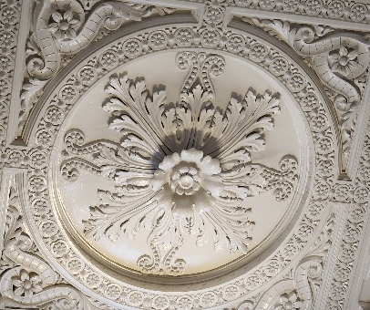 | “ You cannot  not know history.”  Philip Johnson | 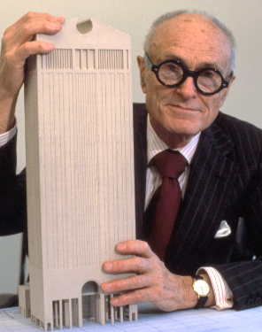
FADM 3355 - COURSE SYLLABUS - updated after Snowdays
Chronology of Styles and Trends in Furnishings and Décor (aka History of Furniture….)
Spring 2026 – Dr. Brandon, MW 9.30am to 10.50am- Chilton 110B
Changes may be made as necessary and updated in Canvas.

COURSE SYLLABUS & STUDENT LEARNING OUTCOMES (SLOs)

Time & Place: | Spring 2025 – Mon & Wed 9.30am to 10.50am. Chilton 110B
Course Description: | Survey of styles and trends in furnishings and the built environment. Emphasis on technological, social, and other influences on historic and contemporary styles.
Required Texts: | 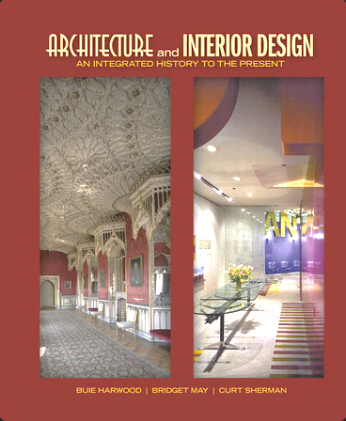 | Architecture and Interior Design: An Integrated History to the Present, 1st edition, Pearson, Buie Harwood and Bridget May
Recommended Texts | Abercrombie & Whiton (5th or 6th ed.)  Interior Design and Decoration,  ISBN-13: 978-0131944046 or  ISBN-10: 0131944045 |  | 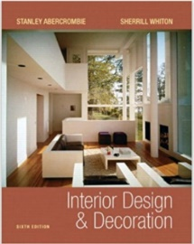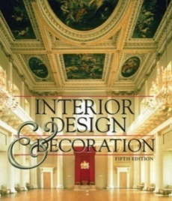
 | Suggested References for your library: See chart for many options and build your resource library.
Instructor &  Office | Dr. Lynn Brandon, Furnishings Merchandising Degree Program Coordinator, 342E Chilton Hall
Office Hours | - Monday thru Thursday: 11am to 12pm  - Via Canvas Inbox, please make an appointment during office hours to ensure availability.  - If time is unavailable during office hours, other by appointment only, in person or virtual.
E-Mail: | Use the Canvas Inbox as first contact option. For FADM degree or other topics, use the email -  Lynn.Brandon@unt.edu Provide your Name, Course Number, topic in Subject line.
E-Mail  check schedule | - Canvas Inbox checked Monday thru Thursday: 11am to 12pm; UNT email checked frequently.  - May occasionally be checked at other times (Mon. – Fri.), but not before 8:00am nor after 5:00pm and not on weekends.  - If you have questions regarding an assignment, do so well in advance of the due date/time of an assignment. The day before or the day of the due date is not “well before”.
Office Hours & | Please make an appointment via Canvas Inbox (not my UNT email) for a time during office hours to ensure availability. Office hours can be in person in Chilton or via Zoom, but you must turn on camera during any Zoom meeting – I need to see you! If your desired meeting time is unavailable during office hours, other times may be possible and made by appointment only.
Brandon’s Weekly Schedule | 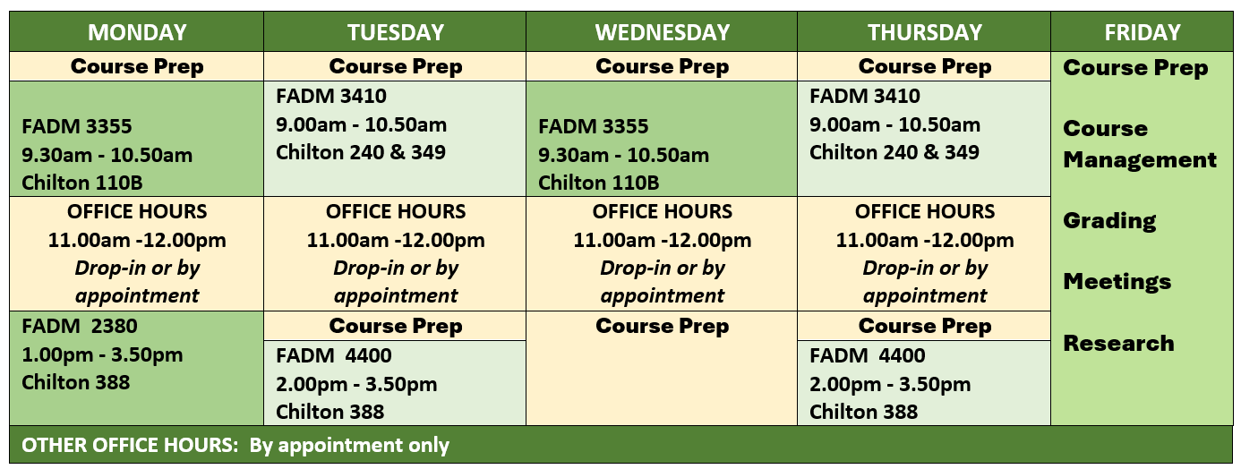
Use of CANVAS | - Canvas is supplement and not a substitution for attending our face-to-face class.  - I use Canvas to communicate many items to you through its Announcement feature.  - You should check Canvas Announcements daily, not just on class days.  - However, some items will be communicated only through face-to-face, so attend class regularly.  - Selected items may be posted for discussions/class topics.  - NOT all course materials will be posted in Canvas.  - Procedural and submission details provided per individual assignments/projects.  - Some assignments are ICA – in-class only and you must be present to participate and earn points. Other assignments will be submitted via Canvas.  - It is your responsibility to be in class to retrieve those items and to keep up with your grades whether they are posted in CANVAS or returned in class.
Canvas Grading | - Canvas is not the final grade book because this is not a 100% online course.  - Your final grade may not be completely known from just the items in the CANVAS gradebook. I keep an official grade book.  - So….keep up with your own grades as they are returned in class or posted in Canvas – create a spreadsheet (Excel, other) you know how or ask me!  - After individual grades are posted or returned, you have one week/7 days to make an appointment to ask about a grade, after that time the grade will stand.
Class Seating & Attendance and Late Arrival | - A seating chart may be used.  - Attendance will be recorded. Be early or on-time to class so ensure your attendance is recorded and stay for the entire class time to keep your full attendance status.  - Late arrivals are recorded and 3 lates = 1 absence. It is your responsibility to be in class on time and if late, inform me of this late arrival at the end of class that day – not after class is over and not by email/Canvas Inbox.
SLOs – Student Learning Outcomes
In completing this course, you will delve into a comprehensive exploration of the genealogy – ancestors and descendants - of architecture, interiors, and furniture. You will analyze how history, technology, and other factors have shaped design movements from antiquity to the modern era. By examining the relationship between historical archetypes and contemporary merchandise, you will develop the critical skills necessary to identify quality, interpret design philosophies, and apply historical influences to the current global marketplace.

Refined Learning Goals and Outcomes
Goal 1: Historical Context & Social Influence
You will examine how global systems and human needs shape the built environment.
1.1 Relate the influence of political, social and other systems to the historical development of furnishings.
(Blooms: Understand)
1.2 Describe the evolution of human comfort as reflected in changes to interiors and furniture design.
(Blooms: Understand)
1.3 Evaluate the meaning and function of architecture, interiors, and furnishings (AIF) within its original context. (Blooms: Evaluate)

Goal 2: Evolution of Style & Form
You will discover and categorize various styles and their transformations through the decades.
2.1 Categorize architecture, interiors, and furnishings by specific historical periods.
(Blooms: Analyze)
2.2 Identify recurring themes and motifs within the "language of ornament."
(Blooms: Remember)
2.3 Recognize the specific products of a period and in which they were created.
(Blooms: Remember)
2.4 Classify historical archetypes and track their reinterpretation through time.
(Blooms: Analyze)
Goal 3: Materiality, Technology & Quality
You will explore the aesthetic and commercial aspects of production and construction.
3.1 Identify construction techniques and technological advancements developed across different eras.
(Blooms: Understand)
3.2 Determine the appropriate use and application of various materials in furniture and décor.
(Blooms: Apply)
3.3 Evaluate quality features and craftsmanship in various furniture forms.
(Blooms: Evaluate)
Goal 4: Professional Research & Market Application
You will synthesize design philosophies and apply historical knowledge to modern industry standards.
4.1 Research and summarize the work and philosophy of key designers and design movements.
(Blooms: Analyze)
4.2 Illustrate and present the works of selected designers in a professional, creative format.
(Blooms: Create)
4.3 Translate features of past styles into insights for the current and future home furnishings marketplace.
(Blooms: Apply/Create)

Tentative Class Schedule/Calendar – may be modified as needed
See Canvas Modules for Videos to watch for each new week’s requirements before attending class.
NOTE: Tests scheduled to be online via Canvas, however, they may be moved to in-class paper only as needed.
Week | Date | Read & Take Notes PRIOR to next class | Topics – Lecture/lessons,  Class Discussions, ICA, etc. | Other as given – you fill in as assigned
1 | M – Jan. 12 |  | Intro & Precedents, East Asia - China | Get textbook; start reading/notetaking.
 | W – Jan. 14 | Ch. 1, 2, 3 | East Asia - China, Japan & Egypt
2 | M – Jan. 19 | MLK Holiday – No Class – but read ahead, take notes, and study for Card Quizzes and Test 1. |  | #1 - 2 Style Profiles submit by Thursday Jan. 22 before 11.59pm.
 | W – Jan. 21 | Ch. 4, 5 | Antiquity - Egypt, Greece | Test 1 – China, Japan, Egypt, Greece  Opens in Canvas Friday at noon, closes Saturday at noon. No reopening options.
3 | M – Jan. 26 | Ch. 6, 7, 8 | ❄️SNOW DAY❄️ - we must catch up! | #2 - 2 Style Profiles (6 to choose from Roman…Gothic), complete as required, submit by Sunday Feb. 1 before 11.59pm. UNT was official open on Thurs. Jan. 29
 | W – Jan. 28 |  | ❄️SNOW DAY❄️ - we must catch up!
4 | M – Feb. 2 | Ch. 9, 10, 11 | Middle Ages/Medieval –  Roman, Early Christian & Byzantine,  Islamic, Romanesque, Gothic | #3 - 2 Style Profiles (choose 2 countries from Renaissance), complete as required, submit by Sunday, Feb.8 before 11.59pm.
 | W – Feb. 4 |  | Middle Ages/Medieval –  Roman, Early Christian & Byzantine,  Islamic, Romanesque, Gothic | Medieval test combined with Renaissance test
5 | M – Feb. 9 | Ch. 12, 13, 14, 15 | Middle Ages/Medieval – Islamic, Romanesque, Gothic, Renaissance
 | W – Feb. 11 | Ch. 12, 13, 14, 15 | Renaissance –  Spanish, Italian, French, English | Test 2 – Roman through Renaissance  Opens in Canvas Friday at noon, closes Saturday at noon. No reopening options
Thurs Feb. 12 | BONUS 1: Leadership Symposium – (Professional Development Opportunity – PDO). Thurs, Feb. 12.  - Union 333, 11am- 12.20pm, bring ID to check in/out; Attend full presentation. I will be there.  - Take notes for Summary submission - 0 to 10 points based on completion of the requirements.  - Compose 1 full page, double spaced in paragraphs (not just bullets) summary of your top 5 take-a-ways, professionally written and formatted for submission (title page, paragraph/section headings, margins, etc.).  - Include a selfie of you before the event with the stage in the background.  - Due in Canvas 1 week after the event – Canvas will open a few days after the event.  - If you are in more than one of my classes, submit the same requirements, but must upload separately in each class.
6 | M – Feb. 16 | Ch. 17, 18, 20 | French styles – Louis XIV  Baroque, Regence, & Rococo
 | W – Feb. 18 | Ch. 17, 18, 20 | French styles – Louis XV  Baroque, Regence, & Rococo | #4 - 2 Style Profiles (8 to choose from this section), complete as required, submit by Sunday Feb. 22 before 11.59pm.
Wed.  Feb 18 | BONUS 2: CMHT Career Expo - Wed 2/18 - 10:00 AM -1:00 PM (come and go, stay at least 1 hour) (another PDO)  - Union 314, bring ID to check in/out. I will be there.  - Visit with at least 4 different companies (apparel, F&D, hotel/restaurant) and meet their reps. Takes notes and selfies.  - Compose a 1 to 2 full pages, double spaced in paragraphs (not just bullets) summary listing the companies you visited and what you learned about entering the work force – their tips for success. Include 2 or more selfies.  - Professionally written and formatted for submission (title page, paragraph/section headings, margins, etc.).  - 0 to 10 points based on completion of the requirements.  - Due in Canvas 1 week after the event – Canvas will open a few days after the event.  - If you are in more than one of my classes, submit the same requirements, but must upload separately in each class.
7 | M – Feb. 23 | Ch. 23, 27 | French styles – Louis XVI, Neoclassic, French Provincial, Directoire, Empire | Architectural Icons Assigned
 | W – Feb. 25 | Ch. 23, 27 | French styles – Louis XVI, Neoclassic, French Provincial, Directoire, Empire | Test 3 – French Styles  Opens in Canvas Friday at noon, closes Saturday at noon. No reopening options
8 | M – Mar. 2 | Ch. 19, 21 | English styles –  Baroque/Restoration, Rococo & Georgian
 | W – Mar. 4 | Ch. 24, 29 | English styles – Neoclassic & Regency | #5 - 2 Style Profiles (11 to choose from this section) complete as required, submit by Sunday, Mar.15 before 11.59pm.
9 | M – Mar. 9 |  SPRING BREAK 
 | W – Mar. 11
10 | M – Mar. 16 | Ch. 16, 22,  25, 30 | American styles – Colonial, Baroque, Rococo & American Georgian
 | W – Mar. 18 | Ch. 16, 22,  25, 30 | American styles –  Federal, Greek Revival | Test 4 – English & American Styles  Opens in Canvas Friday at noon, closes Saturday at noon. No reopening options
11 | M – Mar. 23 | Ch. 26, 28 | Revolution – Industrial, Thonet  Late Neoclassical - Biedermeier | Discovering Designers Assigned
 | W – Mar. 25 | Ch. 31, 32, 33 | Victorian Revivals – Gothic, Italianate, Italian Villa, Renaissance, Second Empire, Rococo, etc. | Architectural Icons Due Sunday, March 29 EOD. No late work
 |  |  |  | #6 - 2 Style Profiles (17 to choose from this section) complete as required, submit by Sunday, Mar.29 before 11.59pm.
12 | M – Mar. 30 | Ch. 34, 35, 36 | Victorian Revivals – Exoticism, Stick, Queen Anne, Romanesque Rev, etc.
 | W – Apr. 1 | Ch. 37, 38, 39 | Academic Historicism 1 – Classical Eclectic, Beaux Arts, Gilded Age, etc. | Test 5–Revolution, Revivals, Historicism 1  Opens in Canvas Friday at noon, closes Saturday at noon. No reopening options
13 | M – Apr. 6 | Ch. 40, 41,  42, 43 | Academic Historicism 2 – Classical Eclectic, Beaux Arts, Gilded Age, etc.  Reforms - Shakers, Aesthetic, Arts & Crafts, Shingle Style, Am. A&C
 | W – Apr. 8 |  | Reforms - Shakers, Aesthetic, Arts & Crafts, Shingle Style, Am. A&C | #7 - 2 Style Profiles (14 to choose from this section) complete as required, submit by Sunday, Apr. 12 before 11.59pm.
14 | M – Apr. 13 | Ch. 44, 45, 46, 47, 48, 49 | Innovation - Art Nouveau, Vienna Secession, Chicago School, Modern Forerunners, De Stijl, Bauhaus
 | W – Apr. 15 |  | Innovation 1- Art Nouveau, Vienna Secession, Chicago School, De Stijl, Bauhaus | Test 6 – Historicism 2, Reforms, and Innovation 1  Opens in Canvas Friday at noon, closes Saturday at noon. No reopening options
15 | M – Apr. 20 | Ch. 50, 51,  52, 53 | Innovation 2 & Modernism 1  International, Art Deco, Art Moderne, Scandinavian, Geometric
 | W – Apr. 22 | Ch. 54, 55,  56, 57 | Modernism 2 & Experimentation  Scandinavian, Geometric, Organic, Modern, Late Mod 1 & 2, Post Mod, etc. | Discovering Designers Due  Sunday, April 26 before 11.59pm.  No late work accepted for grading.
 |  |  |  | #8 - 2 Style Profiles (11 to choose from this section) complete as required, submit by Sunday, Apr. 26 before 11.59pm.
16 | M – Apr. 27 | Ch. 58, 59, 60 | Modernism 2 & Experimentation  Scand, Geometric, Organic, Modern, Late Mod 1 & 2, Post Mod, etc.
Bonus 3: DMA or Bayless-Selby DUE by Sunday, May, 3 EOD – guidelines TBA.
 | W – Apr. 29 |  | Final Project Presentations – this is the only opportunity to present in class, otherwise “0” for presentation.
17 | M – May 4  M – May 6 | Test 7 – Innovation 2, Modernism 1, Modernism 2, Experimentation and other left  via Canvas – Opens and closes per UNT Schedule below. 7.30AM to 9.30AM only –  There is NO makeup option for this test

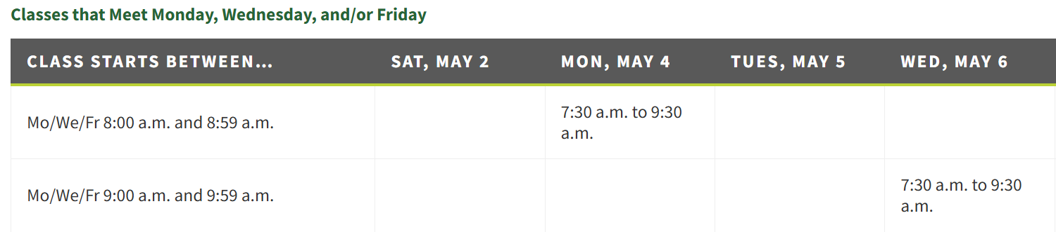
Check the UNT finals schedule and the date and times of all of your final exams and let me know prior to Spring Break if you have more than two exams on the same day.

Assignments and Assessments Section:
Keep up with your grades independently of Canvas
 | Item | Points | Points you earned
Use this chart to record items graded and returned either in class or via Canvas
Style Profiles – as assigned in class, completed outside of class via textbook readings, submitted in Canvas.
 | Style Profiles 1 | 0 to 5
 | Style Profiles 2 | 0 to 10
 | Style Profiles 3 | 0 to 10
 | Style Profiles 4 | 0 to 10
 | Style Profiles 5 | 0 to 10
 | Style Profiles 6 | 0 to 10
 | Style Profiles 7 | 0 to 10
 | Style Profiles 8 | 0 to 10
 | ……
 | Total points this section | 75+ | ~ 10 %
In class only CARD Quizzes and other ICA items – as assigned – expand table and record below as given
 | Quiz 1 | 0 to 5
 | Quiz 2 | 0 to 10
 | Quiz 3 | 0 to 10
 | Add the others
 | …
 | …
 | …
 |  | 150ish | Possible ~ 17 %
TESTS
 | Test 1 | 0 to 50
 | Test 2 | 0 to 50
 | Test 3 | 0 to 50
 | Test 4 | 0 to 50
 | Test 5 | 0 to 50
 | Test 6 | 0 to 50
 | Test 7 | 0 to 50
No test grades dropped, but one make-up allowed, given only on scheduled day at semester end. Notify me asap if missed or if you will miss a test. Any other tests missed, earns automatic “0”.
 | Total test points possible | 350 | ~ 45%
ASSIGNMENTS/PROJECTS/Quizzes - Instructions/due dates given with assignments
 | FLLW Quiz | 0 to 30
 | Architectural Icons Project | 0 to 50
 | Discovering Designers | 0 to 50
 | Presentations – in class only | 0 to 10
 | Peer Evaluations | 0 to 10
 | Total assignment points possible | 150 | ~ 17%
 | Attendance | 0 to 100 | ~ 11%
Any guest speakers, field trips, or required CMHT/MDR events as assigned |  | 0 to 25 ea
 | TOTAL POINTS POSSIBLE: 0 to ~875+ |  | 100%

Any BONUS opportunities are offered to everyone, but not on an individual basis. Complete assigned coursework at a high level of proficiency and use bonuses for insurance! Check announcements in class/Canvas postings for info
 | Bonus 1 | 0 to 10
 | Bonus 2 | 0 to 10
 | Bonus 3 - DMA or Bayless-Selby - Museum Visit - documentation submitted in Canvas required. Instructions posted in Canvas later in semester. | 0 to 10
 | Other items/changes may be added as needed.

COURSE GRADE SCALE:  A = 90% - 100%  B = 80% - 89.9%  C = 70% - 79.9%  D = 60% - 69.9%  F = 0 - 59.9% | - Keep up with your grades - current points earned/(divided by)/current points possible to determine your grade.  - Do not assume percentages will be rounded up for the final grades.  - Grades in Canvas are a repository only. Official Grade Book is NOT Canvas, the Course Excel gradebook I keep is official.  - See Levels of achievement in Canvas for earning points on assignments and projects

Tips from previous students in this class via their own reporting…

- 80% of students spent 4 or more hours per week READING in prepare for the online quizzes.
- 80% of students spent 2 to 3 hours per week WATCHING VIDEOS in prepare for the online quizzes.
- 64% of students spent 3 or more hours per week FINDING ADDITIONAL TOPIC-RELATED ITEMS ON THEIR OWN in preparation for the online quizzes.
- 60% of students immersed themselves more in this course as compared to other lecture courses.

Preparation & Time Commitment
- In-Class Overview:
  - We spend 2.7 hours per week in the classroom—just enough time for a brief review and the "backstory" to complement your readings.
- Outside the Classroom:
  - For success in this course, you may need to spend significant time independently reading, sourcing images, researching terms, and watching videos.
- The "3-to-1" Rule:
University guidelines suggest 3 hours of independent study for every 1 hour of class time.
  - The Math: 2.7 hours in class x 3 = 8 hours of weekly independent study.
- Active Learning:
  - Participate in class, read, sketch, study each topic prior to coming to class.

Not required but I recommend for reference books to build your library. Just a sample of the 1000’s available on furnishings and architecture. If you want to build your resource library with some of these, this is a good start list. Some may be available digitally. I have several that I use on a regular basis.
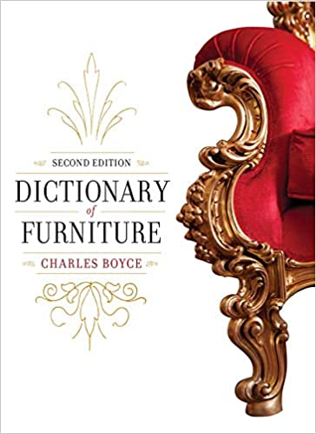  Dictionary of Furniture: 3rd Edition 2014  by Charles Boyce | 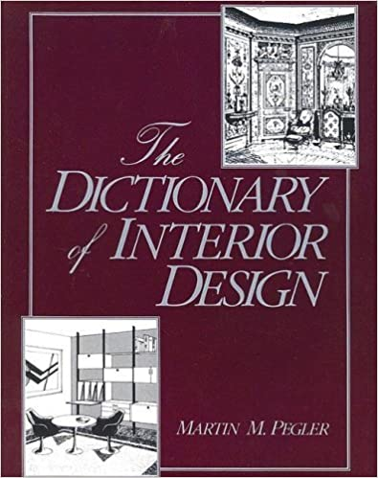  Dictionary of Interior Design  by Martin M. Pegler | 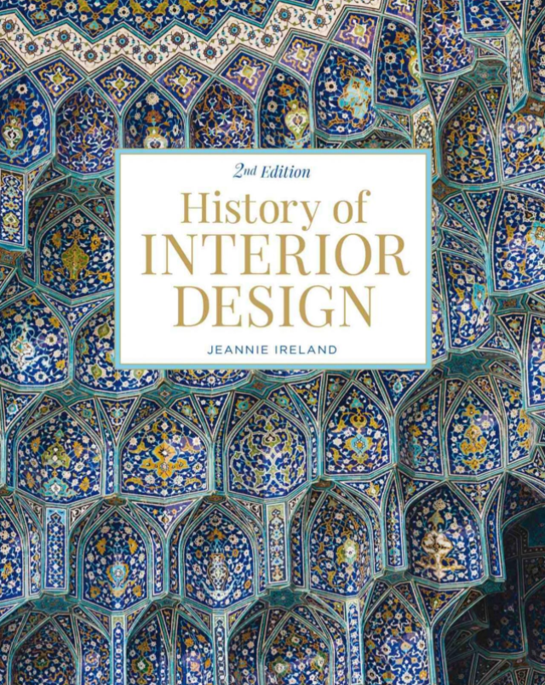  History of Interior Design  By Jeannie Ireland | 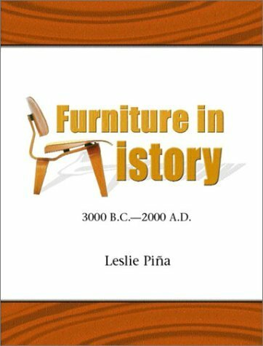  Furniture In History by Leslie Pina | 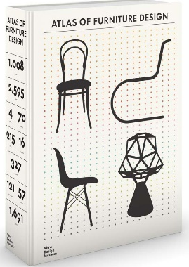  Atlas of Furniture Design Hardcover 2019 Mateo Krie
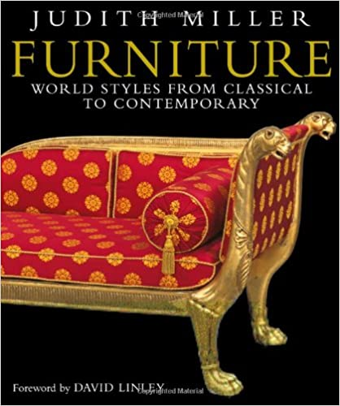  Furniture: World Styles from Classical to Contemporary 2005  by Judith Miller | 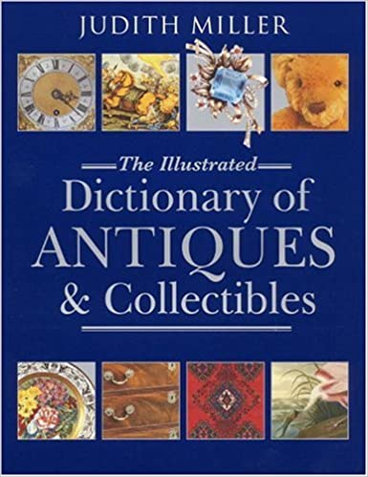The Illustrated Dictionary of Antiques and Collectibles 2001  by Judith Miller | 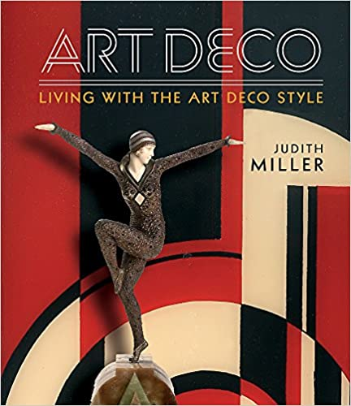  Miller's Art Deco: Living with the Art Deco Style 2016  by Judith Miller | 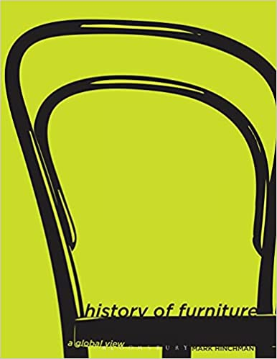  $150 History of Furniture: A Global View  by Mark Hinchman | 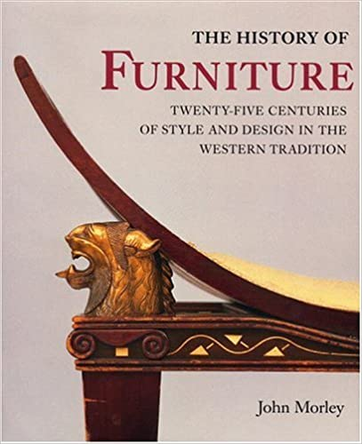  25 Centuries of Style & Design 1999  by John Morley
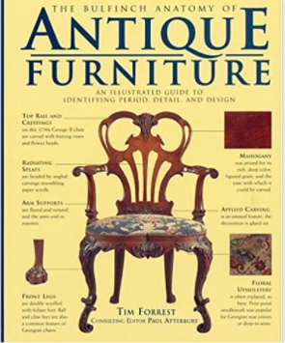  Bulfinch Anatomy of Antique Furniture: An Illustrated Guide to Identifying Period, Detail, & Design 1996  Atterbury & Forrest | 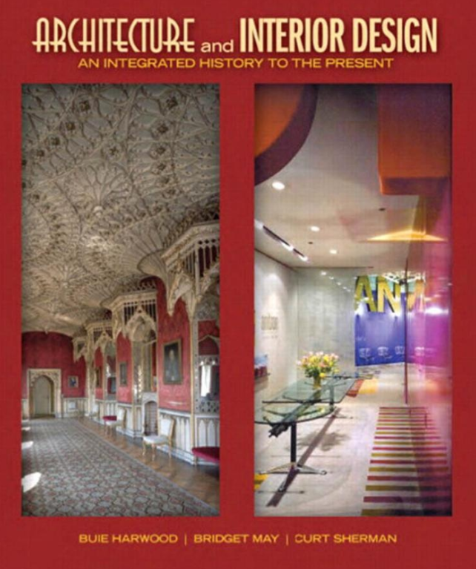  Architecture and Interior Design: An Integrated History to the Present 1st Ed, Buie arwood, Bridget May, Curt Sherman | 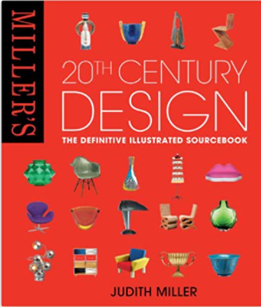  Miller's 20th Century Design The definitive illustrated sourcebook, Judith Miller | 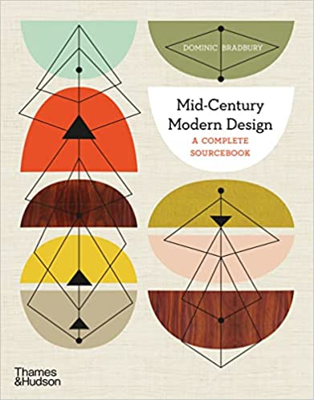  Mid-Century Modern Design: A Complete Sourcebook 2020  by Dominic Bradbury | 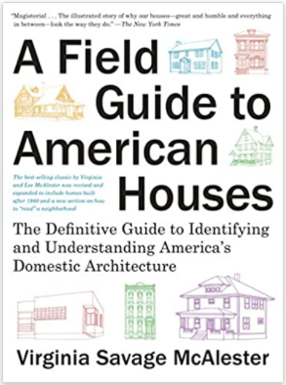  A Field Guide to American Houses:  by Virginia Savage McAlester
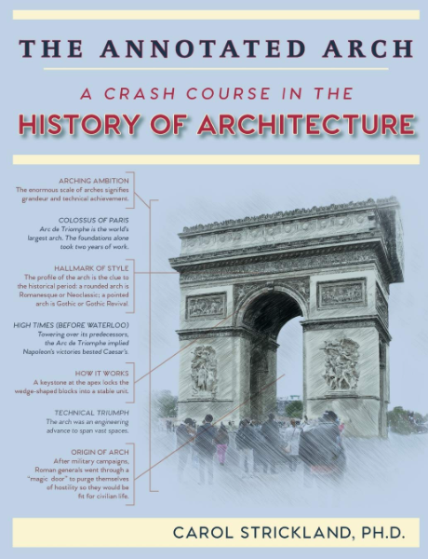  The Annotated Arch: A Crash Course in the History Of Architecture, 2018, Carol Strickland |  | 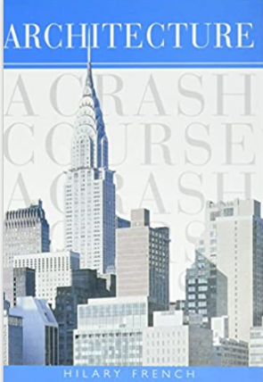  Architecture: A Crash Course by Hilary French

