Syllabus and Policies for FADM Furnishings & Décor Courses
FADM 2655 Textiles for Furnishings & Décor - Fall 2026
Fully the read following before class meeting #2…
1) SMHM Polices and 2) FADM Policies for Courses posted in Canvas
You are responsible for reading and understanding syllabus, policy, course schedule and
other documents related to courses.
Time & Place: | Tuesday & Thursday, 9.35am to 10.55am, Chilton 387, Dr. Lynn Brandon
Description: | Fibers, fabric, construction and finishes applied to selection, use and care of furnishings & decor fabrics.
Required Texts & Resources: | 1. Textiles for Residential and Commercial Interiors, 6th ed by  Yates and Concra authors, Bloomsbury Publisher  2. Interior Design Swatch Kit by Textile Fabric Consultants   - Purchase UNUSED for best course options and points.  - DO NOT open the fabric bundles, DO NOT put the fabric swatches into the Swatchbook – yet! Wait for instructions.  - Bring the Textbook & Swatch book to class every day  - You cannot share required course materials and you cannot borrow mine.  - Both are currently available in UNT Bookstore | 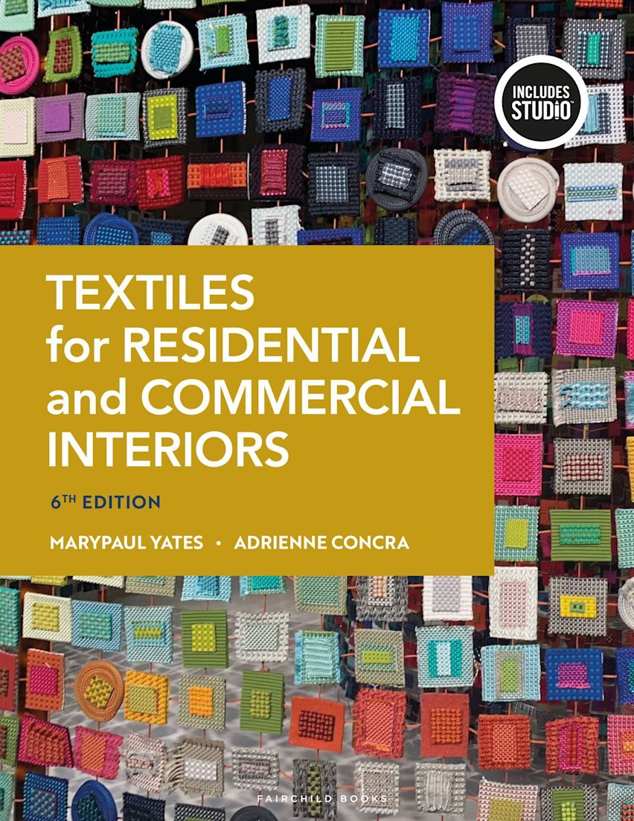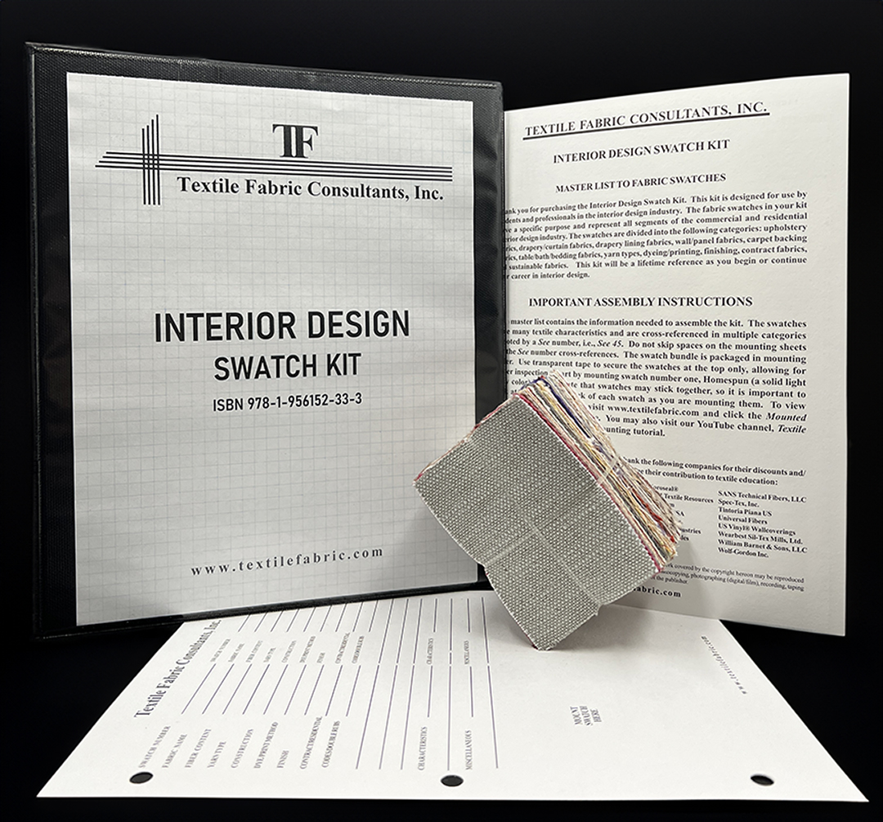  Textbook Swatch Kit
- UNT Library LibGuides/FADM Subject Guides
- F&D Industry Trade publications (F/T, HFN, HAT, others), trade websites, E-newsletters, and assigned for other readings/assignments.
- Use of UNT Library Print & Electronic Resources. APA - Publication Manual of the American Psychological Association, 7th ed. (used in all MDR courses for format of projects and assignments).
Building Your Resource Library | - Textilepedia by Fashionary - Comprehensive guide about textiles – from fiber and yarn to fabric construction and finishing. Highly visual, featuring realistic fabric photographs for easy visualization.  - Fabric Glossary, by Mary Humphries - Mostly related to apparel, but good information in general | 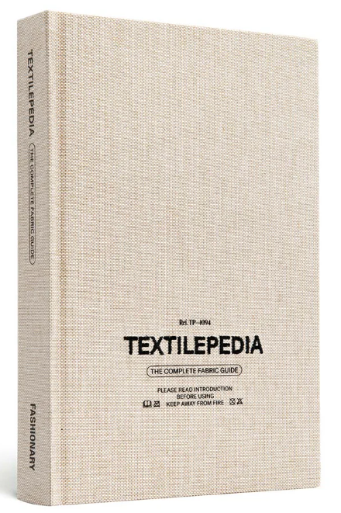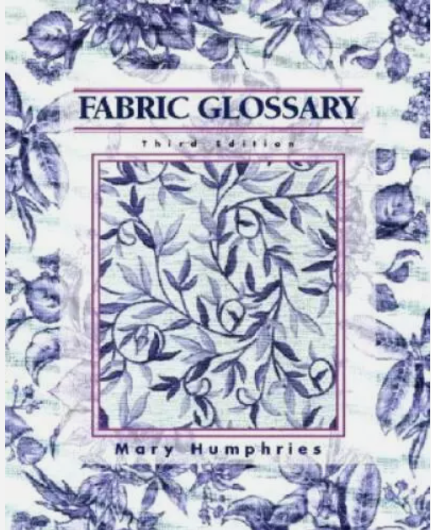
Professor | Dr. Lynn Brandon, Furnishings & Décor Merchandising Program Coordinator
Office & Phone | Chilton 342E. Main office telephone: 940-565-2436.  Canvas Inbox is most efficient/quickest way to get in touch for information and answers.

Office Hours & Teaching Schedule | Please make an appointment via Canvas Inbox (not my UNT email) for a time during office hours to ensure availability. Office hours can be in person in Chilton or via Zoom, but you must turn on camera during any Zoom meeting – I need to see you! If your desired meeting time is unavailable during office hours, other times may be possible and made by appointment only.
Office Hours & Teaching Schedule | 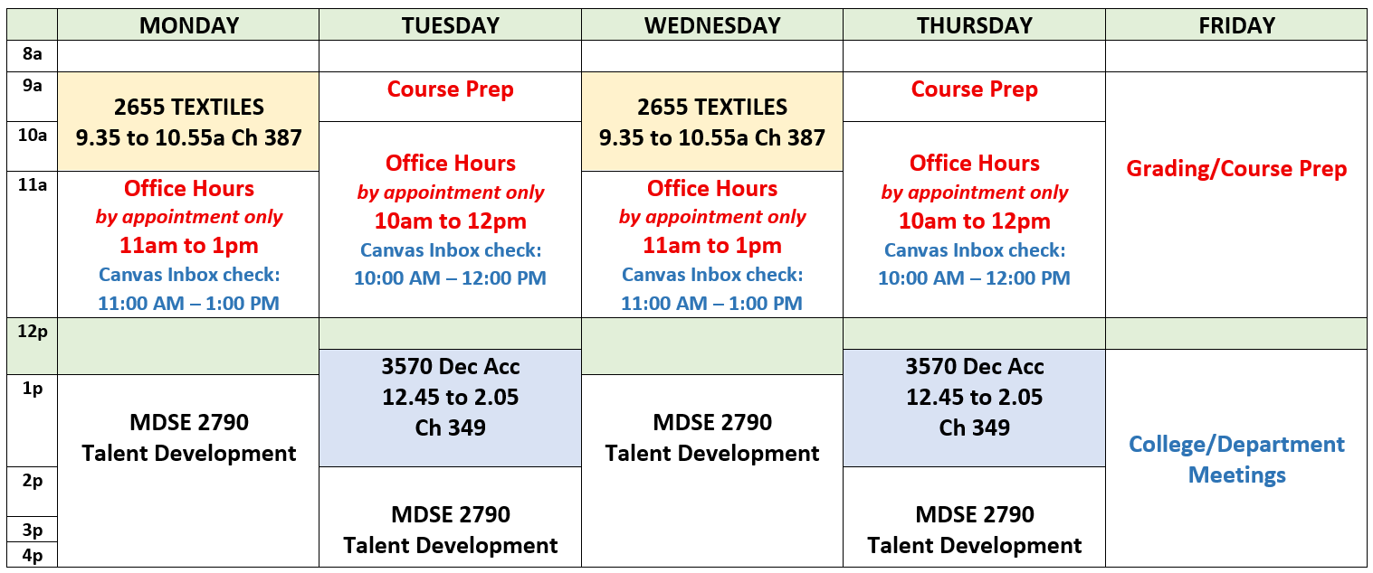
E-Mail: | For class-related questions, only use Canvas Inbox. Canvas email will be answered before UNT email due to volume. However, for general industry, FADM and degree topics, use email - Lynn.Brandon@unt.edu Provide your Name, Course Number, topic in Subject line.
Canvas Inbox and UNT Email Office Hours | - Canvas Inbox checked M & W: 11.00am to 1pm; Tu & Th: 10am to 12pm. It may also be checked at other times (Mon. – Fri.), but not before 8:00am nor after 5:00pm. No weekend checks.  - If you have questions regarding an assignment due over a weekend, ask questions at least 3 days before the due date/time to allow you time to receive an answer.  - UNT email checked regularly, but not as often as Canvas Inbox.
Use of CANVAS | - Canvas is supplement and not a substitution for attending our face-to-face class.  - I use Canvas to communicate many items to you through its Announcement feature.  - Check Canvas Announcements daily, not just on class days.  - However, some items will be communicated only through face-to-face, so attend class regularly.  - Selected items may be posted for discussions/class topics, NOT all items posted in Canvas.  - Individual instructions, via assignment or in class, will be provided per assignments/projects and how they will be submitted. Some assignments are ICA – in-class only and you must be present to participate. Most other assignments will be submitted via Canvas.
Canvas Grading | - Canvas is not the final grade book because this is not a 100% online course.  - Your final grade may not be completely known just from the items in CANVAS gradebook, an official grade book is kept.  - Keep a record of your own grades as returned in class/posted in Canvas (use Excel) you know how or ask me!  - After individual grades are posted or returned, you have one week/7 days to make an appointment to ask about a grade, after that time the grade will stand.
Class Seating & Attendance and Late Arrival | - A seating chart may be used.  - Attendance will be recorded. Be early or on-time to class so ensure your attendance is recorded and stay for the entire class time to keep your full attendance status.  - Late (after 5 minutes of class start time) arrivals are recorded. 3 lates = 1 absence. It is your responsibility to be in class on time. If late, inform me of your late arrival at the end of class that day – not after class is over and not by email/Canvas Inbox.

Student Learning Outcomes - SLOs
SLOs are the basis for the design of your assessments, assignments, quizzes, tests, projects, and more.
This is what you must complete to accomplish the goals set for you in the course.
- Fiber and Fabric Knowledge
  - Identify and describe the properties, structures, and uses of various natural, manufactured, and synthetic fibers.
  - Explain the expected performance and applications of different fibers and fabrics for use in furnishings & decor.
- Textile Construction and Design
  - Determine different textile construction methods.
  - Evaluate the suitability of various textiles for specific applications.
- Design and Innovation
  - Determine trends in textile design, functionality, and aesthetic properties.
- Historical and Context
  - Research historical and contemporary trends in textile design and use.
  - Discuss the cultural significance and influence of textiles in furnishings & décor.
- Sustainable Practices and Ethics
  - Identify sustainable practices in textile production and usage.
  - Recognize the environmental impact of different textiles and determine eco-friendly alternatives.
  - Discuss ethical considerations in textile manufacturing and usage.
- Textile Selection and Specification
  - Apply criteria for selecting appropriate textiles for residential and/or commercial interiors.
  - Specify appropriate textiles for various end uses based on factors such as durability, performance, functionality, aesthetics, maintenance, and environmental impact.
- Communication Skills
  - Use appropriate textile industry language and vocabulary.
  - Communicate effectively both visually and with written presentation skills.
- Critical Thinking and Problem Solving
  - Analyze and solve design challenges related to textile selection and application.
  - Evaluate the performance and aesthetics of textiles.

Note: changes made to course syllabus, schedule, etc. may be made as necessary.

"We learn by repetition, by application, and by being challenged"
American educator and author Jim Taylor, Ph.D.

- You are expected to complete the text readings prior to class.
- Class lectures and other activities are intended to enrich or supplement the assigned readings. They are not intended to summarize or substitute for the readings.

FADM 2655 Textiles for Furnishings & Décor Schedule/Course Calendar SV
M/W – 9.35am to 10.55am – Chilton 387
Dr. Brandon, Fall 2026
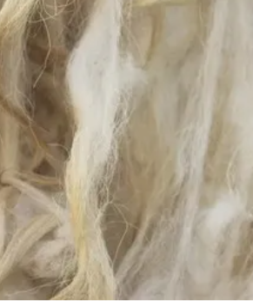 | 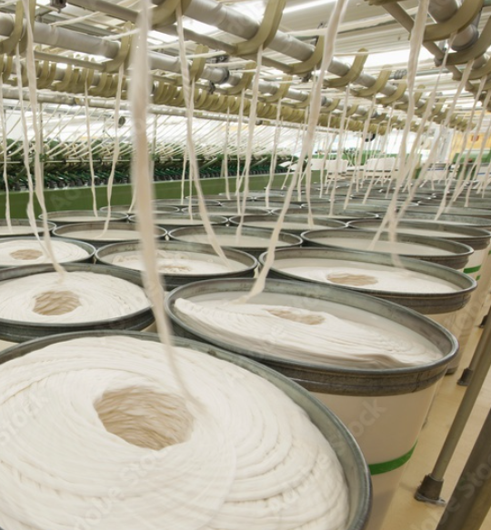 |  | 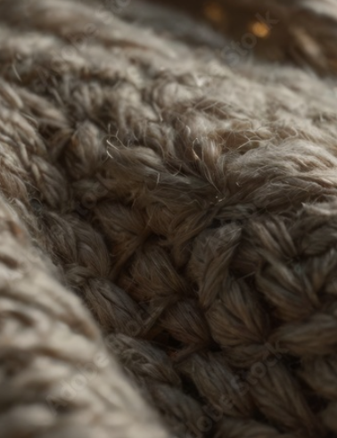 | 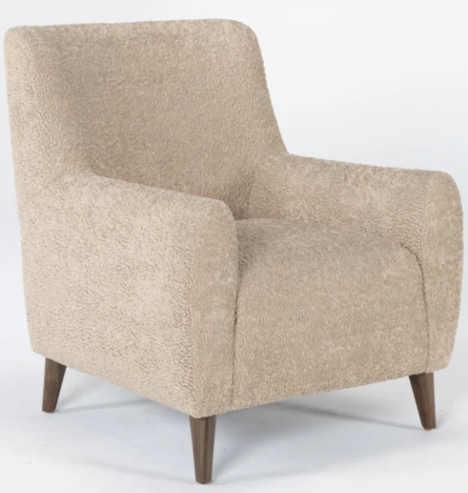

Wk | Dates | Lecture/Lesson Topics & Your Readings  Read chapters & complete other assigned items BEFORE class. |  | Record assignments and items and due dates and details as provided.
Read the Chapters listed and complete the chapter review questions before the beginning of class as scheduled, that is….work ahead.
- Review questions are at end of the chapters; there may be additional questions provided.
- Beside each question, record the page where answers are found OR record the corresponding question number within the text where the answers are found. I need to see that you are reading and answering the questions and looking up the terms.
- Random checks and instructions for uploading completed Chapter Review questions into Canvas during class only will occur. No submission after class accepted.
- Bring your swatch kit and textbook to class daily to prove your work and for submission for credit.
1 | Mon  Aug 17 | The CYCLE -  - The BIG Picture: Intro to F&D Industry and Textiles Sector  - Industry Organizations, etc | - Get Textbook and SwatchKit  - See Week 1 Module and complete the items.  - Read assigned chapters
1 | Wed  Aug 19 | CYCLE - The BIG Picture  - Textile uses - various industries  - Textile Cycle & Textile Market Segments  - Textile knowledge application
2 | Mon  Aug 24 | CYCLE -  - Chapter 1: The Textile Industry  - Chapter 2: Fabric Performance and Evaluation | Prior to class– Read Chapter & Do Review Questions for  UNIT 1: FUNDAMENTALS OF TEXTILES FOR INTERIORS  Chapter 1: The Textile Industry  - Chapter 2: Fabric Performance and Evaluation
2 | Wed  Aug 26 | CYCLE -  - Chapter 1: The Textile Industry  - Chapter 2: Fabric Performance and Evaluation | - Homework: Swatchbook/Kit – Assembly Assignment  - Points earned for completion and correctness
3 | Mon  Aug 31 | CYCLE  - Fabric and Sustainability  - Guest Speaker – ICA | Prior to class– Read Chapter & Do Review Questions for  Chapter 3: Fabric and Sustainability
 | Wed  Sep 2 | COMPONENTS - FIBERS  - Classification and Properties | - Must bring your completed and assembled Swatch Kit  - All samples mounted; no labels/information on pages.  - Assembly Assignment graded in class only  - Cannot bring to me for grading after this class.
4 | Mon  Sep 7 | LABOR DAY NO CLASS
 | Wed  Sep 9 | COMPONENTS - FIBERS  - Natural Fibers - Cellulosic  - Natural Fibers – Protein | Prior to class–Read Chapter & Do Review Questions for  Chapter 4: Fiber Classification and Properties  Chapter 5: Fibers - Natural
5 | Mon  Sep 14 | COMPONENTS - FIBERS  - Manufactured Fibers  - Including Rayon, Bamboo, Modal, Lyocell… | Prior to class– Read Chapter & Do Review Questions for  - Chapter 5: Fibers  - Manufactured Cellulosic Fibers (Rayon, Lyocell, Bamboo)
 | Wed  Sep 16 | COMPONENTS - FIBERS  - Synthetic Fibers - Including Nylon, Polyester, Acrylic, Olefin and more | - Chapter 5: Fibers  - Synthetic Fibers (Polyester, Nylon, Acrylic, Olefin/Polypropylene, High-Performance Synthetics)
6 | Mon  Sep 21 | COMPONENTS - FIBERS  - Synthetic Fibers - Including Nylon, Polyester, Acrylic, Olefin and more | - Chapter 5: Fibers
 | Wed  Sep 23 | Quiz 1 – all up to this point  - In class only, paper, not open book.  - All study items, lectures, etc. fair game. | Lab may be assigned after quiz.
7 | Mon  Sep 28 | COMPONENTS – YARNS  - Spinning Methods & Staple vs. Filaments  - Yarn Classifications  - Yarn Twist and Technical Designations | Prior to class– Read Chapter & Do Review Questions for  - Chapter 6: Yarns
 | Wed  Sep 30 | COMPONENTS – YARNS  - Spinning Methods & Staple vs. Filaments  - Yarn Classifications  - Yarn Twist and Technical Designations | - Chapter 6: Yarns
8 | Mon  Oct 5 | COMPONENTS – YARNS  - Spinning Methods & Staple vs. Filaments  - Yarn Classifications  - Yarn Twist and Technical Designations | - Chapter 6: Yarns
 | Wed  Oct 7 | COMPONENTS – YARNS  - Spinning Methods & Staple vs. Filaments  - Yarn Classifications  - Yarn Twist and Technical Designations | - Chapter 6: Yarns  - Spinning – Drop Spindle
9 | Mon  Oct 12 | Quiz 2 – Yarns and More  - In class only, paper, not open book.  - All study items, lectures, etc. fair game. | Lab may be assigned after quiz.
 | Wed  Oct 14 | CONSTRUCTION – WOVEN  - Plain, Plain Variations,  - Twill,  - Satin  - Complex  - Pile | Prior to class– Read Chapter & Do Review Questions for  - Chapter 7: Weaving (Fabrication)  - Loom Operation & Weaving Fundamentals (Warp, Weft, Selvedge, Grainline)  - Simple Weaves (Plain, Rib, Basket, Twill, Satin/Sateen)  - Complex Weaves (Dobby, Jacquard, Surface-Figure, Double Cloth, Leno, Pique)
10 | Mon  Oct 19 | CONSTRUCTION – WOVEN  - Plain, Plain Variations,  - Twill, Satin  - Complex, Pile | - Chapter 7: Weaving (Fabrication)
 | Wed  Oct 21 | CONSTRUCTION – WOVEN  - Plain, Plain Variations,  - Twill, Satin  - Complex, Pile | - Chapter 7: Weaving (Fabrication)

11 | Mon  Oct 26 | CONSTRUCTION –  OTHER FABRICATIONS  8: Other Fabrications | Prior to class– Read Chapter & Do Review Questions for  Chapter 8: Other Fabrications  - Films and Coated Fabrics (Vinyl, ….)  - Knits (Warp & Weft Knits, Tricot Backings)  - Nonwovens (Felt, Needle-Punched, Spunbonded.)  - Knotted, Twisted, and Compound Fabrics
 | Wed  Oct 28 | Quiz 4 – Construction and Fabrication  - In class only, paper, not open book.  - All study items, lectures, etc. fair game. | - Lab may be assigned after quiz.
12 | Mon  Nov 2 | CONSISTENCY  - Dyes and Printing | Prior to class– Read Chapter & Do Review Questions for  Chapter 9: Dyes and Printing  - Colorants: Dyes vs. Pigments  - Dyeing Methods, Printing Methods  - Factors Affecting Performance
 | Nov 4 | CONSISTENCY  - Finishes | Prior to class– Read Chapter & Do Review Questions for  Chapter 10: Finishes  - Mechanical & Aesthetic Finishes  - Functional & Performance Finishes
13 | Mon  Nov 9 | Performance Fabrics | Prior to class– Read Chapter & Do Review Questions for  UNIT 2: UPHOLSTERY  Chapter 13: Upholstered Furniture Construction  - Construction Features & Internal Framing  - Suspension Systems, Cushioning & Padding Materials
 | Wed  Nov 11 | Upholstery  Chapter 13: Upholstered Furniture Construction  - Construction  - Styles | Chapter 13: Upholstered Furniture Construction
14 | Mon  Nov 16 | COVERINGS  Chapter 14 - Upholstery Coverings & More  CORDING & EMBLELISHMENTS  Chapter 15: Trim and Surface Embellishments | Prior to class– Read Chapter & Do Review Questions for  Chapter 14: Upholstery Coverings  - Upholstery Fibers, Yarns, Construction Stability  - Flat-Weave Upholstery Fabrics  - Pile Upholstery Fabrics  - Leather, Grades, and Performance Fabrics  Chapter 15: Trim and Surface Embellishments  - Passementerie Types  - Application & Attachment Techniques
 | Nov 18 | CONSISTENCY  Chapter 11 – Product Labeling  Chapter 12 – Fire Safety | Prior to class– Read Chapter & Do Review Questions for  Chapter 11: Product Labeling  - Federal Trade Commission (FTC) Regulations (Textile Fiber Products Identification Act)  - Regulatory, Voluntary Labeling & Care Labeling  Chapter 12: Fire Safety  - Consumer Product Safety Regs, Flammable Fabrics Act  - Flammability Testing Standards (CAL 117, CAL 133…)  - Fire Safety Codes for Residential & Commercial Spaces

15 | Mon  Nov 23 | THANKSGIVING BREAK | 
 | Thurs  Nov 25 | THANKSGIVING BREAK
16 | Mon  Nov 30 | Quiz 5 – Construction and Fabrication  - In class only, paper, not open book.  - All study items, lectures, etc. fair game | Lab may be assigned after quiz.
 | Dec 2 | Make up day for any missed Quizzes
17 |  | FINALS WEEK  - Comprehensive Final available on Monday, Dec. 7 8am to 10am. ONLY  - Opens in Canvas for the 2 hour finals window.  - No makeups for this exam, automatic “0” if missed.

Assessments – learning application relevant to course topics.
ICA - IN-CLASS ONLY assignments – typically not announced until we are in class. Total number will vary.
There are no “make up” assignments for these. Fill in below as assigned. Double check with Canvas.
Week | Dates |  | Lecture/Lesson Topics & Your Readings | Record assignments, items, due dates and  details as provided.
Chapters assigned should be read and the chapter review questions completed before the beginning of class on the day they are scheduled, that is….work ahead.
- Review questions are at end of the chapters
- Next to the questions, record the page where answers are found OR record the answers and page numbers for better learning.
- Be prepared to answer in class on Monday of week 2.
- Bring your textbook to class daily to prove your work and for submission for credit.
- Bring swatch book every day.
Item |  |  |  |  | Points Possible | Points you earn
ATTENDANCE |  | Taken daily via Canvas, you earn for attendance and participation, not just showing up. Arriving after 5 mins of class start time is considered late – 3 lates equal 1 absence. |  |  | 0 to 100
 |  |  |  |  | Section Total | 0 to 100
ASSIGNMENTS – Some are ICA - In class only and others per assignment details or for Homework
 |  | VARK - Optional Self-Assessment: Discover Your Learning Preferences |  |  | NA
0 |  | What do you know about F&D textiles? |  |  | 0 to 10
1 |  | Postrel Video Quiz – The Fabric of Civilization |  |  | 0 to 10
2 |  | Swatch Book Assembly – grading check in class only – must be complete at beginning of class. |  |  | 0 to 10
3 |  | Swatch Book Exploration – ICA in class only |  |  | 0 to 10
4 |  | Fibers and Fabrics: Memos |  |  | 0 to 10
5 |  | Textiles in Our Home Environments |  |  | 0 to 10
6 |  | Yarns |  |  | 0 to 10
7 |  | Weaving |  |  | 0 to 10
8 |  | Performance Properties and Uses of Textiles |  |  | 0 to 10
9 - ? |  | Other ALA as needed – add them here as assigned |  |  | 0 to 10 each
 |  | Labs assigned after Quizzes as needed – record as they are assigned |  |  | 0 to 10 each
 |  | Random Chapter Review Complete Questions |  |  | 0 to 10 each
 |  |  |  |  | Section Total | 0 to 100+
The Collective Textiles Resource (series of assignments during the semester involving all students’ contributions)
1 |  | Iconic Motifs | 0 to 15
2 |  | Residential Trends Styles and Textiles | 0 to 15
3 |  | Brands to Know: Textiles Companies and More | 0 to 15
4 ? |  | Other as announced | 0 to 15 each
 |  |  | Section Total |  | 0 to 60+
PROJECTS
P1 |  | Residential Textiles | 0 to 25
P2 |  | Contract/Commercial Textiles | 0 to 25
P3 |  | Application Assignment | 0 to 25
 |  |  | Section Total |  | 0 to 75+
QUIZZES |  | In class only –Make-up for ONE missed quiz allowed; in class on Dec. 2 only.
ICA only |  | Quiz 1 | 0 to 30
ICA only |  | Quiz 2 | 0 to 30
ICA only |  | Quiz 3 | 0 to 30
ICA only |  | Quiz 4 | 0 to 30
ICA only |  | Quiz 5 | 0 to 30
 |  |  | Section Total |  | 0 to 150
TESTS |  | Final Exam is delivered via Canvas online either in the classroom or remotely, details to follow.
Final Exam |  | Comprehensive – 50 to 100 questions  Administered during scheduled final time only.  Monday, Dec. 7 - 8am to 10am | 0 to 50 points
 |  |  | Section Total |  | 0 to 50
Guest Speakers/  Field Trips |  | Required PDOs - Professional Development Opportunities.  Details provided in class and/or on Canvas.
Speakers/Field Trips/ Other:  As assigned in class – (summary report typically required for these)  - Speakers will be announced in advance.  - You must attend the class or the field trip location and fully participate and submit the Summary. See Canvas Module for Summary Report details.  - Submit the Summary Report in Canvas, EOD one week after the event or per instructions |  |  | 0 to 25 each
List each |  | Dr. J. – Sustainability | 0 to 25
 |  | Other Speaker | 0 to 25
- In-Class Attendance & Active Participation: 0–5 points
- Written Summary Report: 0–20 points
When guest speakers visit our classes, they take time from busy professional schedules to share firsthand expertise and perspectives related to our industry. This assignment requires active listening and participation and the submission of a structured, APA-formatted report detailing five substantive takeaways and their direct application to your career preparation and the Furnishings & Décor industry. Do not record the speaker.
Note: If you are absent for guest speaker, you cannot submit the report for grading. There are no makeups.
Written Report Guidelines
- Formatting (APA Style): Double-spaced throughout, 1-inch margins on all sides, standard 12-point font (e.g., Calibri), and a clean APA-style title block at the top of the first page (Your Name, Course Number, Date, Assignment Title).
- Title: Centered, descriptive title reflecting the speaker's topic and company.
- Compose and proofread carefully for spelling, sentence structure, grammatical mechanics, paragraph structure and more.
- Introductory Paragraph: Introduce the speaker, their professional title/affiliation, the presentation’s central theme, and the overall context of their discussion.
- Five Key Takeaways (Headed Sections): Use an APA bold heading for each of the five takeaways. Beneath each, write a focused paragraph in your own words that:
  - Explains the specific concept, advice, or insight shared.
  - Analyzes its direct application to Furnishings & Décor industry or your professional development.
  - Do not use generic information. All content must reflect specific details from the presentation, not general material gathered from textbooks or AI.
Grading Rubric (25 Points Total) for Summary Reports
Category | Criteria | Points
In-Class Attendance & Engagement | Present for entire presentation; attentive and actively engaged (no earbuds or phone use) | 0–5
Introductory Overview | Clearly identifies the speaker, topic, and central focus of the talk. | 0–5
Five Substantive Takeaways | Five distinct, well-developed sections analyzing specific speaker insights and F&D applications. No generic filler. | 0–10
APA Formatting & Mechanics | Double-spaced, 1-inch margins, clear bold headings throughout, correct grammar, and professional sentence structure, grammar, spelling, etc. | 0–5
Total |  | 0 to 25

 |  |  | Section Total |  | 0 to 50+
Actual final semester total determined when all projects/assignments completed.  Total Point Range |  |  |  | 0 to 585+
Bonus PDOs |  | Professional Development Opportunities. Beneficial for your success in your academic career, your internship and career prep, but not for this specific class. That is why I offer bonuses to encourage you to participate. No other bonuses offered on an individual basis.
Tue 9/22/2026 10:00AM-1:00PM  Union 314 ABC - Emerald Ballroom |  | SMHM EXPO  - ID for entry/ exit, swipe in and out, attendance time in/out reported to me.  - Come and go - visit and talk with reps from at least 4 companies. Does not have to be F&D Industry, any company is fine.  - Introduce yourself and practice your people skills.  - Ask them questions about your prep for career success, do they know anyone in the F&D industry, what is their best lesson learned about working with other people? Other questions.  - Include in report at least one selfie or pic with a company rep at the event.  - Pick up some swag.  - Attendance time in/out reported to me.  - Create a typed, double-spaced Summary Report, with an introduction paragraph, and headings with following paragraphs of the name of each company you visited and create a personally written account of what you learned at each stop.  - Spelling, grammar, correct format, etc. expected.  Credit earned for full attendance (or prorated), attendance taken only from official swipe list in/out with Student ID. You may be asked questions in class about your experience. |  |  |  | 0 to 10
Tue 10/13/2026 3:30 PM - 5:30 PM  Union Jade Ballroom A&B - Room 333 |  | Career Conversations with Alumni  - ID for entry/ exit, swipe in and out, attendance time in/out reported to me.  - Attend and learn something you can apply to the F&D industry or to your career prep.  - Include at least one selfie at the event.  - Attendance time in/out reported to me.  - Create a typed, double-spaced Summary Report, with an introduction paragraph, and headings with following paragraphs in your own words of the five take-aways from the event and how they apply to F&D industry or your personal development.  - Spelling, grammar, correct format, etc. expected.  Credit earned for full attendance (or prorated), attendance taken only from official swipe list in/out with Student ID. You may be asked questions in class about your experience. |  |  |  | 0 to 10
Tue 10/20/2026 11:00 AM - 3:00 PM  Gateway Ballroom  More details to follow |  | EIR – Executive In Residence  - ID for entry/ exit, swipe in and out, attendance time in/out reported to me.  - Attend and learn something you can apply to the F&D industry or to your career prep.  - Include at least one selfie at the event.  - Create a typed, double-spaced Summary Report, with an introduction paragraph, and headings with following paragraphs in your own words of the five take-aways from the event and how they apply to F&D industry or your personal development.  - Spelling, grammar, correct format, etc. expected.  Credit earned for full attendance (or prorated), attendance taken only from official swipe list in/out with Student ID. You may be asked questions in class about your experience. |  |  |  | 0 to 10
Details TBA |  | Textiles for Furnishings & Décor  Will be due later in the semester. |  |  |  | 0 to 10

* This is a tentative schedule subject to modifications; if changed, you will be notified.

