
Fall 2026 Syllabus
Class Session:
Asynchronous, through Canvas
Recitation:
Wednesdays
SAGE 230
CHEM 1410: General Chemistry 1
Dr. Amy Petros
University of North Texas

Welcome to General Chemistry 1

Introduction
Table of Contents
Required Material 2
Schedule 3
How to Succeed 4
Format of Class 5
Grades & Assessment 6
Bio & Contact 9
University Policies 10

Contact Information
Dr. Amy Petros
Amy.Petros@unt.edu
Office: CHEM 363

Drop-in Hours:
Wednesdays, 1:00pm – 2:00pm
Other times by request

This is the first of a two-semester sequence of general chemistry for science majors, intended to introduce you to the foundations of chemistry. The material is presented in what’s referred to as an atoms first approach, which means that we begin by talking about the parts of the atom, then how they join together to create molecules, then what kind of reactions the molecules can go through. It is a gradual building up of the information that you need to understand the next topic, hopefully told in a coherent story. We approach problems in both a qualitative and quantitative manner, so math skills (basic arithmetic, algebra, and calculator skills) are a must!

Student Learning Objectives
By the end of the semester, you should be able to:
- Explain atomic structure and behavior on both the microscale and macroscale levels.
- Use particulate-level behavior to predict and explain macroscopic behavior.
- Use molecular structure to predict and explain reactions.
- Apply tools and skills in solving chemical problems.
- Critically assess chemical problems.
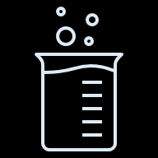

My goal for the semester is that you will develop an appreciation for the complexity of chemistry, as well as begin to gain an understanding of how to think like a scientist, specifically as it applies to critically thinking about the information that you are given and problem-solving skills. This can be frustrating at times, but we will have a lot of resources available to help you do so.
Good study habits will be essential to your success. You will have to use logic and critical thinking to solve various problems. You have many resources, including Peer-led Team Learning (PLTL), departmental tutors, and my weekly office hours. Of course, I am happy to help you outside of class as well.

Required Material
TEXT:
Chemistry, Atoms First, 2nd Ed.

OpenStax book, so freely available! Can also download a PDF for offline-access

HOMEWORK System:
Doing homework on a continual basis is extremely important for checking your understanding and keeping up-to-date.
Homework will be assigned through Canvas, and due every Sunday night. Make sure that you are working on it a little bit every day, or every other day!

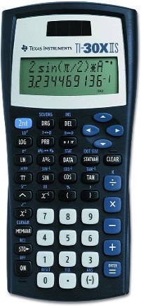
CALCULATOR:
Preferred: Texas Instruments TI-30XII Scientific Calculator
- Cost - less than $20
- Bring calculator to every class
- Practice using your calculator
- Any scientific calculator is fine

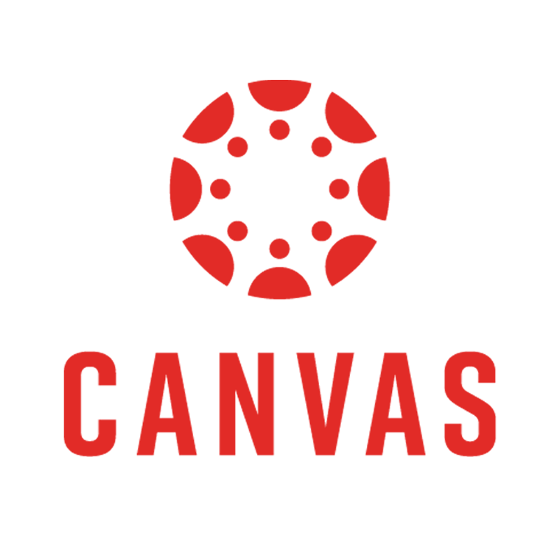

OTHER Apps For Class
- Canvas Learning Management System (LMS)
- iClicker (bring an internet-capable device)


Tentative Course Calendar
Approx Start Date | Topics | Reading Sections (OpenStax text)
8/17 | Class introduction, math review, matter and energy | 1.1 – 1.6
8/24 | Atomic structure | 2.1 – 2.4, 3.6
8/31 | Electronic structure of atoms | 3.1, 3.3
9/7 | Periodic trends | 3.4 – 3.6
 | Exam 1 – 9/15
9/14 | Ionic and covalent compounds | 2.4, 3.7
9/21 | Empirical and molecular formulas, the mole | 4.1 – 4.3, 6.1
9/28 | Structures of molecules | 2.4, 4.2, 4.4, 4.5, 6.2
10/5 | Shapes of molecules | 4.6, 5.1 - 5.3, 10.1
 | Exam 2 – 10/13
10/12 | Stoichiometry of chemical reactions | 7.1, 7.3, 7.4
10/19 | Classifying reactions and predicting products
10/26 | Acid-base reactions and molarity, redox reactions
 | Exam 3 – 11/3
11/2 | Energy: calorimetry and enthalpy | 9.1 – 9.4
11/9 | Gases | 8.1 – 8.3, 8.5
11/16 | Intermolecular forces and phase changes
 | Exam 4 – 11/17

September 7th – Labor Day, university closed
November 23rd – 27th – Fall Break, no classes
December 3rd – Last day of class
Check http://calendar.unt.edu/event-calendar/Academics for other important dates!

I reserve the right to change or modify the syllabus at any time. If changes are made, students will be notified during scheduled class times and the revised syllabus will be made available on Canvas.

Teaching Assistant (TA)

TBD
Office: TBD
Drop-in hours: TBD
Email: TBD
The TA is here to help with the logistics of the class, as well as provide help to you outside of the lecture and recitation. You can attend their drop-in hours as well to ask questions about the material, or what it’s like to be a graduate student in chemistry!

How To Succeed in General Chemistry
- Follow the study cycle. It has been proven to work!

- Attend PLTL – they have tips to tackling my tricky questions.

- Do lots of practice problems. They will show what you do and don’t know.

- Schedule tutoring sessions as early as possible.

Tips to succeed
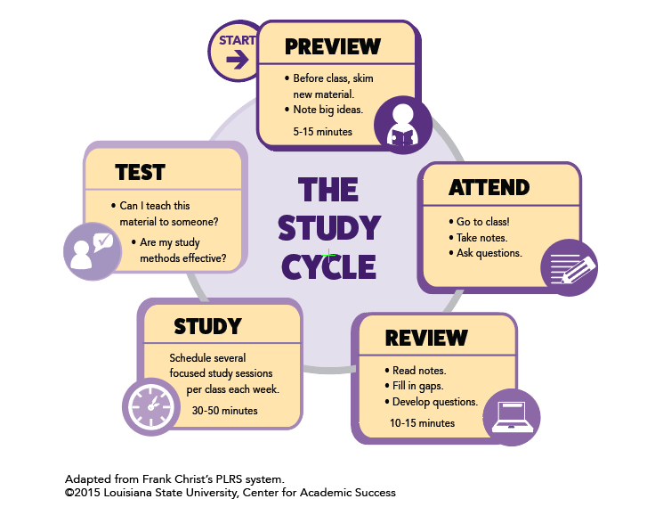

Peer-Led Team Learning (PLTL)
We have a program called PLTL (Peer-Led Team Learning) that is available for this section. You sign up and agree to attend weekly meetings with a group from your class, led by a PLTL leader. This meeting is 90 minutes, once a week. More information about this program will be given in class and can be found on Canvas. This session is NOT intended to be a tutoring session.

Tutoring Center
We have a tutoring center in the Chemistry building, the Chemistry Resource Center (CRC), room 231. It is staffed by Chemistry graduate students and they are available for drop-in tutoring. The Learning Center in Sage Hall also has a tutoring center, with drop-in, appointments, or even online tutoring available. See this link for schedules: https://chemistry.unt.edu/undergraduate-program/instructional-resources
Don’t wait to get help. Tutoring is most effective when it is started early.

Format of Class
Because learning can be challenging, we will be using a more active and student-centered approach to learning. This course is commonly known as a “flipped, hybrid” class, meaning that the content is learned on your own, through modules set up in Canvas. These modules are a combination of reading, videos, and simple problem-solving. We will meet one time per week, in which we will do more challenging problem-solving together.
You will be seated at tables in groups of 8. We will use simulations, iClicker response questions, and group discussions. Your peers at your table will be the first place you can turn to ask questions or verify your knowledge of the topics we are discussing! I ask questions during class and will wait for responses. Even wrong answers are okay! It helps me know where you are at in the discussion.

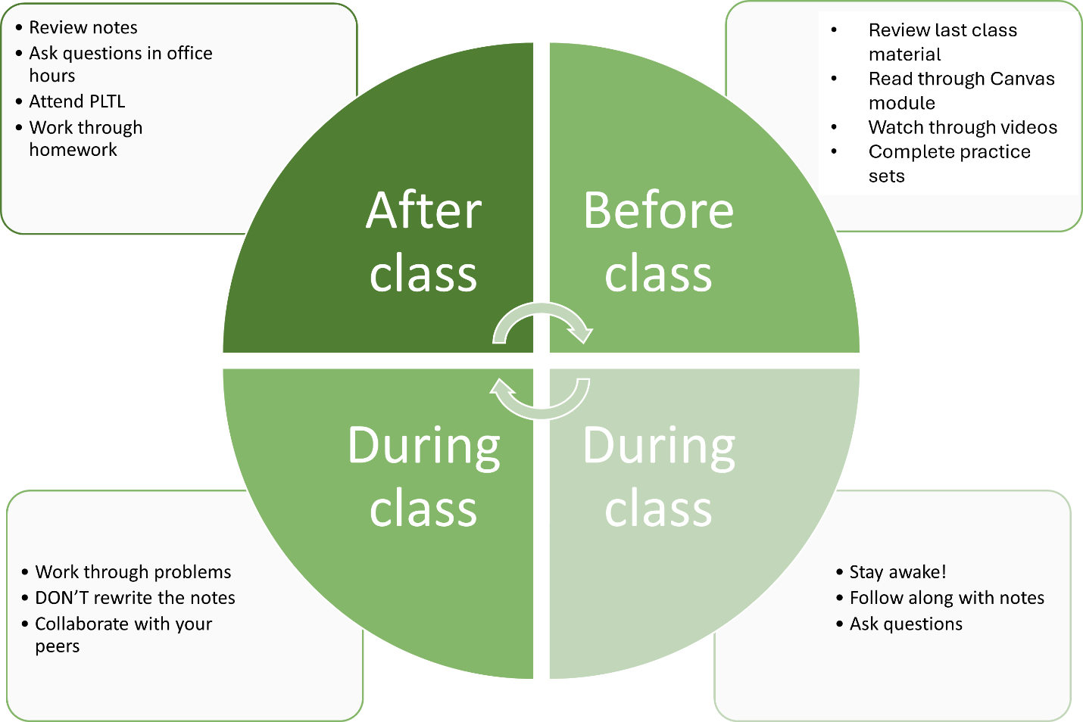

Recitation
Attendance at the recitation hour is required! This is the one in-person meeting that we will have each week. There will be a group assignment, to be turned in at the end of the recitation period (or as otherwise instructed). This is a time for you to work on problems, as chemistry is a quantitative science. This is not the time for working on homework, material for other classes, or a social hour. At the end of every recitation, there will be a quiz covering the material from that week.

Grades and Assessment

Measuring Success in This Course
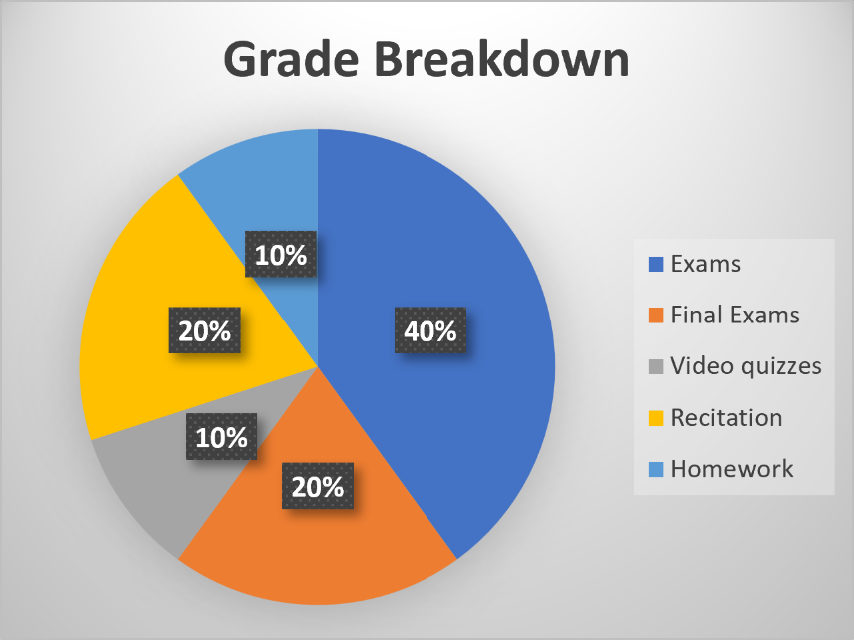

100.0% - 90.0% possible points – A
89.9% - 80.0% possible points – B
79.9% - 70.0% possible points – C
69.9% - 60.0% possible points – D
59.9% - 0.0% possible points – F

There may be extra credit offered throughout the semester, at the discretion of the instructor. Extra credit will not be offered after December 5th, so do not ask! I also DO NOT reopen past assignments for you to redo for a better grade.
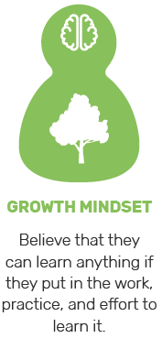
Homework: Doing problems on a continual basis is extremely important for checking your understanding and keeping up-to-date. The practice sets have unlimited attempts, so you can keep working at it until you understand.
Homework (also called practice sets) will be assigned through Canvas. Other sources, including recitation worksheets, will be used for additional practice. The nature of many chemistry problems requires that solutions be written out in detail. It is important to show complete solutions, including set-up, units, and correct use of significant figures, not just final answers, in your notes! If you get stuck, we can’t help you figure it out if you don’t know what you did!


Quizzes: There will be a weekly quiz, given at the end of recitation. If the university is closed that day for whatever reason, there will be no quiz that week.
Quizzes will check your mastery of concepts and skills and generally reflect attendance and the effort put forth in the mastery assessment. If you are doing poorly on quizzes, it is likely that you will do poorly on the exams unless something changes quickly. Use low quiz grades as a warning. Try working some extra problems from the text – and ask for help.


Exams: There will be FOUR 50-minute exams that are comprised of 33 multiple choice questions. Each exam will have 100 points possible. Your average will be calculated after dropping the lowest hourly exam grade. If a student receives a “0” because of cheating, that grade cannot be used as the dropped grade.
All quizzes and exams must be taken as scheduled. All exams must be taken at the regularly scheduled times. Exams cannot be taken outside the scheduled time. There will not be any makeup exams. A missed exam will count as your dropped test (unless there is a well-documented serious illness, requiring hospitalization).

Exam 1 (100 points) – September 15th
Exam 2 (100 points) – October 13th
Exam 3 (100 points) – November 3rd
Exam 4 (100 points) – November 17th
Final Exam (200 points) – December 5th

PLAN ACCORDINGLY FOR THE TEST DATES!

We will be doing online testing, at the testing center on the third floor of Sage Hall. There will be a drop-in time so that you can take the exam at your convenience on the date it is schedule. You are expected to bring the following items to each exam: a writing utensil (preferably a pencil with a good eraser) and a scientific calculator. Cell phones, personal tablets or laptop computers, or other electronic devices will NOT be allowed! Scratch paper and periodic tables will be provided.

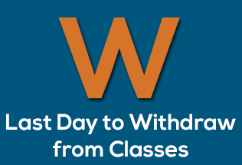
WITHDRAWAL DATE: The last date to withdraw from a course this term (with a “W” grade) is Friday, November 6th. In accordance with University policy, no exceptions will be made to the deadline. If you are failing the class at this point in the semester, you should strongly consider withdrawing.
You must earn a grade of at least C in CHEM 1410 in order to take CHEM 1420, and you must earn a C or better in CHEM 1420 in order to continue taking courses in chemistry.

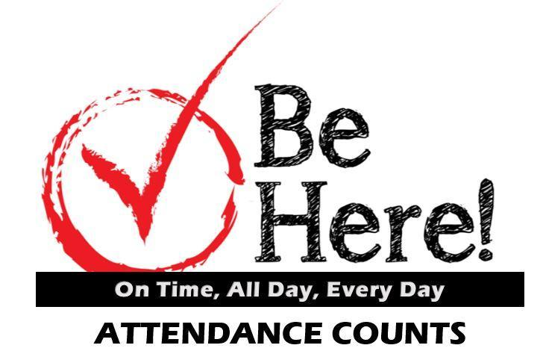
ATTENDANCE: Because class discussion and problem solving is at the heart of this course, you are required to be in class. You will check in either through Canvas or iClicker, so make sure that you bring a phone, laptop, tablet, or other WiFi-enabled device to class. In addition, participation in the course will be measured through the number of iClicker questions (presented throughout the class period) you have answered. Of course, I understand that sometimes emergencies or other unexpected circumstances arise that make attendance that day impossible. If this is the case, please talk with other students in the class to see what you missed, get copies of notes, etc. If you will be absent from a class for a university-sponsored activity, please make arrangements with me — beforehand — regarding any work you might miss.
Disruptive behavior such as talking, giggling, snoring, talking on a cell phone, playing on the Internet, watching videos, or texting, etc, will not be tolerated. Cell phones need to be muted during class. A student engaged in disruptive behavior can be asked to leave class immediately and can be suspended from class for a period of up to a week for the first offense, and longer if the behavior persists.
Taking photographs, video or audio recording of me or presentation materials without my explicit permission is not allowed. In addition, earbuds or headphones are not allowed to be used during class time, unless you have a specific documented need for them. If this is the case, please see the Office of Disability Access (ODA) to ensure that the appropriate paperwork has been filed. https://studentaffairs.unt.edu/office-disability-access

Other Notes

By university regulations, a grade of “I” (Incomplete) cannot be given as a substitute for a failing grade in a course.

CHEM 1430 is the laboratory course and a separate course from CHEM 1410. Students will receive separate grades for the two courses. Dropping either course does NOT automatically drop you from the other course.

Regarding dissemination of information, I exclusively use Canvas to email the entire class with reminders of deadlines, changes to classroom policies, etc. In addition, I post the lecture notes and grades on Canvas. Please make it a habit to check Canvas (and your email) at least twice a week.

I will not respond to email received from non-UNT email addresses, especially concerning grade information. With a personal email address, I cannot be certain that it is you on the other end. As such, please use your official UNT email address to email me. But I welcome emails at any time!

Biography and Contact
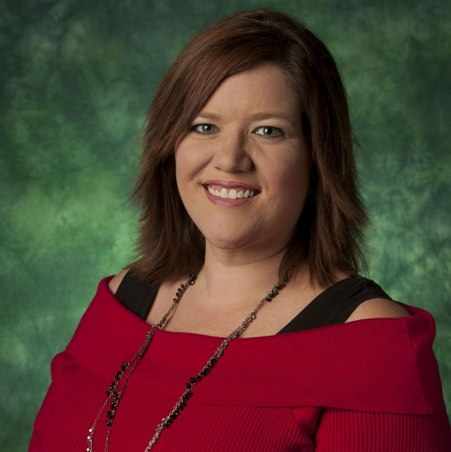
Welcome to General Chemistry 1. This is one of my favorite classes to teach, as it serves as an introduction to a fascinating view of the world, in which we are always questioning how things work around us.
About me: I received my Ph.D. in Physical Chemistry, with an emphasis on computational chemistry. I love physical chemistry, which is where chemistry, physics, and math all come together to give us fundamental information about the world around us in a way that a single discipline on its own cannot.
I also am very interested in chemical education: utilizing best practices in teaching chemistry, determining misconceptions and roadblocks to the understanding of chemistry, and working with students (undergraduates and graduate students) to overcome these roadblocks, either through learning or teaching.
- Why are you teaching? I am teaching because I love this particular topic and I love explaining it to others, hopefully in a way that makes sense! I truly enjoy discussing topics and trying to come up with ways to explain things that helps people to connect the knowledge with what they already know.
- Why are you teaching this course? I enjoy teaching this course because chemistry is all around us. I love being able to help make the connections and point out that life is full of “chemicals”, but that doesn’t have to be a scary word. Chemistry is a very rich, deep, and sometimes complicated subject, but my goal is to help you be successful!
- How do you define successful learning? Successful learning is dependent on the student. You define your own success and my goal is to help you achieve that goal. If you leave my class with more of an appreciation of chemistry, then that is also a success for me!
- What can students expect from you? Chemistry is best learned through discussion and practicing, usually through problems. However, I do not want you to just memorize how to solve a problem! I want you to understand why we use the approach that we do to solve a problem!
Drop-in Hours: Mondays and Wednesdays, 1:00pm – 2:00pm, Fridays, 10:00am – 11:00am, as well as other times by appointment
Drop-in hours are a time that I am in my office, door open and ready to talk to you! Come ask me questions about the material we are covering in class, or anything else about chemistry. There is no question too small to be covered in drop-in hours. If you are coming during my normal hours, posted above, you do not have to make an appointment or otherwise let me know that you are coming. If you can’t make those hours, for whatever reason, send me an email and we can make an appointment.

Other University Policies

ACADEMIC DISHONESTY Students caught cheating or plagiarizing will receive a "0" for that particular assignment or exam. Additionally, the incident will be reported to the Dean of Students, who may impose further penalty. According to the UNT catalog, the term "cheating" includes, but is not limited to: a. use of any unauthorized assistance in taking quizzes, tests, or examinations; b. dependence upon the aid of sources beyond those authorized by the instructor in writing papers, preparing reports, solving problems, or carrying out other assignments; c. the acquisition, without permission, of tests or other academic material belonging to a faculty or staff member of the university; d. dual submission of a paper or project, or resubmission of a paper or project to a different class without express permission from the instructor(s); or e. any other act designed to give a student an unfair advantage. The term "plagiarism" includes, but is not limited to: a. the knowing or negligent use by paraphrase or direct quotation of the published or unpublished work of another person without full and clear acknowledgment; and b. the knowing or negligent unacknowledged use of materials prepared by another person or agency engaged in the selling of term papers or other academic materials.
ACCEPTABLE STUDENT BEHAVIOR Student behavior that interferes with an instructor’s ability to conduct a class or other students' opportunity to learn is unacceptable and disruptive and will not be tolerated in any instructional forum at UNT. Students engaging in unacceptable behavior will be directed to leave the classroom and the instructor may refer the student to the Dean of Students to consider whether the student's conduct violated the Code of Student Conduct. The university's expectations for student conduct apply to all instructional forums, including university and electronic classroom, labs, discussion groups, field trips, etc. The Code of Student Conduct can be found at http://deanofstudents.unt.edu.
ADA STATEMENT The University of North Texas makes reasonable academic accommodation for students with disabilities. Students seeking accommodation must first register with the Office of Disability Accommodation (ODA) to verify their eligibility. If a disability is verified, the ODA will provide you with an accommodation letter to be delivered to faculty to begin a private discussion regarding your specific needs in a course. You may request accommodations at any time, however, ODA notices of accommodation should be provided as early as possible in the semester to avoid any delay in implementation. Note that students must obtain a new letter of accommodation for every semester and must meet with each faculty member prior to implementation in each class. For additional information see the Office of Disability Accommodation website at http://disability.unt.edu. You may also contact them by phone at (940) 565-4323.
EMERGENCY NOTIFICATION & PROCEDURES UNT uses a system called Eagle Alert to quickly notify you with critical information in the event of an emergency (i.e., severe weather, campus closing, and health and public safety emergencies like chemical spills, fires, or violence). The system sends voice messages (and text messages upon permission) to the phones of all active faculty staff, and students. Please make certain to update your phone numbers at http://www.my.unt.edu. Some helpful emergency preparedness actions include: 1) know the evacuation routes and severe weather shelter areas in the buildings where your classes are held, 2) determine how you will contact family and friends if phones are temporarily unavailable, and 3) identify where you will go if you need to evacuate the Denton area suddenly. In the event of a university closure, please refer to Canvas for contingency plans for covering course materials.

RETENTION OF STUDENT RECORDS Student records pertaining to this course are maintained in a secure location by the instructor of record. All records such as exams, answer sheets (with keys), and written papers submitted during the duration of the course are kept for at least one calendar year after course completion. Course work completed via the Canvas online system, including grading information and comments, is also stored in a safe electronic environment for one year. You have a right to view your individual record; however, information about your records will not be divulged to other individuals without the proper written consent. You are encouraged to review the Public Information Policy and the Family Educational Rights and Privacy Act (FERPA) laws and the university’s policy in accordance with those mandates at the following link: http://essc.unt.edu/registrar/ferpa.html

STUDENT PERCEPTION OF TEACHING (SPOT) Student feedback is important and an essential part of participation in this course. The Student Perception of Teaching (SPOT) is a requirement for all organized classes at UNT. This short survey will be made available at the end of the semester to provide you with an opportunity to evaluate how this course is taught.

SUCCEED AT UNT UNT endeavors to offer you a high-quality education and to provide a supportive environment to help you learn and grown. And, as a faculty member, I am committed to helping you be successful as a student. Here’s how to succeed at UNT: Show up. Find Support. Get advised. Be prepared. Get involved. Stay focused. To learn more about campus resources and information on how you can achieve success, go to http://success.unt.edu/

HEALTH AND WELLNESS SUPPORT: UNT and the Chemistry Department care about your health and wellness. Below you will find some of our campus-based, local, and national resources for health and mental health support. These services can be used for you or to help you support a friend. As this list is not exhaustive, please visit https://studentaffairs.unt.edu/push/unt-resources for more information and additional resources on health and wellness.

Counseling and Testing Services  https://studentaffairs.unt.edu/counseling-and-testing-services | Health and Wellness Center  https://studentaffairs.unt.edu/student-health-and-wellness-center
UNT Police  https://police.unt.edu/ | Substance Abuse Center  https://studentaffairs.unt.edu/rise/programs/sure-program
UNT Food Pantry
https://studentaffairs.unt.edu/food-pantry
National Suicide Prevention Lifeline (includes Veteran support services)  1-800-273-TALK | Trevor Project/LGBTQ Support  866-488-7386
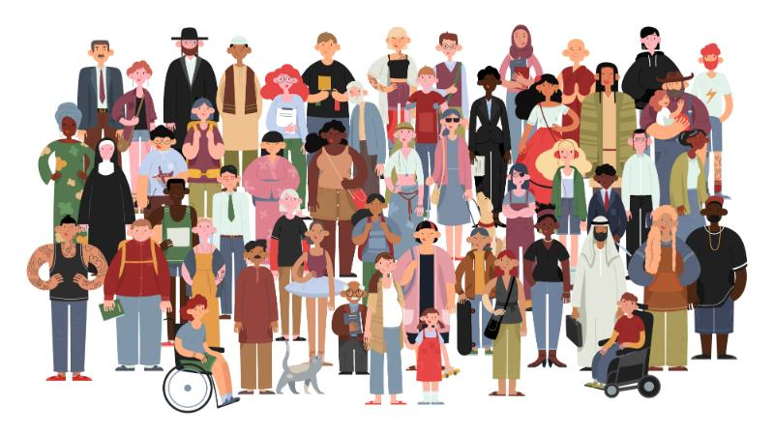
Commitment to Our Community:
As members of the UNT community, we have all made a commitment to be part of an institution that respects and values the identities of the students and employees with whom we interact. UNT does not tolerate identity-based discrimination, harassment, and retaliation so we will work as a class to collaborate in ways that encourage inclusivity. We view community as encompassing the intersecting identities that make us unique individuals, including (but not limited to) ethnic/racial identity, nationality, sexual and LGBTQ+ identity, gender identity and expression, age, religious/spiritual beliefs, socioeconomic status, body shape/size, physical ability status, and varying points of view.

