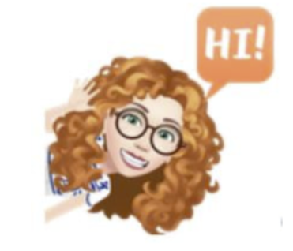
ENGL 1320 Course Syllabus



Professor | Annmarie Woods
UNT Email | annie.woods@unt.edu
Reach out to me through my UNT Outlook email!
Gmail for Document Sharing: awoodsedu@gmail.com
Pronouns | she/her
Office Hours | by appointment (email me and we’ll schedule!)
Where can we meet? | I typically hold conferences in Sycamore Library or via Zoom.

“We edit to let the fire show through the smoke.”
-Arthur Plotnik
I know this syllabus may be long and daunting, but I just want it to be as thorough and inclusive as possible! It is not meant to cause overwhelm.
Readings: FREE!
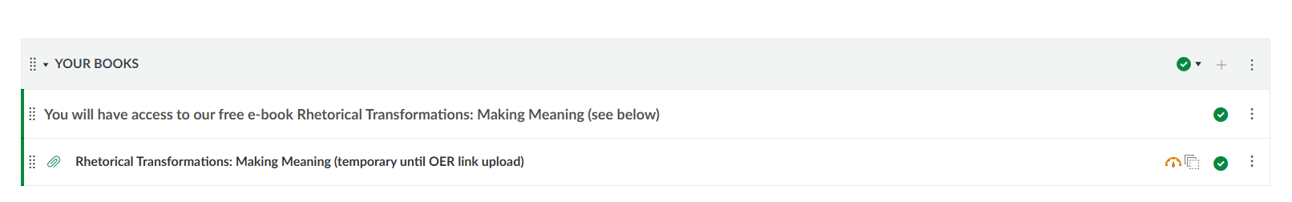
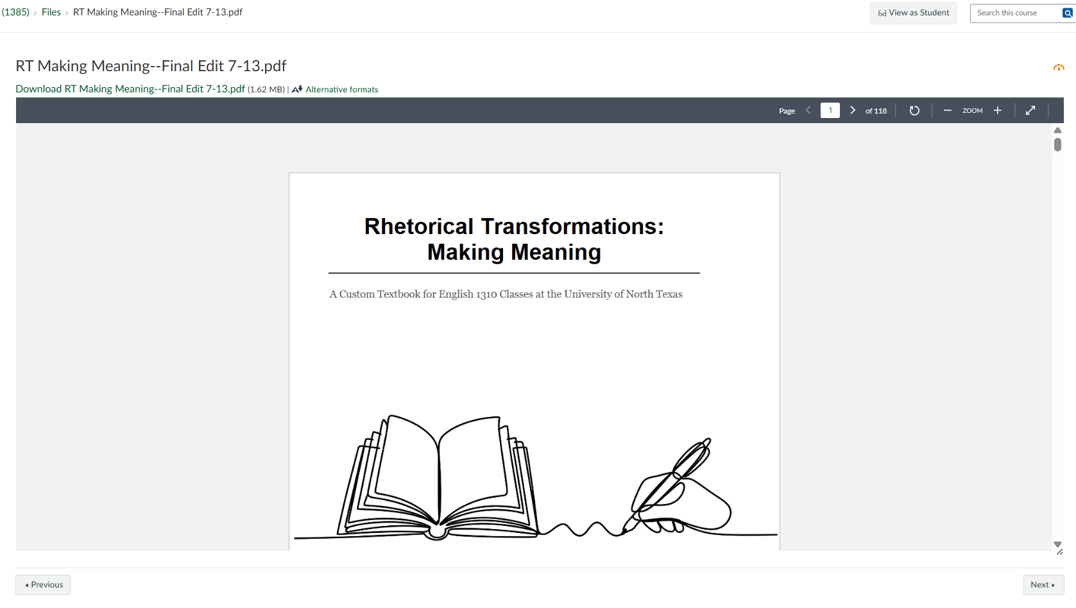
- Write and Communicate Like a Professional. Free PDF in Course Materials.


- Highlighters - yellow, blue, pink, orange, and green (we will be using these a ton for annotations!)
Highlighters are super important.
- Pencil and paper
- We will be completing in-class activities via Canvas and on paper

Where to print at UNT:
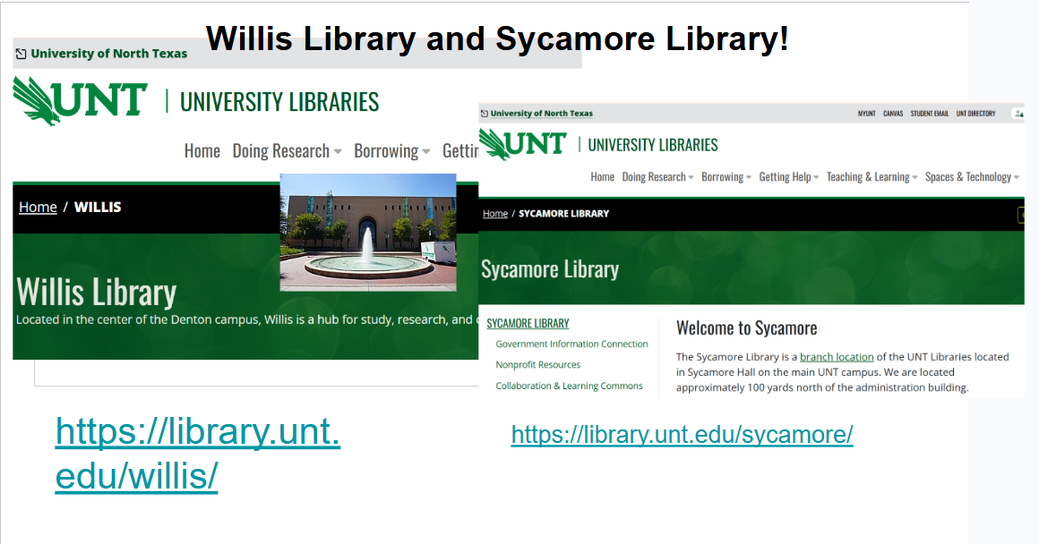

https://library.unt.edu/services/printing-scanning-copies/
Links to an external site.

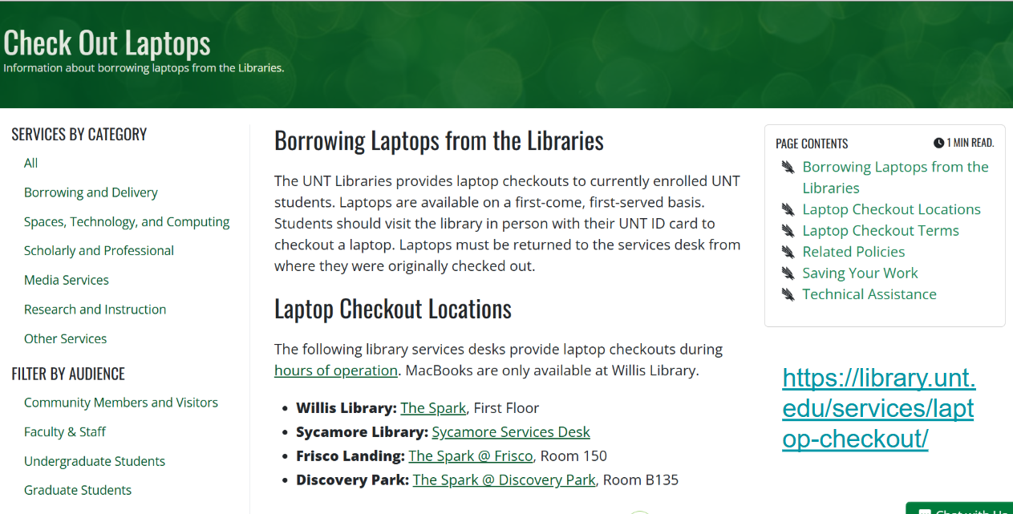
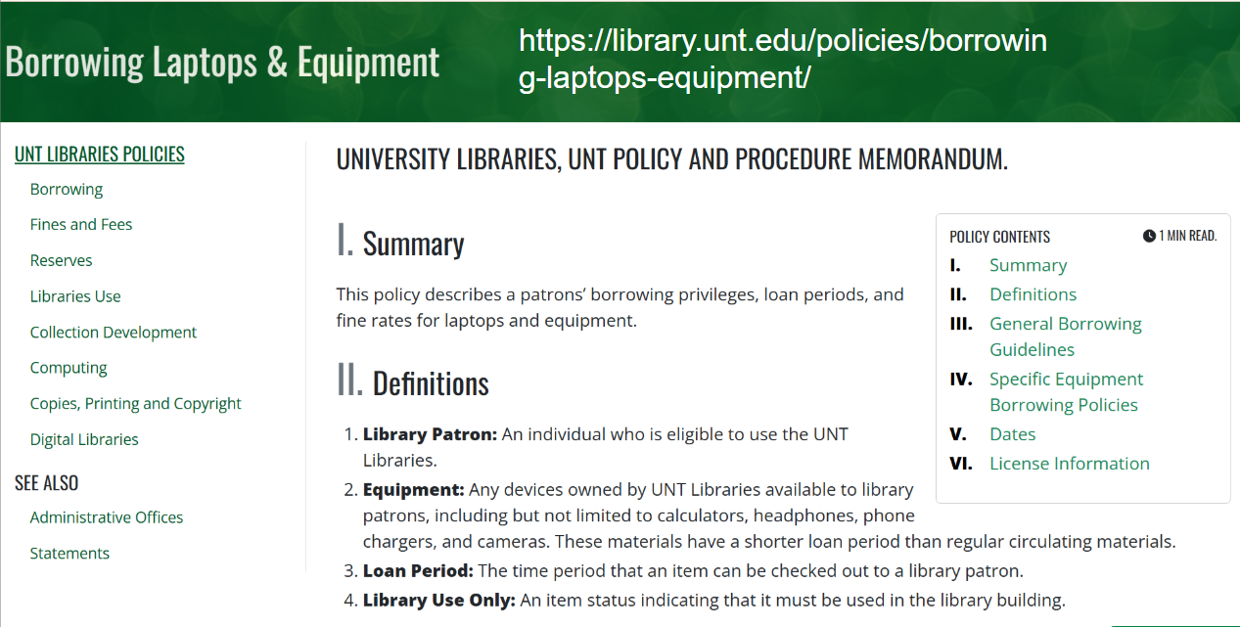
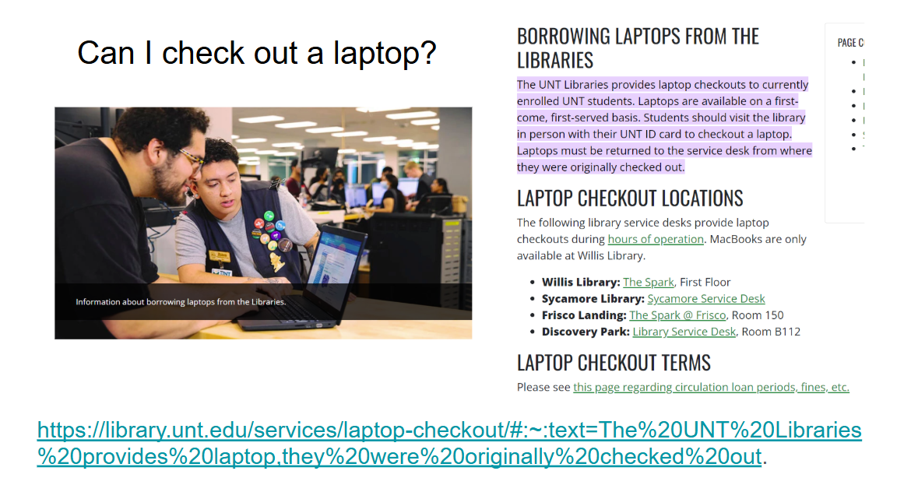

UNT Writing Center—a free service!
https://writingcenter.unt.edu/
https://unt.mywconline.com/ Links to an external site.
You can attend Writing Center appointments in person or via live chat online!
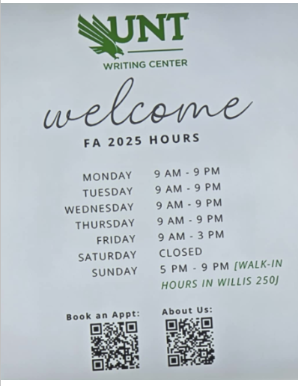
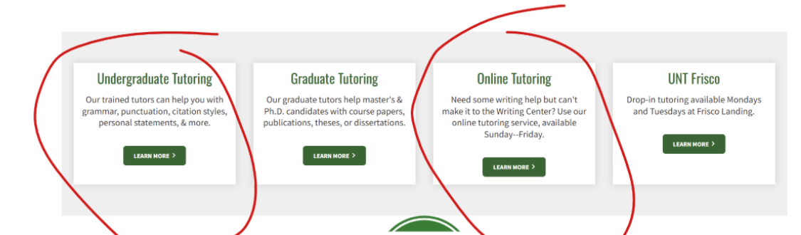

We will uphold the following university policies in all English courses.
University Policies
All students and faculty are required to follow the policies below.
Academic Integrity Standards and Consequences
According to UNT Policy 06.003, Student Academic Integrity
Links to an external site.

Academic dishonesty occurs when students engage in behaviors including, but not limited to:
- Cheating—submitting work that is generated by AI (ChatGPT, Grok, etc.)

- If you write your own essay and run it through AI afterward to fix errors or change your language/voice, the plagiarism checker will still flag it as cheating. Original work requires your original human revision (it's an important part of the writing process!).

- Fabrication—pretending you are writing about a real interview when you really made it up
- Facilitating academic dishonesty—helping someone else cheat
- Forgery
- Plagiarism—submitting someone else’s work
- Plagiarism—using someone else's published work without citing it correctly (in an assignment where citations are allowed)
- Plagiarism—resubmitting work that you have submitted in this class or another class before
- Having someone else complete assignments for you
- Sabotage—setting someone else up to fail

You will be submitting handwritten work in this class. I will compare your voice and skill to work submitted online.

A finding of academic dishonesty may result in a range of academic penalties or sanctions ranging from admonition to expulsion from the University. I am obligated to report any academic dishonesty.

If your essay comes back with a high plagiarism report (and you did not use AI), you can show proof of human effort by taking the following steps:
If you used Google Docs, you should be able to see your progress and edit history! Use the following method and show your process:
File > Version history > See version history

If you used Microsoft Word, you should be able to see your progress and edit history! Use the following method and show your process:
Go to Review > Track Changes
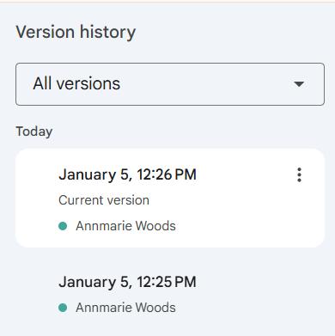
You should see timestamps and strikethrough edits.
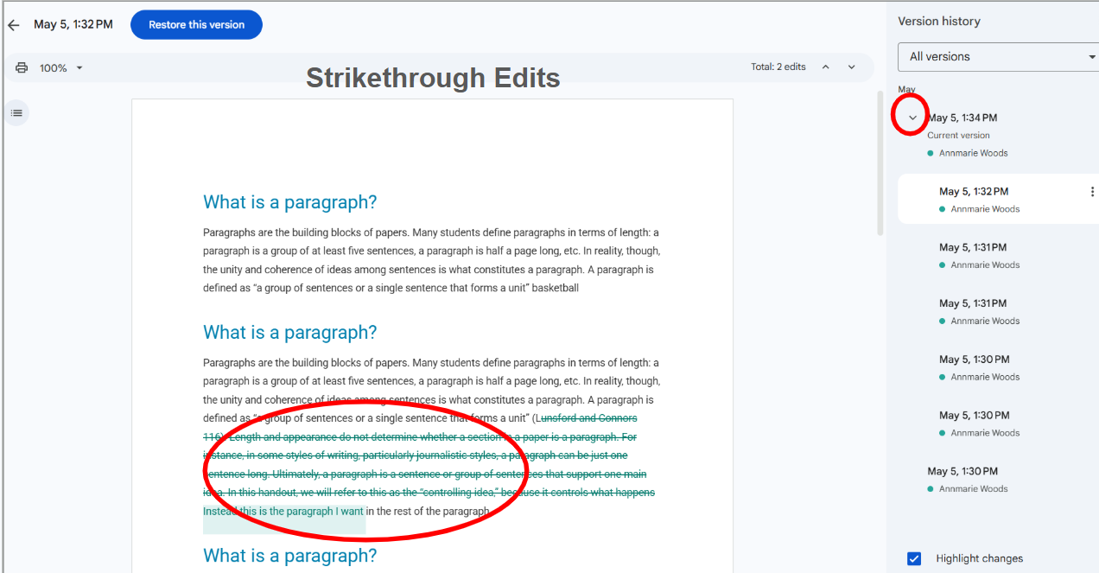
In this classroom setting, you are not permitted to use AI to brainstorm for, generate, or revise assignments. Your personal stance and feelings about AI are your own! That is your right and belief system. That being said, in this setting, we are exercising skills outside of AI. Again, if you support or use AI in other aspects of your life, that is your respected ideology. However, we are a class community in ENGL 1320, and we adhere to this contract.
A finding of academic dishonesty may result in a range of academic penalties or sanctions ranging from admonition to expulsion from the University. I am obligated to report any academic dishonesty.
*UNT Policy 06.003, section IV.C
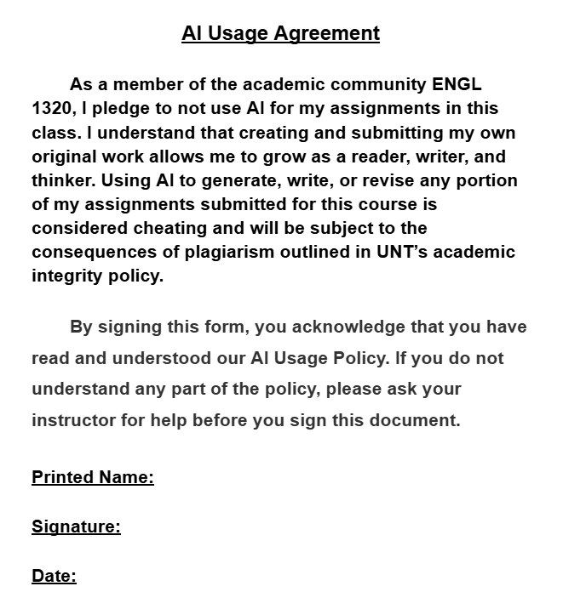

Acceptable Student Behavior
Student behavior that interferes with an instructor’s ability to conduct a class or other students' opportunity to learn is unacceptable and disruptive and will not be tolerated in any instructional forum at UNT.
Students engaging in unacceptable behavior will be directed to leave the classroom and the instructor may refer the student to the Dean of Students to consider whether the student's conduct violated the Code of Student Conduct
Links to an external site.
. The University's expectations for student conduct apply to all instructional forums, including University and electronic classroom, labs, discussion groups, field trips, etc.
The Dean of Students Office (opens in a new window)
Links to an external site.
enforces the Code of Student Conduct (opens in a new window)
Links to an external site.
. The Code explains:
- What conduct is prohibited
- The process the DOS uses to review reports of alleged misconduct by students
- The sanctions that can be assigned
This is a public writing class. You will read and edit the work of your peers. It is vital that you treat all work you encounter with consideration and respect. Remember: everyone comes from different language backgrounds and skill sets.
When students may have violated the Code, they meet with a representative from the Dean of Students Office to discuss the alleged misconduct in an educational process.

ODA/ADA Accommodations
UNT makes reasonable academic accommodation for students with disabilities. To receive accommodation, follow these steps:
- Register with the Office of Disability Access (ODA) to verify their eligibility.
- If a disability is verified, the ODA will provide a student with an accommodation letter to be delivered to faculty to begin a private discussion regarding one’s specific course needs.
- Students may request accommodations at any time; however, ODA notices of accommodation should be provided as early as possible in the semester to avoid any delay in implementation.
- Students must obtain a new letter of accommodation every semester and must meet with each faculty member prior to implementation in each class. For additional information see the ODA website
- Links to an external site.
- You may also contact them by phone at 940.565.4323.
I want to make sure that you get the accommodations you need. That is a priority.

If you need accommodations but have not cemented them through the Office of Disability Services, you need to do so as soon as possible.
https://studentaffairs.unt.edu/office-disability-access/index.html

Dean of Students
If you need an advocate, please contact the Dean of Students. They will advocate on your behalf; they will contact your professors.
If a situation arises (think: emergency), the sooner you contact the Dean of Students, the better.
Follow this link for contact information: https://studentaffairs.unt.edu/dean-of-students/index.html

Sexual Assault Prevention
UNT is committed to providing a safe learning environment free of all forms of sexual misconduct. Federal laws and UNT policies prohibit discrimination on the basis of sex as well as sexual misconduct. If you or someone you know is experiencing sexual harassment, relationship violence, stalking and/or sexual assault, there are campus resources available to provide support and assistance.
The Survivor Advocates can be reached at:
- SurvivorAdvocate@unt.edu
- Dean of Students Office: 940-565-2648
Visit Title IX Student Information (opens in a new window)
Links to an external site.
for more resources.
Undocumented Students
Please see UNT'S Resources for DACA Students
Links to an external site.
web page for more information.
Emergency Notification & Procedures
UNT uses a system called Eagle Alert
Links to an external site.
to quickly provide students with critical information in the event of an emergency (i.e., severe weather, campus closing, and health and public safety emergencies like chemical spills, fires, or violence). In the event of a university closure, please refer to Canvas for contingency plans for covering course materials.
Care Team
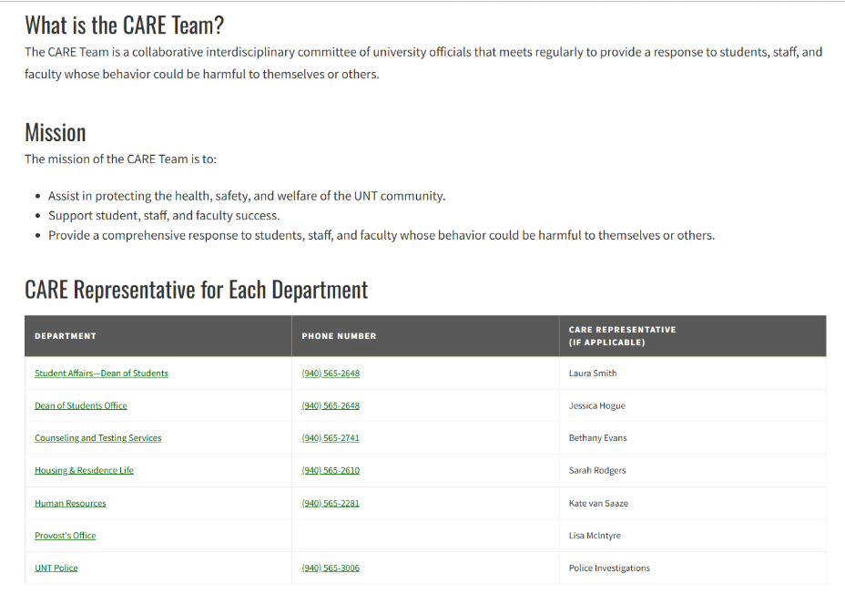
https://studentaffairs.unt.edu/dean-of-students/programs-and-services/care-team/index.html

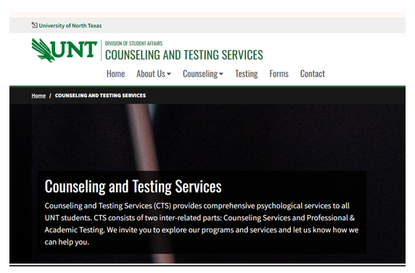


First Year Writing (FYW) Policies

In addition to the policies provided by UNT, our department also has policies that we use to ensure that you are treated fairly.

Evaluation and Grading
You will have four Major Assignments in this class. They are as follows:
Major Assignment 1 | Formal Research Proposal
Major Assignment 2 | Annotated Bibliography
Major Assignment 3 | Research and Analysis Essay
Major Assignment 4 | Reflection Remix
EACH MAJOR ASSIGNMENT IS WORTH 20% OF YOUR GRADE.
Note | To earn a passing grade, you must complete all major writing assignments.
Weekly Writing (Discussion Posts)
In-Class Activities (on paper and in Canvas)
Peer Review
Attendance

Rubrics and Scoring Systems
For the purposes of this course, we describe the grades you will be assigned in this way:
A | 90-100 | Exceeds the assignment's requirements, has few to no errors. Shows a mastery of the concepts being taught. Is impressively sophisticated, inventive, balanced, justified, effective, mature, and expertly-situated in time and context.
B | 80-89 | Meets the assignment's requirements, has few errors. Shows high level of understanding of the concepts being taught. Skilled, revealing, developed, perceptive, but not unusually or surprisingly original.
C | 70-79 | Meets most of the assignment's requirements, has some errors. Shows some understanding of the concepts being taught. Coherent, significant, and perhaps even insightful in places, but ultimately challenged in organization, articulation, perception, and/or effectiveness.
D | 60-69 | Does not meet most of the assignment's requirements, has many errors. Shows low level of understanding of the concepts being taught. Offers an overall response that is incomplete and may be severely lacking: incoherent, limited, uncritical, immature, undeveloped, and overall not reflective of the performance expected of UNT undergraduates.
F | 59 or below | Does not meet the assignment's requirements. The number of errors impede the work's meaning. Shows no understanding of the concepts being taught.

Program Values
The assignments and activities for your course were designed carefully and are based on the following departmental values.

We develop our writing skills through inquiry, experimentation, and discovery.
The act of writing encourages intellectual and personal development, and leads to greater knowledge retention, deep reflection, and empathy. Writing may teach us new ways to understand ourselves, our world, our communities, and others better. Through writing and listening to the writing of others, we grow intellectually, reflect deeply, and respond empathetically to vital issues facing ourselves, our communities, and our world.

When we write, we develop our ability to think critically about complex issues.
Writing is a practice of responding clearly, concisely, and coherently to complex issues. Students studying writing develop their logical skills and learn strategies to address critical problems with precision and purpose.

Writing is a lifelong process supported by revision and reflection.
Beyond traditional academic skills and rules of writing, writers develop flexible strategies to read, listen, plan, and collaborate with others by revisiting and reflecting on their writing experiences. Students studying writing learn to reflect on their own writing processes, which might include critical reading, planning, drafting, collaborating, revising, and reflecting, through multiple pages of drafted material.

Writing is a powerful tool and can give us agency to intervene in social issues.
Writers intervene in their communities by addressing an audience's needs and concerns. Academic audiences expect writers to address difficult questions through well-researched writing that is supported with compelling evidence. Other kinds of audiences and communities expect writers to address their needs differently, through flexible rhetorical strategies that offer relevant and timely information.

Writing is integral to information literacy and critical reading.
To write ethically and build credibility with audiences, writers must read sources carefully and know how to assess and use information effectively.

Writing is learned through effective and engaging teaching.
The First-Year Writing program (FYW) at UNT provides its instructors with ongoing educational training to help them deliver effective and engaging instruction to students. UNT FYW acknowledges excellence in teaching and fosters a culture that facilitates thoughtful instruction and promotes student success.

Required Attendance and Your Final Grade
You are required to attend class unless you are:
- Sick — your doctor told you not to attend
- Attending a university approved activity — sporting event, debate team, etc.
- Have an emergency — car accident, sick child or family member, etc.
According to the UNT First Year Writing Policy no student missing more than 20% of classroom instruction in a first-year writing course should be able to pass the course.
I will check your attendance at the start of every class period. And while I understand everyone gets sick or has emergencies, you must attend class regularly or your grade will be affected:
Number of Classes Missed | Effect on Grade
10% of total Classes — 3 classes | I will deduct 5 points from your final grade for each additional class you miss.
20% of total classes —6 classes | You will fail the course.
Note | If you are more than 15 minutes late, I will count you absent. If you leave more than 5 minutes early, I will count you absent. Refrain from packing up until two minutes before class ends. It just creates a snowball effect.
If you know ahead of time that you must miss class for a planned reason, see me as soon as possible to make arrangements.
The attendance policy is to keep you from failing; this policy is to help you succeed. It is meant to keep you in the loop and keep you from falling behind.
The attendance policy is across all ENGL 1310 and ENGL 1320 courses. Remember: this is meant to promote your success in this class.
Sometimes the hardest part is just showing up.

Authorized Absences
UNT authorizes absences for the following reasons as excusable by the university (policy 06.039):
- Religious holy day, including travel for that purpose
- Active military service, including travel for that purpose
- Participation in an official university function
- Illness or other extenuating circumstances
- Pregnancy and parenting under Title IX
- When the university is officially closed by the President
If you plan to miss class for one of the events above, please see me as soon as possible before the date of your absence, so we can arrange for you to submit work.

Communication Expectations
Communication is key to your success. When you need to reach me follow these practices:
- Communicate with me formally through my UNT email address: annie.woods@unt.edu
- If you need to share a document, my Gmail is awoodsedu@gmail.com
- Include the course and section number in the subject line: 1320.062
- Use appropriate greetings and grammatical language: "Dear Professor Woods," or "Professor Woods,”
- Treat all emails as professional communication.

- I do not respond to emails that fail to adhere to a professional format. I do not respond to emails generated by AI. This is to promote success in your academic and professional communication.

- BE AS SPECIFIC AS POSSIBLE IN THE SUBJECT LINE AND BODY OF YOUR EMAIL. THE MORE SPECIFIC YOU ARE, THE BETTER I CAN HELP YOU. THE MORE SPECIFIC YOU ARE, THE LESS WE HAVE TO EMAIL BACK AND FORTH.
- Respect the personal identities and privacy of yourself, of me, and others.
- Respect identities based on gender, sexuality, race, ethnicity, class, and/or culture.
- Think carefully about what you reveal and do not reveal, particularly if this information involves your health and/or classroom performance. If your emails contain any information that causes me to be concerned for your safety, or the safety of others, I will report it.
- Do not make personal attacks or using language that discriminates based on gender, sexuality, race, ethnicity, class, and/or culture.
Note | I am not able to discuss any information relating to academic records through email.

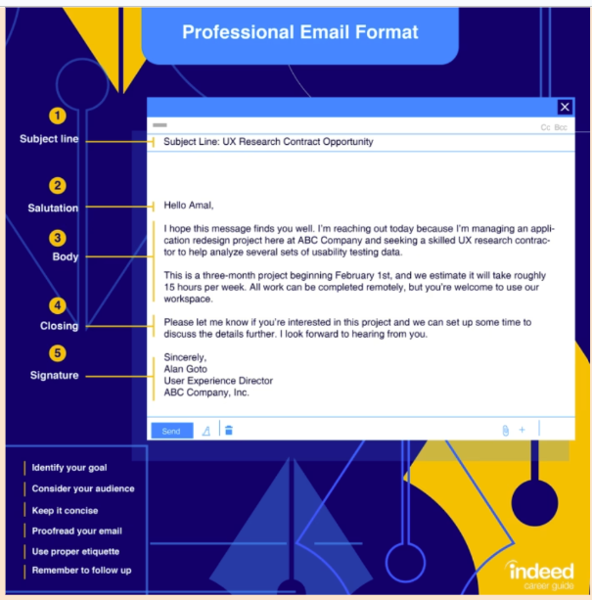
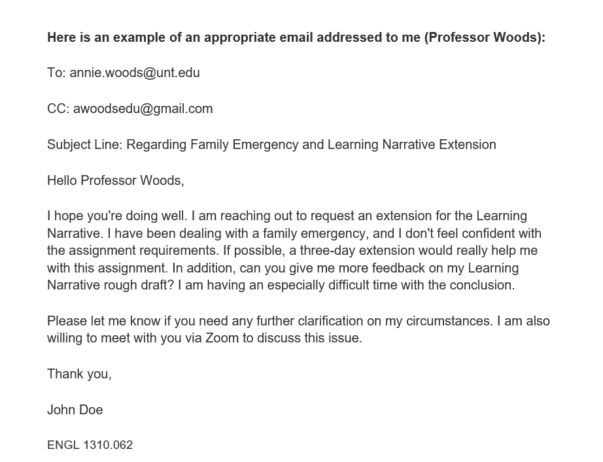

Instructor Responsibilities and Feedback
My responsibility as your instructor is to:
- Challenge you
- Help you understand the course material.
- Help you grow and learn as a student.
To achieve these goals, I will:
- Provide clear instructions for projects and assignments.
- Answer your questions.
- Identify additional resources as necessary.
- Provide substantive feedback on your written work within two weeks of the submission date for each assignment.
Disruptions
Respect the class environment by using your time effectively and helping your classmates do the same. Please avoid
- Wearing headphones (unless instructor allows it for an assignment)
- Using your phone
- Using your personal computer for purposes other than class
- Eating a full meal—small snacks are okay
- Holding side conversations
Remember: we are a class community. We all process information differently; do not distract others.

Participation and Civility
We are all members of an academic community where it is our shared responsibility to cultivate a climate where all students/individuals are valued and where both they and their ideas are treated with respect.
Therefore, I expect you to conduct yourself in a professional and respectful manner during all online interactions and class-­related activities. I expect you to listen to and respect the viewpoints of others, even if you strongly disagree with them. When you do voice disagreement in your writing, do so in a civil manner. Remember that you are accountable for your actions in this course, including your submitted work, your grades, and your interactions with me and with other students.
Everyone will have multiple opportunities to participate in class. Participation can be many things, including the following:
- Participating actively in small group work, class meetings, and discussions
- Showing attention to others in discussion posts
- Completing all assignments on time
- Coming prepared to conferences/office hours
Here are some of the “Rules of Engagement” UNT recommends as guidelines for our class:
- While the freedom to express yourself is a fundamental human right, any communication that uses cruel and derogatory language on the basis of race, color, national origin, religion, sex, sexual orientation, gender identity, age, disability, genetic information, veteran status, or any other characteristic protected under applicable federal or state law will not be tolerated.
- Treat your instructor and classmates with respect in any communication online or face-to-face, even when their opinion differs from your own.
- Speak from personal experiences. Use “I” statements to share thoughts and feelings. Try not to speak on behalf of groups or other individual’s experiences.
- Use your critical thinking skills to challenge other people’s ideas, instead of attacking individuals.
- Be cautious when using humor or sarcasm in emails or discussion posts as tone can be difficult to interpret digitally.
- Avoid using “text-talk” unless explicitly permitted by your instructor.
- Proofread and fact-check your sources.
- Keep in mind that online posts can be permanent, so think first before you type.
You also can visit the Engagement Guidelines
Links to an external site.
page at https://clear.unt.edu/online-communication-tips
Links to an external site.
for more information.
Using Canvas
Canvas is an important tool to help you succeed, and we will use it extensively:
- Submit all assignments through Canvas including quizzes, discussions, weekly writings, and major assignments.
- Check Announcements at least once a day. I will communicate important about our course as an announcement.
All students have access to Canvas through their UNT accounts. For more information on using Canvas,
- See https://community.canvaslms.com/docs/DOC-10701
- Links to an external site.
- .
- Direct questions regarding your use of the Canvas learning management system, to the student help desk at:
  - Email: helpdesk@unt.edu
  - Phone: 940-565-2324.
- Make plans to have a backup way to access the technology each week: another computer; the local library, or one of UNT's open access computer labs. Not having access to the course will not excuse you from the workload each week.
Formatting Your Assignments
- All written work needs to be typed and submitted online to Canvas. You will always upload a file (Google Docs, Microsoft Word) into Canvas.

- In ENGL 1320, we format all of our essays in MLA. Proper MLA format is what makes a solid first impression.
For all essays,
All major assignments need to be in MLA format.
- Include your name and the page number on the top right of each page (i.e.: Lastname 1)
- Include a date and the course number: ENGL 1320 on the top left of each page.
- Use Times New Roman 12 point, with one-inch (1”) margins, and double-spacing.

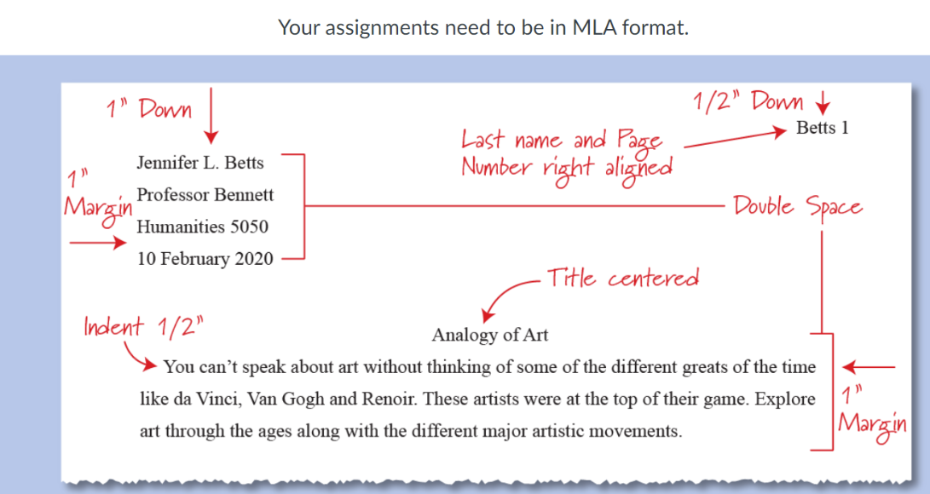
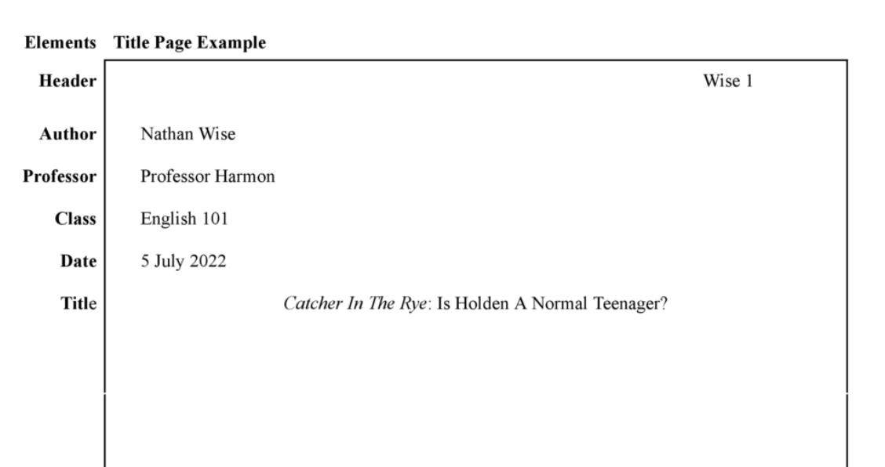
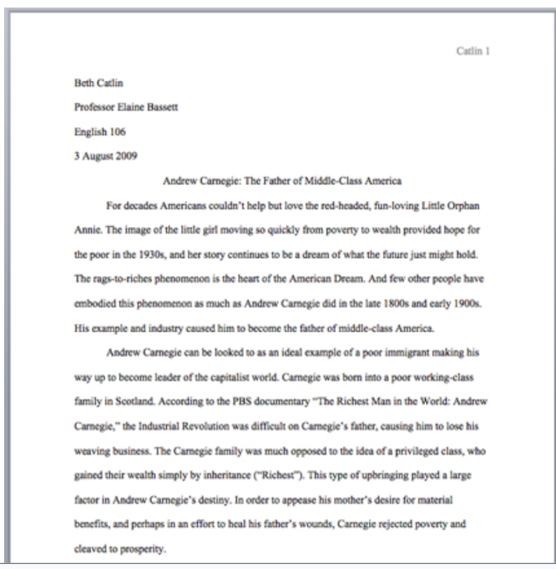

Late or Missed Assignments
I will follow these policies when deciding whether to accept late work:
- All papers are due by the date specified in Canvas.
- If you need extra time on a paper, you must request your extension at least 24 hours before the paper is due.
- I do not accept late papers.
- You cannot pass the course if you have not received a grade for all major assignments.
- Meet with me as soon as possible if you miss a deadline for an assignment.

If you pace yourself correctly, you are less likely to burn out.

Again, if assignments pile up, that will overwhelm you. This policy is to help you succeed!

AI Usage in FYW

Unacceptable Uses of AI

· Do not submit any AI generated material as your own. This is recognized as plagiarism by UNT.

· Do not use AI to identify or correct any specific errors in your work. This is considered academic dishonesty by UNT. For example, do not submit a paper with this prompt: “Find and correct every grammar and punctuation error.”

· Do not use AI to translate your work from one language to another.

Consequences for Unacceptable Use of AI
Action | Consequence
Copying and pasting AI generated work and submitting it as your own writing. | Whether you copy and paste an entire paper, or just a few sentences, you will receive a zero for the assignment.
Using AI to find and correct your errors. | You will receive a zero for the assignment.
Using AI to translate your work from one language to another. | You will receive a zero for the assignment.

No policy can cover every possible scenario for AI, so when in doubt about whether how you plan to use AI is acceptable or not, contact your instructor immediately.

To ensure that you understand this policy, and will follow the guidelines listed, please sign and submit the form your instructor gives you. Your in-class writing will be compared to your online writing.

In this course, we use an academic, scholarly, and peer-reviewed database called EBSCOhost. We will dive more into that later in the course!
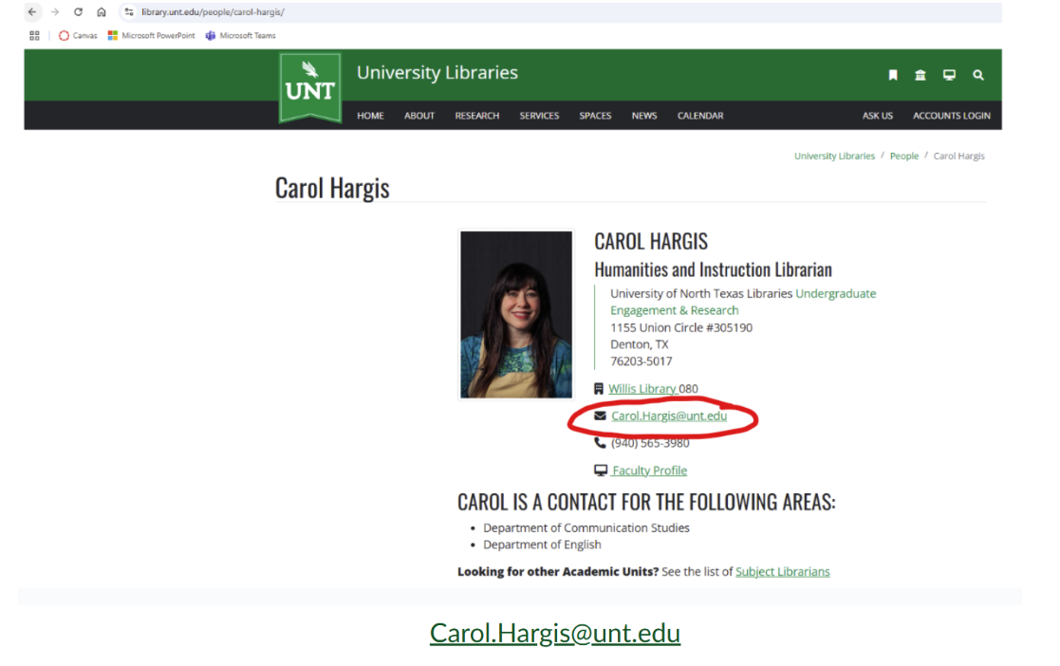
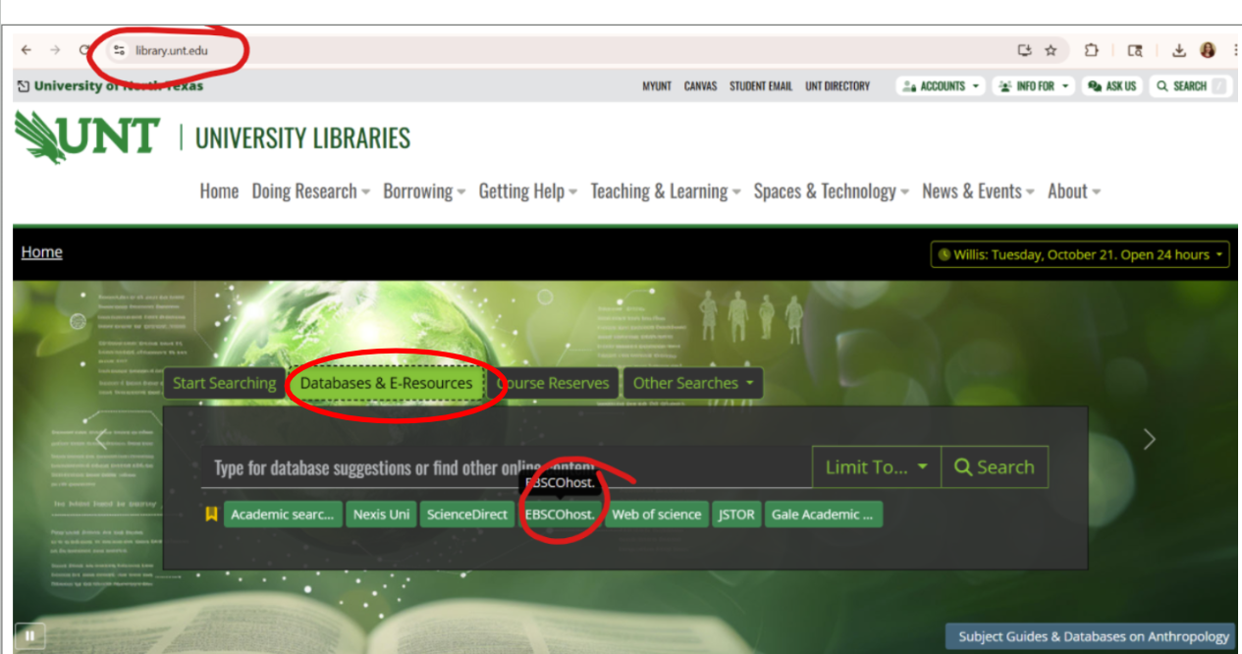

Public Writing
All your submitted writing for this course, including prewriting, drafts, in-class assignments, and final projects, is public writing. The writing that you submit in this course may be viewed by me and possibly your classmates as well. Please do not submit any information about yourself that you do not want to be public.
Syllabus Change Policy
I have made every attempt to provide your syllabus as an accurate overview of the course. However, unanticipated circumstances may make it necessary for me to modify the syllabus during the semester. These circumstances may arise in response to the progress, needs, and experiences of students. These changes may include the ever-evolving progress of AI. Advance notice will be given for any changes made to the syllabus.

Technical Requirements & Skills
Because much of the work, you must have the correct tools:
- Computer with word processing capabilities, internet access, and web browser
- Canvas Technical Requirements
- Links to an external site.
- (https://clear.unt.edu/supported-technologies/canvas/requirements
- Links to an external site.
- )

Computer Skills & Digital Literacy
Students in this course should be able to
- Use Canvas
- We will use Canvas in class.
- Use email with attachments

Chosen Names
A chosen name is a name that a person goes by that may or may not match their legal name. If you have a chosen name that is different from your legal name and would like that to be used in class, please let me know. Below is a list of resources for updating your chosen name at UNT:
- UNT Records
- Links to an external site.

- UNT ID Card
- Links to an external site.

- UNT Email Address
- Links to an external site.

- Legal Name
- Links to an external site.

Pronouns
Pronouns are a public way for people to address you, much like your name, and can be shared with a name when making an introduction, both virtually and in-person.
You can add your pronouns to your Canvas account
Links to an external site.

CORE Requirements Fulfillment
ENGL 1320 meets one of your CORE Communication requirements. The state defines "communication" as:
focusing on developing ideas and expressing them clearly, considering the effect of the message, fostering understanding and building the skills needed to communicate persuasively. Courses involve the command of oral, aural, written and visual literacy skills that enable people to exchange messages appropriate to the subject, occasion, and audience.
This course has four objectives:
- Critical Thinking Skills | innovation, inquiry, analysis, evaluation, and synthesis of information
- Communication Skills | effective development, interpretation and expression of ideas through written, oral and visual communication
- Teamwork | ability to consider different points of view and to work effectively with others to support a shared purpose or goal
- Personal Responsibility | ability to connect choices, actions and consequences to ethical decision-making

Readings:
- Steps to Writing Well (SWW)
- Write and Communicate Like a Professional (WCLP)
Needed:
Highlighters
Pencil and Paper
Device with Canvas

“I went to college because I didn’t have anywhere else to go and it was a fabulous hang. And while I was there, I was exposed to this world that I didn’t know was possible.”
–Tom Hanks

