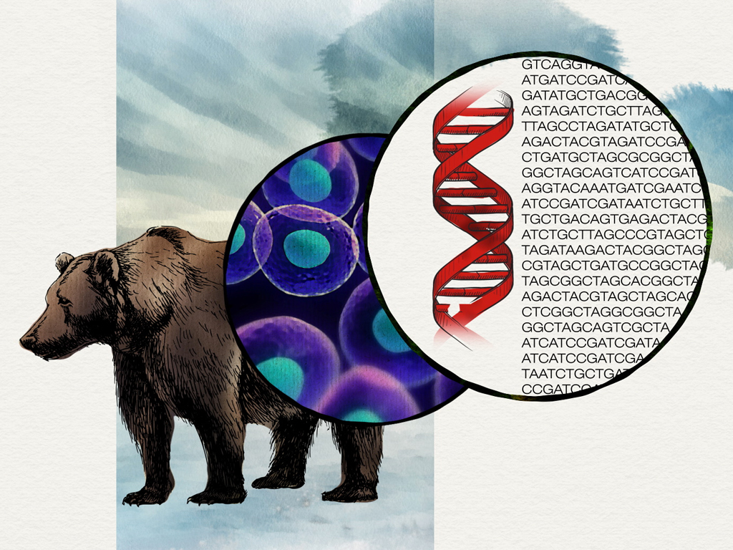
Evolution Lab (BIOL 4261/5261)
Teaching Assistant: Kaley Cave (2-4:50 Lab)
Office: EESAT 371
Email: KaleyCave@my.unt.edu
Office Hours: TBA in Class
________________________________________________________
Teaching Assistant: Reilly Neville (5-7:50 Lab)
Office: EESAT 271
Email: ReillyNeville@my.unt.edu
Office Hours: TBA in Class
Lab Meeting Location: GAB 550
Lab Meeting Time: Tuesdays from 2:00 p.m. - 4:50 p.m. OR 5:00 p.m. – 7:50 p.m.

Schedule:
Following is a tentative schedule for the lab. This may be subject to change depending on availability of materials or other conditions. Labs will use the R Programing Language to Understand Evolutionary Principles. Instructions on downloading and installing R and R Studio can be found here: https://posit.co/download/rstudio-desktop/
While the computer lab we will be working in (GAB 550) will have computers with R and R Studio pre-installed, you may also want to install these open-source packages on your own personal computer so that you can practice coding in R outside of the established lab times. All labs need to be attended in person.
Indicated for each week are the date, subject we will cover, and points for the lab.
Date | Topic | Points | Post Lab Quiz
January 13 | NO LAB | 0 | 0
1. January 20 | Discussion and go over format of lab and final project | 20 | 10 (Canvas Discussion)
2. January 27 | Module 1. Introduction to R and Darwinian Natural Selection | 20 | 10
3. February 3 | Module 2. Phylogenetics 1&2 | 20 | 10
4. February 10 | Module 3. Hardy Weinberg Equilibrium | 20 | 10
5. February 17 | Module 4. Mechanisms of Evolution | 20 | 10
6. February 24 | Module 5. Molecular Evolution and Quantitative Genetics | 20 | 10
7. March 3 | Presentation of 1st Discussion Paper | 20 | 10  (Participation in discussion)
8. March 10 | Spring Break
9. March 17 | Module 6. Adaptation and Phenotypic Plasticity | 20 | 10
10. March 24 | Module 7. Sexual Selection | 20 | 10
11. March 31 | Presentation of 2nd Discussion Paper | 20 | 10 (Participation in discussion)
12. April 7 | Module 8. Speciation | 20 | 10
13. April 14 | Module 9. Coevolution and Evolving Diseases | 20 | 10
14. April 21 | Final Project & Presentations | 40 | 10  (Participation in discussion)
Total 410 |  | 280 | 130

CANVAS:
Information pertaining to class will be posted on Canvas website at https://unt.instructure.com. This may include updates to labs, readings for discussion labs, supplemental readings or announcements. Your grades will be posted as well so you can monitor your progress over the semester. It is wise to make a habit of checking Canvas at least once a day so you do not miss important announcements.
Grades:
Each lab will have a series of responses, questions, or discussion topics worth 20 points, and Workbook Labs will have an additional 10 points per lab for turning in the completed workbook with quiz questions. In addition, there will be a final project where you will take code from one of the labs you complete in this course and apply it to a data set that you find form the peer reviewed literature. As a group you will complete this analysis and present it to the lab. The final project analysis and presentation are worth a total of 50 points. This equals 410 points total for the lab. No labs can be dropped, and there will be no bonus or extra credit points. Additionally, grades for the lab will not be curved. There are two goals to the lab: 1) Expand and develop the concepts introduced in lecture, 2) provide you an introduction to the use of R statistical computing in evolutionary analysis. Each lab session will be worth 30 points and points will be awarded based on completion of lab assignments, answering post-lab questions correctly, and participation in class discussions (for presentation-based labs).
In addition to computer-based labs, there will be two in-class Article Discussion labs, where you will give group presentations on articles related to the following subjects: Mutation, Genetic Variation and Adaptation (March 4th) and the Evolution of Social Behavior (April 1st). These articles will be chosen by your group, and you will present them as a group to the class during lab time. You will have the freedom to choose any peer-reviewed article of your interest, so long as it is published (within the last five years) in a reputable scientific journal and is about the respective subject area defined above. These presentations will be 15-minute PowerPoint presentations that will be graded based on a rubric that will be provided to you before you present. You will obtain 20 points for your presentations, and 10 points for participating in the discussions following other group presentations. You are highly encouraged to formulate your groups ahead of time (4-5 people per group) so that you can select your paper in advance. If you have questions about the eligibility of your paper, you are encouraged to share it with your instructor or TA well before your presentations.
Grade Scale  Points | Grade
216-240 | A
192-215 | B
168-191 | C
144-190 | D
< 144 | F
NOTE: This is a simple 90/80/70/60/<60 grading curve based on a total of 240 points. If the flex lab is added the point totals will be adjusted as appropriate based on that percentage breakdown.
Attendance:
Attending class and being on time are your responsibilities. If you miss a class, you will get a zero for the day. Reasonable accommodation may be offered in actual cases of adversity, but you will have to prove your case to my satisfaction. Extreme tardiness is disruptive to the class, and I will deduct half (10) of the points for the day if you are late by 20 minutes or more. Try to get to class on time.
Attendance During COVID:
Students are expected to attend all labs and to abide by the attendance policy established for the course. It is important that you communicate with your TA prior to being absent, so you, the TA, and the instructional team can discuss and mitigate the impact of the absence on your attainment of course learning goals. Please inform the TA and instructional team if you are unable to attend class meetings because you are ill, in mindfulness of the health and safety of everyone in our community. If you are experiencing any symptoms of COVID (https://www.cdc.gov/coronavirus/2019-ncov/symptoms testing/symptoms.html) please seek medical attention from the Student Health and Wellness Center (940-565-2333 or askSHWC@unt.edu) or your health care provider PRIOR to coming to campus. UNT also requires you to contact the UNT COVID Team at COVID@unt.edu for guidance on actions to take due to symptoms, pending or positive test results, or potential exposure.
Make-Up Labs:
Due to the fact that these labs are done in-person using software installed in the GAB 330 computers, there will be no make-up labs; however, if you have a verifiable, accepted excuse (e.g., illness, COVID-19, a death in the family) with a written note from a doctor or other professional and/or a positive COVID test, then we will allow you to drop a lab and your score will be calculated out of 20 less points (i.e., your final score will not including the lab you missed).
Incomplete (I) Grade:
Do not ask for an “Incomplete” grade unless you have a MAJOR life event that does not allow you to attend class. I will only give an incomplete grade under extraordinary circumstances. Please refer to the UNT policy regarding incomplete grades. The issuance of an Incomplete will be at the discretion of the course instructor not the TA.

Academic Dishonesty:
Students caught cheating or plagiarizing will receive a "0" for that particular assignment or lab. Additionally, the incident will be reported to the Dean of Students, who may impose further penalty. According to the UNT catalog, the term "cheating" includes, but is not limited to: a.) use of any unauthorized assistance in taking quizzes, tests, or examinations; b.) dependence upon the aid of sources beyond those authorized by the instructor in writing papers, preparing reports, solving problems, or carrying out other assignments; c.) acquisition, without permission, of tests or other academic material belonging to a faculty or staff member of the university; d.) dual submission of a paper or project, or resubmission of a paper or project to a different class without express permission from the instructor(s); or e.) any other act designed to give a student an unfair advantage. The term "plagiarism" includes, but is not limited to: the knowing or negligent use by paraphrase or direct quotation of the published or unpublished work of another person without full and clear acknowledgment, and the knowing or negligent unacknowledged use of materials prepared by another person or agency engaged in the selling of term papers or other academic materials. For more information, see: Academic Integrity Policy (PDF) (https://policy.unt.edu/sites/default/files/06.049_Standard%20Syllabus%20Policy%20Statements_supple ment.pdf).
Disabilities Accommodation:
The University of North Texas makes reasonable academic accommodation for students with disabilities. Students seeking reasonable accommodation must first register with the Office of Disability Access (ODA) to verify their eligibility. If a disability is verified, the ODA will provide you with a reasonable accommodation letter to be delivered to faculty to begin a private discussion regarding your specific needs in a course. You may request reasonable accommodations at any time; however, ODA notices of reasonable accommodation should be provided as early as possible in the semester to avoid any delay in implementation. Note that students must obtain a new letter of reasonable accommodation for every semester and must meet with each faculty member prior to implementation in each class. Students are strongly encouraged to deliver letters of reasonable accommodation during faculty office hours or by appointment. Faculty members have the authority to ask students to discuss such letters during their designated office hours to protect the privacy of the student. For additional information, refer to the Office of Disability Access website (http://www.unt.edu/oda). You may also contact ODA by phone at (940) 565-4323.

General Lab Rules:
All labs will take place in GAB 550, which is a computer lab on the third floor of the General Academic Building. Your conduct in this class should conform to the UNT Code of Student Conduct (www.dos.unt.edu/conduct). That being said, we want to encourage a dialogue in this class and nothing stifles dialogue as quickly as disrespect for someone’s opinion or level of knowledge. I expect you to treat your fellow classmates as you want to be treated while expressing your opinion. I want to encourage healthy discussion and even dissent, but disrespect for your fellow students in class discussions is unacceptable.
Acceptable Student Behavior:
Student behavior that interferes with an instructor’s ability to conduct a lab or other students' opportunity to learn is unacceptable and disruptive and will not be tolerated in any instructional forum at UNT. Students engaging in unacceptable behavior will be directed to leave the classroom and the instructor may refer the student to the Dean of Students to consider whether the student's conduct violated the Code of Student Conduct. The university's expectations for student conduct apply to all instructional forums, including university and electronic classrooms, labs, discussion groups, field trips, etc. See https://deanofstudents.unt.edu/conduct for more information. Emergency Procedures and Notifications: Students will be notified by Eagle Alert if there is a campus closing that will impact a class; consequently, the calendar is subject to change. I will also update all students of changes via the course Canvas page. For more information, please refer to the Emergency Notifications and Procedures Policy (PDF) (https://policy.unt.edu/sites/default/files/06.049_Standard%20Syllabus%20Policy%20Statements_supple ment.pdf).

Retention of Student Records:
Student records pertaining to this course are maintained in a secure location by the instructor. All records, such as exams, answer sheets (with keys), and written papers submitted during the duration of the course are kept for at least one calendar year after course completion. Coursework completed via the Canvas online system, including grading information and comments, is also stored in a safe electronic environment. You have a right to view your individual record; however, information about your records will not be divulged to other individuals without proper written consent. You are encouraged to review the Public Information Policy and F.E.R.P.A. (Family Educational Rights and Privacy Act) laws, as well as the university’s policy in accordance with those mandates (see: https://registrar.unt.edu/faculty/ferpa-andstudent-records).

