# ImageCourse Objectives

## Theatrical Design II

“Advanced Techniques for rendering, drawing & painting for scenic, costume and lighting designers. Pencil, ink and watercolor techniques for rendering architecture, scenery, costumes and lighting. Suggested for theatre majors who are interested in design and technology.”

## Angela Malone, instructor

RTFP 252 Angela.malone@unt.edu

OFFICE HOURS

See Canvas

or by appointment- Seriously- make an appointment via email or after class.

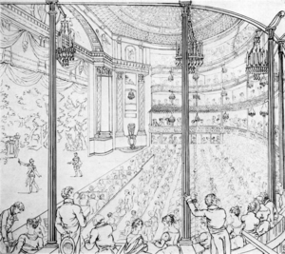

THEA 1701

Monday & Wednesday | SECTION 2-10:30am-11:50am | RTFP 137

Students will learn several different techniques for drawing and accurately depicting both space and the body within it.

This is a theatrical drawing class where the goal is to hone the student’s drawing and rendering skills so they can successfully communicate design concepts with collaborators.

Through a series of in class and homework projects that build upon one another students will explore concepts including the following: Perspective, Proportion, Balance, Composition, Observation and Color Theory.



We will use pencil, ink, pastels, watercolor as well as explore the Adobe Suite of computer design tools such as Photoshop and Illustrator.

## Materials

## Attendance & Etiquette

Come to class and be on time.

* If you are more than 15 minutes late you are considered absent.
* After the first 2 unexcused absences you will loose 50 points from your attendance grade. which totals 200pts.
* 3 lates (1-15 minutes late) will count as an absence

Excuses will be accepted so stay in touch.

If you are sick don’t come.

If you are tired come anyway it will wake you up.

Cellphones will not be tolerated unless explicitly used for a research tool when asked to during class. Please silence them.

Be kind to your fellow classmates. We will be giving constructive critiques and will help each other on their progress in their sketching/ drawing journey.

Be prepared with your materials for each class- especially your sketchbook.

You paid for this class (or will with interest) so get the most out of if by showing up.



* No text is required for this class. *

Multi-media sketch pad- no smaller than 8.5x11. At least 50 pages. - 14x17 is about right.

Various pencils of your choosing- Be sure to get a wide range of grades such as H, 2H, H, HB, B, 2B, 4B, 6B. You may also choose to get mechanical pencil(s) ( Make sure the lead thickness is 0.5 and buy at least 2 grades of lead)

Set of color pencils- at least 24 and a decent brand like Prismacolor and NOT Crayola or generic. *(Feb 27)*

kneaded eraser

pencil cap erasers

portable pencil sharpener

A few binder clips

clear/ translucent straight edge- prefer triangle with at least an 8” edge.

Architectural scale ruler

Your favorite pen(s) in black

…..later in the semester…..

various watercolor brushes *(Feb 24)*

watercolor paints *(Feb 24)*

*AFTER Week 11 if you want to work with Procreate or the link that is fine but we will start with paper & pencil.*

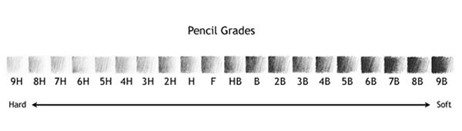

## COURSE LAYOUT

SUBJECT TO CHANGE. ALL CHANGES WILL BE POSTED ON THE CANVAS

**9** March 17: Adobe Illustrator MACLAB

March 19: Adobe Illustrator MACLAB

**10** March 24:Photoshop MACLAB

Match 26: Photoshop MACLAB

**11** March 31: **No Class**

April 2: Finish MACLAB.

**12** April 7: Re Work \**calendar due*

April 9: Re Work

**13** April 14: Costume Rendering

April 16: Costume Rendering

**14** April 21: Scenic Rendering

April 23: Scenic Rendering

**15** April 28: Final Portfolio Prep

April 30: Final Portfolio Prep

**FINAL EXAM**

Saturday May 3@ 7:30am FINAL DUE

\**calendar due*

**1** Jan 13:Introduction Class

Jan 15: Proportion

**2** Jan 20: **MLK NO CLASS**

Jan 22: Perspective \**supplies due*

**3** Jan 27: Figures

Jan 29: Figures in Motion

**4** Feb 3: Fabric. \**calendar due*

Feb 5: Figure & Fabric

**5** Feb 10: Space

Feb 12: Space

**6** Feb 17: Translating Research

Feb 19: Translating Research

**7** Feb 24: Value & Color

Feb 26: Value & Color

**8** March 3: Watercolor \**calendar due*

March 5: Watercolor

**SPRING BREAK**

NOTE ON THE FINAL PORTFOLIO: You will be working on developing and improving prior projects. This means you MUST keep all of your assignments and classwork safe and organized. Primarily your work will reside in your sketchbook but there will be others so keep this in mind as the semester progresses. Lost work will be detrimental to your final portfolio grade.

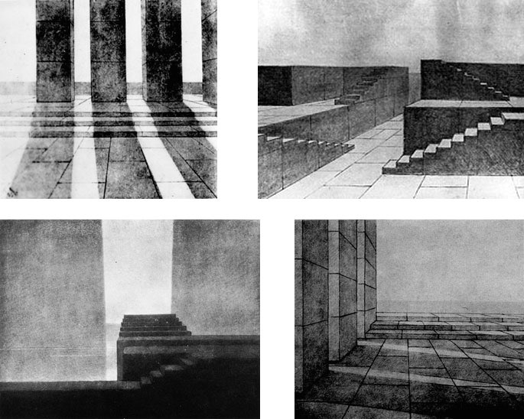

**MOST IMPORTANT POINT**

You WILL be drawing/ painting/ cutting/ pasting and working with your hands to bring to life the images in your mind. You will be graded solely on your effort/ improvement and not on your ability to draw/ paint etc. I am looking for risk and growth. I am fully aware that many of you do not have prior art class experience and imagination and creativity have been tested and drained out of you in your primary education. We are going to work to get you back to the freedom you had as a kindergartener... before you cared if each piece was a masterpiece, before there were absolute right or wrong answers, before exploring wasn’t as important as the destination.

Evaluation Procedures

The goal os the class is 1000

(A= 1000-950, B= 949-850, C= 849-750, D= 749- 700)

Minor Projects: 25 points (total of 300 points)

Calendar: 200

Attendance: 200

Final Costume: 100

Final Scenic: 100

Final Portfolio : 100

**UNT Dance & Theatre Department Policies:** Instructors can drop students on the first day of class for being absent without prior arrangement.

Dance/ Theatre students are expected to budget and organize their time and efforts in order to meet both their academic and production commitments satisfactorily and on time. The faculty and staff recognize that the academic and production assignment within the Department as well ad outside employment and other obligations sometimes impose conflicting pressures on Dance/ Theatre students. One of the principal responsibilities of each student is to carefully identify and monitor the commitments that compromise of their departmental assignments and outside obligations. It is also important to keep in mind hat production work and outside obligations do not constitute an excused absence form any class or from the completion of any required class assignment.

**UNT Policies: Academic Integrity**

Students caught cheating or plagiarizing will receive a "0" for that particular assignment or exam [or specify alternative sanction, such as course failure]. Additionally, the incident will be reported to the Dean of Students, who may impose further penalty. According to the UNT catalog, the term "cheating" includes, but is not limited to: a. use of any unauthorized assistance in taking quizzes, tests, or examinations; b. dependence upon the aid of sources beyond those authorized by the instructor in writing papers, preparing reports, solving problems, or carrying out other assignments; c. the acquisition, without permission, of tests or other academic material belonging to a faculty or staff member of the university; d. dual submission of a paper or project, or resubmission of a paper or project to a different class without express permission from the instructor(s); or e. any other act designed to give a student an unfair advantage. The term "plagiarism" includes, but is not limited to: a. the knowing or negligent use by paraphrase or direct quotation of the published or unpublished work of another person without full and clear acknowledgment; and b. the knowing or negligent unacknowledged use of materials prepared by another person or agency engaged in the selling of term papers or other academic materials.

**Acceptable Student Behavior**

Student behavior that interferes with an instructor’s ability to conduct a class or other students' opportunity to learn is unacceptable and disruptive and will not be tolerated in any instructional forum at UNT. Students engaging in unacceptable behavior will be directed to leave the classroom and the instructor may refer the student to the Dean of Students to consider whether the student's conduct violated the Code of Student Conduct. The university's expectations for student conduct apply to all instructional forums, including university and electronic classroom, labs, discussion groups, field trips, etc. The Code of Student Conduct can be found at [http://deanofstudents.unt.edu.](http://deanofstudents.unt.edu/)

**Access to Information** - Eagle Connect

Your access point for business and academic services at UNT occurs at [http://www.my.unt.edu.](http://www.my.unt.edu/) All official communication from the university will be delivered to your Eagle Connect account. For more information, please visit the website that explains Eagle Connect and how to forward your e-mail: <http://eagleconnect.unt.edu/>

**ADA Statement**

The University of North Texas makes reasonable academic accommodation for students with disabilities. Students seeking accommodation must first register with the Office of Disability Accommodation (ODA) to verify their eligibility. If a disability is verified, the ODA will provide you with an accommodation letter to be delivered to faculty to begin a private discussion regarding your specific needs in a course. You may request accommodations at any time, however, ODA notices of accommodation should be provided as early as possible in the semester to avoid any delay in implementation. Note that students must obtain a new letter of accommodation for every semester and must meet with each faculty member prior to implementation in each class. For additional information see the Office of Disability Accommodation website at [http://disability.unt.edu.](http://disability.unt.edu/) You may also contact them by phone at (940) 565-4323.

**Emergency Notification & Procedures**

UNT uses a system called Eagle Alert to quickly notify you with critical information in the event of an emergency (i.e., severe weather, campus closing, and health and public safety emergencies like chemical spills, fires, or violence). The system sends voice messages (and text messages upon permission) tothe phones of all active faculty staff, and students. Please make certain to update your phone numbers at [http://www.my.unt.edu.](http://www.my.unt.edu/) Some helpful emergency preparedness actions include: 1) know the evacuation routes and severe weather shelter areas in the buildings where your classes are held, 2) determine how you will contact family and friends if phones are temporarily unavailable, and 3) identify where you will go if you need to evacuate the Denton area suddenly. In the event of a university closure, please refer to Blackboard for contingency plans for covering course materials.

**Retention of Student Records**

Student records pertaining to this course are maintained in a secure location by the instructor of record. All records such as exams, answer sheets (with keys), and written papers submitted during the duration of the course are kept for at least one calendar year after course completion. Course work completed via the Blackboard online system, including grading information and comments, is also stored in a safe electronic environment for one year. You have a right to view your individual record; however, information about your records will not be divulged to other individuals without the proper written consent. You are encouraged to review the Public Information Policy and the Family Educational Rights and Privacy Act (FERPA) laws and the university’spolicy in accordance with those mandates at the following link: <http://essc.unt.edu/registrar/ferpa.html>

**Student Evaluation of Teaching (SETE)**

Student feedback is important and an essential part of participation in this course. The Student Evaluation of Teaching (SETE) is a requirement for all organized classes at UNT. This short survey will be made available at the end of the semester to provide you with an opportunity to evaluate how this course is taught.

### Succeed at UNT

UNT endeavors to offer you a high-quality education and to provide a supportive environment to help you learn and grown. And, as a faculty member, I am committed to helping you be successful as a student. Here’s how to succeed at UNT: Show up. Find Support. Get advised. Be prepared. Get involved. Stayfocused. To learn more about campus resources and information on how you can achieve success, go [http://success.unt.edu/.](http://success.unt.edu/)

**UNT Dance & Theatre Department Policies:** Instructors can drop students on the first day of class for being absent without prior arrangement.

Dance/ Theatre students are expected to budget and organize their time and efforts in order to meet both their academic and production commitments satisfactorily and on time. The faculty and staff recognize that the academic and production assignment within the Department as well ad outside employment and other obligations sometimes impose conflicting pressures on Dance/ Theatre students. One of the principal responsibilities of each student is to carefully identify and monitor the commitments that compromise of their departmental assignments and outside obligations. It is also important to keep in mind hat production work and outside obligations do not constitute an excused absence form any class or from the completion of any required class assignment.

**UNT Policies: Academic Integrity**

Students caught cheating or plagiarizing will receive a "0" for that particular assignment or exam [or specify alternative sanction, such as course failure]. Additionally, the incident will be reported to the Dean of Students, who may impose further penalty. According to the UNT catalog, the term "cheating" includes, but is not limited to: a. use of any unauthorized assistance in taking quizzes, tests, or examinations; b. dependence upon the aid of sources beyond those authorized by the instructor in writing papers, preparing reports, solving problems, or carrying out other assignments; c. the acquisition, without permission, of tests or other academic material belonging to a faculty or staff member of the university; d. dual submission of a paper or project, or resubmission of a paper or project to a different class without express permission from the instructor(s); or e. any other act designed to give a student an unfair advantage. The term "plagiarism" includes, but is not limited to: a. the knowing or negligent use by paraphrase or direct quotation of the published or unpublished work of another person without full and clear acknowledgment; and b. the knowing or negligent unacknowledged use of materials prepared by another person or agency engaged in the selling of term papers or other academic materials.

**Acceptable Student Behavior**

Student behavior that interferes with an instructor’s ability to conduct a class or other students' opportunity to learn is unacceptable and disruptive and will not be tolerated in any instructional forum at UNT. Students engaging in unacceptable behavior will be directed to leave the classroom and the instructor may refer the student to the Dean of Students to consider whether the student's conduct violated the Code of Student Conduct. The university's expectations for student conduct apply to all instructional forums, including university and electronic classroom, labs, discussion groups, field trips, etc. The Code of Student Conduct can be found at [http://deanofstudents.unt.edu.](http://deanofstudents.unt.edu/)

**Access to Information** - Eagle Connect

Your access point for business and academic services at UNT occurs at [http://www.my.unt.edu.](http://www.my.unt.edu/) All official communication from the university will be delivered to your Eagle Connect account. For more information, please visit the website that explains Eagle Connect and how to forward your e-mail: <http://eagleconnect.unt.edu/>

**ADA Statement**

The University of North Texas makes reasonable academic accommodation for students with disabilities. Students seeking accommodation must first register with the Office of Disability Accommodation (ODA) to verify their eligibility. If a disability is verified, the ODA will provide you with an accommodation letter to be delivered to faculty to begin a private discussion regarding your specific needs in a course. You may request accommodations at any time, however, ODA notices of accommodation should be provided as early as possible in the semester to avoid any delay in implementation. Note that students must obtain a new letter of accommodation for every semester and must meet with each faculty member prior to implementation in each class. For additional information see the Office of Disability Accommodation website at [http://disability.unt.edu.](http://disability.unt.edu/) You may also contact them by phone at (940) 565-4323.

**Emergency Notification & Procedures**

UNT uses a system called Eagle Alert to quickly notify you with critical information in the event of an emergency (i.e., severe weather, campus closing, and health and public safety emergencies like chemical spills, fires, or violence). The system sends voice messages (and text messages upon permission) tothe phones of all active faculty staff, and students. Please make certain to update your phone numbers at [http://www.my.unt.edu.](http://www.my.unt.edu/) Some helpful emergency preparedness actions include: 1) know the evacuation routes and severe weather shelter areas in the buildings where your classes are held, 2) determine how you will contact family and friends if phones are temporarily unavailable, and 3) identify where you will go if you need to evacuate the Denton area suddenly. In the event of a university closure, please refer to Blackboard for contingency plans for covering course materials.

**Retention of Student Records**

Student records pertaining to this course are maintained in a secure location by the instructor of record. All records such as exams, answer sheets (with keys), and written papers submitted during the duration of the course are kept for at least one calendar year after course completion. Course work completed via the Blackboard online system, including grading information and comments, is also stored in a safe electronic environment for one year. You have a right to view your individual record; however, information about your records will not be divulged to other individuals without the proper written consent. You are encouraged to review the Public Information Policy and the Family Educational Rights and Privacy Act (FERPA) laws and the university’spolicy in accordance with those mandates at the following link: <http://essc.unt.edu/registrar/ferpa.html>

**Student Evaluation of Teaching (SETE)**

Student feedback is important and an essential part of participation in this course. The Student Evaluation of Teaching (SETE) is a requirement for all organized classes at UNT. This short survey will be made available at the end of the semester to provide you with an opportunity to evaluate how this course is taught.

### Succeed at UNT

UNT endeavors to offer you a high-quality education and to provide a supportive environment to help you learn and grown. And, as a faculty member, I am committed to helping you be successful as a student. Here’s how to succeed at UNT: Show up. Find Support. Get advised. Be prepared. Get involved. Stay focused. To learn more about campus resources and information on how you can achieve success, go [http://success.unt.edu/.](http://success.unt.edu/)

Fabulous First Drawing Here

