

American Sign Language 3

SGNL 2040

Section 003: 12:30p – 1:50p in LANG 323

Section 004: 2:00p – 3:20p in LANG 323
Instructor: Audrey Sendejo, M.Ed. (She/Her) Office: LANG 401 E Hours: By appointment: TTH 11:00am – 12:15pm
E-Mail: audrey.sendejo@unt.edu
*Connect with me through email or Canvas. During busy times, my inbox becomes full, so if you contact me and do not receive a response within 2 business days, please send a follow up email.
Tutors: Jenna Jones: JennaJones@my.unt.edu
Text & Other Materials/Supplies:
- Interactive Online Student Materials for Signing Naturally Units 7-12

- Canvas - To fully participate in this class, students will need internet access to reference content on the Canvas Learning Management System and a recording device for expressive assignments. If circumstances change, you will be informed of other technical needs to access course content.
Course Description: The Signing Naturally Units 7–12 and videos are designed to build upon skills you learned
previously in Units 1–6. These materials, along with class instruction, give you opportunities to:
- Review and expand practice of the key grammar from Units 1–6, expand vocabulary and range of topics, increase narrative and conversational fluency, compare aspects of ASL and English through translation exercises, compare aspects of the Deaf culture, American culture, and your own culture and understand your role as an ASL student in the Deaf community.
Upon completion of Unit 7, the student will effectively use ASL receptively and expressively in the following
domains:
- Identifying present people
- Describing personal items
- Describing lost items
Upon completion of Unit 8, the student will effectively use ASL receptively and expressively in the following
domains:
- Making requests
- Agreeing with conditions
- Asking for advice
Upon completion of Unit 9, the student will effectively use ASL receptively and expressively in the following
domains:
- Discussing neighborhoods
- Describing your own neighborhood
- Describing a restaurant
- Suggesting a place to eat
Helpful web resources: www.lifeprint.com, www.aslpro.com, www.aslbrowser.com

How to Succeed in this Course
No Talking Policy: We insist on maintaining a signing environment in the classroom for two reasons:
- It is imperative you develop the habit of signing when Deaf people are present because it is considered rude and insulting to talk in front of a Deaf person. Information should be accessible for everyone present.
- This is an immersion class; only the target language is used. Using ASL will help develop both comprehension and expressive skills quickly and effectively. Talking disrupts this process and delays language development. If a peer asks for help, use signs you have learned, gesture or by writing back and forth.
ADA accommodation statement: The University of North Texas makes reasonable academic accommodation for students with disabilities. Students seeking reasonable accommodation must first register with the Office of Disability Access (ODA) to verify their eligibility. If a disability is verified, the ODA will provide you with a reasonable accommodation letter to be delivered to faculty to hold a private discussion regarding your specific needs in a course. You may request reasonable accommodations at any time; however, ODA notices of reasonable accommodation should be provided as early as possible in the semester to avoid any delay in implementation. Note that students must obtain a new letter of reasonable accommodation for every semester and must meet with each faculty member prior to implementation in each class. Students are strongly encouraged to deliver letters of reasonable accommodation during faculty office hours or by appointment. Faculty members have the authority to ask students to discuss such letters during their designated office hours to protect the privacy of the student. For additional information, refer to the Office of Disability Access. You may also contact ODA at (940) 565-4323.
Participation: Students are expected to attend ALL class meetings and participate during class. It is important to communicate with the professor PRIOR to being absent, so you and the professor, can discuss the impact of the absence on your attainment of course learning goals. Because participation happens in the classroom with the instructor and peers, points cannot be made up. Calculation of participation is based on the number of activities counted by instructor, then divided by the number of participated events student participated in (to give an average).
Research has shown that students who attend class are more likely to be successful. Being punctual indicates our respect for others. Please arrive before class begins to find a seat and connect with your peers. The beginning of class is especially critical however, being late to class is sometimes inevitable. If you are late, know you are welcome to join, but please do so without distracting others.

Supporting Your Success and Creating an Inclusive Learning Environment
I value the perspectives students bring to our campus. Work with me to create a classroom culture of open communication, mutual respect, and inclusion. All discussions should be respectful and civil. Although disagreements and debates are encouraged, personal attacks are unacceptable. I want to ensure a safe and welcoming classroom for all. If you ever feel this is not the case, let me know. We are all learning together.
Every student has the right to learn and engage within an environment of respect and courtesy from others. We will discuss our classroom’s habits of engagement and I encourage you to review UNT’s student code of conduct so that we can all start with the same baseline civility understanding: Code of Student Conduct

Assessing Your Work: Grades are based on mastery of the content. As a rule, I do not grade on a “curve” because that is a comparison of your outcomes to others. I encourage you to find opportunities to learn with and through others. Explore Navigate’s Study Buddy tool to join study groups. Maximize your learning with our student tutors. Focus on areas you are struggling with by attending scheduled study group sessions or with the tutor before each exam.

Course Evaluation
Receptive Exams 30%
Expressive Exams 30%
Participation 15%
Signing Naturally Homework 15%
Deaf Culture/Deaf Events 10%
A = 90-100% B = 80-89.99% C = 70-79.99% D = 60-69.99% F = 59.99% or less
Course Policies
Classroom: Appropriate behavior is expected of all students taking this course. Turn off all electronic devices.
The average college student is expected to spend three (3) hours per week for each one (1) hour of class working on the course to learn the content. If you are an “average” college-level learner, you should spend about nine (9) hours per week to studying for this course. Adjust hours to accommodate your learning level.
Help maintain a positive learning environment by arriving on time, turning off phones before arriving to class, and avoiding distracting behaviors. Any student whose behavior disturbs our learning environment may be asked to leave, and participation points will not be awarded for the day.

Exams: There will be four receptive and four expressive exams this semester. The instructor has a policy of NO MAKE-UP EXAMS unless there is an extreme emergency and SUBSTANTIAL documentation provided the following class attended. No late documentation will be accepted. Documentation must be provided by a qualified practitioner and will be verified. Students must abide by the UNT Academic Integrity Policy. Students committing academic dishonesty will receive a grade of Zero (0) and will be referred to the Dean of Students office (see Student Code of Conduct).

Assignments: Forty percent of your grade will be calculated using your participation, homework assignments and Deaf Culture Events/Assignments. Students will receive regular feedback on their performance from the instructor. This is a college course: NO EXTRA CREDIT opportunities will be available.

Late Work: A grade of zero (0) will be assigned to any homework assignment that is not completed and turned in on the date and time it is due. NO EXCEPTIONS. Do not send homework to the instructor via email.
Academic Honesty: Academic integrity is taking responsibility for one’s own work, being individually accountable, and demonstrating intellectual honesty and ethical behavior. Ethical behavior and independent thought are essential for the highest level of academic achievement. It is the aim of the faculty the University to foster a spirit of complete honesty and a high standard of integrity. The attempt of students presenting any work that they have not honestly performed is regarded by the faculty and administration as a serious offense and renders the offenders liable to serious consequences, possibly suspension. “Scholastic dishonesty” includes, but is not limited to cheating, plagiarism, collusion, falsifying academic records, misrepresenting facts, and any act designed to give unfair academic advantage to the student (such as, but not limited to, submission of essentially the same written assignment for two courses without the prior permission of the instructor) or the attempt to commit such an act. Students who plagiarize will receive a grade of zero for the assignment and the case will be submitted to the Office of Student Conduct.

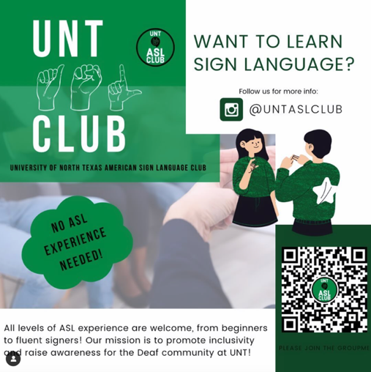
Deaf Culture Events: Students are required to attend or complete two (2) Deaf Culture Events during the semester. Pick any 2 from the following:
ASL Club Meetings – dates and times listed in schedule. A full, 1 page, 12-inch font reflection paper will be due at the end of event.
Contact information: officialuntaslclub@gmail.com

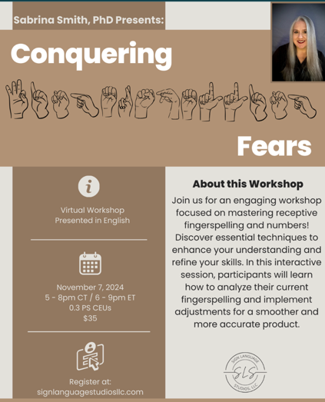
Conquering Fears Virtual Fingerspelling Workshop
Presented in English: November 7, 2024, 5-8pm CT
Workshop Description: Join us for an engaging workshop focused on mastering receptive fingerspelling and numbers! Discover essential techniques to enhance your understanding and refine your skills. In this interactive session, participants will learn how to analyze their current fingerspelling and implement adjustments for a smoother and more accurate product.
Certificate of completion is required to earn credit. Certificate must have name and date of completion to earn credit.

National Deaf Center OnDemand Learning
Certificate of completion is required to earn credit. Certificate must have name and date of completion to earn credit.
Click to register: Building Relationships with Deaf Communities:
Click to register: Introduction to Interpreting Services
Events must be submitted by the due date or credit will not be given. See schedule for details.
SELF-PACED BOOK STUDIES ***If you choose the book study, no additional Deaf events are required.
Certificate of completion must be submitted by due date. See Schedule for details.
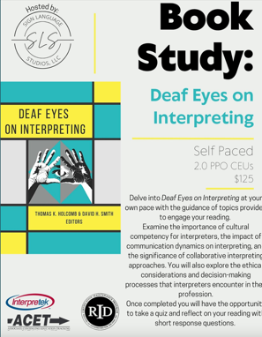

Course Schedule: Calendar is subject to change
Aug 20, Tuesday: Syllabus and Introductions
Aug 22, Thursday: Review of Unit 1

Aug 27, Tuesday: Review of Unit 2
ASL Club Meeting: 6:00 PM - 7:00 PM at UNION 401
Aug 29, Thursday: Review of Unit 3

Sep 3, Tuesday: Review of Unit 4
Sep 5, Thursday: Review of Unit 5

Sep 10, Tuesday: No Class
Sep 12, Thursday: Lesson 7.1 (Read: Key Grammar – Identifying a person and A sign of Caution)
Sep 17, Tuesday: Lesson 7.2, 7.3 and 7.4 (Read: Key Grammar – Describing Personal Items)
Sep 19, Thursday: Lesson 7.5 and 7.7 (Read: Insight – Best Way to Learn a New Language
Sep 24, Tuesday: Lesson 7.6 (Read: Insight – Best Way to Learn a New Language) & Lesson 7.8 (Read: Key Grammar – Describing Personal Items)
ASL Club Meeting: 6:00 PM - 7:00 PM at UNION 401
Sep 26, Thursday: Lesson 7.9, 7.11 (Read: 7:11 Cultural – Greetings and Leave-Takings) and 7.13 (Read: Deaf Profile – Arthur Kruger and Did your Realize)

Oct 1, Tuesday: Review Unit 7
Oct 3, Thursday: Receptive Unit 7 Exam
Oct 4, Friday: SN HW Due: 7.1, 7.4, 7.8
Unit 7 Expressive due Sunday, Oct 6 by 11:59 p

Oct 8, Tuesday: Lesson 8.1 (Read: Key Grammar – Explaining the Situation)
Oct 10, Thursday: and 8.2 & 8.6 (Read: 8.13 Cultural: Minimizing Interruptions)
October 11, Friday: Deaf Event 1 Due by 11:59p on Canvas

Oct 15, Tuesday: Lesson 8.3 (Read: 8.14 Cultural – Name Signs & A Sign of Caution)

Oct 17, Thursday: Lesson 8.4 (Read: Key Grammar – Agree with Condition)

Oct 22, Tuesday: Lesson 8.5, 8.7 (Read: Key Grammar – Conjunction and Asking for Advice) and 8.9

Oct 24, Thursday: Lesson 8.8 & 8.10 (Read: Key Grammar – Conjunction and Explaining the situation) 8.11 and 8.12 (Read: Deaf Profile – Nathie Marbury)

Oct 29, Tuesday: Review Unit 8
Oct 31, Thursday: Receptive Exam Unit 8
Nov 1, Fri: SN HM Due: 8.1, 8.7, 8.8, 8.10, 8.12
Unit 8 Expressive due Sun, Nov 3 by 11:59 p
Nov 5, Tuesday: Lesson 9.1 (Read: Did you Realize…)
Nov 7, Thursday: Lesson 9.3, 9.6 (Read: Sign Tip) & 9.9

Nov 12, Tuesday: Lesson 9.2 (Read: Did you Realize…), 9.4
(Read: Key Grammar – Using Rhetorical) & 9.5

Nov 14, Thursday: 9.7 (Read: Key Grammar – DCL, LCL & ECL) and 9.8

Nov 19, Tues: Rev Unit 9
ASL Club Meeting: 6p – 7p at UNION 401
Nov 21, Thursday: Receptive Exam Unit

Nov 22, Fri: SN HW 9.10

Unit 9 Expressive due Sun, Nov 24 by 11:59p
Nov 25 - Nov 29: Thanksgiving Break (No Classes)

Dec 2, Monday: Self-Paced Book Study Due by 11:59p on Canvas

Dec 3, Tue: Sound and Fury
ASL Club Meeting: 6p – 7p at UNI 401

Dec 5, Th: Course wrap-up and final feedback
Deaf Event 2 Due by 11:59p on Canvas

