English 4145: Worldbuilding and Mythopoesis

Amos Magliocco Spring 2026
amosm@unt.edu Office: Zoom Link Here

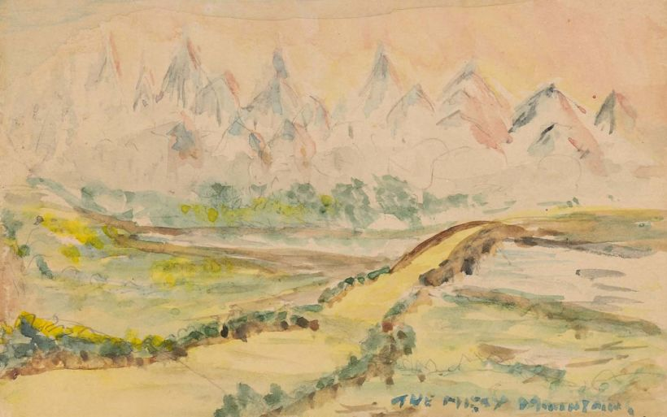 The Misty Mountains as painted by Tolkien. Image: Tolkien Estate. | “People aren't just "fooled by algorithms." They're living with real pressures. The economy is weakening. Young people have very different priorities in life, and there is continued divergence between young men and young women.  Al is weird, too. Platforms are under control by actors who might not have the best intentions at heart…When the machines become echoes for someone's worldview, who are they really for?  So yes: it's the despair and the algorithm, together. To explain where that leaves us, I think we need myths. Myths give us language for recurring human patterns, and frameworks for understanding whatever is going on. They describe the harmony and discord, conflict and scapegoats, plagues and crowds. Books.”  -writer Kyla Scanlon

Tentative Reading List (Link to Campus Bookstore Page):
- Course pack distributed by instructor
- The Power of Myth by Joseph Campbell
- The Divine Comedy by Dante Alighieri (translation by Allen Mandelbaum)
- Burial at Thebes (adaptation of Antigone) by Seamus Heaney
- A Wizard of Earthsea by Ursula K. Le Guin
- Embassytown by China Mievelle
- Primeval and Other Times by Olga Tokarczuk
- Gods of Jade and Shadow by Silvia Moreno-Garcia

Course Description:
Worldbuilding is a term game developers borrow from science fiction and fantasy writers who fashioned it from what authors of big novels and epic poems have done for millennia: create strange new worlds with elaborate structures to serve as a stage for narrative. This fundamentally creative act grants the writer license to imagine elaborate systems of language, law, and even love—not to mention architecture, geography, entertainments, religion, customs, and rituals within which their characters exist, choose, and react in ways that create consequences and therefore meaning.

What makes worldbuilding more important than mere stage decoration is how it also describes the web of expectations, actions, and consequences which function underneath a plot. Antigone insists on a proper burial for her dead brother not only because he deserves it, but because it is the only way he can enter the afterlife and therefore it’s her solemn duty to her brother and the gods who await him. There are consequences for failure.

The novelist Brandon Taylor defines “moral worldbuilding” in fiction as appearing “…at the layer below event. The layer that speaks to what these events mean in the life of the character and the life of the world unfolding. The layer that situates events in an order traced out by lines of causation that might run invisibly through the circumstances of characters, but which link up solidly and tightly, creating a weave of story.”

Our course is called Worldbuilding and Mythopoesis. Mythopoesis means, simply, the creation of those foundational stories that societies and cultures tell about themselves to understand who they are and how their day-to-day lives should unfold. If mythopoesis provides the water we swim in, worldbuilding erects the structures in our aquarium, its rooms and tunnels and secret places.

This semester, we'll examine characteristics and techniques of myth-making, archetypes, and systems of fictional worlds in various literary works. We'll discuss how these systems order new worlds and provide answers for human experience through foundational texts, ancient plays, and resonant contemporary literature. We will compare the worlds we find. We will make our own.

We’ll undertake creative exercises to build individual skills related to worldbuilding with a final course project in mind: maps of planets, continents, and cities; new languages, both spoken and written; religions and systems of workshop and their purpose; alien landscapes seeded them with wild ecosystems; towering architectures and urban spaces to populate with competing political factions and new forms of government. We will imagine foundational stories and mythologies to support and animate actions and the consequences of those actions, including cultural attitudes and biases and even the suffering created as a result. We'll conjure new systems of magic, invent technologies, and imagine how creatures with bodies unlike ours might live different lives than ours.

Grades:
Participation 10%
Quizzes and Worksheets: 10%
Midterm: 20% (in-class)
Course Project: 20%
Final Exam: 20% (in-class)
Final Paper: 20% (first draft done in class)

Attendance:
Attendance is mandatory. If you miss more than three (3) classes (each class meeting is a full week of school), you cannot pass the course. All absences are created equal. There are no excused or unexcused absences. No need to explain any absence later; the three absences are yours to use as needed.

Participation:
I assume you enrolled in this course because this subject interests you; there are certainly easier choices on the course menu. Let’s talk about what we’re reading and our projects and make connections. You will learn so much more if you offer some small observation from something you noticed in the reading or a comment from your classmate. No observation is too small! Details are usually the most important feature of literature. No question is silly. I welcome them all.

Expectations:
You need to read outside class for approximately five hours per week, some of it modestly difficult. I’ll call on students in class to propel our discussions. You need to be willing to ask questions in class about the reading when you don’t understand something or have an interesting observation.

Our exams, project, and final paper will be written almost entirely in class, so the use of outside or nonhuman assistance isn’t possible.

You need to take notes—by hand—in class, like they did in the time of Dante. You’ll need a notebook and writing implement. Don’t arrive for a 4000-level university literature course empty-handed.

Course Content:
The course readings may include passages with vulgar language, explicit descriptions of sex, and disturbing depictions of cruelty and violence. If you do not wish to read or discuss such content, you should drop this course. Feel free to inquire further if you need more detail to make a decision. I’m happy to discuss!

UNT Policies

ADA Policy
UNT makes reasonable academic accommodation for students with disabilities. Students seeking accommodation must first register with the Office of Disability Accommodation (ODA) to verify their eligibility. If a disability is verified, the ODA will provide a student with an accommodation letter to be delivered to faculty to begin a private discussion regarding specific course needs. Students may request accommodations at any time; however, ODA notices of accommodation should be provided as early as possible in the semester to avoid any delay. Note that students must obtain a new letter of accommodation for every semester and must meet with each faculty member prior to implementation in each class. For additional information see the ODA website (https://disability.unt.edu/).

Prohibition of Discrimination, Harassment, and Retaliation (Policy 16.004)
The University of North Texas (UNT) prohibits discrimination and harassment because of race, color, national origin, religion, sex, sexual orientation, gender identity, gender expression, age, disability, genetic information, veteran status, or any other characteristic protected under applicable federal or state law in its application and admission processes; educational programs and activities; employment policies, procedures, and processes; and university facilities. The University takes active measures to prevent such conduct and investigates and takes remedial action when appropriate.

Academic Freedom: UNT has a robust policy regarding academic freedom and academic responsibility. Crucially, this policy encompasses not only the rights of faculty members but also the rights “of the student to freedom in learning.” As a student in this classroom, therefore, you have the right to encounter and debate new ideas, diverse forms of knowledge, and unfamiliar or contrary points of view. According to UNT policy, “it is not the proper role of the University to attempt to shield individuals from ideas and opinions they find unwelcome, disagreeable, or even deeply offensive.” At the same time, to encourage the free exchange of ideas, and to ensure that your right to learn is protected, the tone for such discussion must always be civil and respectful; hateful or discriminatory speech will not be tolerated. For more information, please consult the full UNT policy at https://policy.unt.edu/policy/06-035.

Audio/Video Recording: Although UNT is a publicly supported institution, our classroom is not a public space. Therefore, in order to protect the intellectual property and privacy rights of both faculty and students, video and audio recordings are prohibited during class. The exception is for students who have been granted explicit approval as an ODA accommodation. For more information, please consult the full UNT policy at https://studentaffairs.unt.edu/office-disability-access/faculty/faculty-guide/accommodations-explained/Audio-Recording-Faculty.html

Academic Integrity Policy
Academic Integrity Standards and Consequences. According to UNT Policy 06.003, Student Academic Integrity, academic dishonesty occurs when students engage in behaviors including, but not limited to cheating, fabrication, facilitating academic dishonesty, forgery, plagiarism, and sabotage. A finding of academic dishonesty may result in a range of academic penalties or sanctions ranging from admonition to expulsion from the University.

The use of any generative AI writing tools (such as ChatGPT, GrammarlyGO, GPT-3, GPT-4, BERT, or others) is prohibited. Assignments are designed to help you develop as a writer without the use of these technologies. You will generate ideas, read, revise, and write on your own and/or in consultation with peers, me, or Writing Center tutors, and you will not use AI at any stage of your writing process. You are the author of your work for the course and authorship means you take responsibility for your words and claims. Any use of AI technologies in your work will be considered an violation of UNT's academic integrity policy and addressed accordingly.
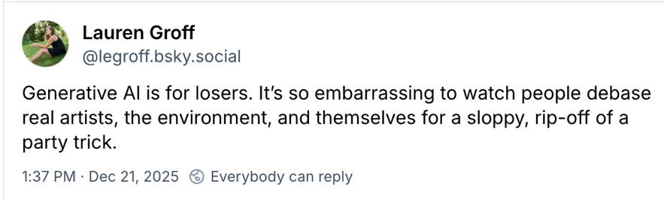
Tentative Schedule

Week One (Jan 14)
- Introduction, books, semester plan
- Create 6 groups of six students to workshop project materials throughout the semester
- Discuss the three worldbuilding labels: “World conjuring,” “hard worldbuilding,” and “moral worldbuilding.”

Week Two (Jan 21)
- Discuss these articles from the course pack (3 hours reading):
  - “Worldbuilding: How Speculative Fiction Broke Out of the Genre Ghetto” by Lillian Wong Selenick
  - “Against Worldbuilding” by Lincoln Michel
  - “In Defense of Worldbuilding” by Emily Temple
  - “Is Your Worldbuilding Up To Code?” by Lincoln Michel
  - “living shadows: aesthetics of moral worldbuilding” by Brandon Taylor
  - “False Light: Moral Worldbuilding and the Virtues of Evil” by Brandon Taylor
- Introduce the Course Project due April 29
- Groups assemble and begin preliminary plans (worksheets distributed)

Week Three (Jan 28)
- Discuss Readings
  - First three chapters of The Power of Myth (2 hours to read)
  - Chapters 1-3, chapter 11: verses 1-9, and chapters 6-9 in The Book of Genesis (2 hours to read)
  - (guest speaker, Professor Jeff Doty)

Week Four (February 4)
- Discuss readings:
  - Chapters 4-6 in The Power of Myth (2 hours to read)
  - The Burial at Thebes (2 hours to read / Seamus Heaney’s translation of Antigone by Sophocles)
- Groups discuss project progress, share preliminary materials

Week Five (February 11)
- Discuss these readings:
  - From The Divine Comedy selections in the course pack (4 hours to read)
  - Pairs:
    - Inferno I & Purgatorio I
    - Inferno III & Purgatorio III

Week Six (February 18)
- Discuss these readings:
  - From The Divine Comedy selections in the course pack (4 hours to read)
    - Inferno IV & Inferno V
    - Inferno X & Purgatorio X & Paradiso X
    - Inferno XVIII

Week Seven (February 25)
- Project workshop groups
- Discuss readings:
  - Inferno XXXIV
  - Purgatorio XXX & XXXI
  - A Wizard of Earthsea by Le Guin (5 hours to read)

Week Eight (March 4)
  - A Wizard of Earthsea by Le Guin (5 hours to read)
  - MIDTERM EXAM

Week Nine (March 19)
- Introduce Final Paper
- Discuss Readings
  - Primeval and Other Times by Olga Tokarczuk (5 hours to read)

Week Nine (March 18)
- Project workshop groups for 45 minutes
- Discuss readings:
  - Embassytown by China Mieville (8 hours to read)
  - “Worldbuilding Efficiently with Neologisms and Box Words” by Matt Bell (article)

Week Eleven (April 1)
- Project workshop groups 45 minutes
- Discuss reading:
  - Embassytown by China Mieville (8 hours to read)

Week Twelve (April 8)
- Project workshop groups 45 minutes
- Discuss readings:
  - “Mimetic Worldbuilding: Historical Fantasy and Why To Do It” by Boris Stremlin
  - Gods of Jade and Shadow by Silvia Moreno-Garcia (6 hours to read)

Week Thirteen (April 15)
- Project workshop groups 45 minutes
- Discuss readings:
  - Gods of Jade and Shadow by Silvia Moreno-Garcia (6 hours to read)

Week Fourteen (April 22)
- Final Paper Due

Week Fifteen (April 29)
- Semester Project Due

Week Sixteen (finals week)
- Final Exam (time TBA)

