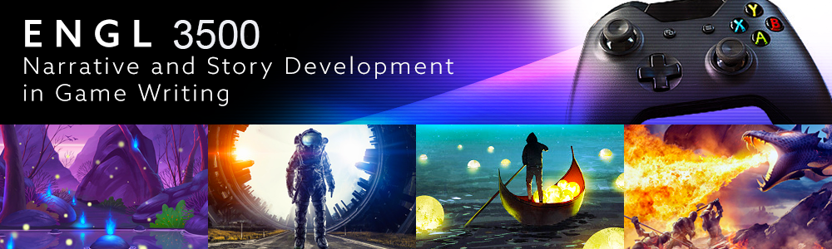
Beginning Game Writing Workshop: Storytelling Through Narrative Design

Instructor: Amos Magliocco (amosm@unt.edu)

Office Hours:
ZOOM office hours Thursdays 10am to 11:30am or by appointment

REQUIRED TEXTS:
The Ultimate Guide to Video Game Writing and Design by Flint Dille and John Zuur Platten
Video Game Storytelling by Evan Skolnick
Wired for Story by Lisa Cron

COURSE DESCRIPTION AND REQUIREMENTS
Video games are the new frontier of imaginative literature. Game writers rely on traditional narrative concepts but also craft stories within the unique context of gameplay and mechanics. In recent years, titles such as The Last of Us and What Remains of Edith Finch demonstrate the rapid advancement in the sophistication of story-rich gaming. This course examines basic elements of game writing in the framework of design, how characters develop, and questions of how to integrate gameplay and story. Craft elements in traditional narrative will be scrutinized for their utility within the forms of video game genre and mechanics.

The course is a workshop in which you will produce overviews and scripting. Exercises and assignments will prioritize methods of characterization and how to incorporate characterization techniques into game mechanics. You will produce a Game Concept Document and then a partial script incorporating your ideas developed through a character template and that concept material. You will produce a significant revision of the scripting by incorporating feedback from the workshop and instructor.

A workshop is a collaborative effort. For our workshop to succeed, you must be willing to offer feedback about your peers’ work after having read it carefully and considered the goals it suggests for itself, rather than your own ideas for what might work better. You are graded as much for your contributions to the workshop effort as the imaginative dynamics of your own work.

I look forward to reading your work and exploring with you how game writers conceive story and characters and participate in the larger production team effort.

Grade Breakdown by Assignment
Revision of Scene 15%
Discussions and Workshop Critiques 25%
Writing Exercises 5%
Quizzes 10%
Game Concept Document 15%
Cutscene Script 20%
Character Template 10%

PLAGIARISM
Plagiarists will receive an “F” and be reported to the Dean of Students. You cannot submit work written for another class or a previous attempt at this class.

The use of generative AI writing tools (such as ChatGPT, GrammarlyGO, GPT-3, GPT-4, BERT, or others) is prohibited in this class. Assignments for the course have been designed to help you develop as a writer without the use of these technologies. You will generate ideas, read, revise, and write on your own and/or in consultation with peers, me, or Writing Center tutors, and you will not use AI at any stage of your writing process. You are the author of your work for the course and authorship means you take responsibility for your words and claims. Any use of AI technologies in your work will be considered an violation of UNT's academic integrity policy and addressed accordingly. *Statement composed by Annette Vee, under CC-BY-NC (Creative Commons By-Noncommercial license).

EMAIL (amosm@unt.edu)
I reply to all email. I can’t promise better than a 24-hour response time during the week, however. I will occasionally send class announcements via email. Please check your university email periodically. I also respond to messages in Canvas, but I might not see those as soon as I will see UNT email.

I send important course updates via the Announcements on Canvas. Please check Canvas announcements daily for course reminders, changes, and other important information.

LETTERS OF RECOMMENDATION
Down the road, some of you will need recommendations for graduate school. I’m happy to write these for students who earn an “A” in the course, produce outstanding critiques, participate thoughtfully in discussions. If you think you’ll need a recommendation eventually, this is the standard.

ADA COMPLIANCE
If you have a disability for which you will require reasonable accommodation under the terms of the Americans with Disabilities Act of 1973, please discuss your needs with me and present your written requests to the campus Office of Disability Accommodation.

SEMESTER SCHEDULE (tentative!)

Level 1: Video Game Stories and their writers
- Discussion: How do game writers see themselves and their stories?
- Materials Comprehension Quiz
- Writing Activity: Weave a story into a common game

Level 2: Building Characters in the Context of Game Construction
- Discussion: Character Empathy and Player Agency
- Quiz
- Writing Activity: Character Template
Level 3: Create your own Game Concept Document
- Quiz
- Major Assignment: Concept Document
Level 4: Script Your Cutscene/Cinematic or Quest
- Writing Exercise: Rewrite a Key Moment
- Major Assignment: Cinematic/Cutscene script or Quest Structure
Level 5: Workshop Concept Document
Level 6: Workshop Concept Document
Level 7: Workshop Concept Document

Level 8: NPCs (Non-Player Characters) who make a difference.
- Quiz
- Discussion: NPCs and Agency

Level 9: Worldbuilding: “I have all this Lore!”
- Discussion: Reverse Engineer a Favorite World
- Exercise: Take Us to Your World

Level 10: Workshop Your Cinematic/Cutscene or Quest
Level 11: Workshop Your Cinematic/Cutscene or Quest
Level 12: Workshop Your Cinematic/Cutscene or Quest
Level 13: Workshop Your Cinematic/Cutscene or Quest

Level 14: Revision (Iterations) in the Team Project Environment
- Major Assignment: Revision of Cinematic/Cutscene or Quest

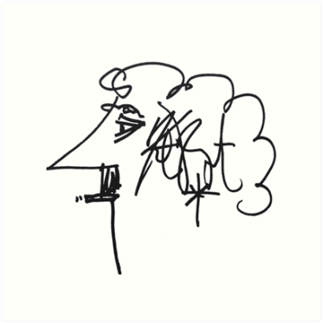

Kurt Vonnegut’s Creative Writing 101:
“Then I took to teaching creative writing, first at Iowa, then at Harvard and then at City College in New York. Joseph Heller, author of Catch-22, was teaching at City College also. He said to me that if it hadn’t been for the war, he would have been in the dry-cleaning business. I said to him that if it hadn’t been for the war, I would have been garden editor of The Indianapolis Star.
- Use the time of a total stranger in such a way that he or she will not feel the time was wasted.
- Give the reader at least one character he or she can root for.
- Every character should want something, even if it is only a glass of water.
- Every sentence must do one of two things—reveal character or advance the action.
- Start as close to the end as possible.
- Be a sadist. No matter how sweet and innocent your leading characters, make awful things happen to them—in order that the reader may see what they are made of.
- Write to please just one person. If you open a window and make love to the world, so to speak, your story will get pneumonia.
- Give your readers as much information as possible as soon as possible. To heck with suspense. Readers should have such complete understanding of what is going on, where and why, that they could finish the story themselves, should cockroaches eat the last few pages.
The greatest American short story writer of my generation was Flannery O’Connor (1925-1964). She broke practically every one of my rules but the first. Great writers tend to do that.”

