ENGL 3140 – Beginning Fiction Writing: Fall 2026
Instructor: Amos Magliocco (amosm@unt.edu)
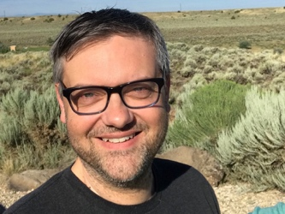
- Class meets Thursdays in ENV 190
- Office Hours: Tuesdays 2:30 – 4:30 AUDB 213B (after week 3)

Required Books (please purchase hard copies immediately):
Our textbooks:
  - 100 Years of the Best American Short Stories. edited by Lorrie Moore
  - Thrill Me: Essays on Fiction. by Benjamin Percy
 | 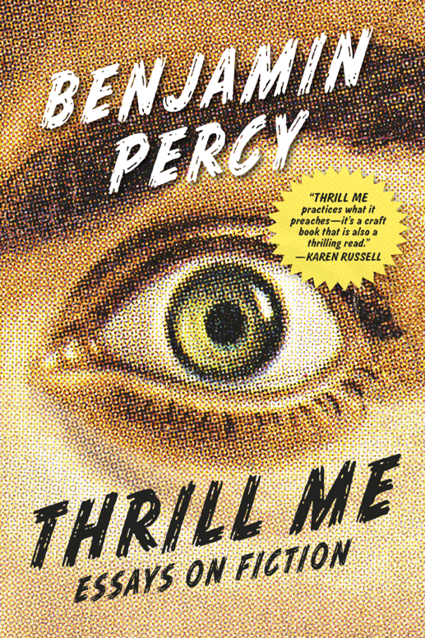

Course Description and Requirements
This course introduces techniques in composing character-based fiction in the short story form, with theories and practices for revision to achieve fully realized characters and narratives.
What does all that mean? Well, we’ll do writing exercises, write a story “start,” and then a full short story. The “start” will be shared with a small workshop group and the full story we’ll all read together, the entire workshop. At the end of the semester, we produce a significant revision of that full story.
Writing exercises introduce craft concepts and help generate new material. During workshop, each student writes feedback for each peer story, usually two peer stories per class meeting. Learning to read your classmates’ work with a helpful, collaborative eye imparts valuable skills for reading our own drafts.
A workshop is highly collaborative. Much of the “material” of this course is the in-person collaboration. It’s a talking class where everyone contributes observations about choices made in the story and the effects those choices create. A successful workshop needs participants willing to talk about the stories after having read them carefully and so each writer hears a wide variety of reader response. That’s why participation is 20% of your final grade. If you find it challenging to speak in class, I understand! I will help you devise strategies to make it easier to join the conversation.
I look forward to reading your fiction and talking with you about how writers write and how they read their own work. Our aspiration is that the skills you take from our workshop will enhance your appreciation of literary art and guide your own artistic journey.
Attendance
You are allowed three (3) absences for any reason. You will be counted absent if you arrive more than ten (10) minutes late. If you cannot attend for religious or university-related purposes, you must comply with university policies regarding prior notification.
All absences are treated equally. There are no excused or unexcused absences. You are either present or absent. It is entirely up to you how to use your absence allotment, though I strongly encourage you to save absences for illness and unforeseen personal matters. If you miss more than three meetings you will not pass the course.
Phones & Other Tech
Cell phones wreck our concentration, as you know. Concentration is the most important skill a writer can nurture. It matters infinitely more than creativity or flair for language. In this course, we will power off our phones and store them in bags or boxes or coffee cans. It cannot be out on your desk or in your lap. No laptops or iPads or other devices. We’re entirely analog in cognitive and communication activities.
Grade Distribution
Story Start: 20%
Feedback Responses: 20%
Class Participation: 20%
Workshop Story: 20%
Revision: 20%

Class participation (20% of your grade) is calculated this way:
- 100 = more than one bright comment per discussion & writing exercise volunteer reader each class, no more than 2 absences
- 90 = one bright comment per story discussion & writing exercise volunteer reader each class, no more than 3 absences
- 80 = one bright comment every other story discussion & writing exercise volunteer regularly, no more than 4 absences
- 70 = one bright comment every third story discussion
- 60 = one bright comment every week
This is an upper division (3000-level) writing course. Students must have proficiency in fundamental grammar, punctuation, spelling, syntax, and other mechanics of writing. We will not spend class time on these topics, and I lower grades for excessive errors. You must build time in your writing process for proofreading. I reserve the right to withhold manuscripts from workshop for reasons of mechanics or offensive content.
Plagiarism and AI
Plagiarism results in an “F” and violators are reported to the Dean of Students. If you don’t know what constitutes plagiarism, speak with me, please. You cannot submit work written for another class or a previous attempt at this class. Using software of any kind, including AI, to create any portion of your work is plagiarism.

The use of generative AI writing tools (such as Claude, ChatGPT, GrammarlyGO, GPT-4, GPT-5, BERT, or others) is prohibited in this class. Assignments have been designed to help you develop as a writer and artist without the use of these technologies. You will generate ideas, read, revise, and write on your own and/or in consultation with peers, me, or Writing Center tutors, and you will not use AI at any stage of your writing process. You are the author of your work for the course and authorship means you take responsibility for your words and claims. Any use of AI in your work will be considered a violation of UNT's academic integrity policy.
Email (amosm@unt.edu)
I try for a 24-hour response window during the week. I occasionally send announcements via UNT email and Canvas. Please check Canvas and your UNT email regularly and communicate with me via UNT email whenever possible (as opposed to Canvas messaging).
Letters of Recommendation
Down the road, you might need letters of recommendation for graduate school. I’m happy to write these for students who earn an “A” in the course, produce outstanding critiques, participate vigorously in discussions, and miss no more than ONE class meeting.
ADA Compliance
If you have a disability for which you require reasonable accommodation under the terms of the Americans with Disabilities Act of 1973, I am happy to discuss your needs and find the best possible solutions. Please schedule to meet with me within the first two weeks of school and present your written requests to the Office of Disability Accommodation. They will notify me electronically, then you must schedule a meeting with me to discuss the application of your accommodations. Your accommodations are not in effect until we meet. Please do not hesitate to initiate this process.

Tentative Schedule
Thursday AUG 20:
- Introductions and greetings!
- What is a short story? Why read (or write) them?
- Read “My Old Man” by Ernest Hemingway (in-class handout also in 100 Years textbook)
- Exercise to identify beginning, middle, and end
- In-class writing: my beginning / your middle / their ending
Thursday AUG 27
- Feedback due for “The Enormous Radio” by John Cheever (100 Years page 160)
- Feedback due for “Sonny’s Blues” by James Baldwin (100 Years page 181)
- Discuss “Urgency” in Thrill Me
- Introduce Story Start assignment
- In-class writing
Thursday SEP 3:
- Feedback due for “Everything That Rises Must Converge” by Flannery O’Connor (227)
- Feedback due for “Friend of My Youth” by Alice Munro (452)
- Discuss “Set Pieces: Staging the Iconic Scene” in Thrill Me
- In-class writing
Thursday SEP 10:
- Mini-Workshops for Story Starts
  - Five groups of 4, thirty minutes per story-start
  - Take picture of your handwritten feedback and submit on Canvas
- Introduce Full Workshop Story assignment
Thursday SEP 17:
- Feedback due for “The Third and Final Continent” by Jhumpa Lahiri (544)
- Feedback due for “Old Boys, Old Girls” by Edward P Jones (603)
- Discuss “Making the Extraordinary Ordinary” and “Designing Suspense” in Thrill Me
- In-class writing
Thursday SEP 24:
- Feedback due for “Brownies” by ZZ Packer (562)
- Feedback due for “Diem Perdidi” by Julie Otsuka (673)
SUNDAY SEP 27th
- Full Workshop Story Due on Canvas
Thursday OCT 1: Full Workshop
- Student Story
- Student Story
Thursday OCT 8: Full Workshop
- Student Story
- Student Story
- Student Story
Thursday OCT 17: Full Workshop
- Student Story
- Student Story
- Student Story
Thursday OCT 22: Full Workshop
- Student Story
- Student Story
- Student Story
Thursday OCT 29: Full Workshop
- Student Story
- Student Story
- Student Story
Thursday NOV 5: Full Workshop
- Student Story
- Student Story
- Student Story
Thursday NOV 12: Full Workshop
- Student Story
- Student Story
- Student Story

Thursday NOV 19 Revision is the Magic Spell
- Discuss “The Bath” and “A Small Good Thing” by Raymond Carver (handouts)
- Discuss “Revision as Renovation” and “Go the Distance” in Thrill Me

Thursday DEC 3
- Extended Office Hours for Consultation
SUNDAY DEC 6:
- Workshop Story Revision Due on Canvas

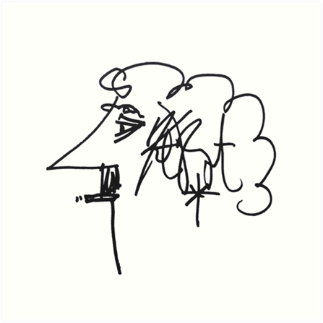
Kurt Vonnegut’s “Rules” of Creative Writing 101:
“Then I took to teaching creative writing, first at Iowa, then at Harvard and then at City College in New York. Joseph Heller, author of Catch-22, was teaching at City College also. He said to me that if it hadn’t been for the war, he would have been in the dry-cleaning business. I said to him that if it hadn’t been for the war, I would have been garden editor of The Indianapolis Star.
- Use the time of a total stranger in such a way that he or she will not feel the time was wasted.
- Give the reader at least one character he or she can root for.
- Every character should want something, even if it is only a glass of water.
- Every sentence must do one of two things—reveal character or advance the action.
- Start as close to the end as possible.
- Be a sadist. No matter how sweet and innocent your leading characters, make awful things happen to them—in order that the reader may see what they are made of.
- Write to please just one person. If you open a window and make love to the world, so to speak, your story will get pneumonia.
- Give your readers as much information as possible as soon as possible. To heck with suspense. Readers should have such complete understanding of what is going on, where and why, that they could finish the story themselves, should cockroaches eat the last few pages.
The greatest American short story writer of my generation was Flannery O’Connor (1925-1964). She broke practically every one of my rules but the first. Great writers tend to do that.”

