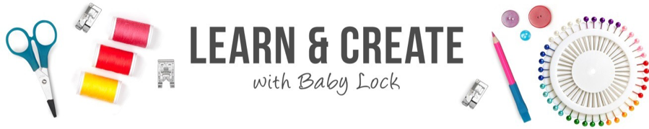

Serger Pillowcase Project



Learn how to make a pillowcase with your serger! Pillowcase projects are great for beginners and advanced sewers. Plus, it is a fun project to create with your kids.

Over the years, Baby Lock has partnered with American Patchwork & Quilting to support their 1 Million Pillowcase Challenge. Their goal is to unite quilters, sewers and crafters to donate one million pillowcases to local charities. Many charities can benefit from the donation of a pillowcase and the challenge gives you the opportunity to donate and make a difference in your community. Visit their website for additional resources including patterns and places to donate: http://millionpillowcases.allpeoplequilt.com/

Skill Level: Beginner/Intermediate

- Techniques:
- 4-thread seaming
- Corded piping
- Wave edge piping
- Attaching piping
- Supplies:
1- 27” x 42” fabric panel (pillowcase bottom)
1- 10” x 42” contrasting fabric panel (pillowcase band)
1- 2” x 42” contrasting fabric panel (piping trim)
2” x 42” fusible stabilizer (for Wave piping)
Cording (piping)
All-purpose serger thread
Decorative threads (for Wave piping)
Marking Pen or Pencil
Binding clips
Cording Foot
Standard or clear presser foot
Piping Ruler (optional)

- Instructions:

Fabric Band

- Fold and press the 2” X 42” strip of fabric in half, creating a 1” band.
- This would be used instead of corded or Wave piping. The cording foot is not required for pillowcase assembly.

Creating Chorded Piping

- Set up serger for a 4-thread overlock stitch using all-purpose thread.
- Attach the cording presser foot and set the stitch width to the widest width, 7.5mm
- Encase the cording within the 2” strip of fabric. Pinch the raw edges of the fabric strip together and snug against the piping.
- Place the wrapped cording under the presser foot with the cording resting in the groove of the foot and the edges of the fabric strip to the right.
- Lower the presser foot and check to make sure the cording is in the groove of the foot.
- Serge slowly. The left needle should be close to the cording. The fabric edges will be trimmed neatly as the chording is created

Create wave edge piping:

- Fuse stabilizer to the 2” wide strip. Fold strip wrong sides together and stitch.
- Set-up serger for a 3-thread Wave stitch. Refer to the Quick Reference Guide.
- Use two contrasting colors of decorative thread in the upper and lower loops.
- Serge the Wave stitch along the folded edge of the fabric strip to create Wave edge piping.
- Trim the seam allowance using a Parrs ruler.
- Another trimming option is to use the serger to trim the strip. Once your machine is set-up for the pillow construction with a 4-thread overlock and the cording foot, run the folded strip through the serger with the wave stitch placed in the groove of the cording foot. This will trim down the folder strip for the pillow construction.
- Make sure that the right side of the wave edge piping will be features when attaching the band and the pillowcase bottom.

Construct the pillowcase and attach the piping

- Set up serger for a 4-thread overlock stitch using all-purpose thread.
- Fold the 10” x 42” fabric panel (band) in half lengthwise, wrong sides together. Press.
- Open out the pillowcase bottom fabric and place it right side up.
- Align the finished edge of the piping with the top edge of the fabric.
- Place the folded band of fabric to the top of the piping and pillowcase bottom fabric, aligning all fabric edges.
- Note: You can also use the Burrito method for layering your fabrics and piping together.
- With the cording foot attached, serge all layers together with the piping placed in the groove of the cording foot.
- Press the band and piping seam allowances towards the pillowcase bottom.
- Fold pillowcase in half, right sides together and pin or use binder clips to hold fabric edges together.
- Remove the cording foot and attach the standard or clear presser foot. Serge down the side of seam of the pillowcase. Slow down when approaching the band and the piping. Continue slowly serging to keeping fabric edges aligned.
- Wrap the previous seam allowance and serge the bottom edge of the pillowcase. Wrapping the seams will give you a nice point.
- Turn the pillowcase right side out and press.

For other exciting projects like this one, visit our website at www.babylock.com

©2020 Baby Lock USA. This project may be freely used by individuals for non-commercial purposes. Project instructions may not be sold or distributed without approval from Baby Lock. Baby Lock must be acknowledged as the source of the project instructions through copyright or online link.

