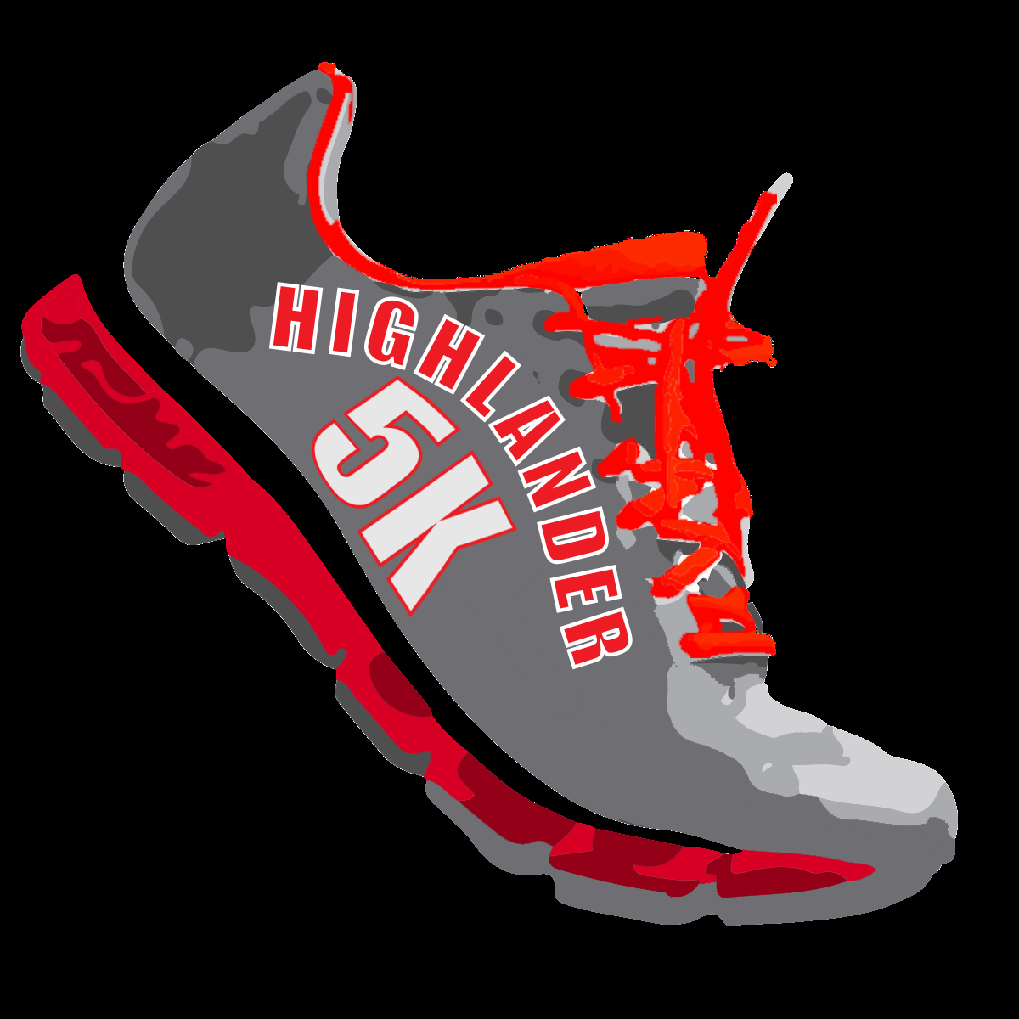

**HIGHLANDER 5K**

**Sponsor Information:**

On Saturday April 29th, 2017 McLean High School is hosting the 1st Annual Highlander 5K! Advertising for this event will reach 1000s of homes in the McLean community and the surrounding areas. 100 % of the proceeds go directly to the students at McLean High School. The event includes a 1-Mile “Fun Run” and the “Highlander 5K” as the main event. The Highlander 5K event covers a wide range of ages and fitness levels and will reach all schools in our pyramid. Here is your chance to show your support of the McLean High School students to our entire community by becoming a sponsor.

**PLATNIUM SPONSOR: $2,000**

Includes “Gold” and also provides the following:

* Headlines all e-mails with hyperlinked logo
* Leading logo on event shirt
* Multiple banners may be supplied by the sponsor for display at the tournament
* Banners provided will be included in photos of awards

**GOLD SPONSOR: $1,000**

Includes “Silver” and also provides the following:

* Logo displayed prominently at Packet Pick-Up
* Logo gets placed on our event site and school’s[webpage](http://fallschurchsports.org/)
* Logo on 2nd sponsor line on event shirt

**SILVER SPONSOR: $500**

Includes “Bronze” and also provides the following:

* One banner could be supplied by sponsor for display at the event
* Logo on the school webpages: <http://mcleanactivities.org> and <http://www2.fcps.edu/McLeanHS/>
* Logo on all event e-mails which will reach 1000s of homes and businesses
* **Sponsor able to be **on-site** during event**

**BRONZE SPONSOR: $250.00**

Includes “Support Sponsor” and also provides the following:

* Logo on t-shirt
* Sponsor can provide items to be placed in all registration bags (please submit a minimum of 800 items)

**SUPPORT SPONSOR: $100.00**

Includes logo on the event webpage.

Please contact Tzeitel Barcus @ McLean HS for questions: [tabarcus@fcps.edu](mailto:tabarcus@fcps.edu)