KNIT AND CROCHET GROUP-Would you be interested in participating in a group that knits and crochets? If so, please email Cindy Cope at cjcope1055@gmail.com and add your preference for day of the week/time/frequency of meetings you could attend.
 | ELECTRONIC GIVING OPTION – If you would like to make an electronic donation to FMC Moorestown, go to www.fmcmoorestown.com/give or scan this QR code to connect to our digital giving page. Please consider giving generously to support the ministries of FMC that impact communities locally and globally.  SERMON NOTES:
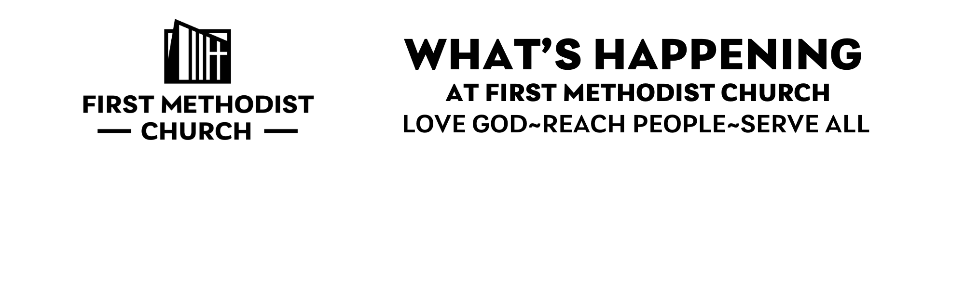
___________________________________________________________________
WEEK OF FEB 16-FEB 22, 2025
_______________________________________________________________
WEEK OF FEB. 23-MAR. 1
WELCOME TO FMC-As part of our Lenten series, From The Inside Out: A Journey Of Faith, we celebrate Mission & Service Sunday–remembering that faith shaped on the inside is lived out in love and service. Today we give thanks for our partnership with The Maker’s Place and welcome our guest preacher Callie Crowder, Executive Director of the organization. We will also offer our pledges to Faith Promise for the year. We’re so grateful for all the ways FMC seeks to be a relevant, compassionate presence in our community. Whoever you are and wherever you are on your journey, you belong here.
FAITH PROMISE CARDS- All pledges for our 2026 missions commitments will be consecrated at today’s services. Cards can also be mailed to the church or put into collections plate any Sun. The Missions Commission is also seeking new members. If you are interested, please contact Diane Dyson at dianemdyson@gmail.com.
FAMILIES WITH YOUNG KIDS-The nursery in the Parlor is staffed by childcare volunteers. There are also Busy Bags filled with coloring pages in the back of the church for children who want to sit in the Sanctuary. Questions or to volunteer, contact Sarah Owens at sarahmowens13@gmail.com.
HEARING ASSISTED DEVICES-can be found in the tech booth at the rear of the sanctuary.
RED CROSS BLOOD DRIVE-Our next blood drive will be Mon., Mar. 2 in Fellowship Hall from 230-7:30pm. Please contact Jen Dunne at jendunne1@gmail.com if you are able to donate life-giving blood.
KIDS’ CHURCH-Our Kids’ Church Sunday school program meets during our 9am worship service in Room F103 for students in Grades K-5.

COPIES OF THE SERMON - can be found on the Narthex table.
YOUTH GROUP-Our Youth Group (for students in Grades 6-12) typically meets from 5-7:30pm on Sun. evenings. The program includes choir, dinner, games, and Bible lessons. For more information, please pick up a Youth Group brochure from the welcome table or reach out to Jeremiah at jeremiah@fmcmoorestown.com.
YOUNG FOLLOWERS-Our Young Followers program is for students in Grades K-5 and meets from 5-6:30pm on Thurs. evenings. The program includes choir, dinner, games, and Bible lessons. For more information, please pick up a Young Families brochure from the welcome table or reach out to Jeremiah at jeremiah@fmcmoorestown.com.
MIND CAFE-will again provide a safe place for local teens and young adults to meet and share a meal, discuss relevant topics, and build community. It’s free! We meet bimonthly on Fri. nights in F105 from 6:30-8:30pm, with our next meeting on Feb. 27. To sign up, go to http:mindcafeconnect.org or contact Jen Kaminski at 609 929 8687.
PASTOR RICH’S BIBLE STUDY-The study of First and Second Peter entitled Courage in Times of Trouble will be held at 7pm on Weds. in the Heritage Room. The study dates are Feb. 25, Mar. 4, 11, 18, 25 and Apr. 1. Please RSVP to Elite Law at elitelaw@gmail.com or 609 560 2009.
VACATION BIBLE SCHOOL-will be held this August 10-14 from 9am-noon. All children from age 3 through 5th grade are welcome! Children must be potty-trained to attend. We will be going “on a road trip with God.” There will be fun activities, Bible lessons, and crafts. All children, grandchildren, nieces and nephews, and neighbors in our community are welcome, so spread the word!
CRAFTS FOR GOOD-will meet on Mon., Mar. 9 from 1:30-3pm in F105 to continue making crafts to support our ministries. Questions, contact Cindy Cope at cjcope1055@gmail.com
EUREKA! BOOK CLUB-will next meet in the Parlor on Tues., Mar. 17 at 6pm (bring your dinner) and discussion. This month we will read and discuss Demon Copperhead by Barbara Kingsolver. This Pulitzer prize-winning book is based on Charles Dickens’ David Copperfield and addresses discrimination, institutional poverty, mortality, and addiction. Questions, contact Patti Walz at revwalz@gmail.com.
NEW RELEASE & RELAX YOGA GROUP BEGINNING!-Led by Peggy Koenitzer, this group will meet twice a month from 10-11am on Fri. in Room F105, next on Feb 27. The class is free (just please bring a donation to the food pantries) and can hold up to 12 participants. We will do gentle yoga poses and breathing techniques to enhance strength, coordination, flexibility, and balance. To RSVP for each class and for questions, contact Peggy at paboblenz@comcast.net.
MONDAY MORNING BIBLE STUDY-Everyone is welcome to join us on Zoom on Mons. from 9:30-11am. We are studying the Bible from beginning to end. Questions, contact Peggy Koenitzer at paboblenz@comcast.net.
THURSDAY MORNING WOMEN’S GROUP-meets on Thurs. From 8:30-10am in the Parlor. Please join us for fellowship, prayer, and spiritual growth. As we complete our present study, we will begin the Lenten study of Meeting Jesus At The Table by Campbell and Fohr.. Questions, contact Carol Talbot at 856 577 3051.
FRIDAY MORNING MEN’S GROUP-is a spiritual development and mutual support group for men of any age that meets on Fri. at 7am in the Parlor. We typically select books by Christian authors as a springboard for discussion of how we live out our faith. New members are welcome and encouraged to join! Questions, call Tom Kulp at 609 707 4708.

