SERMON NOTES:

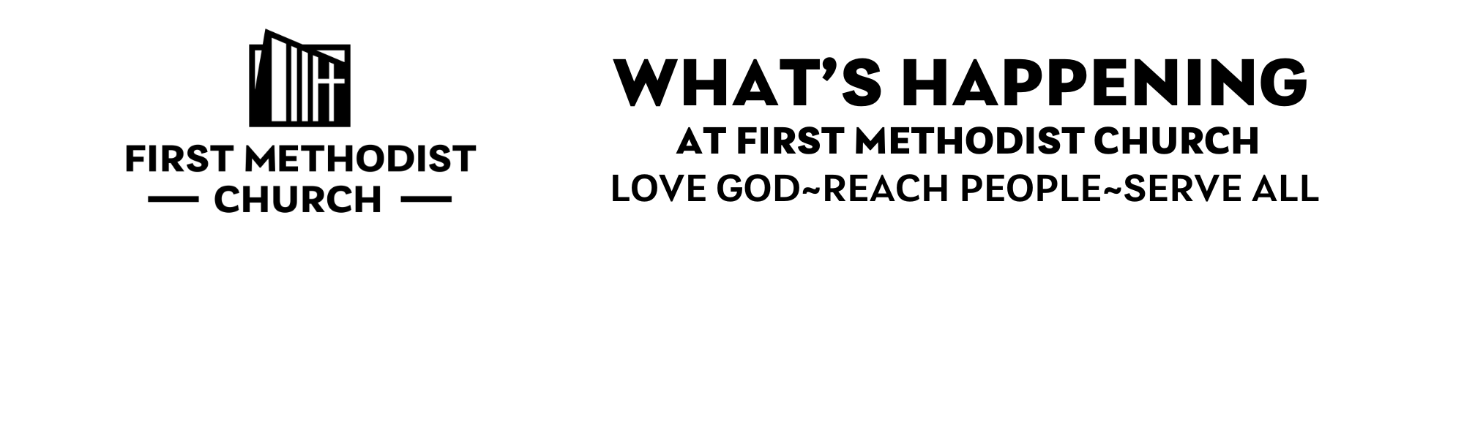

____________________________________________________________________
WEEK OF JAN 19 -JAN 25, 2025
HAPPY NEW YEAR & WELCOME TO FMC-This morning we are grateful to welcome Central District Superintendent Ronell Howard as our guest preacher. Her leadership and message today helps us connect our lives together as followers of Jesus Christ and as part of the Greater NJ Conference of the United Methodist Church. DS Howard lives a wholehearted life and strives to help us all do the same. Come as you are– this is a place where questions are honored, faith is nurtured, and all belong.

COFFEE HOUR- is held between services in Fellowship Hall. Join us!

FAMILIES WITH YOUNG KIDS-The nursery in the Parlor is staffed by childcare volunteers. There are also Busy Bags filled with coloring pages in the back of the church for children who want to sit in the Sanctuary. Questions or to volunteer, contact Sarah Owens at sarahmowens13@gmail.com.
FMC NOW HIRING Director of Youth Ministries: 15 hrs/wk, $19,500/yr to lead 6th–12th grade youth (Sun. nights 5–7:30pm), retreats/mission, and college connections. Help our students Love God, Reach People, Serve All! Contact Jeremiah Appleton at jeremiah@fmcmoorestown.com.

MIRACLES EVERYWHERE CAMPAIGN-As we engage this season of generosity, we celebrate how our faith and giving help make miracles happen. If you have not yet had the opportunity to complete and submit your Commitment card for 2026, you can still mail it to the church or take one from the Welcome table in the Narthex.
KIDS’ CHURCH-Our Kids’ Church Sunday school program meets during our 9am worship service in Room F103 for students in Grades K-5.

YOUTH GROUP-Our Youth Group program (for students in Grades 6-12) typically meets from 5-7:30pm on Sun. nights and includes dinner, games, worship, and small group discussion. For more information, please pick up a Youth Group brochure from the welcome table or reach out to Jeremiah at jeremiah@fmcmoorestown.com.
YOUNG FOLLOWERS-Our Young Followers program is for students in Grades K-5 and meets from 5-6:30pm on Thurs. evenings. The program includes choir, dinner, games, and Bible lessons. For more information, please pick up a Young Families brochure from the welcome table or reach out to Jeremiah at jeremiah@fmcmoorestown.com.
FAITH PROMISE SUNDAY-is next Sun., Jan. 25. We will have breakfast between services at 10am in Fellowship Hall. Please join us so you can learn more about what we are doing both nationally and globally to support important missions. Also, our morning speaker will be Ms Callie Crowder, Director of The Maker’s Place Diaper Depot in Trenton. She will share information about the organization and how it serves the community. Lastly, we are looking for more people to join the Missions Committee. For more information, contact Diane Dyson at dianemdyson@gmail.com.
TROOP 44 PASTA FEST-The Boy Scouts invite all to their annual pasta dinner in Fellowship Hall on Sat., Jan. 31. Seatings are at 3pm, 4pm, and 6:30pm. Tickets cost $10. Bring the whole family and support our Scouts! You can dine in or bring a take-out container to be filled for you. The Scouts prepare, cook and serve the whole meal.
SUPER BOWL HOAGIE FUNDRAISER-This annual Youth Group fundraiser is back in support of our summer Mission Trip with Appalachia Service Project. Turkey, Italian, and Cheese hoagies are available with an option of gluten-free rolls. Orders can be placed at the Narthex table after services or by emailing jeremiah@fmcmoorestown.com between now and Weds., Feb. 4 and will be available for pick up between 10am-12:30pm on Sun., Feb 8. Hoagies are $10 each. The enclosed flyer has a QR card to scan and order. If you prefer a printed order form, they are on the Narthex table.
EQUITY & SOCIAL JUSTICE-invites you to attend the MLK Day Celebration at Bethel AME Church, 512 N. Church St., Moorestown on Mon., Jan. 19 at 5pm. Moorestown Mayor Quinton Law will be the guest speaker. The event will include the community choir, praise dancing, and spoken word.

MEN’S RETREAT-We are holding a retreat entitled Vocation: Living Life on Purpose to which all men in the church are invited. In it, we will explore the call and purpose of the second half of life. The retreat will be held in the Heritage Room from 7-9pm on Fri., Jan. 30 and from 8-11am on Sat., Jan. 31. Questions, contact Rich Hendrickson at richhendrickson58@gmail.com.
MIND CAFE-will again provide a safe place for local teens and young adults to meet and share a meal, discuss relevant topics, and build community. It’s free! We meet biweekly on Fri. nights in F105 from 6:30-8:30pm beginning on Jan. 30. To sign up, go to http:mindcafeconnect.org or contact Jen Kaminski at 609 929 8687.
PASTOR RICH’S BIBLE STUDY-The study of First and Second Peter entitled Courage in Times of Trouble will be held at 7pm on Mons. (Zoom) and Weds. (Heritage Room). The Mon. study dates are Feb. 9, 16, and 23 and Mar. 2, 9, 16, and 23. The Weds. study dates are Feb. 11, 18, and 25 and Mar. 4, 11, 18, and 25.
MONDAY MORNING BIBLE STUDY-Everyone is welcome to join us on Zoom on Mons. from 9:30-11am. We are studying the Bible from beginning to end. Questions, contact Peggy Koenitzer at paboblenz@comcast.net.
THURSDAY MORNING WOMEN’S GROUP-meets on Thurs. From 8:30-10am in the Parlor. Please join us for fellowship, prayer, and spiritual growth. We have begun studying Abba’s Child by Brennan Manning, who encourages us to freely accept our belovedness as a child of our heavenly Father. Questions, contact Carol Talbot at 856 577 3051.
FRIDAY MORNING MEN’S GROUP-is a spiritual development and mutual support group for men of any age that meets weekly on Fri. at 7am in the Parlor. We typically select books by Christian authors as a springboard for discussion of how we can live out our faith. New members are welcome and encouraged to join! Questions, contact Tom Kulp at 609 707 4708.
COPIES OF THE SERMON-can be found on the Narthex table.
 | ELECTRONIC GIVING OPTION – If you would like to make an electronic donation to FMC Moorestown, go to www.fmcmoorestown.com/give or scan this QR code to connect to our digital giving page. Please consider giving generously to support the ministries of FMC that impact communities locally and globally!

