PRAYER CONCERNS: Carol Heller, Cathy Carty, Lori Hayes, Bruce Scheyhing, Kate Kenny, Barbara Harris, Madison Luyber, Mary Raroha, Girard Kalinay, Sue Mitchell, Ruth Rosvold, Esther, Jenny Zollers, Gene Glavin, Joyce Thompson, Larry Cook, Jeanne Hoffner’s sisters Anne Patterson and Mary Cardi, Peggy Carson, all who mourn, those recovering from natural disasters, for all living amidst war and violence, and for refugees who suffer worldwide.

 | ELECTRONIC GIVING OPTION – If you would like to make an electronic donation to FMC Moorestown, go to www.fmcmoorestown.com/give or scan this QR code to connect to our digital giving page. Please consider giving generously to support the ministries of FMC that impact communities locally and globally! | 

THE STAFF OF FIRST METHODIST CHURCH
Rev. Dr. Gina Hendrickson, Lead Pastor Gina@fmcmoorestown.com
Jeremiah Appleton, Program Ministries Director Jeremiah@fmcmoorestown.com
Barbara Morgan, Executive Office Administrator Devika Gill, Preschool Director
Matt Callender, Communications Director Bill Marshall, Property Coord.
Donna Banes, Co-Music Leader Sarah Owens, Nursery Coord.
Dustin Beck, Co-Music Leader & Worship Prod. Manager Antonio Silva, Sound Tech.
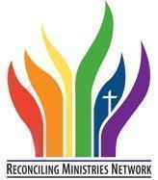
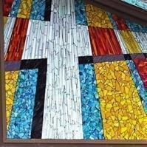
WORSHIP SCHEDULE
9:00 A.M. Contemporary Worship
11:00 A.M. Traditional Worship
Services are held in our Sanctuary and livestreamed
on Facebook and YouTube
CCLI License #782839 |Streaming License #CSPL124152 | CVLI License #504330184

  facebook.com/fmcmoorestown |   youtube.com/@fmcmoorestown446 |   instagram.com/fmcmoorestown

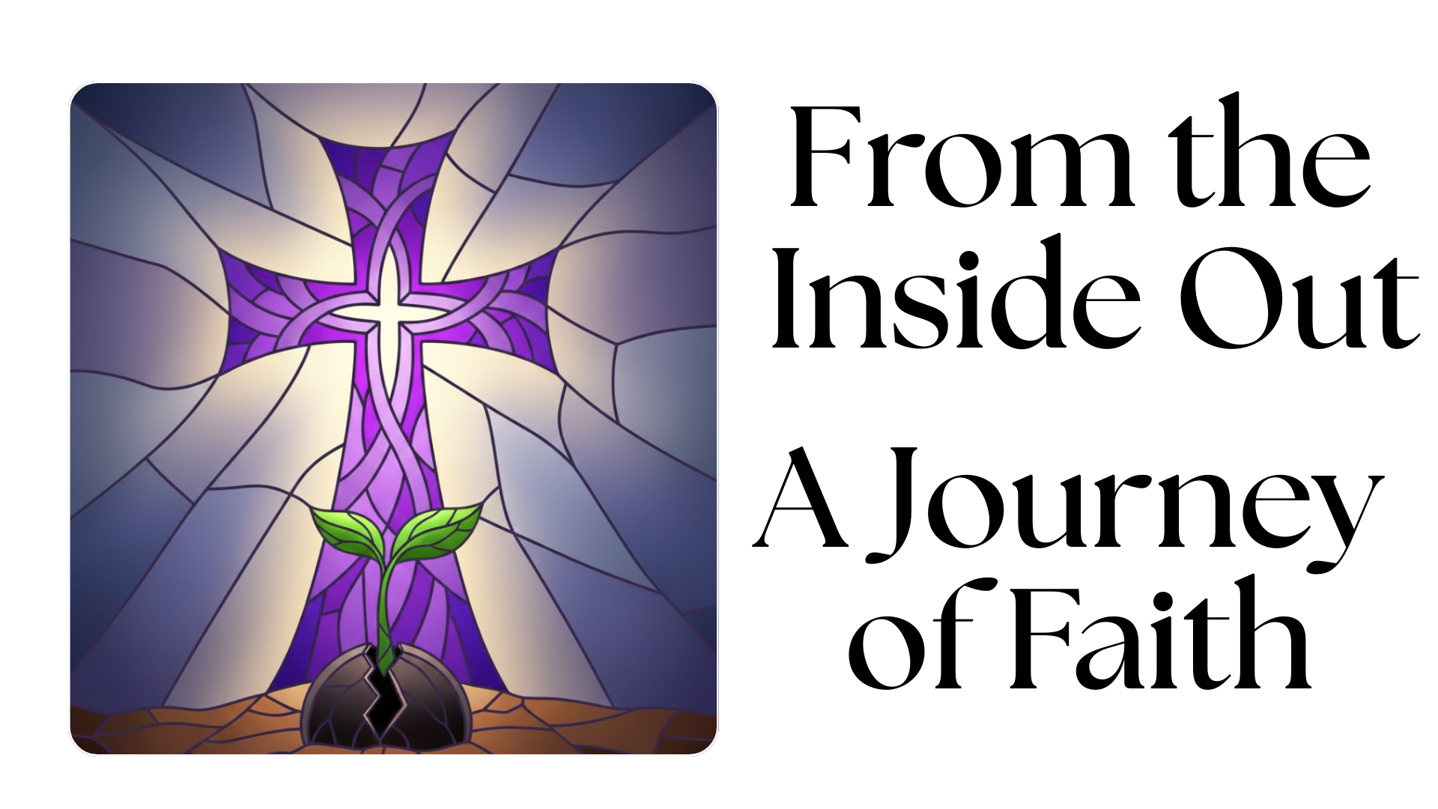
LOVE GOD ~ REACH PEOPLE ~ SERVE ALL

February 22, 2026 Lent & Mission Sunday 9:00 A.M.

WELCOME Rev. Dr. Gina Hendrickson

*SONG Holy Water FMC Worship Team

*CALL TO WORSHIP Doug Carty
Leader: God calls us to love not only in word—
People: But in action and truth.
Leader: God sends us to serve with humble hearts.
People: We offer our lives as signs of hope.
Leader: Come, let us worship the God who sends us.
All: We worship with hearts open to serve.
*OPENING PRAYER Rev. Diane Dyson
God of mercy and mission, open our eyes to the needs around us. Shape us into people who love boldly, serve faithfully, and follow Jesus with open hands. As we worship today, stir our hearts to see where you are already at work and give us the courage to join you. May our praise become compassion, and our faith take shape in lives of justice, generosity, and hope. Amen.

*SONGS OF WORSHIP FMC Worship Team
Build my Life
Made for More

MINISTRY IMPACT MOMENT Joel Bewley

MORNING PRAYER/THE LORD’S PRAYER Allan Estrin
Our Father, who art in heaven, hallowed be thy name. Thy kingdom come, thy will be done on earth as it is in heaven. Give us this day our daily bread. And forgive us our trespasses, as we forgive those who trespass against us. And lead us not into temptation, but deliver us from evil. For thine is the kingdom, and the power, and the glory, forever. Amen.

CELEBRATING OUR LIFE TOGETHER Jeremiah Appleton
We welcome all who worship with us this morning. Please fill out an attendance card as well as prayer concerns (on the back of the attendance card) at this time.

OFFERING OUR GIFTS AND TITHES Jeremiah
We ask you to prayerfully consider giving generously to support the ministries of FMC and the communities we serve for Christ. You can place your offering in the plate as the ushers pass it to you. Gifts can also be given online and prayers can be emailed to church@fmcmoorestown.com.

OFFERTORY FMC Worship Team
Just A Closer Walk With Thee

SCRIPTURE Matthew 4:12-23 (NRSVUE) Ken Hoffner

INTRODUCTION OF SPEAKER Rev. Diane Dyson
MESSAGE Living From the Inside Out--The Promise
Callie Crowder, Executive Director, The Maker’s Place

*CLOSING SONG Child of Love Worship Team
During this song everyone is invited to prayerfully bring their Faith Promise pledge cards forward and leave it in the basket.

*PRAYER OF DEDICATION Pastor Gina

*BENEDICTION Callie Crowder

*POSTLUDE

*THE PEOPLE STAND IN BODY OR SPIRIT

