THE BENEDICTION
C: Amen!

CLOSING HYMN: “Forth in the Peace of Christ We Go” (920)

Pastor: We have gathered this morning to worship the Lord, to be renewed and strengthened in God’s love and the forgiveness of sins. As we go, let us remember who we are and what we do:
C: “We are rooted in God’s love, united in connecting people to Jesus.”
Pastor: You are dearly loved and treasured by God, planted and growing in God’s love. As God’s beloved children, go in peace! Love one another! Be a blessing! Share the faith! Serve the Lord with gladness!
C: Thanks be to God!

Service Acknowledgments
Divine Service, Setting One from Lutheran Service Book. Used by permission. All rights reserved. Created by Lutheran Service Builder © 2018 Concordia Publishing House. LSBHymnLicense.net 100011351

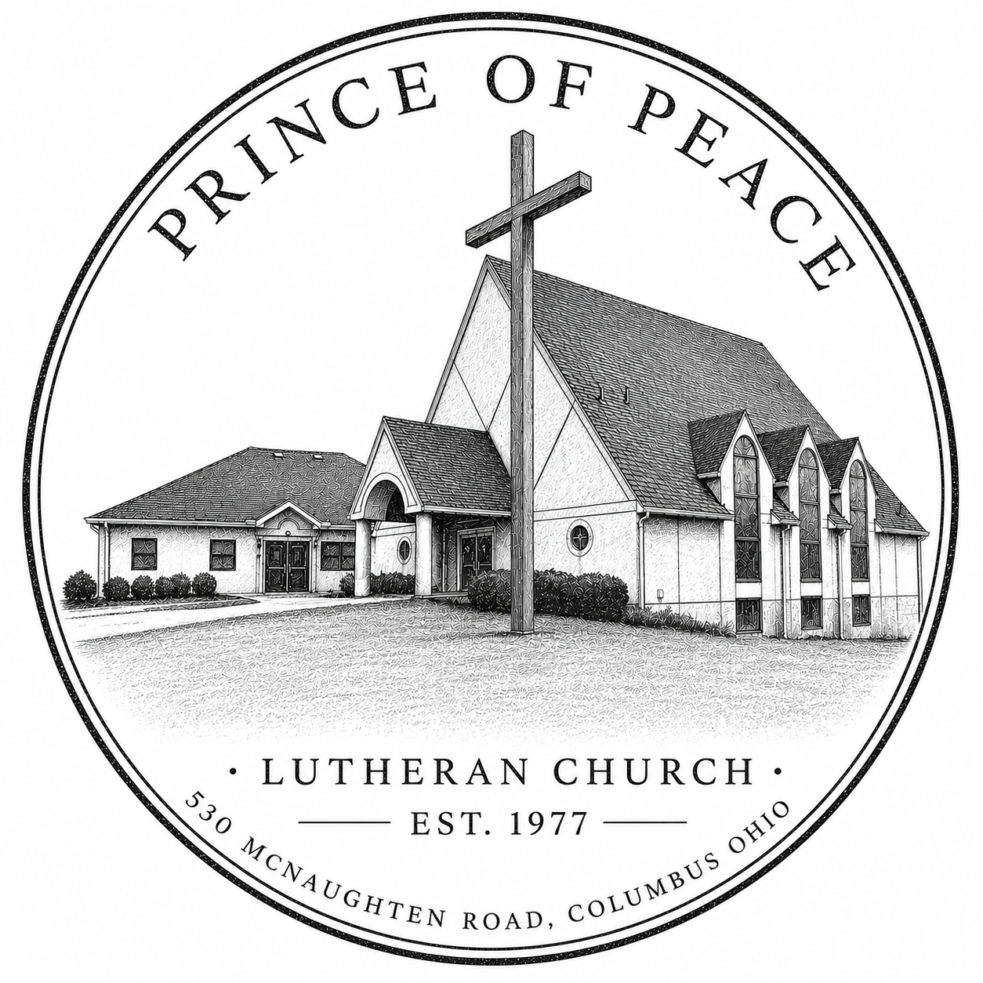

Fifteenth Sunday after Pentecost
September 6th, 2026

“We are rooted in God’s love, united in connecting people to Jesus!”
PRELUDE MUSIC

WELCOME and INVOCATION

OPENING PRAISE: “Come, Thou Fount, of Every Blessing” (686)

CONFESSION OF SINS AND ASSURANCE OF FORGIVENESS
P: Beloved in the Lord, if we say we have no sin, we deceive ourselves, and the truth is not in us.
C: But if we confess our sins, God, who is faithful and just, will forgive our sins and cleanse us from all unrighteousness.

Silence for reflection on God’s Word and for self-examination.

P: Let us then confess our sins to God our Father.
C: Most merciful God, we confess that we are by nature sinful and unclean. We have sinned against You in thought, word, and deed, by what we have done and by what we have left undone. We have not loved You with our whole heart; we have not loved our neighbors as ourselves. We justly deserve Your present and eternal punishment. For the sake of Your Son, Jesus Christ, have mercy on us. Forgive us, renew us, and lead us, so that we may delight in Your will and walk in Your ways to the glory of Your holy name. Amen.
P: Almighty God in His mercy has given His Son to die for you and for His sake forgives you all your sins. As a called and ordained servant of Christ, and by His authority, I therefore forgive you all your sins in the name of the Father and of the Son and of the Holy Spirit.
C: Amen. Thanks be to God!

SONG OF PRAISE: “There is a Redeemer” (Screens)
“There is a Redeemer” Text and Tune: Melody Brown © 1982 Universal Music - Brentwood Benson Publishing (Admin. by Brentwood-Benson Music Publishing, Inc.) Birdwing Music (Admin. by Capitol CMG Publishing) Ears To Hear (Admin. by Capitol CMG Publishing) (Admin. by BMG Music Publishing) Used by permission. CCLI License #488425

KYRIE PRAYER (Spoken)
P: In peace let us pray to the Lord.
C: Lord, have mercy.
P: For the peace from above and for our salvation let us pray to the Lord.
C: Lord, have mercy.
P: For the peace of the whole world, for the well-being of the Church of God, and for the unity of all let us pray to the Lord.
C: Lord, have mercy.
P: For this holy house and for all who offer here their worship and praise let us pray to the Lord.
C: Lord, have mercy.
P: Help, save, comfort, and defend us, gracious Lord.
C: Amen.
PRAYER FOR THE DAY
P: The peace of the Lord be with you.
C: And also with you!
P: Let us pray together:
C: Almighty God, from whom all good proceeds, grant to us, Your humble servants, Your holy inspiration, that we may set our minds on the things that are right and, by Your merciful guiding, accomplish them; through Jesus Christ, Your Son, our Lord, who lives and reigns with You and the Holy Spirit, one God, now and forever, Amen!

TODAY’S SCRIPTURE READINGS
The Epistle reading is Romans 13.1-10. The Apostle Paul wrote about the divine institution of government and the Christian’s response to it.

Our Psalm for today is Psalm 32.1-7. This Psalm is a Psalm of confession from David after his affair with Bathsheba.

Today’s Gospel is from Matthew 18.1-20. The Lord teaches the disciples and us our view and actions towards greatness and humility.

Please stand for the reading of the Gospel

L: These are the Words of the Lord.
C: Thanks be to God!

CONFESSION OF OUR FAITH Apostles’ Creed (Screens)

SERMON HYMN: “Father Welcomes” (605)

SERMON: Matthew 18.1-20

OFFERING & OFFERTORY

ANNOUNCEMENTS

PRAYERS & THE LORD’S PRAYER
Congregational response to each petition is: “Hear our prayer”
X

AFFIRMATION OF HOPE
P: To you, O God, Father, Son, and Holy Spirit, be all honor and glory, in Your holy Church forever and ever. Amen!
C (Loudly): CHRIST HAS COME! CHRIST IS RISEN! CHRIST SHALL COME AGAIN!

