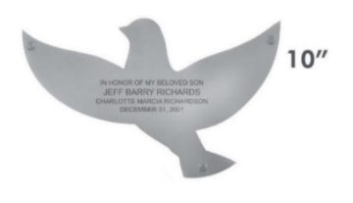
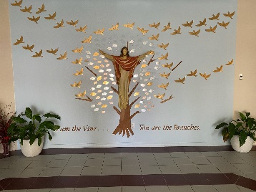
Tree of Life
Order Form
8”
Please PRINT
Date_______________

Name:_____________________________________________________________________________________________

Address:___________________________________________________________________________________________

City:________________________________State:______________________ Zip Code:_________________

Home Phone:___________________________________ Cell Phone:__________________________________________

Email:_____________________________________________________________________________________________

Please check which DONOR LEAF you would like to purchase and complete the inscription. (up to 3 lines). Please print clearly and double check information/spelling. If you wish to order more than one leaf, either make copies of this form or write on the back.
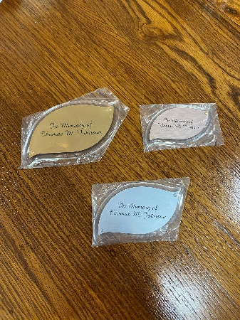
_______ Copper (overall size 3-3/8” x 2-2/8”) $50.00 donation

_______ Silver (overall size 4-7/8” x 3”) $150.00 donation

_______ Gold (overall size 3-1/4” x 5-3/4”) $300.00 donation

_______ 8” Silver Dove – donation of $400.00

_______ 10” Gold Dove – donation of $500.00 and above

Inscription for Leaf or Dove

Line 1 ________________________________________________________________________________

Line 2 ________________________________________________________________________________

Line 3 ________________________________________________________________________________
(Maximum 24 characters and spaces per line PLEASE PRINT CLEARLY)

Please make check payable to: Our Lady of Grace Catholic Church and write Tree of Life on the memo line. Return to church office, place in the collection basket at Mass, or mail to: Our Lady of Grace Catholic Church, 595 E. Main St., Avon Park, FL 33825 Attention: Tree of Life. Any questions, please call the Parish Office, 863-453-4757.

