Cycles for Christ 2025 Year in Review
Cycles for Christ is a ministry of Hudson Presbyterian Church located at 202 W Streetsboro St Hudson, OH. The goal of the ministry is to serve God’s people by providing bikes to those who for assorted reasons cannot afford a bike. Our clients usually belong to one of these groups: poor, homeless, immigrants, refugees, and/or veterans. Bikes are collected, repaired, and distributed. Recipients get a helmet and lock with most bikes. A letter is provided to recipients telling them why we are doing this and inviting them to attend our Church or a Church of their choosing. We ask that they pray and thank God if they have been blessed by our ministry. When opportunities are presented, testimony is provided to the recipients in formal and informal settings.
2025, our 15th year of operation, has been a successful year for our ministry. God has blessed Cycles for Christ with generous donors who have given us their time, money, parts, and bikes. Because of these donations we have been able to distribute 450 bikes, 342 helmets and 309 locks to individuals and organizations in Hudson, and surrounding communities, including Akron, and Cleveland. Our total numbers of bike delivered were down this year due to limited immigrants entering the United States. In addition to the bikes we distributed we have also repaired another 98 bikes and returned them to their owner for a total of 548 bikes. The average cost for parts to repair a bike is approximately $8.00. The cost for a helmet is approximately $8.00. The cost for a lock is $6.00.
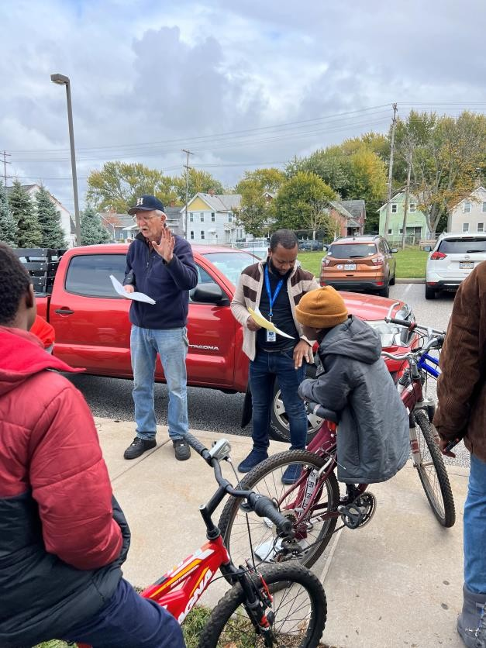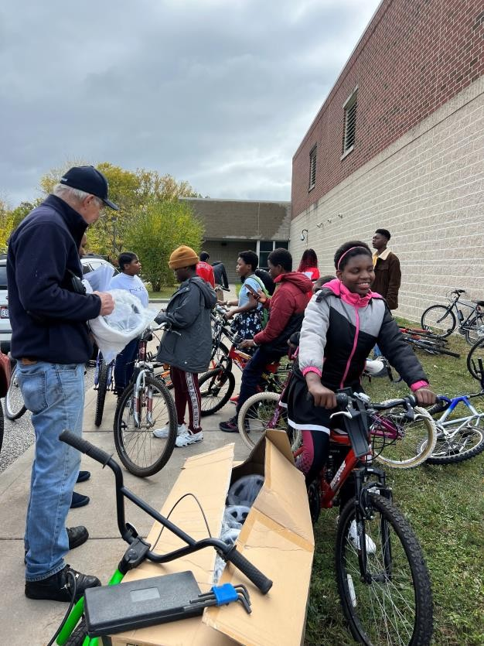
Bike Delivery at Thomas Jefferson School in Cleveland

We delivered Bikes through community or faith-based organizations that identify individuals who need bicycles. The organizations we continued to work with for distribution are Hudson Community Service Association, the Emergency Assistance Center in Macedonia, Urban Vision, US Committee for
Refugees and Immigrants, Urban Community School in Cleveland, Thomas Jefferson School in Cleveland,
Peter Maurin Society, Valor House in Akron, Miller House in Kent, Christ Community Chapel, First
Congregational Church Hudson, Rooted in Christ Community Church, International Welcome Center, Baskets of Love Food Pantry, Our Community Hunger Center and Catholic Workers that works with the poor in Akron. We developed new relationships this year with Garden Christian Academy and Macedonia Methodist Church.

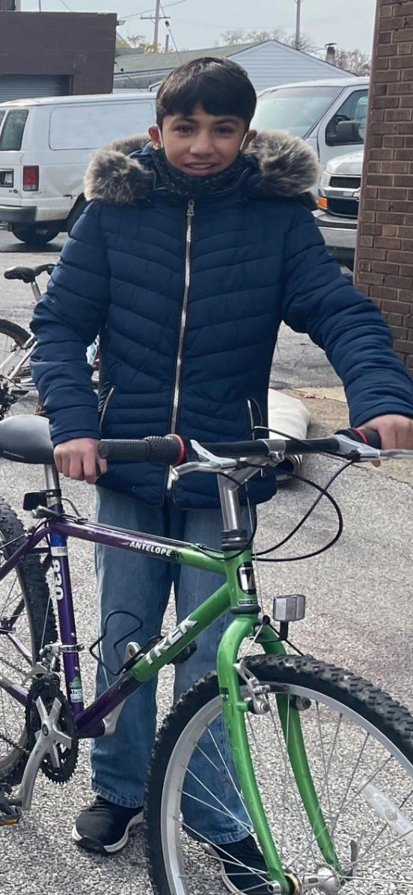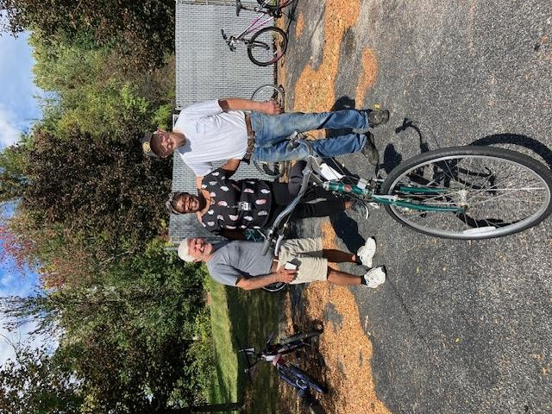
Afghan Refugee Delivery to Miller House, Kent OH with Ed Davidian
We have been blessed that a local bike shop has provided support to us throughout the year. Eddy’s Bike Shop with various locations, collected bikes from folks who wanted to donate them and provided us with a discount on parts.
The Cycles for Christ Ministry was blessed by support from the congregation and community. This year we received enough money from donations and sales of bicycles to pay for all our parts and helmets. This reduced possible strain on the church budget. In addition, we donated $500 to support the HPC El Salvador Mission trip with funds from bikes we sold. Church members have collected bikes from their garages and neighborhood garage sales. Some neighbors purchased bikes to support us financially. We have the use of a local barn to store bikes. The barn is a real blessing to our ministry. We also had several groups helping us out. Goodyear sent us bike repair helpers through their Week of Volunteering program.
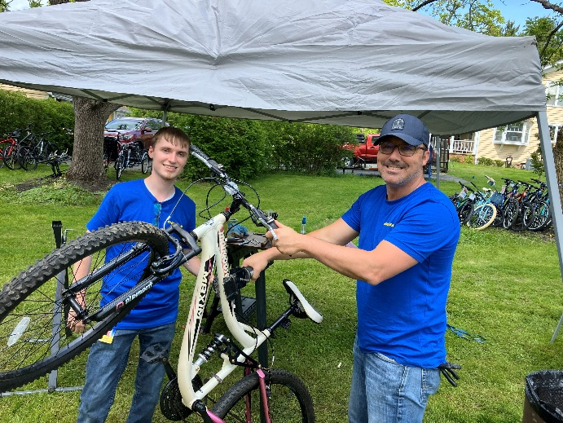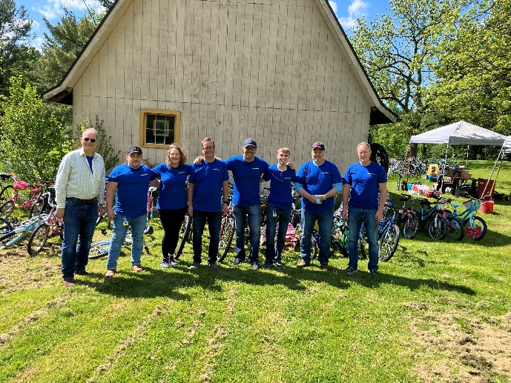
Scenes from Goodyear Week of Volunteering
Cub Scout Pack 3327 has been a significant contributor to our program for over 10 years. They hold an annual bicycle collection drive “Scouting for Bikes” at the United Methodist Church. Their program “Scouting for Bikes” collected over 65 bikes this year. Through the years they have collected nearly 1400 bikes. Goodyear Day of Caring sent 24 volunteers to help repair bikes in June. They were able to inspect and repair over 100 bikes. Goodyear also provided a $500.00 donation. Gloria Die Lutheran Bible School kids once again helped out by repairing bikes for other kids. Church members, friends, and neighbors offered their time, prayers and equipment; without this support the mission would not have succeeded.
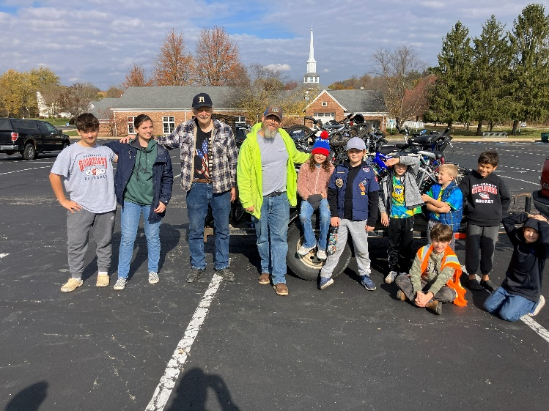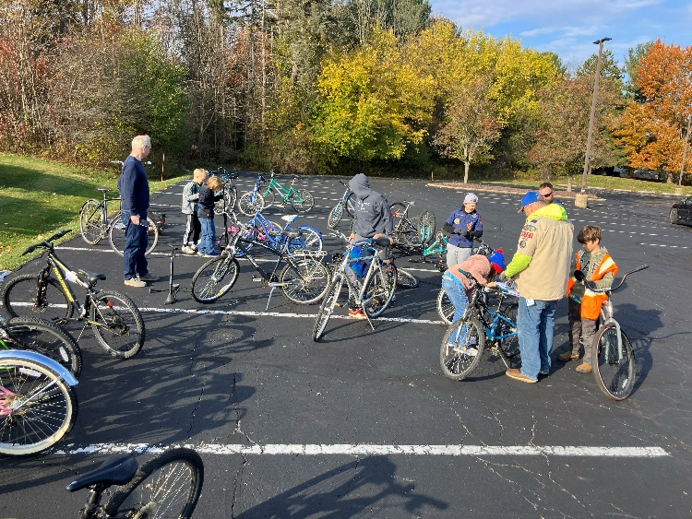
Pack 3327 Hudson – Scouting for Bikes Pack 3327 Collecting Bikes

Volunteers
Faithful volunteers who helped Cycles for Christ include Bill McLure, Mark Prebe, Carson Heiner, Scott Lindner, Ed Davidian Lazlo Repay and Tim Moffit. Sadly, we lost Bill Mclure our longest service volunteer to cancer this year, we miss him. Mark Justice has loaned his trailer since the beginning of our ministry, over the years we have picked up and delivered thousands of bikes to and from the shop on hundreds of trips. The work everyone joyfully and willingly provides has made our ministry a success.
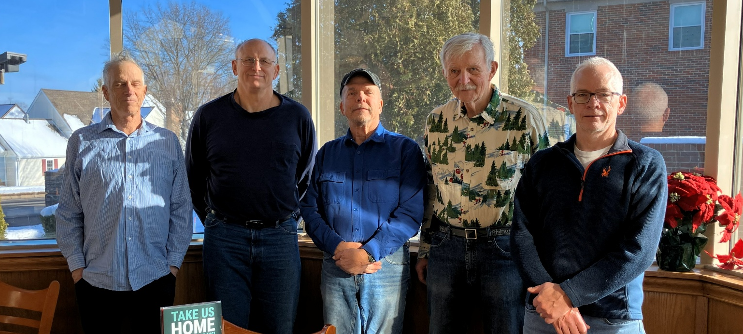
Cycles for Christ Crew
Carson Heiner, Scott Lindner, Mark Prebe, Jon Polhamus, Tim Moffit, Not shown Laslo Repay

Cycles for Christ – Seminole FL
In 2020 Jon Polhamus was asked by Faith Community Church in Seminole Florida to assist with establishing a chapter of Cycles for Christ at their church. Jon, a snowbird, had worked with the church over the last 10 years distributing bikes to Faith Café (food pantry) attendees and disadvantaged youth. Faith Community Church wanted to be able to give away bikes throughout the entire year. Jon worked with members of the congregation to set up a shop, acquired tools, and provided basic training in bicycle repair. The group has been a success and is serving Faith Community Church (EPC) clientele. Jon is looking forward to working with them at their shop in Florida.

Goals for 2026
Our goals for 2026 are to continue to serve existing client agencies and develop additional contacts where we can be of service. God has blessed this ministry, and it has flourished. Over the history of Cycles for Christ we have given away approximately 6,100 bikes and repaired and returned another 1060 bikes. Each of those bikes represents a life we have touched, a seed sowed in Gods Garden. It is safe to say that we have done little more than scratching the surface of need. Positive feedback from the groups we work with reassures us that Cycles for Christ is a blessing to our clients. We have an inventory of bikes ready to start the year and are looking forward to continuing our work in the 2026 bicycling season.
Nothing that we have accomplished would have happened without God guidance and provision. We are blessed to have had the opportunity to serve God’s people in this ministry.
An invitation is extended to anyone who would like to assist. You need not be a bike repair “expert”, just a willing worker. Contact Jon Polhamus 330-524-8564 or by email at jonpolhamu@aol.com.

