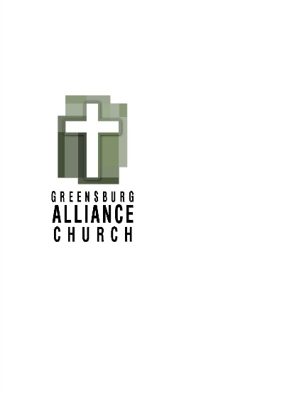

**Greensburg Alliance Church Governing Board Meeting Minutes**

**Tuesday, May 20, 2025**

**Governing Board Members Present:**  Bob Callen, George Cross, Mark DiAndreth, Donna Hixson, Rigel Holmes, Bill Hugland, James (Lu) Llewellyn, Rusty Loy, Todd Murgi, Mark Obringer, Eric Simpson, Bob Statler, Dave Tomko, Jayme White

The regular monthly meeting of the Greensburg Alliance Church Governing Board was called to order by Pastor Lu at 6:30pm in Conference Room 550. Pastor Lu provided an overview of how to log onto our website to find the monthly reports.

1. Devotion – Pastor Lu’s devotion was taken from the book, Ruthless Elimination of Hurry. The book references the discipline of silence. There are two dimensions of silence, internal and external. Internal silence is the toughest to manage. Many people find that quiet in the shower. We were asked to consider where we go to achieve internal silence.

1. Jayme opened the meeting in prayer.

# Adoption of Minutes – Motion to accept April minutes- Bill – seconded Bob C.

# Treasurer’s Reports – Motion to accept Bob C. – seconded Mark O.

# Ministry Reports – Motion to accept all ministry reports – Dave – seconded George.

## Trustees

## No action

## Director of Children’s Ministries

* Request to approve volunteers for VBS; Sue Trout, Izzy Seaton, Shelby Hughes, Leah Wheelus, Katie Momeyer, Dominick DiAndreth.

Motion to approve Mark O – seconded Bill.

## Director of Worship Ministries

* No action.

## Assistant Pastor for Youth

* No action.
  1. Director of Administration and Discipleship
* A request was made to transition to Planning Center (PC) as our Church Management Software system.

Motion to approve Mark O. – seconded Rusty.

* 1. Lead Pastor
* No action

# Old Business

* Items to be discussed in the elders meeting after the board meeting.

1. New Business

* Request for update on our fundraising. The decision was made to complete the current work on the landscaping and the bathrooms.
* After that we will know exactly the monies needed for the sanctuary and roof work. Will be able to present that amount to the congregation.
* Recommendation was made to provide training for the Welcome Team in short 5-minute huddles prior to the service. It was also suggested that we create a team handbook.

# Motion to adjourn – Rusty – seconded Eric.

**Meeting was adjourned at 7:38pm**

# The next meeting of the GAC Governing Board will be held on **June 17, 2025**.

Respectfully Submitted,

Donna Hixson, Governing Board Secretary