ACKERMANVILLE UNITED METHODIST CHURCH
1410 Ackermanville Road Bangor, PA 18013
www.ackermanvilleumc.org
Rev. Dr. Sukja Bang
155th Anniversary Celebration
November 9, 2025
*Please stand as you are able
Please silence your electronic devices.

PRELUDE

GREETING AND ANNOUNCEMENTS

SHARING THE PEACE OF CHRIST

*HYMN #140 Great Is Thy Faithfulness
(Please hand your prayer request cards to the ushers.)

*CALL TO WORSHIP
L: We gather, looking back to see the paths we have taken,
P: And looking forward to the path that lies ahead.
L: We honor those who have gone before us,
P: Learning from their faith, their courage, and their perseverance.
L: We celebrate who we are today,
P: And welcome the possibilities and opportunities before us.
L: We gather to worship God-
P: The God of yesterday, today, and tomorrow.

*OPENING PRAYER
Loving and eternal God, we give you thanks for this day of celebration. For 155 years, your Spirit has guided this congregation – through seasons of challenge and joy, you have been our Shepherd and our Strength. We thank you for all who have proclaimed your Word, offered their prayers, and served in love. As we worship today, renew in us the joy of your salvation. Help us to serve you with gladness, to be steadfast in faith, and to carry your light into the world with grateful hearts. In the name of Jesus Christ, our Lord. Amen.

*THE GLORIA PATRI #70 Glory Be to the Father

CHILDREN’S MESSAGE

CONGRATULATORY REMARKS Bishop Cynthia Moore-Koikoi

PSALTER READING Psalm 100 Rev. Evelyn Stupp
(Pew Bible pg. 481)
L: This is the Word of the Lord.
P: Thanks be to God.

ANTHEM How Great Is Our God

*EPISTLE READING 2 Timothy 4: 1-8
(Pew Bible pg. 968)
Pastor: This is the Gospel of our Lord Jesus Christ.
People: Thanks be to God.

MESSAGE “Let’s Run Hard and Finish Well” Rev. Dr. Hunju Lee

*HYMN #545 The Church’s One Foundation (vv. 1-4)

JOYS AND CONCERNS

PASTORAL PRAYER

LORD’S PRAYER

TIME OF OFFERING

*DOXOLOGY #94

*OFFERTORY PRAYER (UNISON)
Heavenly Father, we thank You for 155 years of ministry, praising You for the faithfulness of those who came before us and for the community You have built. As we present this offering, we pray that it will continue Your work, helping us to grow in faith and love, to serve the needy in our community, and to be a light for those around us for many years to come, all in Jesus’ name, Amen.

*HYMN #569 We’ve a Story to Tell to the Nations

*BENEDICTION

*BENEDICTION RESPONSE #664 Sent Forth by God’s Blessing (v.1)

POSTLUDE

Please remember to keep bringing in the Weis Markets receipts.

*The Food Pantry needs our help. If you will, please bring your donation of food or paper goods and place them in the bins in the narthex, in the hallway outside of Young Hall, and an extra collection bin in the vestibule. The food is taken to the Food Pantry once a month.

To order flowers. . .
First, write your name and the message you would like in the bulletin on the Flower Calendar located in the narthex of the sanctuary.
Second, call Albanese Florist (610)588-0441 and place the order with them under the Ackermanville UMC account.
Then place the cost of the flowers in the offering plate on Sunday and designate that it is for the cost of the flowers. Thank You.

Pastor Rev. Dr. Sukja Bang
sukjabang53@gmail.com
Parsonage: 610-452-2699
Church School Superintendent Jeff Sandercock
Choir Director Del Roberts
Lay Leader Barry Young
Organist Cindy Doll
Church Secretary Charleen Hutchison
ackermanvilleumc@gmail.com
Office: 610-588-7818
The Ministers All the Congregation

Online Giving www.ackermanvilleumc.org/donate

https://aumc.churchtrac.com/give

155th Anniversary Celebration Service

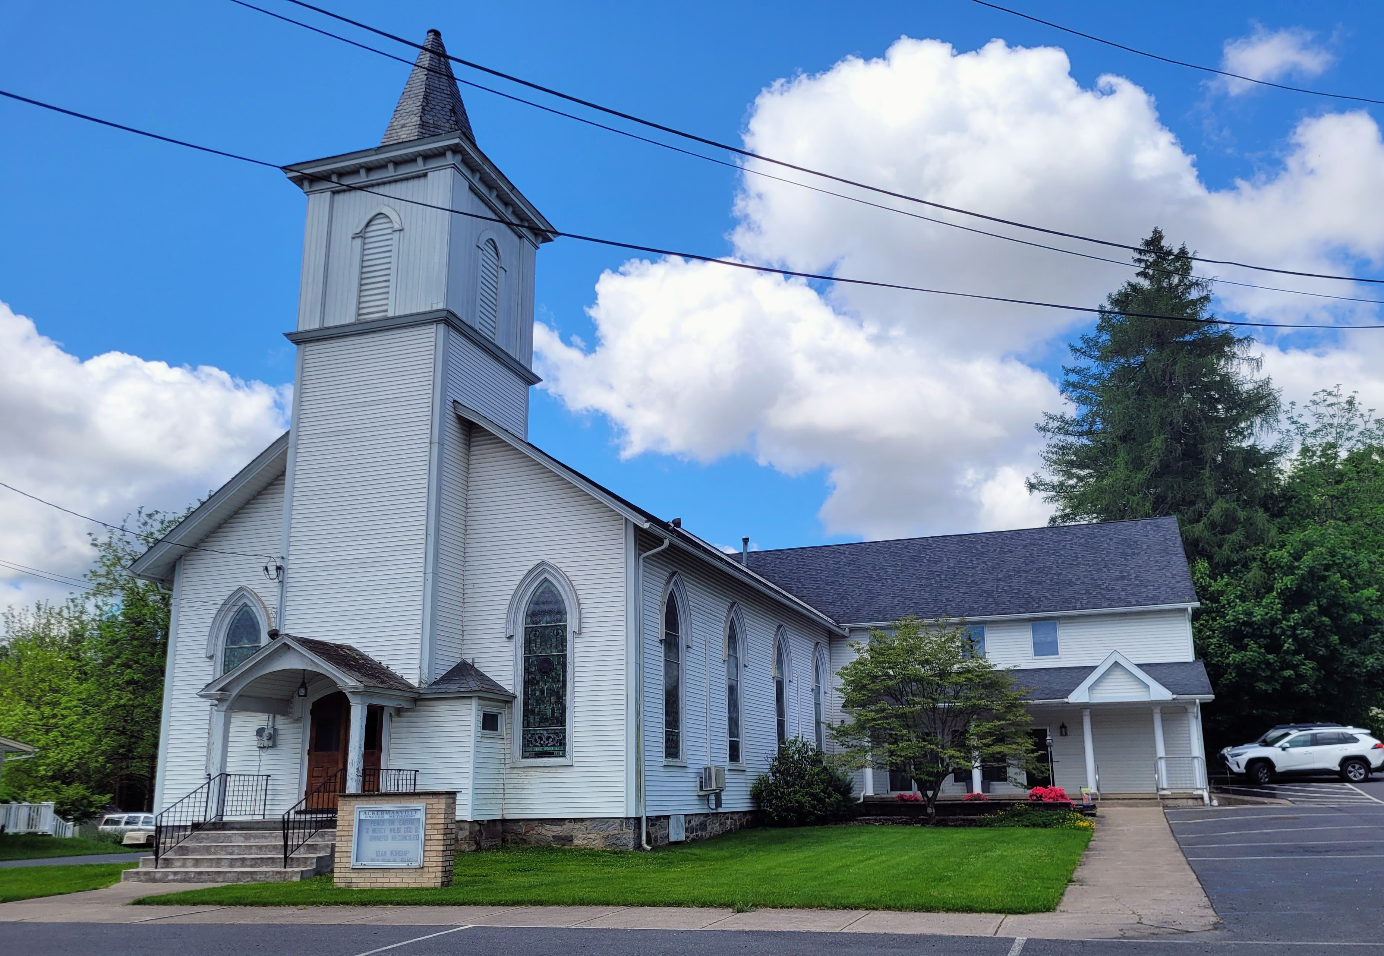


Ackermanville
United Methodist
Church

ACKERMANVILLE, PENNSYLVANIA

