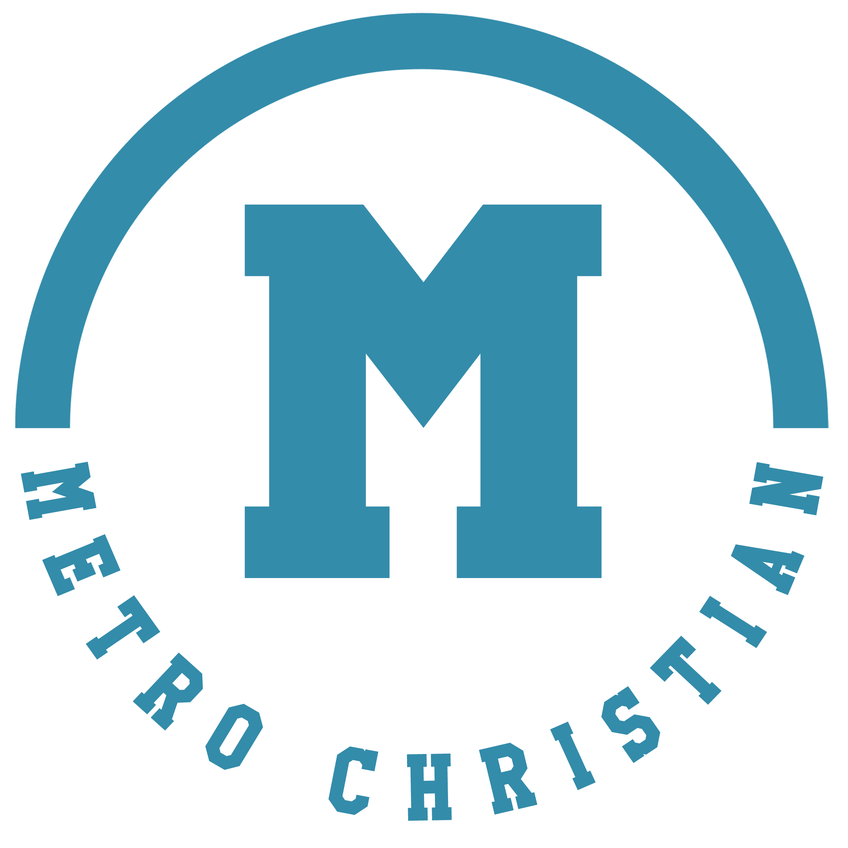

Metro Christian Academy is a growing K3-12th Grade school. Our academy has celebrated more than 35 years in Christian education, training young people to love and serve the Lord for a lifetime. Our preschool has been in operation more than 20 years. Our beautiful twenty-three-acre campus is located in Goodlettsville, Tennessee, a suburb of Nashville. Our staff actively serves the Lord in the classroom and in our church ministry.

MCA has doubled in size in the last two years and we are currently in the process of adding a 22,000 sq/ft addition to our facility for school and preschool use.

For more information please contact Dewayne Coleman at 615-390-1648 or dewaynecoleman@mcaeagles.com.

Job Openings:

JR/SR High History Teacher
Metro Christian Academy has an open position for a full-time Middle School and High School History teacher for the 2023-2024 school year. Specific course and grade level assignments will depend on the strengths of the candidate.

The teacher must be able to manage a classroom effectively, teach with excellence, and be able to create an engaging, relational, and joy-filled learning environment with students. The applicant must demonstrate excellence in planning, teamwork, and communication.

We want teachers who are willing to be creative, have a strong work ethic, can think "outside the box," and are able to work effectively as part of a team.

Applicants experienced in teaching history with biblical integration and engaging inquiry activities are preferred. Candidates must be willing to obtain AACS certification. All employees must be a born-again believer in Jesus Christ; and agree with the philosophies, Statement of Faith.

A degree in History is required and a History Education degree is preferred.

Benefits:
Health Insurance
Paid time off
Discounted tuition for eligible family members
Competitive Salary

For more information please contact Dewayne Coleman at 615-390-1648 or dewaynecoleman@mcaeagles.com.

JR/SR High Science Teacher
Metro Christian Academy has an open position for a full-time Middle School and High School Science teacher for the 2026-2027 school year. Specific course and grade level assignments will depend on the strengths of the candidate.

The teacher will work closely with students to prayerfully help students learn attitudes, skills, and subject matter that will contribute to their development as mature, able, and responsible Christians who will make a transforming influence in their world to the praise and the glory of God.
The teacher should be able and willing to share and introduce students to a life of faith with Jesus Christ. Curriculum may include foundations of Christian faith, biblical worldview, survey of Old Testament, and/or survey of New Testament.
Required Personal Qualities
Is in whole-hearted agreement with the school's Statement of Faith and Christian philosophy of education.
Demonstrates the character qualities of enthusiasm, courtesy, flexibility, integrity, gratitude, kindness, self-control, perseverance, and punctuality.

Candidates must be willing to obtain AACS certification. All employees must be a born-again believer in Jesus Christ; and agree with the philosophies, Statement of Faith.

A degree in Bible is required and experience teaching is preferred.

Benefits:
Health Insurance
Paid time off
Discounted tuition for eligible family members
Competitive Salary

For more information please contact Dewayne Coleman at 615-390-1648 or dewaynecoleman@mcaeagles.com.

