


Fall is Here!

The BCC Church Picnic last Sunday afternoon was a big success! Perfect planning and perfect weather combined for a strong impact highlighting the value of being in a Life Group and enjoying the fellowship with other BCC brothers and sisters.

A big thank you to Leacarol Bennett for organizing the event and to Linda Bley who headed up the food arrangements for the picnic. Thanks also to all who volunteered with the Life Group tables, games, kitchen help, publicity, set-up and clean-up. Your combined effort was wonderful.

This Sunday’s message, “What Jesus Said About…The Empathetic,” will have value preparing us to the question of “How should a Christian give support and show mercy to those who are hurting?” We will unpack how to fulfill Matthew 5:7 together.

BCC member Joy Lake will be representing the Lord and BCC on a mission trip in Costa Rico, serving with a mission that is providing clean drinking water and sharing the “living water” of Jesus with the people. Pray for her travel, safety, and impact.

Love,

Jeff

A Message From Jeff…
Midweek Update
10/7/2026
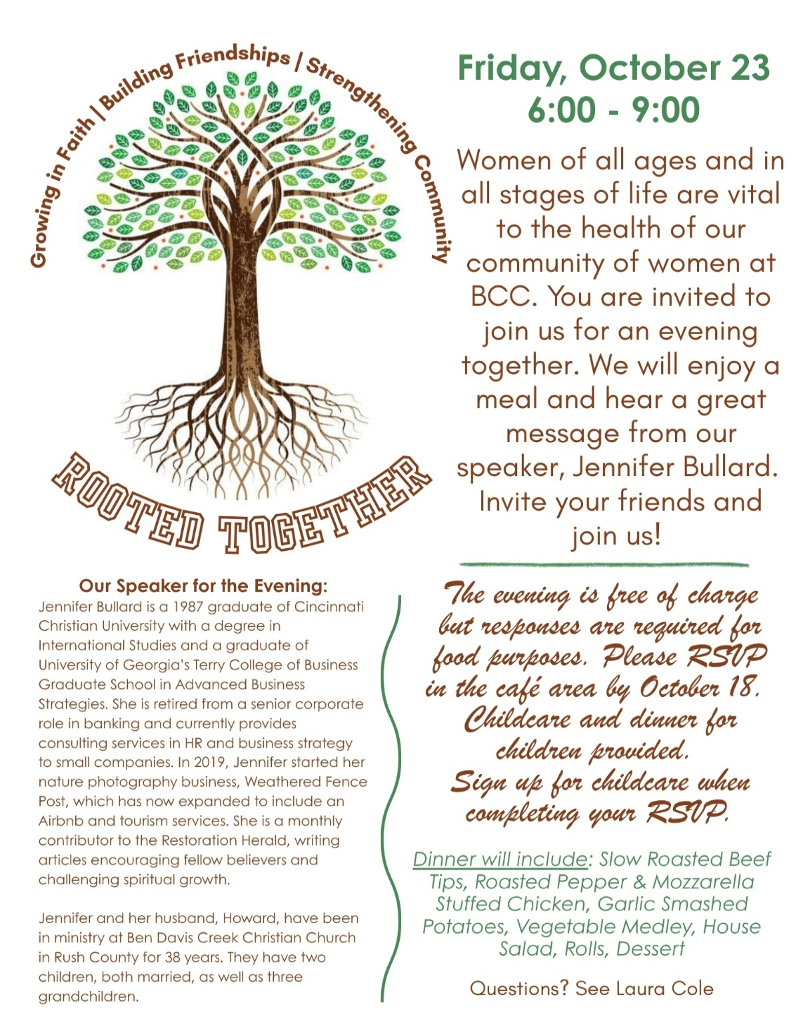
“Applesauce Money”
Watch for the “Applesauce Money” envelopes that we will use to help fund the Holiday Baskets to be distributed to individuals/families in need at Thanksgiving and Christmas.
Our goal is to collect $2,000 (above and beyond regular church giving) to help with this special cause. (Remember, we are not collecting jars of applesauce, only cash/checks, to provide applesauce).
Address checks to: BCC, Memo: Food Pantry( for the Pantry to purchase applesauce).

If you missed last week’s message about “What Jesus Said about... The Judgmental” be sure to click on the link to view it.
(CLICK HERE)

Recent Message:
Current Message Series:
What Jesus Said About…
9/6 | The Hypocritical | Matthew 23
9/13 | The Overlooked | Mark 2
9/20 | The Lost | Luke 15
9/27 | The Angry | Matthew 5
10/4 | The Judgmental | Matthew 7
10/11 | The Empathetic | Matthew 5
10/18 | The Prayerful

Welcome!
Last Sunday we welcomed Tyler & Kyrstyn Hokey as they came forward as already immersed believers transferring their membership. We are so glad they are going to be serving the Lord with us. Please give them a warm BCC welcome!
Home address:
1321 Fairfield Ave., Brookville, IN 47012

Food Pantry Volunteers
Help is needed at the Food Pantry every Wednesday in October.
We have been asked to provide 8-9 workers each week so your service will be greatly appreciated.
Volunteer sign-up sheet is in the Gathering/ Coffee Area. Please sign up as often as you can.
Time is from 11:45 a.m. –4:00 p.m.
Questions? Contact Karen Trebley via email: trebley@ectzone.com.



Men’s Dinner at The Farm
Tuesday, October 20
(Sign up to attend on Sunday)


Fall Leaves Tour
Thursday, October 29
Sign up to on Sunday
Seniors’ event that begins with devotions at BCC 8:30 a.m. then caravan viewing the fall foliage between visits to Weberding’s Carving Shop, Vogt Farm, an apple orchard, enjoy lunch together at Wagner’s in Oldenburg, and the confectioner’s shop in Metamora.
Prayer Service
Sunday, October 18 at 6:00p.m.
Prayer Focus: Pray for the
Persecuted Church
will be led by Rus Bailiff

Items Needed for the
Mountain Mission School – Mission Trip
1. | Laundry Detergent
2. | Permanent Markers – All Colors
3. | Toilet Paper
4. | Black Sharpie Fine Point Markers
5. | Scotch Tape for Dispersers (3/5 x 1000”)
6. | Masking Tape
7. | Dry Erase Markers (EXPO ONLY)
8. | Dry Erase Cleaner for White Boards
9. | Composition Note4books
10. | 2-Pocket Folders
11. | 8.5 x 11 (20 LB) Copy Paper
12. | Moisturizing Shampoo / Conditioner
13. | Moisturizing Body Wash
14. | Lotion
15. | Toothbrushes / Toothpaste
Direct Shipping: MMS
1760 Edgewater Drive
Grundy, VA 24614

Operation Christmas Child

Thank you to each person and family participating in the Christmas Child Shoebox event. The insert included with this bulletin gives suggestions for what to pack in the shoebox you give. Keep in mind that you may use any sturdy shoebox you may have at home (but feel free to use a shoebox from our display in the lobby).

Here are some important instructions:
Do not wrap the box or any items with gift wrap, and do not tape the box closed.
Do not include foods or liquids.
Please DO use one of the labels from the display, so we know whether the box is for a girl or boy, and what age.
Scan the QR code with your phone so you can track the progress of the package.

Love God. Love People. Impact the World.
ELDERS
Rus Bailiff Jeff Stone
Terry Harrison Dick Veach
Charlie McGee Richard Zeigler
elders@batesvillechristianchurch.org

DEACONS
Darren Cole Brent Fudge
Bill Graves Doug Haldeman
Drew Moenter Jake Nuhring
Russell Nuhring Bill Trebley

deacons@batesvillechristianchurch.org

MINISTRY STAFF:

LEAD MINISTER Jeff Stone
jstone@batesvillechristianchurch.org

WORSHIP/TEEN Tyler Hokey
MINISTER

CHILDREN’S DIRECTOR Brittany Kurtz
bkurtz@batesvillechristianchurch.org

OFFICE ASSISTANT Pam McAlpin
admin@batesvillechristianchurch.org

1294 Columbus Avenue
Batesville, IN 47006
(812) 934-5147
www.batesvillechristianchurch.org

