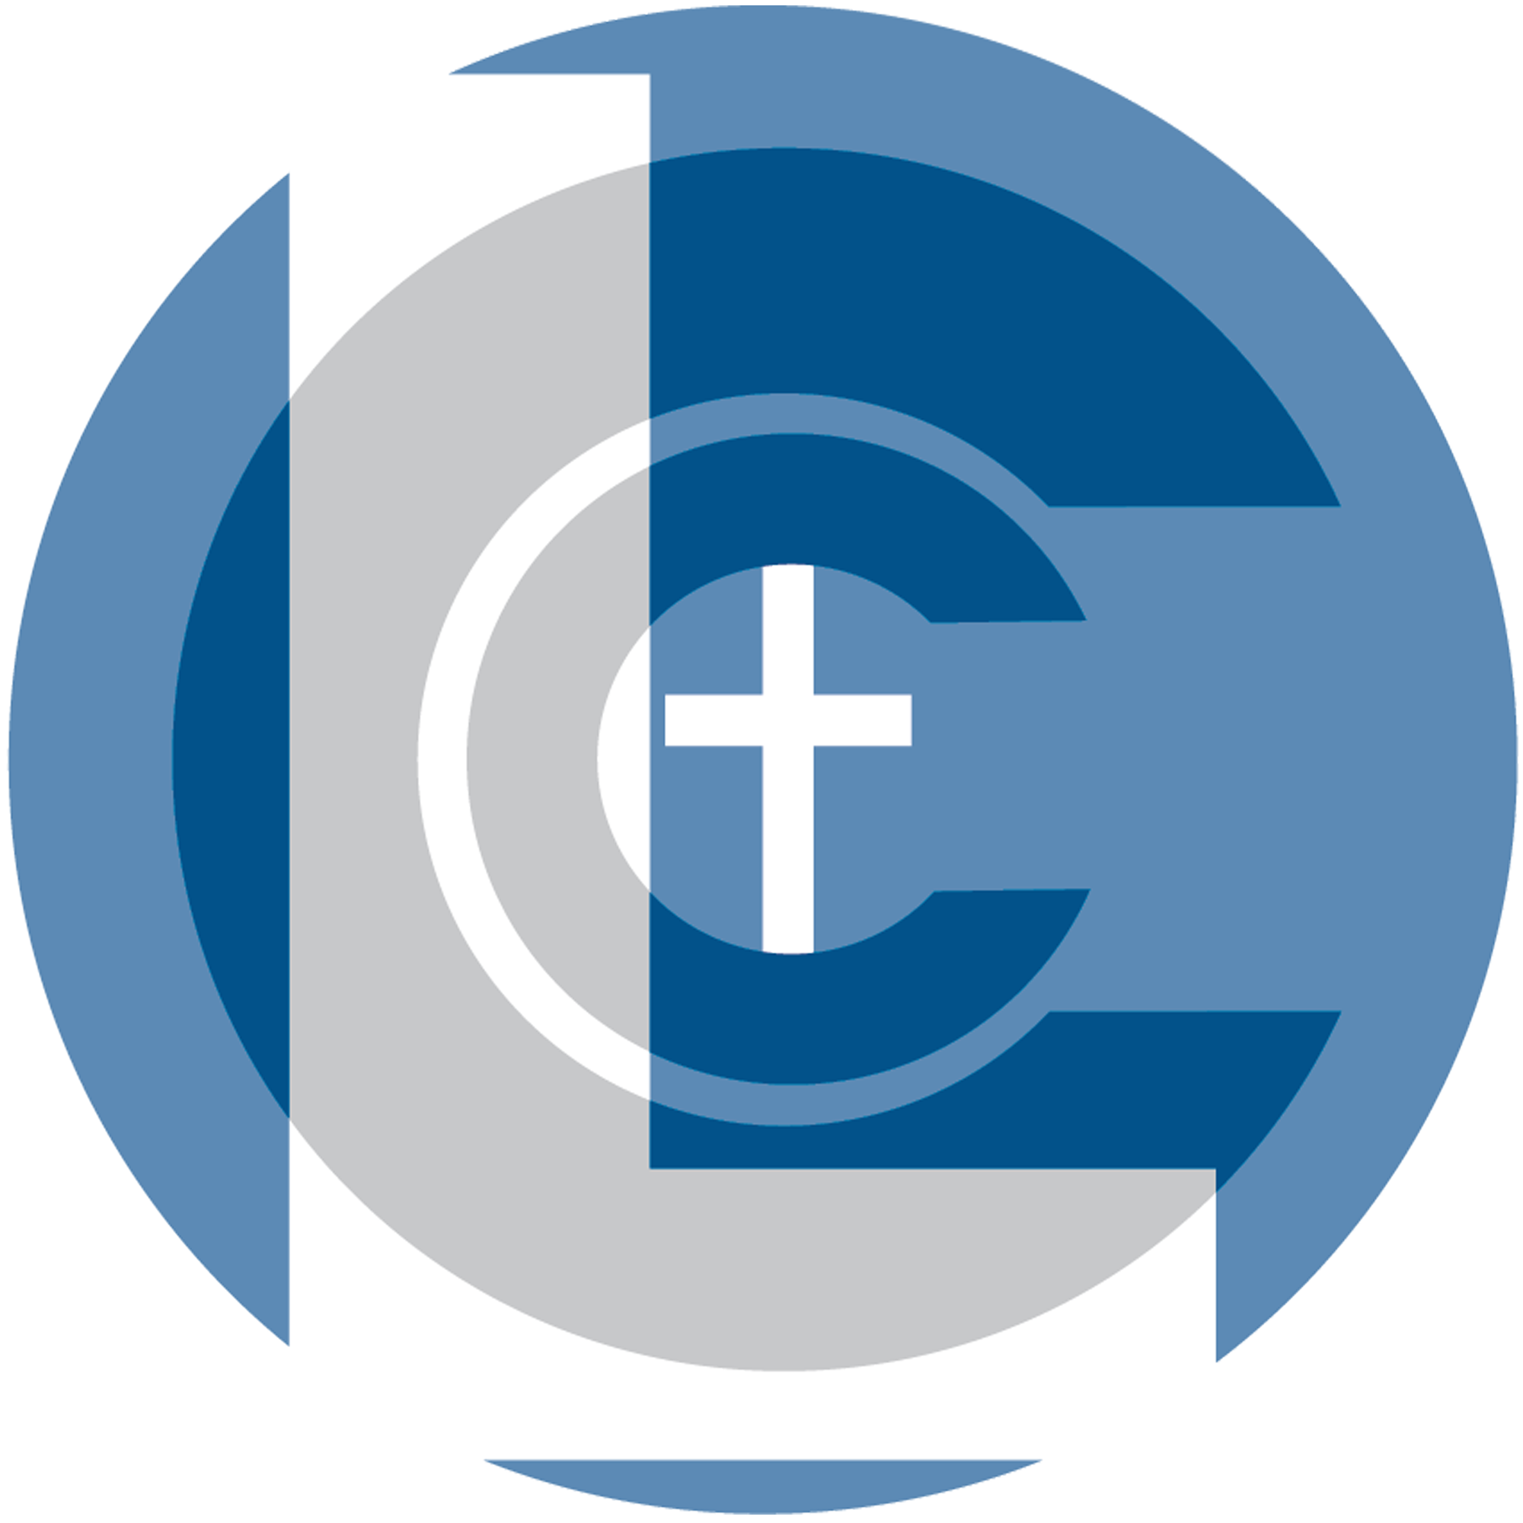 Mental Health Resources

Boone County Suicide & Referral Line
(765) 482-1599
Crisis Line Available 24/7 CALL 988

Aspire Indiana Health
1600 West Main Street, Lebanon
To schedule an appointment: (765) 482-7100
24-hr. Crisis Line: (800) 560-4038
TTY: (317)475-7272
aspireindiana.org
Whole health behavioral treatment for children, adolescents, and adults; Child, individual, family & group therapy; Psychiatry services; Community-based behavioral health treatment; Substance use disorders treatment; Extended outpatient program; Medication assisted therapy; Crisis services; Housing assistance; Employment services; Deaf services

The Cabin: A Family Counseling & Resource Center
112 N 9th St, Zionsville 953 Monument Dr Lebanon
(317) 873-8140 765-859-3110
115 N. Union St. Westfield, IN
317-804-3697
thecabin.org
Christian-focused ministries
Individual and family counseling
Treatment for anger management, anxiety, family transitions, depression, eating disorders, marital issues, and more
Sliding fee scale

Care to Change Counseling
10080 E US Hwy 36 Suite A; Avon
7230 Arbuckle Commons, Suites 126 and 127; Brownsburg
(317) 790-9396
https://www.caretochange.org/

help@caretochange.org
Adults, couples, adolescents, children

Therapists specialized in marriage, parenting, trauma, women’s issues, trauma and EMDR, divorce recovery, teen issues, church leadership, sexual addiction, adoption/foster care, anxiety/depression, personality, mood, and conduct disorders, Trust-Based Relational Intervention, men’s issues, faith issues, and finding purpose and clarity.

Crisis Text Line
Text HOME to 741741
crisistextline.org
Free, confidential access to Crisis Counselors
For any type of personal crisis

Crosswinds Counseling (Carmel)
5110 Commerce Square Dr, Suite F, Indianapolis
(877) 594-9204
info@crosswinds.org
https://crosswindscounseling.org/
Children and families, adolescents, adults, marriage, couples, teens, women, minorities
Specialties: trauma, mood disorders, substance abuse, marriage, family, communication, depression, anxiety, OCD, self-esteem, relational conflict, life transitions, grief, identity formation, eating disorders.

Cummins Behavioral Health Services Inc.
940 Lasley Drive, Lebanon
(888) 714-1927
Fax: (765) 482-7421
24-hr Emergency Line: (888) 714-1927 (ext. 1501) TTY cumminsbhs.org
Individual, family, and group counseling
Child, adolescent, and adult therapy
Substance use treatment
Inpatient referral and coordination services
Psychological and psychiatric services
School-based services
Skills training
If in need, please call regardless of anticipated eligibility
Same day access

Depression and Bipolar Support Alliance (DBSA)
dbsalliance.org
Free and confidential support groups for those with mood disorders like depression and bipolar disorders and their friends/family.
Meetings held in Marion and Hamilton counties.

E91 Counseling Ministry (Castleton)
6049 E 91st St; Indianapolis, IN 46250
(317) 598-1580
https://e91church.com/counseling/
Adults, adolescents 12+, individuals, couples, families
Resident, intern, and practicum counselors at E91’s Counseling Ministry are under licensed supervision. The cost for these sessions is determined by counselor availability and a sliding fee scale.
Specialties: trauma, intimacy, sex, marriage, pregnancy/infant loss

Ekklesia Counseling Services, LLC (Northwest Indianapolis)
9511 Angola Ct Suite 222, Indianapolis 46268
(317) 840-8367
daniel@ekklesiaindy.com
https://www.ekklesiaindy.com/
Teens, adults, individuals
Specialties: career counseling, teenagers, college students

Faithful Counseling
https://www.faithfulcounseling.com/

Online counseling platform.
Children, adolescents, adults, families
Specialties: self-esteem, perfectionism, kids going through divorce, anxiety: panic, chronic worry, OCD, phobias

Groff & Associates (Castleton)
7425 East 86th St; Indianapolis, IN 46256
(317) 474-6448
https://groffandassociates.com/

Children, adolescents, adults, couples, families
Specialties: play therapy, mood disorders, anger management, stress, couples distress, blended family, trauma, divorce recovery, anxiety/depression, marital/premarital, addiction, adjustment, CBT, grief, loss, crises, eating disorders, body dysmorphia and body image distress, trauma, work-life balance

Heart2Heart Counseling Services Indy, LLC
(Northeast Indianapolis)
7627 Island Club Dr. #S, Indianapolis 46214
(317) 659-1678
https://www.h2hcouselingservicesindy.com/
Individual, couples and adolescent
Specialties: Depression, Anxiety, Trauma, Brain spotting

ILLUME Counseling & Wellness Center
127 E Main St, 2nd Floor, Crawfordsville, In
(447) 298-3014
Crawfordsville@illumewellnesscenter.com
We provide compassionate and professional mental health services for individuals, couples and families.
Many major insurance plans are accepted. Sliding scale rates available. Telehealth appointments are available.

Integrative Wellness, LLC (InWell)
1310 South Lebanon Street, Lebanon
(765) 680-0071
inwell.org
Serving children, adolescents & adults
Behavioral health, addiction, & health coaching
Extended outpatient dual diagnosis program
Crisis intervention
Psychiatry services
School and community-based services
Medicare, Medicaid, insurance, and self-pay accepted

LifeStream Counseling Inc (Noblesville)
23 S. 8th Street. Suite 3100; Noblesville
(317) 792-5050
lisa@lifestreamcounseling.com
http://www.lifestreamcounseling.com/
Children 5+, adults, couples
Specialties: children, marriage, women (anxiety and depression), ministry staff, couples work, ministry leaders, depression, anxiety, trauma

Mental Health America of Boone County
1122 North Lebanon Street, Lebanon
(765) 482-3020
Crisis line: (765) 366-1050
mhaboonecounty.org
Parenting coordination and classes, mediation
Anger management screening and classes
Active listening, coping classes, support groups
Supervised visitation programs
Victims advocacy
Before & After School Enrichment (B.A.S.E)
S.T.A.R. & S.T.A.F. (At risk youth & families)
Career interest & development
Depression and suicide risk screening
Crisis Intervention Team (C.I.T)
Mental health information source

National Eating Disorders Association Helpline
(800) 931-2237
Text “NEDA” to 741741 if in crisis
Helpline Chat: nationaleatingdisorders.org/ helpline-chat
Monday-Thursday, 9am-9pm
Friday, 9am-5pm
For those struggling with an eating disorder, those who are concerned they might have one, and concerned loved ones

National Suicide Prevention Lifeline
988 TTY: 1 (800) 799-4TTY
Spanish: 1 (888) 628-9454
suicidepreventionlifeline.org
Crisis Textline on Facebook Messenger: facebook.com/crisistextline
Free, confidential access to trained crisis workers
Available in 150 languages
Available for friends and family members of
those who are struggling
Emotional support for any mental distress

New Hope Counseling (Downtown Indianapolis)
228 E 15th St, Indianapolis 46202
(317) 983-5281
counseling@newhopeindianapolis.org
https://www.newhopeindianapolis.org/
Children, adolescents, teens, adults, seniors, couples
Specialties: grief, anxiety/depression, trauma, sexual abuse, OCD, body image/weight loss management, co-dependency, postpartum, grief, life transitions, trauma and abuse, life transitions and adjustments, marital and relationship issues, sexual issues, spiritual/faith issues

Project Lifesaver of Boone County
5900 S Main St, Whitestown (317) 769-6557

projectlifesaver.org
Provides tracking devices to help locate people with autism, Down syndrome, Alzheimer’s, dementia, and other cognitive disorders who may get lost

Refining Grace Counseling
5900 S Main St. Whitestown In
(317) 760-3864
https://www.refininggracecounseling.com/
info@refininggracecounseling.com
Children, adolescents, teens, adults, couples, men
Specialties: marriage, family, personal bound, domestic violence recovery, affair recovery, women's issues, family, couples, marriage, trauma recovery (EDMR trained), grief and loss, men’s issues, anger, communication, pornography, parenting, miscarriage recovery, stress management/coping skills, grief & loss, depression/anxiety, interpersonal skills, self-esteem issues

Renewal Counseling (Carmel)
12265 37 Hancock St., #37; Carmel 46032
(317) 730-5155
hello@myrenewalcounseling.com
https://www.myrenewalcounseling.com/
Adults, couples, adolescents, couples
Specialties: family of origin issues, life transitions, adoption, high school females, communication, identity exploration (Enneagram), affair/infidelity recovery, discernment counseling, marriage, pre-marital, faith and life direction issues

Rock Life Counseling
725 Shelby St., Suite 31 Indianapolis
317-647-6507
https://rocklifecounseling.com/
Online counseling platform.
Clients: Children, adolescents, adults, couples

Specialties: addictions, trauma, stress, parenting, career difficulties

Sojourners Rest Counseling

(Northwest Indianapolis)
3905 Vincennes Rd Suite 303; Indianapolis
(317) 471-3527
phillips@sorestcounseling.com
https://sorestcounseling.com/
Adults, couples, adolescents 13+,
Marriage; sexual addiction, dysfunction/marital intimacy issues, sexual abuse, affair recovery, and sexual identity struggles
Distance counseling is available to clients who reside within any county in Indiana.

Southside Pastoral Counseling
3905 Vincennes Rd., Carmel 46268
(317) 471-3527
connect@indypastoralcounseling.com
https://indypastoralcounseling.com/
Children, adolescents, adults, families, women, couples
Specialties: children with ADHD, children with sexually acting out behaviors, highly sensitive individuals, anxiety/depression, borderline PD, co-dependency, coping skills, trauma, self-esteem, spiritual concerns, women’s issues, perfectionism, kids going through divorce, anxiety: panic, chronic worry, OCD, phobias; special needs, severe behavioral disorders, addiction, spousal or parent/adult child conflict, sexual behavior problems, sexual abuse, family conflict, substance abuse

Ascension St. Vincent Indianapolis Stress Center
8401 Harcourt Rd., Indianapolis 46260
(317) 338-4800
stvincent.org/Services/Mental-and-Behavioral- Health
Confidential treatment for depression, anxiety, substance abuse, family concerns, and more
Individual, marital, family, and group therapy.
Crisis intervention
Inpatient, outpatient, or partial hospitalization
Serves adults, youth, and seniors

ThrivePointe
8604 Allisonville Rd. Suite 160 Indianapolis 46250
(833)914-4688

m.hengge@thrivepointe.com
https://www.thrivepointe.com/

Individual, marriage, family, teens
Specialties: anxiety, depression, relationship concerns, couples

Vibrantly Live (Brownsburg)
709 East Main Street Suite B; Brownsburg
(317) 520-1476
info@VibrantlyLive.com
https://www.vibrantlylive.net/
Women, teen/children, parents/family, adult women in transition
Specialties: leaving for college, marriage, parenting, career changes, empty nesting, conflictual relationships, grief, wresting with faith, depression, anxiety, and relationship concerns, life transitions career, college, etc), divorce/separation, social phobia

Witham Emergency Services

Lebanon Location:
2605 North Lebanon Street, Lebanon, IN 46052
(765) 485-8000
witham.org/EmergencyServices

Zionsville Location:
6085 Heartland Drive, Ste. 100
Zionsville, IN 46077
(317) 768-2100
ansoner.com
Emergency department services
Staff trained to identify and address domestic violence

Witham Health Services
Transitions Behavioral Health Care Services
2605 North Lebanon Street, Lebanon
(765) 485-8700
witham.org/body.cfm?id=98
Supports emotional and medical needs of seniors
Crisis stabilization
Individual and group therapy
Medication management, physical and activity therapy
Inpatient services only

Veterans Crisis Line 988
TTY: 1 (800) 799-4889
Text 838255
Crisis Chat: veteranscrisisline.net/get-help/chat veteranscrisisline.net
Free, confidential, available 24/7
For veterans, service members, National Guard & Reserve, friends and families
For any sort of personal crisis–not just suicide

Group Ministries

Northview Church’s Carmel Campus
12900 Hazel Dell Pkwy, Carmel
https://www.northviewchurch.us/resources/events-calendar/

*Check the web site for any updated times and classes

Men's Recovery Group Wednesdays 7:00PM
Are you feeling stuck or struggling with unhealthy habits, destructive patterns or addictions? This group is designed to help you move forward with making choices that lead to healing and freedom from your struggles. This recovery-based group is a confidential and safe community that will help you overcome your obstacles and experience freedom from addiction of any kind!.

Men's Integrity Group Wednesdays 7:00PM
This is a group committed to men’s sexual integrity using the 12 spiritual actions of AA. If you would like to live a life of freedom to worship Christ fully through discovering sexual integrity this group is for you.

Women's Abuse Recovery Tuesdays 7:00PM
Women's Abuse Recovery is a group for women survivors of childhood and domestic abuse. Based on God's Word, it is a group for hope and healing through Jesus Christ. Our 13-week session meets on Tuesday evenings. Limited childcare is available. Please contact the group leader to arrange it in advance.

Never Alone Widows Thursday 6:30 PM
Never Alone Widows local groups exist to provide a safe environment where community can be created, healing can occur, and hope can be found. We believe that it’s possible for women who have
experienced the untimely loss of a spouse to find purpose in their pain and a new understanding of themselves and their Heavenly Father.

Divorce Care Wednesdays 6:45PM
Divorce Care is a friendly, caring group of people who will walk alongside you through one of life's most difficult experiences: divorce or separation. This 13-week course will meet from 6:45 p.m. to 8:45 p.m. The cost of the course material is $20. Book Scholarships available if needed.

*Check the web site for any updates on times and locations for the available classes.

Grief Share Group Thursdays at 6:30PM
GriefShare is a special weekly seminar and support group designed to help you rebuild your life after the death of a loved one. Our group is led by caring people who have experienced grief and want to help you through the difficult days ahead. This is an open group where you can join at any time.

Divorce Care Fall of 2026
Divorce Care is a friendly, caring group of people who will walk alongside you through one of life's most difficult experiences: divorce or separation. This 13-week course will meet from 6:45 p.m. to 8:45 p.m. The cost of the course material is $20. Book Scholarships available if needed.

Mothers in Waiting Thursdays 6:30PM
If you are walking through the heartbreak of infertility, you don't have to face it alone. This group offers a safe, compassionate space to connect with other women, find encouragement, and grow in faith together. Using the book Mothers in Waiting, we'll explore hope-filled stories, discuss God's presence in the waiting, and support one another through every season of the journey. Whether your story includes infertility, pregnancy loss, or waiting to grow your family, you are welcome here.

Helpful Podcasts
Becoming Well
https://www.moodyradio.org/podcasts/becoming-well/
Dr. Deb Gorton on Moody Radio

New Life Live
https://newlife.com/
New Life Live is a radio program with a podcast archive of past programs.

Ozarks Teen Challenge Support Recovery Podcast
https://ozarksteenchallenge.com/about-us/podcasts/
This podcast may be particularly helpful for family and friends of people struggling with addictions.

Recovery Resources

Residential Programs for Adult Men

Wheeler Mission Men’s Residential Center
Hebron Addiction Recovery Program
245 N. Delaware St., Indianapolis
(317) 750-1471
https://wheelermission.org/our-work/mens-services/

New Day Network
Residential & outpatient recovery programs
6330 Digital Way, Indianapolis
(317) 291-1967
https://thenewdaycenter.com/

Celebrate Freedom, Inc
Sober living transitional house
10124 E. 46th St., Indianapolis
(317) 210-3733
https://indysoberliving.com/

Residential Programs for Adult Women

Wheeler Mission Center for Women and Children
Higher Ground Addictions Program
3208 E. Michigan St., Indianapolis
(317) 687-3630
https://wheelermission.org/our-work/womens-services/

Grace House
2822 E. New York St., Indianapolis
(317) 829-1155
https://teenchallengeusa.org/centers/tcin105/

Residential Program for Teen Women

Central Indiana Teen Challenge
P.O. Box 564, Lebanon
(317) 348-0711
office@indianatc.org
http://indiana-atc.org/centers-programs/central-indiana-teen-girls

Celebrate Recovery
Local Weekly Support Groups
Lebanon First Community Church
701 North Lebanon St
Contact Craig: (765) 918-1559
pastorcarrell@gmail.com

Celebrate Recovery is a Christ-centered, 12-step recovery program to provide community and freedom for anyone struggling with hurt, pain or addiction of any kind.

180XChange
East 91st St Christian Church
6049 E 91st St, Indianapolis
(317) 849-1261

The 180Xchange is a weekly Life-Change Recovery Ministry that is based on the biblical principles of transformation and the Twelve Steps. Hurts, habits and hang-ups don’t need to dictate our lives.

