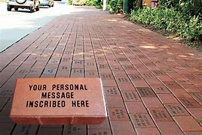

Prayer Garden Bricks
We are planning a path of personalized bricks in our new prayer garden. These bricks can be in memory of a loved one, to honor someone important in your life or as a thank you.
These bricks are 8” x 4” and will be able to hold 3 lines of text. Each line of text can be 20 characters per line and each space counts as a character. Payment needs to be turned in with the completed form below. The cost of each brick is $50. Checks would be made out to FUMC.

_ _ _ _ _ _ _ _ _ _ _ _ _ _ _ _ _ _ _ _ _ _ _ _ _ _ _ _ _ _ _ _ _ _ _ _ _ _ _ _ _

Name _________________________ Phone __________________
Text for brick:
_____________________________________________________________
_____________________________________________________________
_____________________________________________________________

