The Lord’s Day
June 21, 2026 † 11:00 AM

Order of Worship
“He has not dealt with us according to our sins, nor punished us according to our iniquities.” – Psalm 103:10

Welcome & Announcements
Call to Worship
Choral Call to Worship “Praise Him! Praise Him!”
*Hymn (Red) #100 “Holy, Holy, Holy!”
*Invocation and The Lord’s Prayer
*Nicene Creed Back of Bulletin
Children’s Message
Anthem “Wonderful, Merciful Savior”
Pastoral Prayer
*Bible Song (Green) #220 “Motives to Gratitude”
*Scripture Reading Job 11
Sermon "Zophar: You Deserve Worse"
*Hymn (Red) #708 “O Love That Wilt Not Let Me Go”
*Benediction
*Doxology Bible Song # 155
*Congregation will stand
WELCOME TO WORSHIP
We extend a warm welcome to all who assemble to worship the true and living God. If you are visiting, we are glad you are here. Please fill out a visitor card (located in the pew racks) and leave it in one of the offering plates on the way out.
- Offering Plates are located by each door.
- Nurseries are available for infants & toddlers.
- Children’s Church is available for ages 2-4.
Attendance and Offerings: June 14, 2026
Morning Worship:107; Evening Worship: 19; Online: 45
Sunday School: Jimmy S: 11; Ladies: 9; Adults: 14; Young Adults: 0; Youth: 10; Children: 9; Nursery: 0
Kids Night: - children -, adults -
$ Needed per week to meet Gen. Fund budget $7,662.00
Average weekly General Fund offering YTD $7,907.52
Offerings for June 14, 2026
General Fund $10,381.30
500 Fund $0
Simons Fund $450.00
Faith Promise $0
Faith Promise Offering YTD $4,990.00

RECORD OF GOD’S FAITHFULNESS
Psalm 33:4 – “For the word of the Lord is right and true; he is faithful in all he does.”

WEEKLY ACTIVITIES
Sunday
Prayer Meeting 9:30 AM
Sunday School 10:00 AM
Worship Service 11:00 AM
Evening Worship 5:00 PM
Kids’ Night Resumes after summer break
Middle School Youth Group 6:00 PM
High School Youth Group 6:00 PM
Tuesday
Choir Practice 6:00 PM
Wednesday
Men’s Prayer Meeting 8:00 AM
Wednesday Prayer Luncheon Noon
Youth Bible Study Resumes after summer break
Men’s Bible Study Resumes after summer break

Flowers
The flowers in the sanctuary today are given to the glory of God and in loving memory of Sam Bailes and Des Killian, in honor of Jimmy Killian and Chris Cox, and in celebration of all fathers on Father’s Day.
ANNouncements

HAPPY FATHER’s DAY
Happy Father’s Day to all fathers of the congregation.
“And, ye fathers, provoke not your children to wrath: but bring them up in the nurture and admonition of the Lord” (Ephesians 6:4)

Sunday Evening Activities
There will be no Sunday evening activities tonight.

HORIZON SUMMER CAMP
Horizon summer retreat for high school students is this week (June 22–27). The bus will depart at 12:30 PM on Monday. Preacher Mark will be the speaker this week.

BONCLARKEN CAMPING WEEKEND
Our annual family weekend at Bonclarken is July 10-12. All who plan to attend are asked to sign up as soon as possible on the signup sheet posted in the Education Building lobby so we can begin advising Bonclarken of lodging requirements and plans for meals. An email including lodging and campsite information has been sent. Additional details will be forthcoming in the next couple of weeks.

BONCLARKEN…DID YOU KNOW
When the ARP Church purchased property in Hendersonville, NC in 1921 as a place for assembly, a name was needed. The name came as a result of a contest held in 1922. Mrs. Sallie Miller Brice of Chester, SC offered the following: “I submit a name for our Assembly Grounds. It is Bon-clar-ken, and it has this meaning, Bon- from the Latin, bonus – ‘good,’ -clar from the Latin clarus – ‘clear,’ -ken from the Scotch – ‘vision.’ Bon-clar-ken — Good-clear-vision.” Since 1922, Bonclarken has had a good, clear vision to serve as “a Christian environment for inspiration and renewal.”

VBS REGISTRATION
Vacation Bible School is only one week away (June 28-July 2) from 5:00 – 8:00 PM. Mark your calendars and invite your friends!

Thank you for your donations and for volunteering (we have all the adult help needed). We will be decorating on Friday, June 26 beginning at 3:00 PM and would appreciate help if you would like to come join us.


Please scan the QR Code below to register to attend.

Thank you Elizabeth Love for your time and leadership. She can be contacted via email elizabethmlove33@gmail.com or text at 803-389-3115.

SAVE THESE DATES
June 22 – 27 | Horizon
June 28 – July 2 | VBS
July 10 – 12 | Bonclarken Camping Weekend
July 27 – July 30 | Family Bible Conference

NICENE CREED
We believe in one God, the Father Almighty, Maker of heaven and earth, and of all things visible and invisible.

And in one Lord Jesus Christ, the only-begotten Son of God, begotten of the Father before all worlds; God of God, Light of Light, very God of very God; begotten, not made, being of one substance with the Father, by whom all things were made.

Who, for us men and for our salvation, came down from heaven, and was incarnate by the Holy Ghost of the virgin Mary, and was made man; and was crucified also for us under Pontius Pilate; He suffered and was buried; and the third day He rose again, according to the Scriptures; and ascended into heaven, and sitteth on the right hand of the Father; and He shall come again, with glory, to judge the quick and the dead; whose kingdom shall have no end.

And we believe in the Holy Ghost, the Lord and Giver of Life; who proceedeth from the Father and the Son; who with the Father and the Son together is worshipped and glorified; who spake by the prophets.

And we believe in one holy catholic and apostolic Church. We acknowledge one baptism for the remission of sins; and we look for the resurrection of the dead, and the life of the world to come. Amen.
The Diaconate
Tyler Lowe, chairman
Class of 2026 Class of 2027 Class of 2028
Jason Blair Judd Baird Robert Burnett
Tyler Lowe Kyle Hodges Patrick Glenn
Chris Munsey Ryan Postma Andrew Love
Billy McCain

The Session
G. Starnes, vice-moderator – B. Bodenstein, clerk
Class of 2026 Class of 2027 Class of 2028
Alan Abernathy Bruce Bodenstein Jimmy Killian
David McElwee Jimmy Sherrill Doug Pryor
Ron Wallace Greg Starnes
Jay Young
Clover Associate Reformed Presbyterian Church

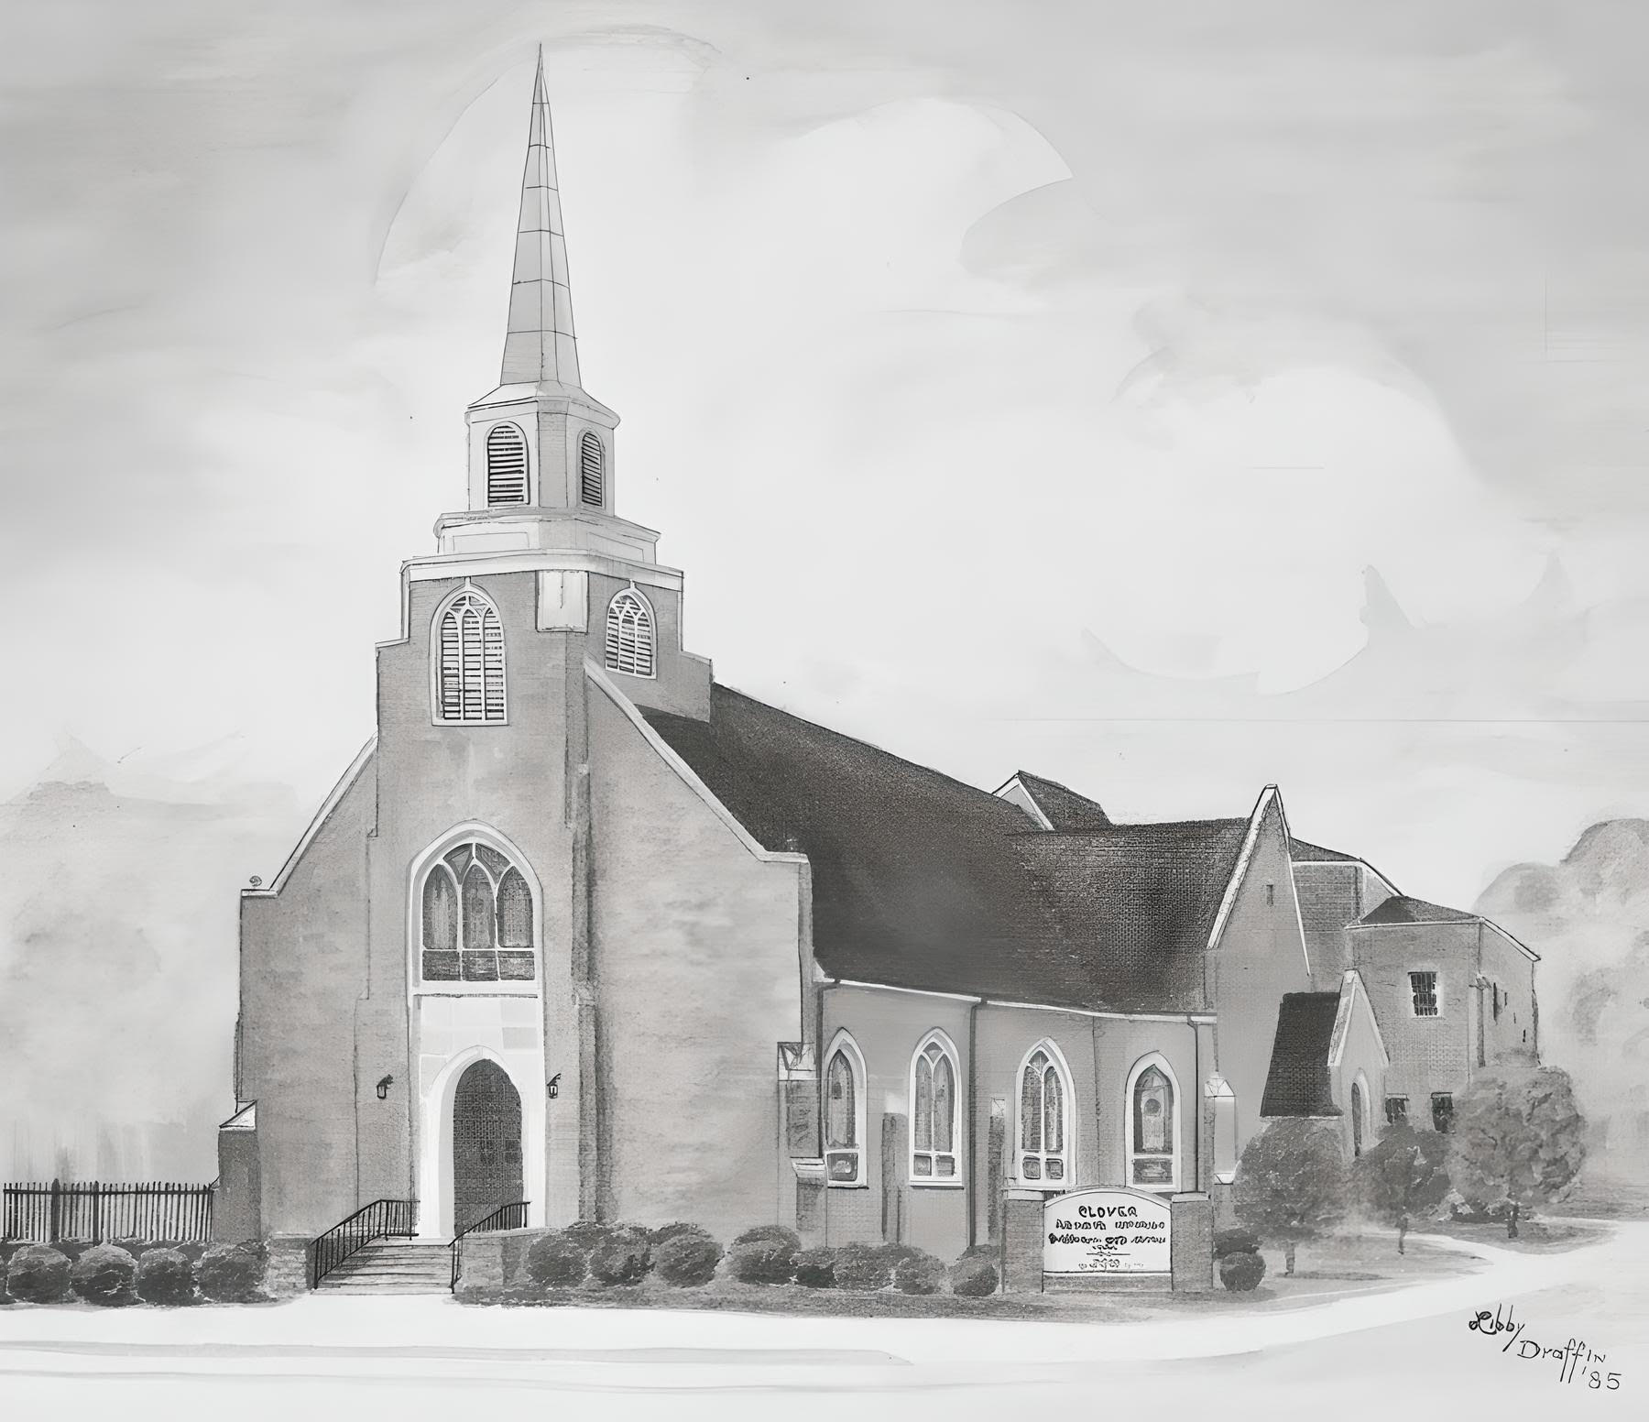
“Seeking to bring praise to God through faith
in His Son and obedience to His Word.”

127 Kings Mountain St.
Clover, SC 29710

Church Office
803-222-9584
office@cloverarp.org
Cloverarp.org

Pastor – Mark Miller
Pastoral Care – Calvin Draffin
Youth Director – Scott Frazier
Music Director & Pianist – Cory Dover

