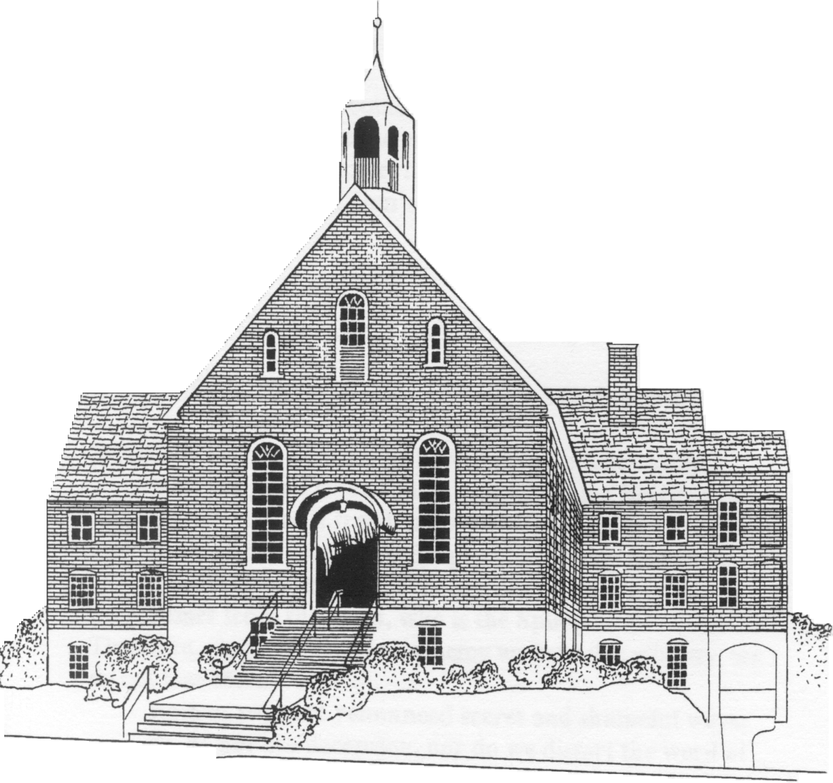

Ardmoremoravian.org
Eleventh Sunday after Pentecost
August 25, 2019

WATCH WORD FOR THE WEEK:

The steadfast love of the Lord is from everlasting to everlasting
on those who fear him.
Psalm 103:17

Matthew 28: 18-20

¹⁸ And Jesus came and said to them, “All authority in heaven and on earth has been given to me.
¹⁹ Go therefore and make disciples of all nations, baptizing them in the name of the Father and of the Son and of the Holy Spirit,
²⁰ and teaching them to obey everything that I have commanded you. And remember, I am with you always, to the end of the age.”

We welcome and thank Jamie Johnson for being with us again today and sharing his message.

The flowers are placed today to the glory of God and
in loving memory of my dad, Jim Michael, aka PopPop,
for his birthday, by Jody Eckard and family.

Elder/Trustee Greeter for Today, August 25th: Joel Mabe
Elder/Trustee Greeter for September 1st: Dennis Adams

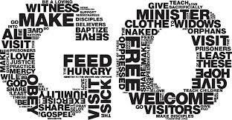

ARDMORE MORAVIAN CHURCH
Eleventh Sunday after Pentecost
August 25, 2019

PRELUDE “King of Love” Words p. 3
WELCOME / ANNOUNCEMENTS
RIGHT HAND OF FELLOWSHIP
CALL TO WORSHIP “Sing For Joy” arr. Clydesdale
PRAISE SONGS “One True God” p. 5 p.
“It Is Well With My Soul” p. 6
CONGREGATIONAL PRAYER
WORSHIP IN OUR GIVING
OFFERTORY “Be Not Afraid” Hayes

SONG OF THANKS
Praise God from whom all blessings flow
Praise Him all creatures here below.
Praise Him above ye heavenly host
Praise Father, Son and Holy Ghost. Amen

PRAYER
ANTHEM “O Breath of God” arr. James
THE WORD OF GOD Bible p. 812 Bible p.
MESSAGE “The Great Commission” Jamie Johnson
CLOSING HYMN MWB p. 548
“O For A Thousand Tongues To Sing”
BENEDICTION
POSTLUDE “The Regal Trumpet” Paxton
King of Love

The King of Love my Shepherd is
Whose goodness faileth never
I nothing lack if I am His
And He is mine forever
And He is mine forever

Where streams of living water flow
My ransomed soul He leadeth
And where the verdant pastures grow
With food celestial feedeth

Chorus: Never failing, Ruler of my heart
Everlasting, Lover of my soul
On the mountain high or in the valley low
The King of Love my Shepherd is
The King of Love my Shepherd is

Lost and foolish off I strayed
But yet in love He sought me
And on His shoulder gently laid
And home rejoicing brought me
In death's dark veil I fear no ill
With Thee, dear Lord, beside me
Thy rod and staff my comfort still
Thy cross before to guide me

CHORUS

Bridge: Oh, Hallelujah, Hallelujah
Oh, Hallelujah, Hallelujah

Never failing, Ruler of my heart
Everlasting, Lover of my soul
On the mountain high or in the valley low
The King of Love my Shepherd is

Never failing, Ruler of my heart
Everlasting, Lover of my soul
On the mountain high or in the valley low
The King of Love my Shepherd is
The King of Love my Shepherd is

And so through all the length of days
Thy goodness faileth never
Good Shepherd, may I sing Your praise
Within Your house forever
Within Your house forever

One True God
One voice in the dark, A song that lights up the stars
One breath that gives life, One sovereign in pow’r
Who speaks with thunder and fire, One Lord, one King
There is no other that can compare to You!
Chorus: You are The One alone in greatness, The One who never changes, Jesus, You are The One who rose in power, The One who reigns forever, Jesus, The One True God
One man on a cross, One light of the world
One Name, one Word, One Way to be saved
One Lamb that was slain, One Love above all
There is no other that can compare to You
Chorus

You are The One true God
And we have seen the glory of The One and only Son of God!
(Repeat x3)

And You are The One alone in greatness
The One who never changes, Jesus, You are
The One alone in greatness The One who never changes
Jesus, You are The One who rose in power
The One who reigns forever Jesus, the One True God
You are the One True God! You are the One True God!
It Is Well With My Soul
Our scars are a sign
Of grace in our lives
And Father, how You brought us through.
When deep were the wounds
And dark was the night
The promise of Your love You proved.
Chorus 1
Now every battle still to come
Let this be our song
It is well (It is well)
With my soul (With my soul)
It is well, it is well with my soul!

Weeping may come
Remain for a night
But joy will paint the morning sky.
You're there in the fast
You're there in the feast;
Your faithfulness will always shine.
(Repeat Chorus 1)

Chorus 2
Trust Your ways (Trust Your ways)
Trust Your name (Trust Your name)
It is well, It is well with my soul!

Bridge
You lead us through battles (You lead us through battles)
You lead us to blessing (You lead us to blessing)
And You make us fruitful (And You make us fruitful)
In the land of our suffering, God.
It is well, it is well with my soul.

Chorus 3
It is well (It is well)
With my soul (With my soul)
It is well, it is well with my soul!
Trust Your ways (Trust Your ways)
Trust Your name (Trust Your name)
It is well, it is well with my soul!
It is well, it is well with my soul!

Opportunities for the Week

Sunday, Sept. 1 Twelfth Sunday after Pentecost
8:30 AM Men’s Breakfast
9:00 AM Prayer with Pastor Daniel Dockery
9:30 AM Sunday School
10:30 AM Worship Service

Kitchen Clean-Up Day

We will have a clean-up day to concentrate on washing dishes and cleaning out the inside of the cabinets in the kitchen on Saturday, September 14, beginning at 8:30 AM. Contact Rick Peery if you have any questions.

Please contact Pat Nelson if you would like to give
flowers in honor or in memory of someone on one
of the following dates: September 23rd, October 14th,
or October 28th, or poinsettias on December 2nd.

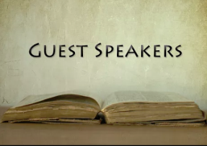
Upcoming Guest Speakers
09-01 Daniel Dockery
09-08 Bob Shackleford
09-15 Bill Shields

A NOTE FROM PASTOR DOCKERY
It was a joy to worship with you several weeks ago. God has blessed your church in so many ways. As we prepare for worship next week (September 1st), please meditate daily on Hebrews, Chapter 12 and pray that God will strengthen our resolve to worship and serve Him faithfully. Likewise, I plan to be in your Prayer Room at 9:00 AM next Sunday morning, praying with all who are present. I encourage you to join us as we make ready our hearts and minds to worship God. I look forward to a marvelous day of worship with you.
To God be the glory,
Daniel Dockery

People for Whom We are Praying

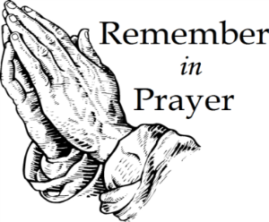
Members
James & Marie Adams; Ed Blazer;
Amanda Bowles; Annie Boyd; Ruth Long;
Alice Pierce; Bett Warner; Connie Wester

Friends
Cheryl Bain, friends of Ruth Long and MaryAlice Adams; Emily Burge; Olive Moore; Rosemary Stewart;
Ezekiel Stuemke, grandson of Cyndi Stuemke;
Donna Tesh, Michael’s mother;
Jake Williams, Donna Williams’ son

The Numbers – General Operating Budget
Amount Needed to Meet Budget: $ 171,600
Receipts as of 08-18-19: $ 131,486
Over/(Under) to Date: $ (40,114)

Attendance: August 04 = 56
August 11 = 58
August 18 = 53

Holiday Décor Sale September 21st

If you have any gently used holiday decorations, clothing, jewelry, aprons, etc. for July 4th, Autumn, Halloween, Thanksgiving, Christmas, Winter, Valentine’s Day, St. Patrick’s Day, Easter, Spring, or Summer that you would like to donate please contact Beth Kiger Mabe at mailaboo@bellsouth.net.

This is a project of AMC Women’s Fellowship Circle #5 with all proceeds going to the Church’s General Fund. The sale will be in the Fellowship Hall on Saturday, September 21 from 2:00-5:00 PM.

BRING YOUR FRIENDS WHO LOVE HOLIDAYS!

Dear Ardmore Moravian Church,
Thank you very much for allowing the P.L.A.Y. Music Program to use your beautiful space this summer. Our students learned so much and developed a deeper love for their instrument thanks to you! Thank you for allowing us space for our annual cookout as well!
With Appreciation,
Allie & Rachel,
WS Youth Symphony
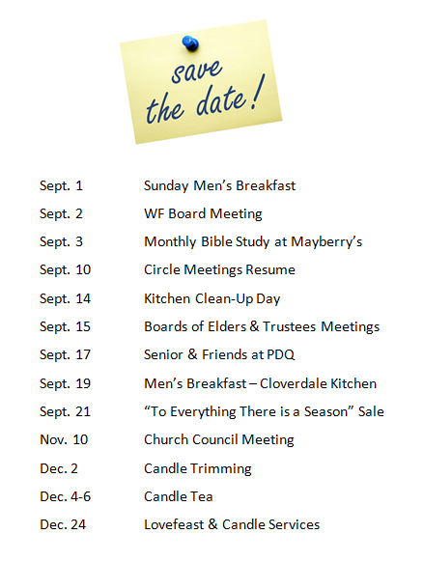
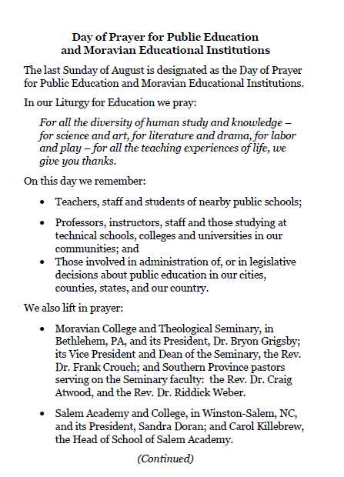
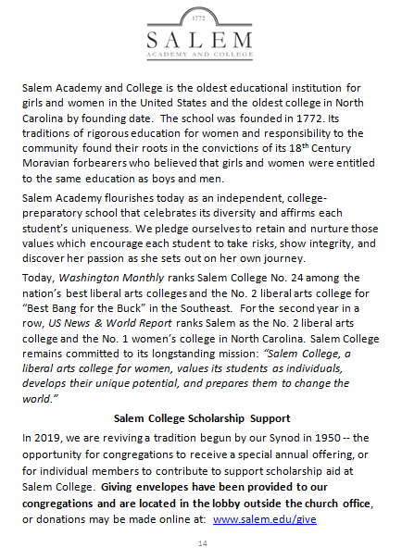
OTHER EVENTS

FALL BAND CLASSES will begin September 3, 2019 at Home Moravian Church. Sponsored jointly with Salem Congregation, Beginning Band Classes as well as Second and Third Year classes will once again be offered under the leadership of Robah Ogburn and Connie Merritt. Each Tuesday night, the beginners’ class will meet at 6:30pm for all ages 4th grade and up (we have had students starting in their 80’s). Second and Third Year players meet for class at 7:30pm. The classes are held in the Rehearsal Room on the lower level of the building. If you do not know what instrument you want to learn the leaders will help you make that decision on first night. Please contact Connie (kapwing@triad.rr.com) or Robah (RobahOgburn@Yahoo.com) if you have questions or need additional information.

Boldly & Beautifully Made – a fundraiser to support the Moravian Prison Ministry. Friday, September 6th from 5:30 – 7:30 PM at the Hampton House Art & Framing. Call 336-416-5801 for General Admission or VIP tickets information.

SALEM BAND AT THE MOVIES: Join us for an afternoon of music from your favorite films including Somewhere in Time, Casablanca, O Brother Where Are Thou, Star Wars, Robinhood, and more. Sunday, September 22, 2019 at 3:00 PM in Hanes Auditorium, Salem College campus, FREE.

Welcome to Ardmore Moravian Church
“Where Communion and Community Come Together”

We are a Christ-centered fellowship of people bound by love of Jesus and one another. Our greatest hope is that God will be glorified through the power and presence of the Holy Spirit among us. We have gathered to worship; celebrating the eternal life won for us by Christ through His death and resurrection as promised in the Bible.

God has created and called us into relationship with Himself (communion) and with one another (community). We need the Lord, and we need each other. As you draw close to God, may you also grow in friendship with those around you. We believe God has gifted people in every age. So our worship is marked by a variety of styles and expressions of music, liturgy, prayer and proclamation. We seek to blend these expressions in a way that pleases God and edifies one another.

The Moravian Church, while unfamiliar to many, is actually one of the oldest Protestant denominations in the world. Our roots and heritage run deep, even one hundred years prior to the Great Reformation. Yet our sense of mission is alive and active today as we serve the Lord in ministry together.

Jesus said to His disciples, “…you shall be My witnesses both in Jerusalem, and in all Judea, and Samaria, and even to the remotest part of the earth.” At Ardmore Moravian we sincerely strive to live that promise. We worship, study the Holy Scriptures, fellowship and grow as Disciples of Christ together here at the corner of Hawthorne and Academy. We ask the Lord then to send us out and employ us for His glory as we share the Gospel - the Good News of Christ - locally, regionally and globally.

If you are searching for a meaningful relationship with God and productive friendships with other people, you’ve come to the right
place, “Where Communion and Community Come Together”.

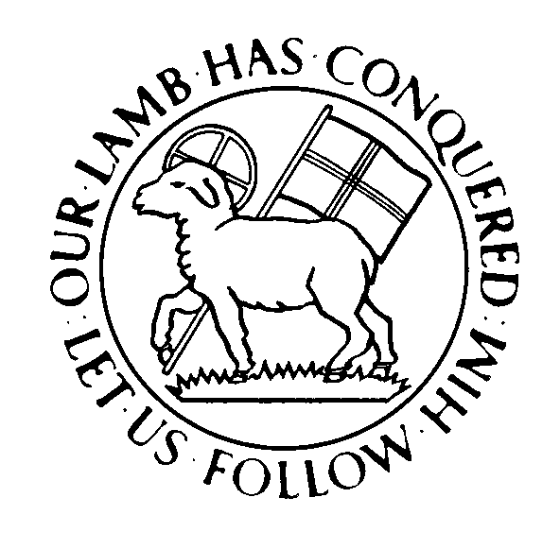

Director of Music: Brian Haskell
Organist/Accompanist: Chris Heckman
Office Administrator: Cyndi Stuemke
Address: 2013 West Academy Street
Winston-Salem, NC 27103
Church office: 336-723-3444

Office: office@ardmoremoravian.org
Online: ArdmoreMoravian.org
@ArdmoreMoravian

(All songs printed under CCLI# 1007661)

