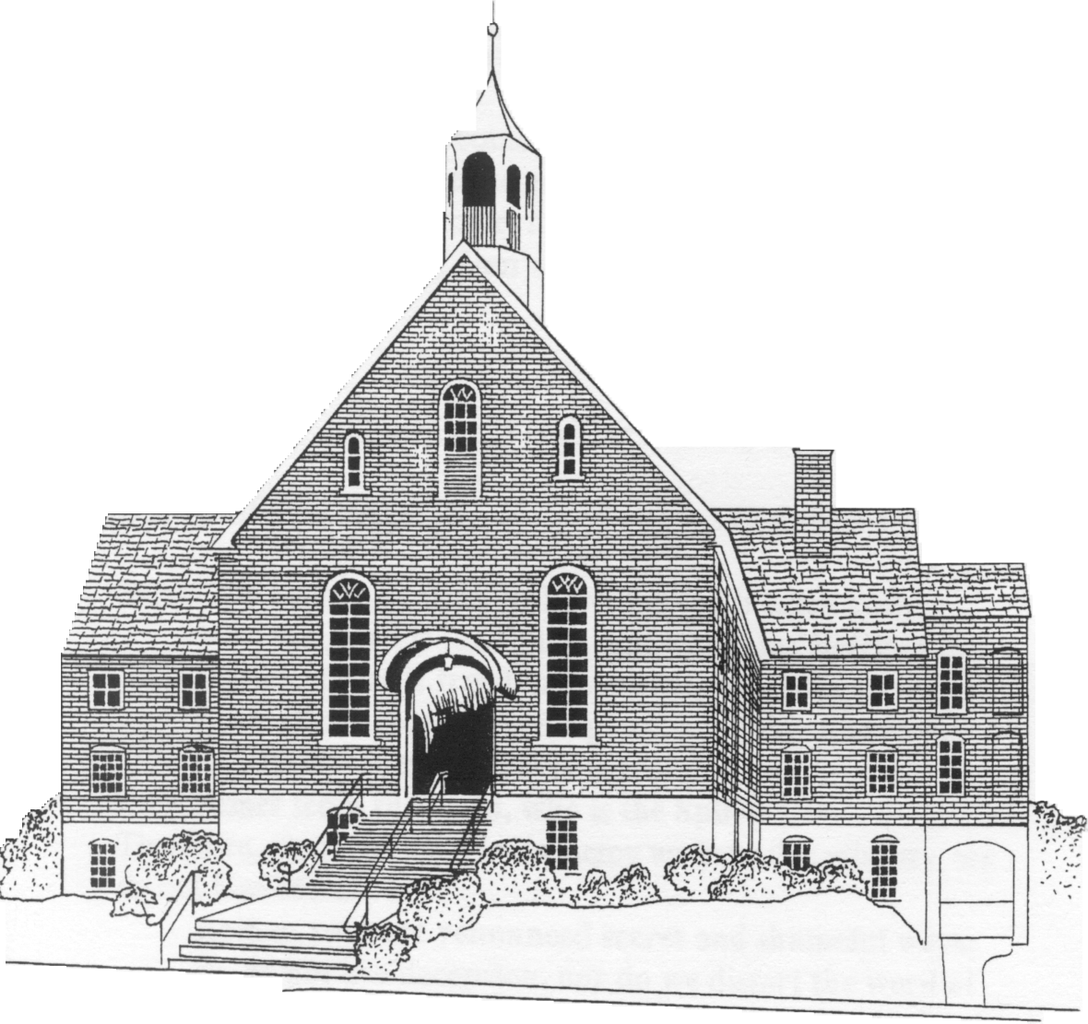

Ardmoremoravian.org
Fourth Sunday after Pentecost
July 7, 2019

WATCH WORD FOR THE WEEK:

So let us not grow weary in doing what is right.
Galatians 6:9

Luke 10: 1-11

¹After this, the Lord appointed seventy others and sent them on ahead of him in pairs to every town and place where he himself intended to go.

² He said to them, “The harvest is plentiful, but the laborers are few; therefore ask the Lord of the harvest to send out laborers into his harvest.

³ Go on your way. See, I am sending you out like lambs into the midst of wolves.

⁴ Carry no purse, no bag, no sandals; and greet no one on the road.

⁵ Whatever house you enter, first say, ‘Peace to this house!’

⁶ And if anyone is there who shares in peace, your peace will rest on that person; but if not, it will return to you.

⁷ Remain in the same house, eating and drinking whatever they provide, for the laborer deserves to be paid. Do not move about from house to house.

⁸ Whenever you enter a town and its people welcome you, eat what is set before you;

⁹ cure the sick who are there, and say to them, ‘The kingdom of God has come near to you.’

¹⁰ But whenever you enter a town and they do not welcome you, go out into its streets and say,

¹¹ ‘Even the dust of your town that clings to our feet, we wipe off in protest against you. Yet know this: the kingdom of God has come near.’

We welcome and thank Scott Venable for being with us today and sharing his message.

The flowers are placed today to the glory of God and
in memory of Virginia Hutchison’s birthday
on July 3rd by John Hutchison.

Elder/Trustee Greeter for Today, 7th : Dennis Adams
Elder/Trustee Greeter for July 14th : Clive Goodson

Upcoming Guest Speakers

July 14: Robert Shackleford
July 21: Daniel Dockery
July 28: Doug Cline
August 4: Bill Shields

ARDMORE MORAVIAN CHURCH
Fourth Sunday after Pentecost
July 7, 2019

PRELUDE
WELCOME / ANNOUNCEMENTS
RIGHT HAND OF FELLOWSHIP
CALL TO WORSHIP “Joy Of The Lord” arr. Angerman
PRAISE SONGS “My Feet Are On The Rock” Words p. 3
“Days of Elijah” Words p. 5
CONGREGATIONAL PRAYER
WORSHIP IN OUR GIVING
OFFERTORY

SONG OF THANKS
Praise God from whom all blessings flow
Praise Him all creatures here below.
Alleluia, Alleluia
Praise Him above ye heavenly host
Praise Father, Son and Holy Ghost.
Alleluia, Alleluia, Alleluia, Alleluia, Alleluia!

PRAYER
ANTHEM “Our God” Tomlin & Redman
THE WORD OF GOD Luke 10: 1-11 Bible p. 844
MESSAGE “A Joyful Return” Rev. Scott Venable
HOLY COMMUNION MBW p. 196
POSTLUDE

"My Feet Are On The Rock"
I can see the clouds roll in
I can feel the winds, they try to shake me
I will not be moved
My feet are on the rock
I can feel the waters rise
I can hear the howling lies that haunt me
Fear won't hold me now
My feet are on the rock
Chorus: When I feel my hope about to break
I will cling to Your unchanging grace
Let the waters come and the earth give way
I'll be dancing in the rain
My feet are on the rock
I can see the morning light
I can feel the joy on the horizon
Here my faith is found
I stand on solid ground

Chorus: When I feel my hope about to break
I will cling to Your unchanging grace
Let the waters come and the earth give way
I'll be dancing in the rain
My feet are on the rock
Bridge: On Christ the solid rock I stand
All other ground is sinking sand
So stomp your feet and clap your hands
Our feet are on the rock
(Repeat 2 times)
When I feel my hope about to break
I will cling to Your unchanging grace
Let the waters come and the earth give way
I'll be dancing in the rain
When I feel my hope about to break
I will cling to Your unchanging grace
Let the waters come and the earth give way
I'll be dancing in the rain
My feet are on the rock
My feet are on the rock
My feet are on the rock

“Days of Elijah”

These are the days of Elijah,
declaring the Word of the Lord;
And these are the days of Your servant, Moses,
Righteousness being restored;

And though these are days of great trials,
Of famine and darkness and sword;
still we are the voice in the desert crying,
“Prepare ye the way of the Lord.”

Chorus: Behold He comes, riding on the clouds,
Shining like the sun at the trumpet call;
Lift your voice it’s the year of Jubilee
And out of Zion’s hill salvation comes.

These are the days of Ezekiel;
the dry bones becoming as flesh;
And these are the days of Your servant David,
Rebuilding a temple of praise;

And these are the days of the harvest,
The fields are as white in the world,
And we are laborers in Your vineyard,
Declaring the Word of the Lord.

Chorus: Behold He comes, riding on the clouds,
Shining like the sun at the trumpet call;
Lift your voice it’s the year of Jubilee
And out of Zion’s hill salvation comes.

Bridge: There is no god like Jehovah,
There is no god like Jehovah,
There is no god like Jehovah,
There is no god like Jehovah,
There is no god like Jehovah,
There is no god like Jehovah,
There is no god like Jehovah.

Chorus: Behold He comes, riding on the clouds,
Shining like the sun at the trumpet call;
Lift your voice it’s the year of Jubilee
And out of Zion’s hill salvation comes.

Opportunities for the Week

Sunday, July 14 Fifth Sunday after Pentecost
9:00 AM Prayer in Prayer Room
9:15 AM Joyful Voices
9:30 AM Sunday School
10:30 AM Worship Service

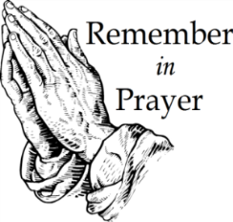
People for Whom We are Praying
Members: Marie Adams; Ed Blazer;
Amanda Bowles; Ruth Long; Alice Pierce;
Bett Warner; Connie Wester

Friends: Emily Burge; Olive Moore, Cheryl Bain friends of Ruth Long and MaryAlice Adams; Rosemary Stewart; Jake Williams, Donna Williams’s son

Hospital News: Annie Boyd

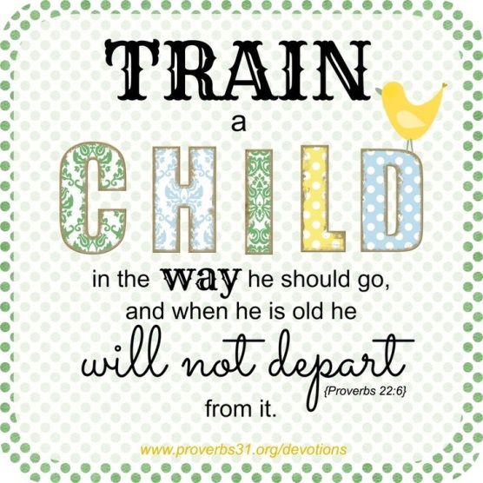
The Nursery Ministry is looking
for passionate individuals who
want to make a difference in the
lives of children and the future of
our church.

Contact Carol Ann Bowles for more
information.

-------------------------------------------------------------------------------------
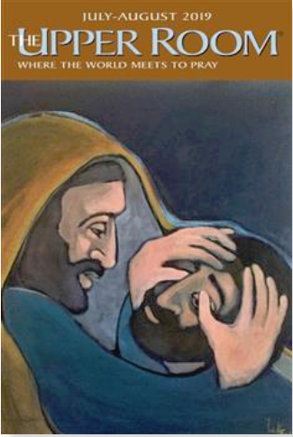
The July/August Upper Room devotion booklet is available in the lobby outside of the church office
Small Print - $1.00
Large Print - $1.50
-------------------------------------------------------------------------------------
Please visit the various bulletin boards around our church, including the one located directly outside the church office, for more information on events and ministries.

Sept. 21 “To Everything There is a Season”
(Seasonal Holiday Decorations Sale)
November 10 Church Council Meeting
December 2 Candle Trimming
December 4-6 Candle Tea
December 24 Lovefeast & Candle Services

The Numbers – General Operating Budget
Amount Needed to Meet Budget: $ 135,200
Receipts as of 06-30-19: $ 103,608
Over/(Under) to Date: $ (31,592)

Attendance: June Average = 57

Al Ray
Dear Friends,
Thanks to all who made this [95th Anniversary] celebration happen – the congregation was overflowing with living saints and with all those who have gone on before…
I saw Al Haworth on the front row, Elmer Stelter up front, Harry and Frances Collins in the balcony, heard Jerry Johnson playing (loudly) on the organ, and Betty Cook in the choir.
Congratulations for such an amazing event!
Sincerely,
Al Ray

Newsletter Submissions – Please submit by email or bring to the office by the 15th of the month to be included in the next issue. All items may be reviewed for accuracy and content and are included at the discretion of the communications team.
from the Board of Trustees
This is to inform the congregation that Betsy Annese has stepped down from the Board of Elders and her position as Vice Chair. We thank Betsy for her service over the past year and a half. When you see her around the church, be sure to give her your thanks.
Clive Goodson has been appointed to carry out her term as Vice President.

Welcome to Ardmore Moravian Church
“Where Communion and Community Come Together”

We are a Christ-centered fellowship of people bound by love of Jesus and one another. Our greatest hope is that God will be glorified through the power and presence of the Holy Spirit among us. We have gathered to worship; celebrating the eternal life won for us by Christ through His death and resurrection as promised in the Bible.

God has created and called us into relationship with Himself (communion) and with one another (community). We need the Lord, and we need each other. As you draw close to God, may you also grow in friendship with those around you. We believe God has gifted people in every age. So our worship is marked by a variety of styles and expressions of music, liturgy, prayer and proclamation. We seek to blend these expressions in a way that pleases God and edifies one another.

The Moravian Church, while unfamiliar to many, is actually one of the oldest Protestant denominations in the world. Our roots and heritage run deep, even one hundred years prior to the Great Reformation. Yet our sense of mission is alive and active today as we serve the Lord in ministry together.

Jesus said to His disciples, “…you shall be My witnesses both in Jerusalem, and in all Judea, and Samaria, and even to the remotest part of the earth.” At Ardmore Moravian we sincerely strive to live that promise. We worship, study the Holy Scriptures, fellowship and grow as Disciples of Christ together here at the corner of Hawthorne and Academy. We ask the Lord then to send us out and employ us for His glory as we share the Gospel - the Good News of Christ - locally, regionally and globally.

If you are searching for a meaningful relationship with God and productive friendships with other people, you’ve come to the right
place, “Where Communion and Community Come Together”.

Director of Music: Brian Haskell
Organist/Accompanist: Chris Heckman
Office Administrator: Cyndi Stuemke
Address: 2013 West Academy Street
Winston-Salem, NC 27103
Church office: 336-723-3444

Office: office@ardmoremoravian.org
Online: ArdmoreMoravian.org
@ArdmoreMoravian

(All songs printed under CCLI# 1007661)

