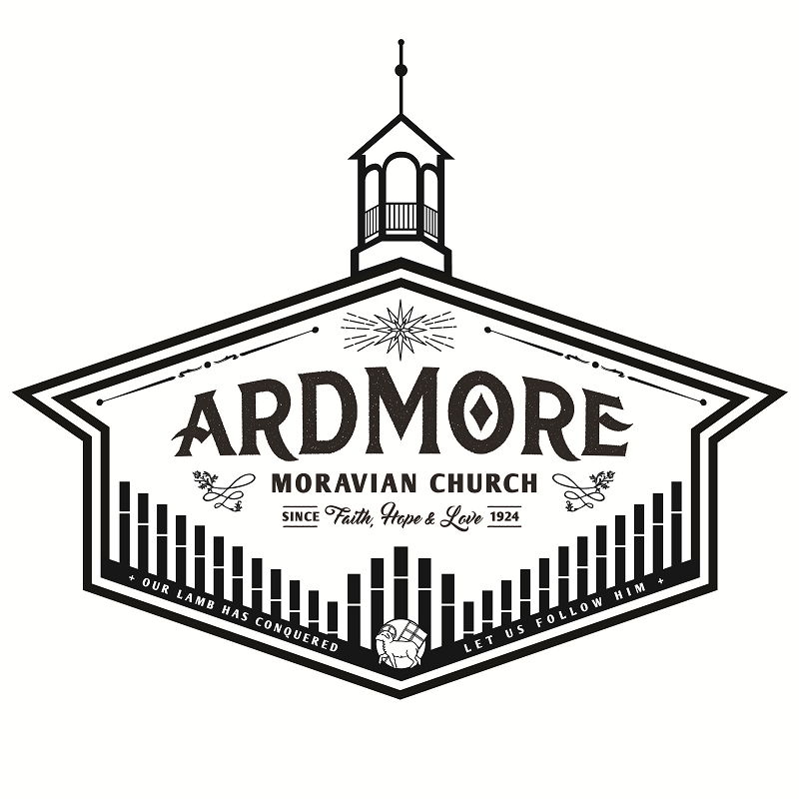

March 17, 2019
Ardmoremoravian.org

WATCH WORD FOR THE WEEK:

The Lord is my light and my salvation; whom shall I fear?
Psalm 27:1

Luke 13: 31-35
³¹ At that very hour some Pharisees came and said to him, “Get away from here, for Herod wants to kill you.” ³² He said to them, “Go and tell that fox for me, ‘Listen, I am casting out demons and performing cures today and tomorrow, and on the third day I finish my work. ³³ Yet today, tomorrow, and the next day I must be on my way, because it is impossible for a prophet to be killed outside of Jerusalem.’ ³⁴ Jerusalem, Jerusalem, the city that kills the prophets and stones those who are sent to it! How often have I desired to gather your children together as a hen gathers her brood under her wings, and you were not willing! ³⁵ See, your house is left to you. And I tell you, you will not see me until the time comes when you say, ‘Blessed is the one who comes in the name of the Lord.’”

ARDMORE MORAVIAN CHURCH
Second Sunday of Lent
March 17, 2019

PRELUDE “Come Thou Fount of Every Blessing”
Handbells McChesney
WELCOME / ANNOUNCEMENTS
RIGHT HAND OF FELLOWSHIP
CALL TO WORSHIP “Blessed Be Your Name” arr. McDonald
LENT I LITURGY MBW p. 72
PRAISE SONGS “Wonderful Merciful Savior” Words p.3
“Who You Say I Am” Words p.4
CHILDREN’S MESSAGE
CONGREGATIONAL PRAYER
WORSHIP IN OUR GIVING
OFFERTORY “Agnus Dei” Raney
Handbells

SONG OF THANKS
Praise God from whom all blessings flow
Praise Him all creatures here below.
Alleluia, Alleluia
Praise Him above ye heavenly host
Praise Father, Son and Holy Ghost.
Alleluia, Alleluia, Alleluia, Alleluia, Alleluia!
PRAYER
ANTHEM “On Eagle’s Wings” arr. Harlan
THE WORD OF GOD Luke 13: 31-35 Bible p. 849
MESSAGE God Moves … past all Obstacles Chaz Snider
HYMN “When I Survey the Wondrous Cross” MBW p. 350
POSTLUDE “Fanfare On Original Theme” Martin

“Wonderful Merciful Savior”

Wonderful, Merciful Savior, Precious Redeemer and Friend;
Who would have thought that a Lamb could
Rescue the souls of men?
Oh, You rescue the souls of men.

Counselor, Comforter, Keeper, Spirit we long to embrace;
You offer hope when our hearts have
Hopelessly lost the way.
Oh, we've hopelessly lost the way.

(Chorus) You are the One that we praise,
You are the One we adore.
You give the healing and grace our hearts always hunger for,
Oh, our hearts always hunger for.

Almighty, infinite Father
Faithfully loving Your own
Here in our weakness You find us
Falling before Your throne
Oh, we're falling before Your throne

(Chorus) 2 x’s

"Who You Say I Am"
Who am I that the highest King
Would welcome me
I was lost but He brought me in
Oh His love for me
Who the Son sets free
Oh is free indeed
I'm a child of God
Yes I am
Free at last He has ransomed me
His grace runs deep
While I was a slave to sin
Jesus died for me
Yes He died for me
Who the Son sets free
Oh is free indeed
I'm a child of God
Yes I am
In my Father's house
There's a place for me
I'm a child of God
Yes I am
I am chosen, not forsaken
I am who You say I am
You are for me, not against me
I am who You say I am
I am chosen, not forsaken
I am who You say I am
You are for me, not against me
I am who You say I am
I am who You say I am
Who the Son sets free
Oh is free indeed
I'm a child of God
Yes I am
In my Father's house
There's a place for me
I'm a child of God
Yes I am

The flowers are placed today to the glory of God and in honor of Jody’s birthday today by Vic Eckard.

Serving Today

Elder/Trustee Greeter for Today, March 17th: Joel Mabe
Elder/Trustee Greeter for March 24th: Clive Goodson
Nursery Worker for Today, March 17th: Kaye Brookshire
Nursery Worker for March 24th: Tracie Marshall
Lay Reader for Today, March 17th: Janice Irwin
Lay Reader for March 24th: Betsy Annese

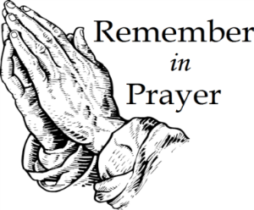
People for Whom We are Praying
Members: Marie Adams; Annie Boyd; Amanda Bowles;
Ruth Long; Alice Pierce; Bett Warner;
Connie Wester; Jim Brookshire
Home Bound Members: Peggy Gimmon

Friends: Emily Burge; Olive Moore, Cheryl Bain friends of Ruth Long and MaryAlice Adams; Rosemary Stewart; Jake Williams, Donna Williams’s son; Judy West, friend of Beth Mabe.

2019 Days of Prayer

Wednesday, March 20,2019-ARDMORE MORAVIAN
Speaker: Rev. Dan Nelson
9:45 - Coffee Hour 10:45 - Music
11:00 - Worship, Nursery Provided

Wednesday March 27, 2019-CALVARY MORAVIAN
Speaker: Rev. Chaz Snider
9:45-10:45 - Coffee Hour
11:00 - Worship, Nursery Provided

Wednesday April 3, 2019-FAIRVIEW MORAVIAN
Speaker: Rev. Victoria Lasley
10:30 - Band Prelude
11:00 - Worship with Communion, Nursery Provided

Wednesday, April 10, 2019 -KONNOAK HILLS MORAVIAN
Speaker: Rt. Rev. Carol Foltz
11:00 - Lovefeast

AMC Opportunities for the Week

Today, March 17 Second Sunday of Lent
4:00 PM Board of Elders Meeting – Young Adult Classroom
4:00 PM Board of Trustees Meeting – Stelter Haus
7:00 PM The Giannini Brass Concert – Fries Memorial
Moravian Church

Tuesday, March 19
11:30 AM Seniors and Friends – Ichiban

Wednesday, March 20
9:45 AM Day of Prayer Coffee Hour
11:00 AM Worship Service - Rev. Dan Nelson
6:30 PM Handbell Rehearsal
7:30 PM Sanctuary Choir Rehearsal

Thursday, March 21
8:30 AM Men’s Breakfast – Cloverdale Kitchen

Sunday, March 24 Third Sunday of Lent
9:00 AM Prayer in Prayer Room
9:15 AM Joyful Voices
9:30 AM Sunday School
10:30 AM Worship Service

News from the Board of Trustees:

New Staff Member:
Stop by the office and welcome our new administrative assistant, Cyndi Stuemke (last name pronounced stem key). She’s in the office every Tuesday from 8:30 AM – 12:30 PM, every Wednesday from 8:30 AM – 4:30 PM, and Thursday from 8:30 AM – 4:30 PM.

The Numbers – General Operating Budget

Amount Needed to Meet Budget: $ 52,000
Receipts as of 03-10-19: $ 38,572
Over/(Under) to Date: $(13,428)

Attendance: March 3 = 60
March 10 =58

Save The Dates:
April 14th -21st Holy Week Services
April 27th Women’s Fellowship Garden Party
June 8th Family Friendly BINGO Afternoon
June 23rd 95th Church Anniversary Sunday
September 21st “To Everything There is a Season For Décor”
(Seasonal Holiday Decorations Sale)
TBD October Fall Festival
December 2nd Candle Trimming
December 4th -6th Candle Tea

Welcome to Ardmore Moravian Church
“Where Communion and Community Come Together”

We are a Christ-centered fellowship of people bound by love of Jesus and one another. Our greatest hope is that God will be glorified through the power and presence of the Holy Spirit among us. We have gathered to worship; celebrating the eternal life won for us by Christ through His death and resurrection as promised in the Bible.

God has created and called us into relationship with Himself (communion) and with one another (community). We need the Lord, and we need each other. As you draw close to God, may you also grow in friendship with those around you. We believe God has gifted people in every age. So our worship is marked by a variety of styles and expressions of music, liturgy, prayer and proclamation. We seek to blend these expressions in a way that pleases God and edifies one another.

The Moravian Church, while unfamiliar to many, is actually one of the oldest Protestant denominations in the world. Our roots and heritage run deep, even one hundred years prior to the Great Reformation. Yet our sense of mission is alive and active today as we serve the Lord in ministry together.

Jesus said to His disciples, “…you shall be My witnesses both in Jerusalem, and in all Judea, and Samaria, and even to the remotest part of the earth.” At Ardmore Moravian we sincerely strive to live that promise. We worship, study the Holy Scriptures, fellowship and grow as Disciples of Christ together here at the corner of Hawthorne and Academy. We ask the Lord then to send us out and employ us for His glory as we share the Gospel - the Good News of Christ - locally, regionally and globally.

If you are searching for a meaningful relationship with God and productive friendships with other people, you’ve come to the right
place, “Where Communion and Community Come Together”.

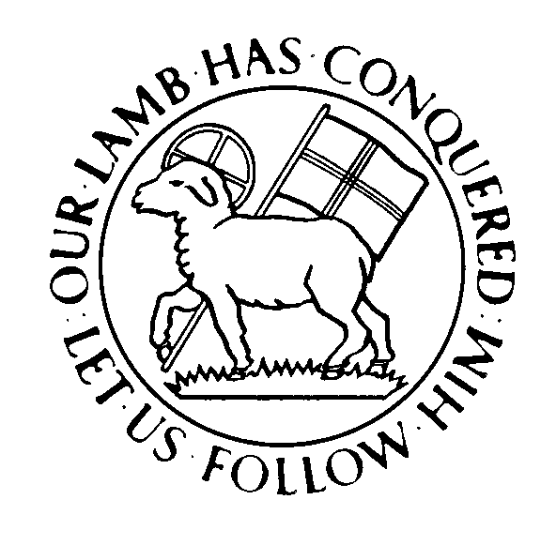

Pastor: Chaz Snider
Director of Children, Youth and Family Ministry: Michaleh Snider
Director of Music: Brian Haskell
Organist/Accompanist: Chris Heckman
Office Administrator: Cyndi Stuemke

Address: 2013 West Academy Street
Winston-Salem, NC 27103
Church office: 336-723-3444
Pastor: chaz@ardmoremoravian.org
Office: office@ardmoremoravian.org
Online: ArdmoreMoravian.org
@ArdmoreMoravian

(All songs printed under CCLI# 1007661)

