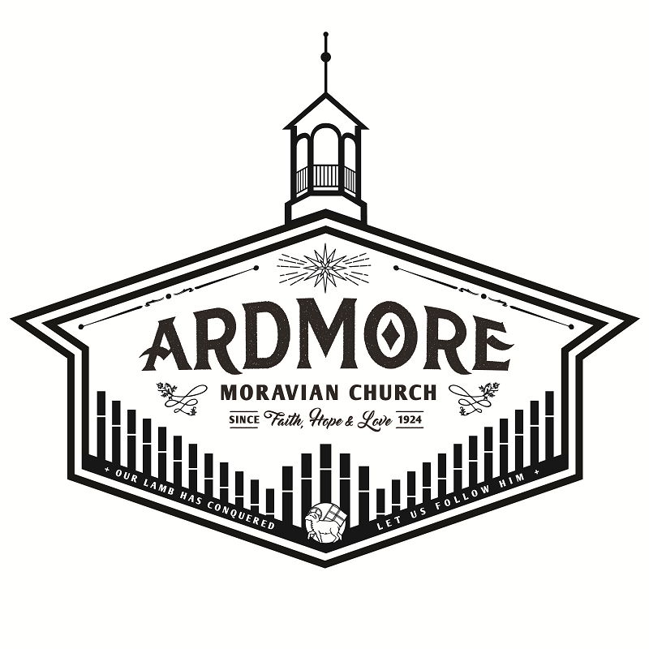

Ardmoremoravian.org
March 8, 2020

WATCH WORD FOR THE WEEK:

For God so loved the world that he gave his only Son, so that everyone who believes in him may not perish, but may have eternal life.
John 3:16

Proverbs 3:5-6
⁵ Trust in the Lord with all your heart and lean not on your own understanding;
⁶ in all your ways submit to him, and he will make your paths straight.

******

Matthew 22:34-37
³⁴ Hearing that Jesus had silenced the Sadducees, the Pharisees got together.
³⁵ One of them, an expert in the law, tested him with this question:
³⁶ “Teacher, which is the greatest commandment in the Law?”
³⁷ Jesus replied: “Love the Lord your God with all your heart and with all your soul and with all your mind.”

ARDMORE MORAVIAN CHURCH
Second Sunday in Lent
March 8, 2020
PRELUDE
WELCOME / ANNOUNCEMENTS
RIGHT HAND OF FELLOWSHIP
CALL TO WORSHIP “Grateful” arr. Smith
LENT 1 LITURGY MBW p. 72
PRAYER
WORSHIP IN OUR GIVING
OFFERTORY
SONG OF THANKS
Praise God from whom all blessings flow
Praise Him all creatures here below.
Alleluia, Alleluia
Praise Him above ye heavenly host
Praise Father, Son and Holy Ghost.
Alleluia, Alleluia, Alleluia, Alleluia, Alleluia!
THE WORD OF GOD Proverbs 3:5-6
Matthew 22:34-37

ANTHEM “He Knows My Name” Walker
MESSAGE “Jesus is Lord” Charlie Paschall
CLOSING SONGS

“Living For Jesus”
Living for Jesus, a life that is true,
Striving to please Him in all that I do;
Yielding allegiance, glad-hearted and free,
This is the pathway of blessing for me.

Refrain:
O Jesus, Lord and Savior, I give myself to Thee,
For Thou, in Thy atonement, didst give Thyself for me;
I own no other Master, my heart shall be Thy throne;
My life I give, henceforth to live, O Christ, for Thee alone.

Living for Jesus Who died in my place,
Bearing on Calv’ry my sin and disgrace;
Such love constrains me to answer His call,
Follow His leading and give Him my all.

Living for Jesus, wherever I am,
Doing each duty in His holy Name;
Willing to suffer affliction and loss,
Deeming each trial a part of my cross.

Living for Jesus through earth’s little while,
My dearest treasure, the light of His smile;
Seeking the lost ones He died to redeem,
Bringing the weary to find rest in Him.

“Resurrection Power”
You called me from the grave by name
You called me out of all my shame
I see the old has passed away
The new has come
Chorus:
Now I have resurrection power Living on the inside Jesus, You have given us freedom
No longer bound by sin and darkness Living in the light of Your goodness
You have given us freedom
I’m dressed in Your royalty, Your Holy Spirit lives in me
And I see my past has been redeemed The new has come
[Chorus]
Bridge:
Freedom, You have given us freedom
You have given us freedom My chains are gone
Freedom, You have given us freedom
You have given us freedom Hallelujah!

Freedom, You have given us freedom
You have given us freedom My chains are gone
Freedom, You have given us freedom
You have given us freedom Hallelujah!
[Chorus - 2x’s]

POSTLUDE
We want to thank Charlie Paschall for sharing his message with us today.
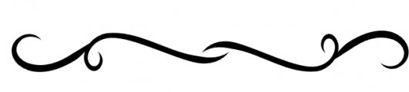

The flowers are placed today to the glory of God and in honor of the 7th wedding anniversary of Joel & Karin Mabe.

Elder/Trustee Greeter for Today, March 8: Barry Flynn
Elder/Trustee Greeter for March 15: Clive Goodson

Women’s Fellowship Board
Special called meeting TODAY
Immediately following the worship service

Opportunities for the Week at AMC

Today, March 8 Called WF Board Meeting after the service

Tuesday, March 10
10:00 AM Circle #3 - Parlor
6:00 PM Circle #5 – Fellowship Hall: Set up Day of Prayer
6:30 PM Circle #4 – Stelter Haus

Wednesday, March 11 – DAY OF PRAYER
9:45 AM Coffee Hour
11:00 AM Worship Service with Pastor Daniel Dockery
6:30 PM Handbell Practice
7:30 PM Choir Rehearsal

Saturday, March 14
2:00 PM Bridal Shower for Catie Irwin (See pg. 9)

Sunday, March 15
9:00 AM Prayer in Parlor
9:30 AM Sunday School
10:30 AM Worship Service with Rev. Scott Venable
4:00 PM Board of Elders & Trustees Meetings
REMAINING 2020 DAYS OF PRAYER

Wednesday, March 11, 2010 - ARDMORE MORAVIAN
Speaker: Rev. Daniel Dockery
9:45 AM – Coffee Hour
10:45 AM – Music
11:00 AM – Worship

Wednesday March 18, 2020 - CALVARY MORAVIAN
Speaker: Rev. Adam Goodrich
9:45 AM – Coffee Hour
11:00 AM – Worship; Nursery Provided

Wednesday March 25, 2020 - FAIRVIEW MORAVIAN
Speaker: Rev. Zachery Dease
10:30 AM – Band Prelude
11:00 AM – Worship with Communion; Nursery Provided

Wednesday, April 01, 2020 -KONNOAK HILLS MORAVIAN
Speaker: Rt. Rev. Carol Foltz
11:00 AM – Lovefeast

Please join Circle #5
for a
Bridal Shower Honoring
Catie Irwin
March 14, 2020
2-4 p.m.

Ardmore Moravian Church Fellowship Hall
2013 W. Academy St.
Winston-Salem, N.C.

RSVP to Terri Kessler 336-972-1925
by March 10
Bridal Registries at Target and Bed Bath & Beyond

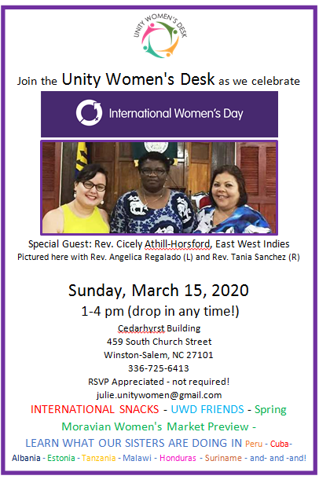

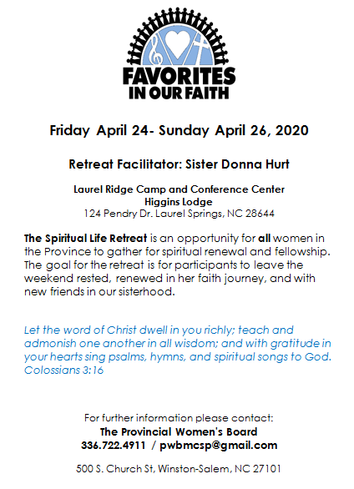
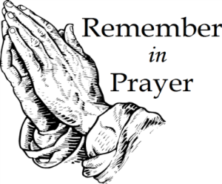
People for Whom We are Praying

Members:
James & Marie Adams; Annie Boyd; Amanda Bowles;
Annie Boyd; Adam Lefevre; Ruth Long; Alice Pierce;
Bett Warner; Connie Wester

Friends:
Cheryl Bain, Olive Moore, friends of Ruth Long and MaryAlice Adams
Emily Burge
Jane Crouse
Marlys Hudson, friend of Nancy Crouse
Rosemary Stewart
Donna Tesh, Michael’s mother
Revelle Washburn, friend of Beth Kiger Mabe
Renee Webb, friend of Chris Lefevre

If you would like to place flowers in memory or in honor
of someone in the 2nd quarter of 2020, please select
from these dates and notify the church office:
April 5, 19, 26, May 17, 24, June 7, 14

Welcome to Ardmore Moravian Church
“Where Communion and Community Come Together”

We are a Christ-centered fellowship of people bound by love of Jesus and one another. Our greatest hope is that God will be glorified through the power and presence of the Holy Spirit among us. We have gathered to worship; celebrating the eternal life won for us by Christ through His death and resurrection as promised in the Bible.

God has created and called us into relationship with Himself (communion) and with one another (community). We need the Lord, and we need each other. As you draw close to God, may you also grow in friendship with those around you. We believe God has gifted people in every age. So our worship is marked by a variety of styles and expressions of music, liturgy, prayer and proclamation. We seek to blend these expressions in a way that pleases God and edifies one another.

The Moravian Church, while unfamiliar to many, is actually one of the oldest Protestant denominations in the world. Our roots and heritage run deep, even one hundred years prior to the Great Reformation. Yet our sense of mission is alive and active today as we serve the Lord in ministry together.

Jesus said to His disciples, “…you shall be My witnesses both in Jerusalem, and in all Judea, and Samaria, and even to the remotest part of the earth.” At Ardmore Moravian we sincerely strive to live that promise. We worship, study the Holy Scriptures, fellowship and grow as Disciples of Christ together here at the corner of Hawthorne and Academy. We ask the Lord then to send us out and employ us for His glory as we share the Gospel - the Good News of Christ - locally, regionally and globally.

If you are searching for a meaningful relationship with God and productive friendships with other people, you’ve come to the right
place, “Where Communion and Community Come Together”.

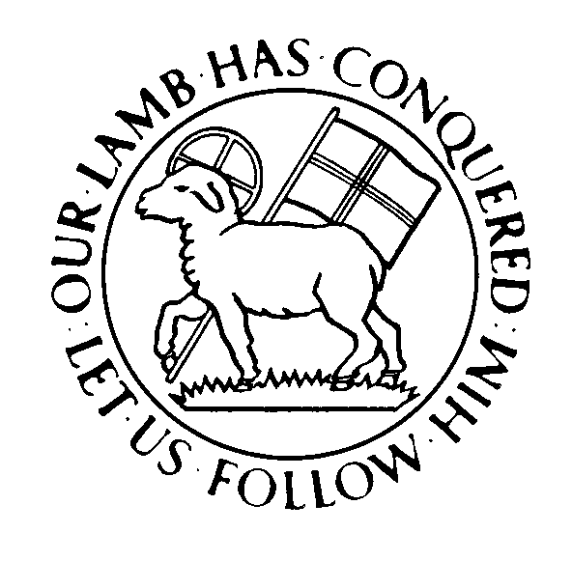

Director of Music: Brian Haskell
Organist/Accompanist: Chris Heckman
Office Administrator: Cyndi Stuemke
Address: 2013 West Academy Street
Winston-Salem, NC 27103
Church office: 336-723-3444

Office: office@ardmoremoravian.org
Online: ArdmoreMoravian.org
@ArdmoreMoravian

(All songs printed under CCLI# 1007661)

