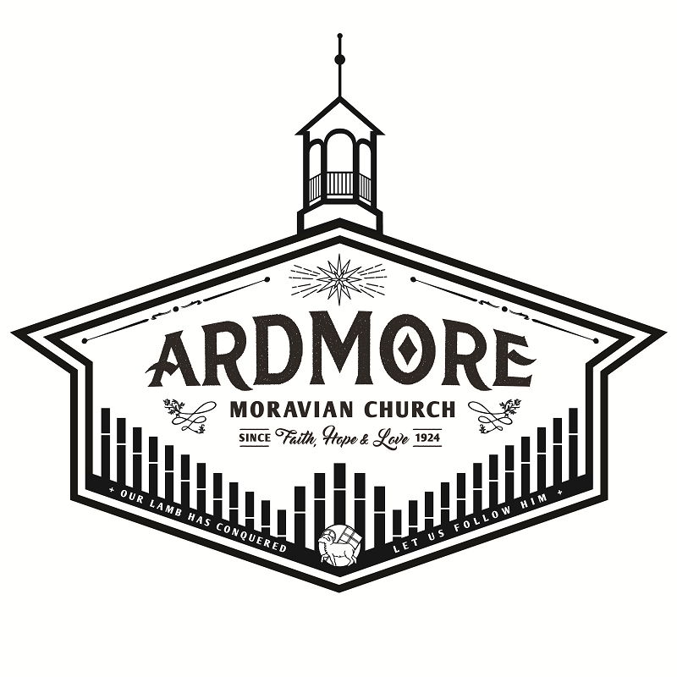

Ardmoremoravian.org
March 1, 2020

WATCH WORD FOR THE WEEK:

Be glad in the Lord and rejoice, O righteous,
and shout for joy, all you upright in heart.
Psalm 32:11

Romans 5:12-19
¹² Therefore, just as sin entered the world through one man, and death through sin, and in this way death came to all people, because all sinned—
¹³ To be sure, sin was in the world before the law was given, but sin is not charged against anyone’s account where there is no law.
¹⁴ Nevertheless, death reigned from the time of Adam to the time of Moses, even over those who did not sin by breaking a command, as did Adam, who is a pattern of the one to come.
¹⁵ But the gift is not like the trespass. For if the many died by the trespass of the one man, how much more did God’s grace and the gift that came by the grace of the one man, Jesus Christ, overflow to the many!
¹⁶ Nor can the gift of God be compared with the result of one man’s sin: The judgment followed one sin and brought condemnation, but the gift followed many trespasses and brought justification.
¹⁷ For if, by the trespass of the one man, death reigned through that one man, how much more will those who receive God’s abundant provision of grace and of the gift of righteousness reign in life through the one man, Jesus Christ!
¹⁸ Consequently, just as one trespass resulted in condemnation for all people, so also one righteous act resulted in justification and life for all people.
¹⁹ For just as through the disobedience of the one man the many were made sinners, so also through the obedience of the one man the many will be made righteous.

We welcome and thank Rev. Wayne Byerly for being with us today and sharing his message.

Rev. Wayne Byerly has served in the Southern Province as a pastor since 1997. He was ordained at Friedland Moravian Church and served the Fulp and Bethania congregations in full-time service.

Following retirement in 2010, he has served as Interim Pastor at Enterprise for 2-1/2 years and Fulp for 1 year. For the past 4 years, he has served Friedland as the Interim Senior Pastor.

Rev. Byerly is married to Patricia Byerly and they have three children, 8 grandchildren, and 9 great-grandchildren.

ARDMORE MORAVIAN CHURCH
First Sunday in Lent
March 1, 2020

PRELUDE
WELCOME / ANNOUNCEMENTS
RIGHT HAND OF FELLOWSHIP
CALL TO WORSHIP “Creation Sings” arr. Koerts

Let Us Sing!
SPEAKER: Let us sing to the Lord a new song. Let us sing to the Lord, all the earth.

PEOPLE: We will sing to the Lord and praise His name, proclaiming his salvation day after day.

ALL: We will declare His glory among the nations, and His marvelous deeds to all peoples.

SONG “Holy Is The Lord”
We stand and lift up our hands,
For the joy of the Lord is our strength.
We bow down and worship Him now.
How great, how awesome is He.
And together we sing everyone sing.

Chorus: Holy is the Lord God Almighty
The earth is filled with His glory
Holy is the Lord God Almighty
The earth is filled with His glory,
The earth is filled with His glory.

We stand and lift up our hands,
For the joy of the Lord is our strength.
We bow down and worship Him now
How great, how awesome is He.
And together we sing everyone sing
(Chorus)

It’s rising up all around
It’s the anthem of the Lord’s renown.
(Repeat)

And together we sing
Everyone sing
(Chorus)
SONG “Resurrecting”
The head that once was crowned with thorns
is crowned with glory now.
The Savior knelt to wash our feet, now at his feet we bow.

The one who wore our sin and shame, now robed in majesty.
The radiance of perfect love now shines for all to see.

Chorus: Your name, Your name is victory.
All praise will rise to Christ our King.
Your name, Your name is victory.
All praise will rise to Christ our King.

The fear that held us now gives way to him who is our peace
His final breath upon the cross is now alive in me. (Chorus)

By Your Spirit I will rise, from the ashes of defeat.
The resurrected King is resurrecting me.
In Your name, I come alive to declare Your victory.
The Resurrected King is resurrecting me. (repeat)

The tomb where soldiers watched in vain
was borrowed for three days.
His body there would not remain,
Our God has robbed the grave, our God has robbed the grave.

(Chorus x 2)
PRAYER
WORSHIP IN OUR GIVING
OFFERTORY
SONG OF THANKS
Praise God from whom all blessings flow
Praise Him all creatures here below.
Alleluia, Alleluia
Praise Him above ye heavenly host
Praise Father, Son and Holy Ghost.
Alleluia, Alleluia, Alleluia, Alleluia, Alleluia!

THE WORD OF GOD Romans 5:12-19
ANTHEM “O Church Arise” arr. Mauldin
COMMUNION MEDITATION Rev. Wayne Byerly
An Amazing Transaction
HOLY COMMUNION MBW p. 196
In Celebration of the Atonement
POSTLUDE

The flowers are placed today to the glory of God.

Elder/Trustee Greeter for Today, March 1: David Peery
Elder/Trustee Greeter for March 8: Barry Flynn

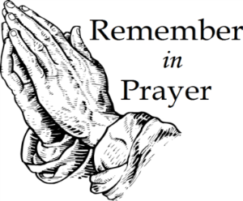
People for Whom We are Praying

Members:
James & Marie Adams; Annie Boyd; Amanda Bowles;
Annie Boyd; Adam Lefevre: Ruth Long; Alice Pierce;
Bett Warner; Connie Wester

Friends:
Cheryl Bain, Olive Moore, friends of Ruth Long and MaryAlice Adams;
Emily Burge;
Marlys Hudson, friend of Nancy Crouse
Rosemary Stewart; Donna Tesh, Michael’s mother
Revelle Washburn, friend of Beth Kiger Mabe
Renee Webb, friend of Chris Lefevre

Opportunities for the Week at AMC

Monday, March 2
7:00 PM Women’s Fellowship Board Meeting

Tuesday, March 3
9:00 AM Bible Study – Mayberry’s

Wednesday, March 4
5:30 PM Prayer in Parlor
6:00 PM Meal
6:30 PM Bible Study
6:30 PM Handbell Practice
7:30 PM Choir Rehearsal

Sunday, March 08 Second Sunday of Lent
9:00 AM Prayer in Parlor
9:30 AM Sunday School
10:30 AM Worship Service

If you would like to stay in touch with Pastor Daniel, you may contact him by phone, mail, or email at:
Daniel Dockery
105 River Ridge Drive
Morganton, NC 28655
danieldockery@charter.net
(828) 778-1691
2020 Days of Prayer

Sunday, March 01, 2020 - CHRIST MORAVIAN
Speaker: Rev. Richard Spaugh
2:00 PM – Lovefeast; Nursery Provided

Wednesday, March 04, 2020 - TRINITY MORAVIAN
Speaker: Rev. Chris Thore
11:00 AM – Worship
Luncheon

Wednesday, March 11, 2010 - ARDMORE MORAVIAN
Speaker: Rev. Daniel Dockery
9:45 AM – Coffee Hour
10:45 AM – Music
11:00 AM – Worship

Wednesday March 18, 2020 - CALVARY MORAVIAN
Speaker: Rev. Adam Goodrich
9:45 AM – Coffee Hour
11:00 AM – Worship; Nursery Provided

Wednesday march 25, 2020 - FAIRVIEW MORAVIAN
Speaker: Rev. Zachery Dease
10:30 AM – Band Prelude
11:00 AM – Worship with Communion; Nursery Provided

Wednesday, April 01, 2020 -KONNOAK HILLS MORAVIAN
Speaker: Rt. Rev. Carol Foltz
11:00 AM – Lovefeast

Welcome to Ardmore Moravian Church
“Where Communion and Community Come Together”

We are a Christ-centered fellowship of people bound by love of Jesus and one another. Our greatest hope is that God will be glorified through the power and presence of the Holy Spirit among us. We have gathered to worship; celebrating the eternal life won for us by Christ through His death and resurrection as promised in the Bible.

God has created and called us into relationship with Himself (communion) and with one another (community). We need the Lord, and we need each other. As you draw close to God, may you also grow in friendship with those around you. We believe God has gifted people in every age. So our worship is marked by a variety of styles and expressions of music, liturgy, prayer and proclamation. We seek to blend these expressions in a way that pleases God and edifies one another.

The Moravian Church, while unfamiliar to many, is actually one of the oldest Protestant denominations in the world. Our roots and heritage run deep, even one hundred years prior to the Great Reformation. Yet our sense of mission is alive and active today as we serve the Lord in ministry together.

Jesus said to His disciples, “…you shall be My witnesses both in Jerusalem, and in all Judea, and Samaria, and even to the remotest part of the earth.” At Ardmore Moravian we sincerely strive to live that promise. We worship, study the Holy Scriptures, fellowship and grow as Disciples of Christ together here at the corner of Hawthorne and Academy. We ask the Lord then to send us out and employ us for His glory as we share the Gospel - the Good News of Christ - locally, regionally and globally.

If you are searching for a meaningful relationship with God and productive friendships with other people, you’ve come to the right
place, “Where Communion and Community Come Together”.

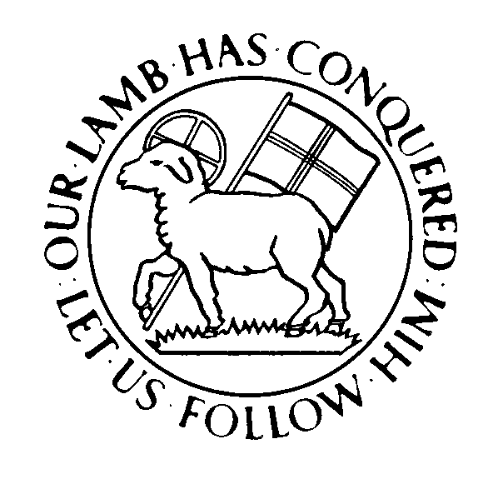

Director of Music: Brian Haskell
Organist/Accompanist: Chris Heckman
Office Administrator: Cyndi Stuemke
Address: 2013 West Academy Street
Winston-Salem, NC 27103
Church office: 336-723-3444

Office: office@ardmoremoravian.org
Online: ArdmoreMoravian.org
@ArdmoreMoravian

(All songs printed under CCLI# 1007661)

